SUMMER PROJECT REPORT

On
Application of industrial waste in the construction of flexible pavement
BY
Alisha Waghmare (230104007)



DISCIPLINE OF CIVIL ENGINEERING
INDIAN INSTITUTE OF TECHNOLOGY GUWAHATI

Application of industrial waste in the construction of flexible
pavement
A PROJECT REPORT
Civil ENGINEERING
Submitted by:
ALISHA WAGHMARE (230104007)
Guided by:
Dr. Sharad Gokhle
INDIAN INSTITUTE OF TECHNOLOGY GUWAHATI

CANDIDATE’S DECLARATION

We hereby declare that the project entitled “Application of industrial waste in the construction of flexible pavement” submitted inThis is to certify that the Summer Project in Civil Engineering was successfully completed by the student under the supervision of Dr. Neelima Satyam D., Associate Professor, Department of Civil Engineering, and Dr. Saikat Sarkar, Assistant Professor, Department of Civil Engineering, IIT Guwahati. The work presented herein is an authentic and original work carried out during the summer project..
ALISHA WAGHMARE
_________________________________________________________________

CERTIFICATE by PROJECT Guide(s)

It is certified that the above statement made by the students is correct to the best of my knowledge.

Dr. Sharad Gokhle
Discipline of Civil Engineering

Preface

This report on “Application of industrial waste in the construction of flexible pavement" is prepared under the guidance of Dr. Sharad Gokhle

Preface write-up may be decided by the students. An example of the same is given below:
(Through this report we have tried to give a detailed design of an innovative car control utility for the vehicles and try to cover every aspect of the new design, if the design is technically and economically sound and feasible.
We have tried to the best of our abilities and knowledge to explain the content in a lucid manner. We have also added 3-D models and figures to make it more illustrative.)

ALISHA WAGHMARE
B.Tech. IV Year
Discipline of Civil Engineering
IIT GUWAHATI

Acknowledgments

I wish to thank Dr. Sharad Gokhle for their kind support and valuable guidance.

It is their help and support, due to which I became able to complete the design and technical report.

Without their support this report would not have been possible.

Alisha waghmare (230104007)
B.TECH 4TH YEAR student
Civil Engineering Department
Indian institute of technology Guwahati

Abstract
The surface layer of flexible pavement is made of composite materials consisting of binder (bitumen), aggregates and mineral filler, which are mixed and paved as top layer by paver provides more than 70% strength to it. With the increment in the intensity of traffic loading with a more commercial vehicle, the core strength of flexible pavement should be strengthened to improve pavement characteristics and quality by doing possible modifications.
Silica Fume, an industrial waste product, has an adverse impact on the environment if not disposed of safely. It is an extremely fine nanocrystalline polymorph of silica and has a significant potential of use as a mineral filler. The bituminous mix, a distinctive pavement material with more than 18% void ratio, is used to construct porous paved structures. In paved structures, porosity is essential for water drainage and noise reduction, along with structural defects like rutting, fatigue, potholes, and raveling. Usage of mineral filler in bituminous mix leads to porosity reduction and densification, resulting in improvement of strength and durability.
This project investigates the effective reuse of industrial waste silica fume as a replacement of conventional mineral filler along with Polypropylene (Plastic waste, non-biodegradable) in a bituminous mix to densify paved structures. Mechanical resistivity, durability of the bituminous mix has been assessed using Marshall Stability Strength (MSS), Indirect Tensile Strength (ITS), Mean Marshall Stability Ratio (MMSR), Index of Retained Strength (IRS), and Water Sensitivity (WS) Tests for varying percentages of bitumen (4.5%. 5.0%, 5.5%, and 6.0%), silica fume (i.e.
2.0%, 4.0%, and 6.0%) and Polypropylene (2%, 4% and 6%) content.
Inclusion of silica fume and Polypropylene increased the weight density, while the air void percentage remained within the acceptable limits as prescribed by MoRTH. Results justify the utilization of industrial waste silica fume as a sustainable substitute for conventional mineral fillers. The results also show significant improvement in the strength and aging performance of bituminous mix with the inclusion of 6.0 % silica fume and 4.0 % Polypropylene at 5.5% bitumen content.
Numerical analysis with ABAQUS is carried out to evaluate the Fatigue failure with experimental and theoretical values for three cases that showed an optimum margin of 26.478 %, 24.17 %, 30.59 % for silica fume with polypropylene, silica fume only and without silica fume respectively.

Table of Contents
Declaration of Authorship 3
Certificate 3
Acknowledgment 5
Abstract 6
List of Figures 9
List of Tables 11

1. Introduction 12
1.1 Definition …………………………………………………………………… 12 1.2 Background ………………………………………………………………… 12 1.3 Objectives ……………………………………………………………………. 13

2. Literature Survey 14
2.1 Experimental analysis ……………………………………………………… 14 2.2 Numerical analysis ………………………………………………………… 14

3. Materials 15
3.1 Aggregate …………………………………………………………………… 15 3.2 Bitumen ………………………………………………………………………. 16 3.3 Silica Fume …………………………………………………………………… 17 3.4 Polypropylene ………………………………………………………………… 18

4. Experiments 19

4.1 Marshall Stability Test ………………………………………………………..19 4.2 Volumetric properties …………………………………………………………19
4.2.1 Maximum Theoretical Specific Gravity………………………………20 4.2.2 Dry Density ……………………………………………………………..20 4.2.3 Air Voids (VA) ………………………………………………………….20 4.2.4 Voids in Mineral Aggregate (VMA) …………………………………...20 4.2.5 Voids Filled with Bitumen (VFB) ……………………………………...20
4.3 Indirect Tensile Strength ……………………………………………………….21 4.4 Index of Retained Strength ………………………………………………….....21
4.5 Long Term Aging (LTA) ……………………………………………………...22 4.6 Water Sensitivity Test …………………………………………………………22
- Numerical Approach 23
  - Equations Used ……………………………………………………………… 23 5.2 Boundary Conditions ………………………………………………………….24 5.3 Mesh element and Size ……………………………………………………… 24 5.4 Interaction Properties …………………………………………………………25 5.5 Load condition …………………………………………………………………25
- Results 27
  - Silica Fume as mineral filler ………………………………………………….. 27 6.2 Silica Fume and polypropylene ………………………………………………. 32 6.3 Numerical analysis ……………………………………………………………. 37
- Conclusion and Future work 41

References 43

List of Figures
- Grain size distribution curve of aggregate as per MoRTH requirement for aggregate………………………………………………………………………………………...16
- Mesh element and Size……………………………………………………………………….24
- Boundary condition and load condition…………………………………………………….25
- Effect of silica fume on a) Bulk density b) Flow c) Marshall stability d) Marshall quotient (SF)………………………………………………………………………………………………28
- Effect of silica fume on a) Air voids b) Voids in mineral filler c) Voids filled with bitumen d) Percentage volume of bitumen (SF)………………………………………………………………………………………………29
- Effect of silica fume on indirect tensile strength of the bituminous mix (SF)………………………………………………………………………………………………30
- Effect of silica fume on the index of retained strength of the bituminous mix (SF)………………………………………………………………………………………………30
- Effect of silica fume on the Mean Marshall stability ratio of bituminous mix (SF)………………………………………………………………………………………………31
- Effect of silica fume on water sensitivity test of bituminous mix (SF)………………………………………………………………………………………………32
- Effect of silica fume on a) Bulk density b) Flow c) Marshall stability d) Marshall quotient (SF+PP)………………………………………………………………………………..33
- Effect of silica fume on a) Air voids b) Voids in mineral filler (SF+PP)………………………………………………………………………………………….34
- Effect of silica fume on indirect tensile strength of the bituminous mix (SF+PP)………………………………………………………………………………………….35

- Effect of silica fume on the index of retained strength of the bituminous mix (SF+PP)…………………………………………………………………………………………35
- Effect of silica fume on the Mean Marshall stability ratio of bituminous mix (SF+PP)………………………………………………………………………………………….36

15. Effect of silica fume on water sensitivity test of bituminous mix (SF+PP)…………………………………………………………………………………………37

| P a g e

List of Tables

1. Properties of Aggregate considered…………………………………………….. 15 2. Properties of Bitumen Considered……………………………………………… 16 3. Properties of Silica Fume Considered…………………………………………… 17 4. Properties of polypropylene fiber considered…………………………………… 18 5. Input parameter given for numerical analysis………………………………….. 26 6. Summary of conversion error with ABAQUS………………………………….. 38 7. Summary of Experimental Results (SF)…………………………………………. 39 8. Summary of Experimental Results (SF+PP)…………………………………….. 40

Chapter 1

Introduction

1.1 Definition
A multi-layered pavement with Bituminous Mix as a surface layer, is what simply considered as a flexible pavement with conical load transfer from every point of contact down the layer. The bituminous mix is a preferable material for enhancing the strength, durability, water resistance, smoothness, and noise reduction in paved structures [1–4]. The surface layer of flexible paved structures is a mixture of asphalt concrete, i.e. aggregate and binder (Bitumen is the traditional binder used), with graded minerals used for improving stiffness [5,6]. The surface layer of the paved structure mostly comprises of coarse aggregate and mineral filler with more than 90% of Hot Mix Asphalt (HMA) [2,7]. However, surface layer contributes to the strength of paved structures [8,9] with materials such as lime [10], cement [11], dust stone, fly ash [12–15] as fillers and HDPE (High Density Polyethylene) [16–18], crumb rubber [19–22] and volcanic ash [23] as binder substitute. Mineral filler and bituminous binders are two major constituents of reducing air voids and enhancing stability and durability of bituminous mix against the rutting and shoving [24–28]. A higher concentration of mineral filler with low bituminous binder content produces a dry mix that is not suitable for the construction of a paved structure, whereas overfilling with a bituminous binder imparts fluid-like characteristics to the hot mix asphalt (HMA) [29]. The inclusion of optimum content of mineral filler increases the modulus of elasticity of HMA; however, overdoses of mineral filler reduce the aggregate content, and reduction in strength is observed [30].

1.2 Background
The cement is the conventional mineral filler used in a bituminous mix to increase the stability and durability [31], which causes global warming due to CO₂ emission [32,33]. The cement production industry emitted approximately 522.00 MT CO₂ in the year 2016 [34] and the production of oneton cement effectuate approx. 0.8T CO₂ [35,36]. Cement production ramps up at breakneck speed via a yearly increase of 2.5 percent and 4.6BT of gross production in 2015 [37]. India is the 2nd largest cement manufacturer causing the threat of higher CO₂ emission; therefore, researchers are constantly looking for new technologies that can substitute cement [38]. The Sustainable uses of various industrial waste like Phosphate waste filler [39], Jordanian oil shale fly ash [40], baghouse fines [41] , recycled waste lime [42], municipal solid waste incineration ash [30,43] and waste ceramic material [44,45] have been investigated as mineral filler. Results indicate the optimum performance of the bituminous mix with the inclusion of industrial waste as mineral [46,47].
The industrial wastes are constantly being used to construct sustainable and environmental friendly paved structures. Silica fume (microsilica) is an extremely fine silica nanocrystalline polymorph formed as a by-product of silicon and ferrosilicon alloy processing in electric arc furnaces (EAFs). Furthermore, the material involved in the pozzolanic reaction with the calcium hydroxide crystals producing additional cementing material (C-S-H) and eliminating areas of stress concentrations prone to failure initiation [48–51]. Silica Fume (SF) has been used in the concrete industries to improve compressive strength, hardening of concrete and as a partial replacement of cement [51– 55] . SF is being used in transportation geotechnics to reduces swelling pressure and increasing the bearing capacity of the paved structure subgrade [56,57]; however, there is a minimal investigation carried out to use as a filler in HMA. The use of industrial waste lime considered as economical mineral filler in HMA has been investigated, and the result shows that 4% lime content by weight of aggregate increase Marshall Stability Strength [58] and 2 to 10-year durability can be increased with the inclusion of 1-1.5% hydrated lime [28]. Silica fume having similar pozzolanic properties as lime[59], which encourages the use of silica fume as mineral filler in HMA.
Plastic being the most non-conventional waste and due to its non-biodegradable nature, becomes hazardous to the environment and ecosystem. A perfect ban on plastic cannot be an optimum solution as its alternative is very hard to find and in today’s day to day life its requirement is more often, these are some of the reasons that lead its objectivity in the field of engineering.

1.3 Objective
As different mineral filler has been used to maximize the performance of surface layer of flexible pavement [62-65], this report used silica fume (an industrial waste) and then polypropylene along with silica fume as a mineral filler to stabilize HMA, after getting experimental values fatigue failure behavior is simulated with ABAQUS software to determine the percentage conversion rate of experimental values with numerical values.
Chapter 2

Literature Survey
This chapter mainly focuses on the methodology of factors affecting surface layer, filler in bituminous mix, fatigue failure of flexible pavement and numerical analysis with different software.

2.1 Experimental analysis
Mineral filler is one of the important component of HMA and many experiments have been done to utilize fine material as per ASTM D-5329 (16), fly ash and hydrated lime was used as a mineral filler and it was observed that with addition of 4% fly ash in HMA, 7% reduction in optimum bitumen content (OBC) was seen [62]. Crushed stoned dust was used and it was observed that with the addition of 10% stone dust marshall stability and flow was 8.2 kN and 3.4 mm [63]. Cement was used as mineral filler and it was observed that increment of bulk density and marshall stability with 4.3% and 25% respectively [64]. Binder substitute is also used in HMA to strengthen its core strength such as HDPE (High-Density Polyethylene) that shows optimum use of 10% HDPE to improve marshall stability [65].

2.2 Numerical analysis
Numerical analysis for flexible pavement is done with many software such as ABAQUS, IITPAVE, PlAXIS etc. to simulate the behavior of pavement under different load conditions such as aircraft load at different mesh sizes and elements that shows its relationship with time-frequency [66]. The analysis with horizontal loads and interface conditions is carried out with to simulate life for flexible and semi-rigid pavement [67]. An analysis with ABAQUS is carried out to figure out different load area conditions such as rectangular, circular, semi-circular and ellipsoidal n which circular and rectangular contact area come out to be optimum [68]. Load Vs Deflection analysis is carried out with ABAQUS to examine the different material properties such as mass density, Young’s modulus etc. [69].

Chapter 3

Materials

3.1 Aggregate
The crushed quartz aggregates are used in the study. To assess the quality of aggregate various lab experiments i.e. cleanliness, grain size distribution, bulk specific gravity, Los Angles Abrasion, soundness. Shape and size, impact strength and water absorption have been carried out. The experimental results of the physical properties of considered aggregate are shown in Table 1 and Fig 1. The gradation curve of considered aggregate has been compared with MoRTH upper limit and lower limit of aggregate per cribbed for the flexible paved structure construction which designates the material as grade II.

Table 1: Properties of Aggregate Considered
Test Parameters | Specified limit  (MoRTH) | Test  Result | Test Method
Cleanliness (Dust) (%) | Max 5 % | 3 | IS 2386 Part I
Bulk Specific gravity | 2-3 | 2.68 | IS 2386 Part III
Percent wear by Los angles abrasion (%) | Max 35 % | 10.6 | IS 2386 Part IV
Soundness loss by sodium sulfate solution  (%) | Max 12% | 3.4 | IS 2386 Part V
Soundness loss by Magnesium Sulphate solution (%) | Max 18% | 3.7 | IS 2386 Part V
Flaky and Elongation Index (%)  20mm  10mm  Impact Strength (%)  20 mm  10 mm  Water absorption (%)  Water Sensitivity (%) | Max 35%  Max 27%  Max 2%  Min 80% | 27.93  32.13  4.15  5.91  1.67  93 | IS 2386 Part I  IS 2386 Part IV  IS 2386 Part III  AASTHO 283

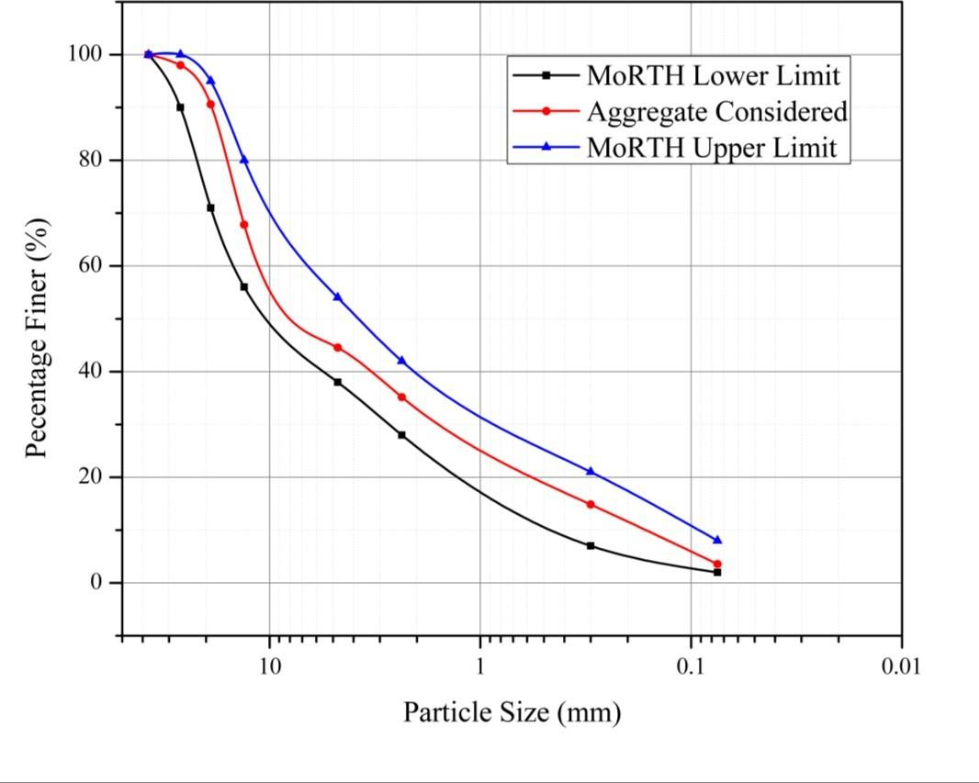
Figure 1: Grain size distribution curve of aggregate as per MoRTH requirement for aggregate

3.2 Bitumen
The conventional VG–30 Grade of bitumen have been used in the present study provided by Tiki Tar Industries (Baroda) Limited Gujarat India. The properties of the binder were assessed by carrying out the viscosity, flash point, penetration, softening point, matter soluble, ductility and specific gravity lab experiments. The physical properties of a bitumen binder consider in the study are presented in Table 2.

Table 2: Properties of Bitumen Considered
Test Parameters | Specified limit  (MoRTH) | Test Result | Test Method
Absolute viscosity at 60°C poises | 2400-3600 | 2855 | IS 1206 (P-2)
Kinematic viscosity at 135°C cSt, Min. | 350 | 392 | IS 1206 (P-3)
Flashpoint cleave land open cup, °C, Min. | 250 °C | 304 | IS 1448 (P-  69)
Penetration at 25°C, 100gm, 5sec,  1/10mm, Min | 45 | 60 | IS 1203
Softening point (R&B), °C, Min | 75°C | 49 | IS 1205
Ductility at 25°C, cm, Min. 40 75 IS 1208
Specific Gravity gm/cc 0.97-1.02 0.987 IS 1202

3.3 Silica Fume
The processed silica fume used in the research work provided by the Safew Tech system Indore (India) in powder form and air-dried. The various chemical and physical properties of silica fume are given in Table 3.

Table 3: Properties of Silica Fume Considered
Property | Value
Density, (Mg/m3) | 92.25
SiO₂ (%) | 98.87
Al2O₃(%) | 0.02
Fe2O₃ (%) | 0.01
K₂O (%) | 0.08
CaO (%) | 0.23
Specific surface area  Percentage (m²/kg)fines (%) | 15000-30000  91

3.4 Polypropylene
Polypropylene have been used in this project as a binder substitute to observe its variability with different amount of mineral filler (here SF) as they have many advantages, such as High strength, chemically inertness, non-corrosiveness, etc. For the present study, fibers with a length of 6 mm were used provided by Bajaj Reinforcements Nagpur India. The physical, chemical, and mechanical properties of Polypropylene shown in Table 4.

Table 4. Properties of polypropylene fiber considered
S.No. | Property | Value
1. | Bulk Density | 910
2. | Tensile strength (kN/mm²) | 0.67
3. | Young’s modulus  (kN/mm²) | 4.0
4. Melting point (°C) 165

Chapter 4

Experiments
After preliminary material characterization, the mix design of a bituminous mix has been carried out. The varying percentage of silica fume (i.e. 0.0%, 2.0%, 4.0%, and 6.0%) with bitumen (4.5%. 5.0%, 5.5%, and 6.0%) and Polypropylene (i.e. 2.0%, 4.0% and 6.0% by weight of silica fume) by weight of aggregate are used to investigate the stability and durability of bituminous mix The prepared bituminous mix mechanical resistivity, durability have been assessed using of the bituminous mix Marshall Stability Strength (MSS), Indirect Tensile Strength (ITS), Mean Marshall Stability Ratio (MMSR), Index of Retained Strength (IRS), and Water Sensitivity (WS) Tests. The bituminous mixes were prepared by using MoRTH guidelines. The bituminous mix was compacted in the desired size as per test requirement using standard compactor with 75 blows.

4.1 Marshall Stability Test
The test sample with varying percentages of silica fume (i.e. 2.0%, 4.0%, and 6.0%) and bitumen (4.5%. 5.0%, 5.5%, and 6.0%) by weight of aggregate content has been prepared. After getting the optimum mineral filler content test sample with varying percentages of polypropylene (i.e. 2%, 4%, 6%) by weight of silica fume is carried out. The cylindrical specimen of 67 ± 3mm diameter and 102.0mm thickness is statically compacted and kept in the water bath at 60 ± 1 °C temperature for the duration of 35± 5 min [60]. Three specimens of each grade of mix prepared to investigate the effect of repeatability and results are reported by applying standard deviation. The 100kN load cell and 50mm LVDT with a data acquisition system were used to measure and record the maximum load resistance and respective deformation at the constant strain rate of 50.4 mm/min.
The results of the experiments have been reported as Marshall's stability, flow, and quotient.

4.2 Volumetric properties
The volumetric properties represent the volume of the binder, mineral filler, and coarse-aggregates necessary to produce a bituminous mixture of desirable material properties. The volumetric parameters of the bituminous mix are significant for the long-term strength and durability of a paved structure. The various volumetric properties, which include maximum theoretical specific gravity, dry density, percentage of air voids, voids in mineral filler, voids filled with bitumen content of the bituminous mix has been evaluated to assess modified mix. The following mathematical equations have been considered for the calculation of volumetric properties

4.2.1 Maximum Theoretical Specific Gravity (G_{mm})
G_{mm}= Wmix
(Vmix-Va)

4.2.2 Dry Density
W_{A}
Dry density=
(WSSD-Ww)

4.2.3 Air Voids (VA)
Gmm-Gmb
V_{A}= ( )×100
Gmm

4.2.4 Voids in Mineral Aggregate (VMA)
VMA-VA
VMA= (1-)×100
VMA

4.2.5 Voids Filled with Bitumen (VFB)
VMA-VA
VFB= ( )×100 VMA
Where,
W_{mix} = Weight of bitumen mix,
W_{SSD} = Weight of the saturated surface dry samples
V_{mix} = Volume of bitumen mix,
V_{a} = Volume of air voids
VMA = Voids in mineral aggregate
G_{mm} = Maximum theoretical specific gravity
G_{mb} = Bulk specific gravity of the mix

4.3 Indirect Tensile Strength
In accordance with ASTM D6931 [61] Indirect tensile strength (ITS) test has been conducted on the test specimen prepared. The cylindrical specimen of 67 ± 3mm diameter and 102mm thickness by ASTM D3549/D3549M [62] was statically compacted and 4 hours air-dried specimen are kept in the water bath at 60 ± 1 °C temperature for the duration of 35± 5 min. The indirect tensile strength test has been conducted to calculate the stiffness modulus which represents the cracking, fatigue and rutting property at low temperature. The test has been carried out at a constant strain rate of 50.4mm/min. The mathematical equation to calculate the maximum tensile strength given in Eq. 6:
2×P_{max} σ_{t}= πHD
Where;
𝜎_{𝑡} = Indirect tensile strength (kPa)
P_{max} = Maximum load carrying capacity (kN)
H = Height of the specimen (mm)
D = Diameter of the specimen (mm)

4.4 Index of Retained Strength
IRS test has been conducted as per ASTM D6927 [60] standard to evaluate the moisture damage effect on a bituminous mix. The results of the test represent the loss of cohesion caused due to water action. The total 6 specimens of each modified grade have been prepared in accordance with ASTM D3549/D3549M [62]. The 3 specimens were kept at 60 ± 1 °C temperature for the duration of 24 hrs. in water bath and remaining 3 specimens are air-dried for 4 hrs. and then placed in water bath at 60 ± 1 °C temperature for the duration of 35± 5 min for testing. The specimens were tested at constant strain rate 50.4 mm/min to calculate the ultimate load-carrying capacity of the bituminous mix. The mathematical expression for the index of retained strength used for the calculation is given in 7.
S_{w}
IRS (%)= ( )×100
S_{d}
Where
S_{w}: Wet specimen compressive Strength after 24 hrs.
S_{d}: Dry specimen compressive strength after 35± 5 min.

4.5 Long Term Aging (LTA)
LTA was calculated to evaluate the long term hardening of paved structures during in-service life. The LTA was calculated as per SHRP A-003A, the specimens are cured in an oven at 80 ± 5 °C for 5 days simulate the long term hardening of 10 years in-service life [63]. The 6 specimens with varying content of bitumen and silica fume and then with polypropylene cured in the water bath and then tested by ASTM D6927 [60] at 60 ± 1 °C. The long-term aging results are presented by MMSR. The mathematical equation to calculated MMSR is given in Eq. 8.
MSafter aging
MMSR=
MSbefore aging

4.6 Water Sensitivity Test
The resistance provided to water-induced damage for the bituminous mixes due to the addition of the silica fume and then polypropylene as mineral filler was calculated by reduction in the indirect tensile strength (ITS) percentage, before and after controlled moisture condition i.e. water bath immersion for 24 hrs. at 60°C by AASHTO T-283.

Chapter 5

Numerical approach
Abaqus software is used here for numerical analysis of flexible pavement for fatigue failure and linear elastic model is considered.

5.1 Equations used
1. Linear Elastic model for pavement layers
ᵋ11 1/𝐸  ᵋ22 −𝑣/𝐸  ^{ᵋ33} = ^{−𝑣/𝐸}  ᵞ12 0 ᵞ13 0 {ᵞ23} [ 0  and | −𝑣/𝐸 −𝑣/𝐸 0  1/𝐸 −𝑣/𝐸 0  −𝑣/𝐸 1/𝐸 0  0 0 1/𝐺  0 0 0  0 0 0  𝐺=𝐸/2(1+𝑣) | 0  0  0  0  1/𝐺  0 | 0 𝜎𝜎1122  0  0 𝜎33  0 𝜎12  0 𝜎13  1/𝐺 ] {𝜎23}
Where
ᵋ = Strain at a point 𝝈 = Stress at a point v = Poisson’s ratio
E = Young’s modulus
G = Shear modulus
2. Fatigue failure equation for max. 20 % crack at bottom of surface layer
𝑁𝑓
Where
𝑁𝑓 = 𝑁𝑜. 𝑜𝑓 𝑐𝑢𝑚𝑚𝑢𝑙𝑎𝑡𝑖𝑣𝑒 𝑠𝑡𝑎𝑛𝑑𝑎𝑟𝑑 𝑎𝑥𝑙𝑒𝑠 𝑡𝑜 𝑝𝑟𝑜𝑑𝑢𝑐𝑒 20% 𝑐𝑟𝑎𝑐𝑘𝑒𝑑 𝑠𝑢𝑟𝑓𝑎𝑐𝑒
Ɛt = Tensile strength at any point on bottom of surface layer
E = Young’s modulus at any point on the bottom of surface layer

5.2 Boundary Condition
The sides of pavement are restricted from rotation and moving from all the possible direction when we look in the real scenario, thus we have taken ENCASTRE boundary condition that says,
U1 = 0 UR1 = 0
U2 = 0 UR2 = 0 U3 = 0 UR3 = 0
Where
U1, U2, U3 are movement in X, Y and Z direction respectively.
UR1, UR2, UR3 are rotation in X, Y and Z direction respectively.

5.3 Mesh element and size
Mesh element and size is taken to have fine parts and effective nodes, the element and size are given below
Mesh (Global) size at the point of load = 0.01
Mesh (Global) size elsewhere = 0.1
Mesh elements used = wedge (C3D6, 6 node linear triangular prism)
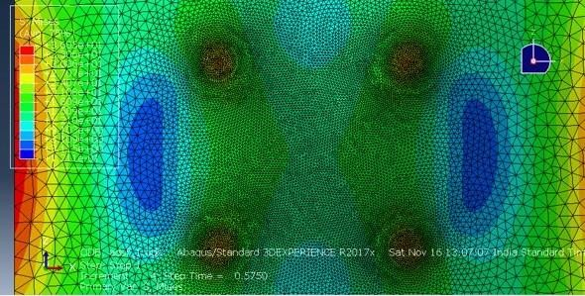
Figure 2: Mesh element and size

5.4 Interaction properties
Surface-to-surface contact is considered as layers are deformable and rigid and lower part of surface layer is taken as master surface and upper part of base layer is considered as slave layer
as the later one is below the former one. Tangential property is defined by ‘Rough’ as practically it is not possible to have a smooth surface.

5.5 Load condition
As per the IRC 37 the standard load for wheel is given to be 80 kN, so by accordance with the IRC 37 we have considered four points on surface layer and 20 kN is given to each point having circular contact diameter of 198 mm for the analysis of flexible pavement.
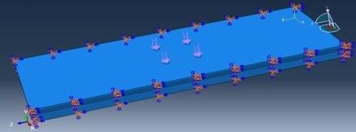

Figure 3: Boundary condition and load condition

Table 5: Input parameter given for numerical analysis
Parameters used | Without SF | With SF | With SF + Polypropylene
Length | 10 m | 10 m | 10 m
Width | 3.5 m | 3.5 m | 3.5 m
Height | 0.01 m | 0.01 m | 0.01 m
Young’s Modulus | 221631.0 kN/m² | 1193980.0 kN/m² | 1197480.0 kN/m²
Poisson’s Ratio | 0.35 | 0.35 | 0.35
Load condition | 80 kN (vertical down) | 80 kN (vertical down) | 80 kN (vertical down)
Boundary condition | Encastre | Encastre | Encastre
Mesh element | Wedge (C3D6) | Wedge (C3D6) | Wedge (C3D6)
Mesh Size | 0.01 (Global) | 0.01 (Global) | 0.01 (Global)
Time Step | 0.1 to 1 Second | 0.1 to 1 Second | 0.1 to 1 Second
Interaction property | Rough (f=0.47) | Rough (f=0.47) | Rough (f=0.47)

Chapter 6

Results

6.1 Silica Fume as a mineral filler
Marshall Stability of a bituminous mix is the ultimate load that the specimen can carry, while the Marshall flow is the deformation of the specimen that occurred under peak load. Figure 2 shows the effect of mineral filler as silica fume on a) Bulk density b) Flow c) Marshall Stability d) Marshall quotient of the varying percentages of silica fume and bitumen content. From Fig. 2 (a) it can be observed that the bulk density of the bituminous mix increased with the addition of 2% and 4% SF content, however with the 6 % SF content inclusion, the reduction in the bulk density has been observed. The SF having higher specific surface area and with the inclusion of the fine particles in the bituminous mix voids filled closely and the increment in bulk density was observed. Since silica fume is lightweight material hence higher concentration of SF content reduced a bulk density. The pozzolanic reaction of silica fume occurs during the curing period of bituminous mix, which induced cementation effect in the specimen and as a result, stiff bituminous mix obtained. Due to stiffness in the specimen Marshall flow reduced as shown in Fig 2(b). Figure 2(c) shows the effect of silica fume on Marshall stability of bituminous mix, as noted with the inclusion of SF the bulk density has been increased, and flow (mm) has been decreasing; hence a significant amount of improvement in the Marshall stability has been observed. Figure 2 (d) depicts the effect of SF content on Marshall quotient of bituminous mix. As the Marshall stability value has been increased and stability flow has been decreased, as a result the Marshall quotient has been increased up to 3.01. As per the MoRTH [64] recommendation the MQ should be lies between 2 to 4 for the paved structures. The bituminous mix during loading deformed in cohesion and adhesion. The cohesion and adhesion failure occurs due to the failure of binder and binder- aggregate interface, respectively. It has been observed that the adhesive bond between binderaggregate is the controlling mechanism for failure in MSS test. The binder content increases the adhesive bond and silica fume fills the void in the specimen, which sufficiently increases the specific surface area to carry the traffic load. Figure 2(c) shows the MSS value increase with increasing the binder and mineral filler content. However, a higher concentration of mineral filler with low bituminous binder content produces a dry mix, whereas overfilling with a bituminous binder imparts fluid-like characteristics in the specimen, as a result the reduction in the stability strength was observed at high concentration. The higher stability with lower flow rate is the primary indicator of resistance of paved structures against the deformation.
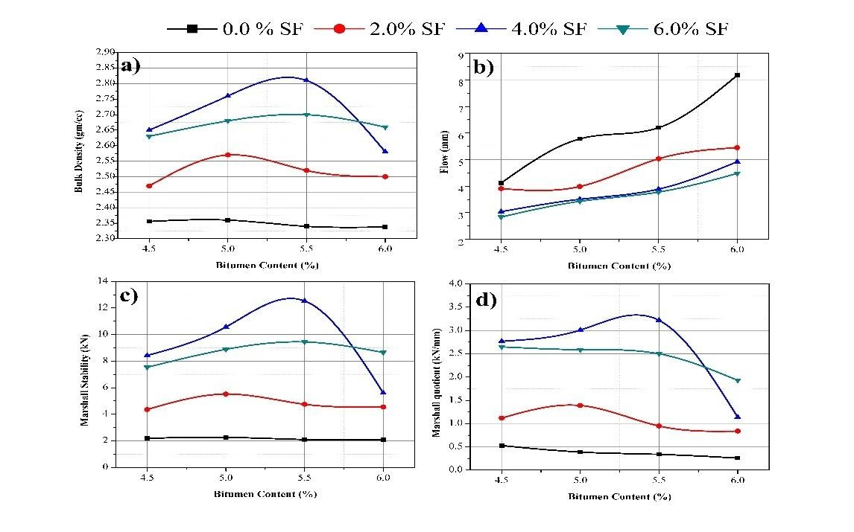

Figure 4: Effect of silica fume on a) Bulk density b) Flow c) Marshall stability d) Marshall quotient
The increase in the bulk density also shows the densification of the bituminous mix which can be used in paved structure in case of stiff mix requirement. The aggregates having a higher density than the mineral filler silica fume hence SF particles penetrated in a specimen and formed a layer on the aggregate surface. The SF particles fill the air voids present in the specimen, but the values obtained are under specified limit 3% to 5% as given by MoRTH [64] for mineral filler. The bulk specific gravity is the air voids depended parameter, the minimum air voids reduce the bulk volume of the bituminous mix which significantly increases the specific gravity as shown in Fig. 2 (a).
Figure. 3 shows the effect of silica fume on a) Air voids b) Voids in mineral filler c) Voids filled with bitumen d) Percentage volume of bitumen. The air voids of the bituminous mix have been reduced from 13.97 % to 4.17 %. As shown in Fig 3 (a) and (b), with the addition of SF as filler material the void ratio and void in mineral aggregate have been reduced. Figure 3 (d) depicts the effect of SF content on percentage volume of bitumen content and it can be observed that with the increase of the SF content the reduction in the % volume of bitumen content has been observed since the SF fines fill the voids up to a great extent.
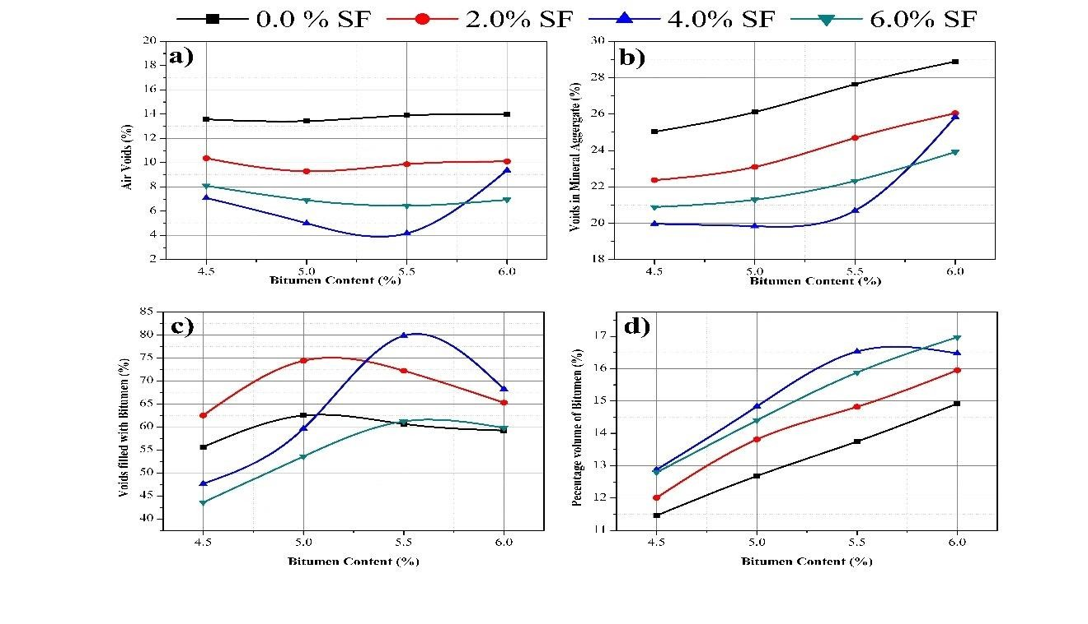

Figure 5: Effect of silica fume on a) Air voids b) Voids in mineral filler c) Voids filled with bitumen d) Percentage volume of bitumen
Figure 4 shows the effect of silica fume on an ITS of a bituminous mix. It can be observed that with the inclusion of silica fume in the bituminous mix the ITS value of mixes increases significantly, however, the over dosses of silica fume content reduces the ITS value. The maximum value of ITS was observed at the 4.0 % silica fume mixed with 5.5% VG 30 grade of bitumen; the more or less similar results have also been observed at 5.0% VG 30 content. The inclusion of silica fume in the mixing process the pozzolanic action during the curing, and hence, the tangible improvement in the ITS has been observed. From Fig.4 it can be seen that 2 % SF at 5.0% bitumen content, 4.0% and 6.0% SF at 5.5 % bitumen content gives higher values. The inclusion of a higher percentage of the SF content also increases the requirement of bitumen for processing adequate strength. The no filler material reduces the strength of bituminous mix up to a great extent and gives similar results even by increasing the bitumen content in the mix. The presence of SF content as a filler material reduces the void ratio hence with the densified bituminous mix the strength has been increased.
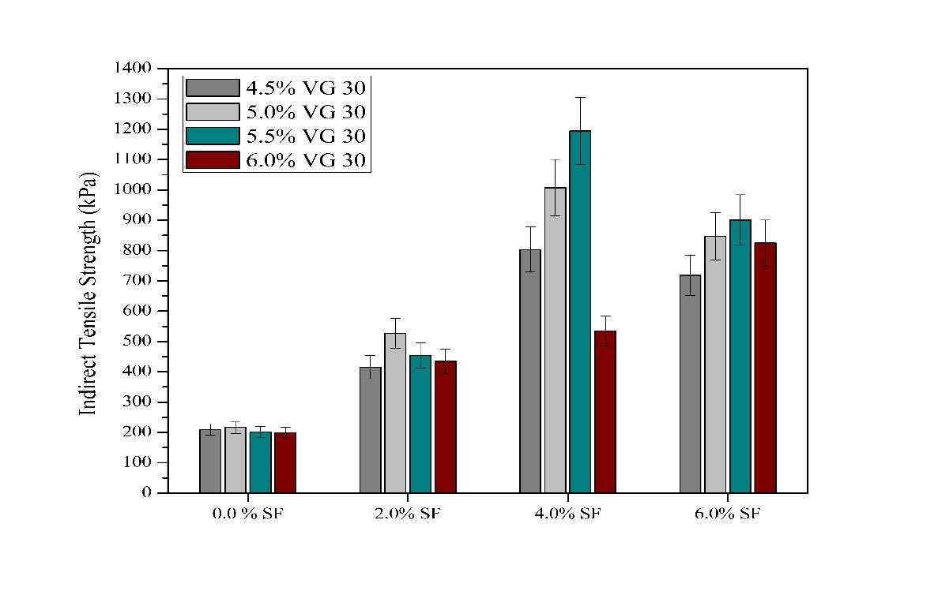

Figure 6: Effect of silica fume on indirect tensile strength of the bituminous mix

Figure 5 illustrated the effect of silica fume on the index of retained strength of a bituminous mix. It is clearly shown that there is less influence by moisture damage with the addition of silica fume in a bituminous mix. The IRS value has been increased from 39 % to 86 % with the addition of SF content. The maximum performance to the IRS was observed by 4.0% and 6.0 % SF at 5.5% bitumen content in the mix. The higher content of silica fume makes bituminous mix as stiffer, and as a result in low reduction in the strength has been observed with increasing the SF content.
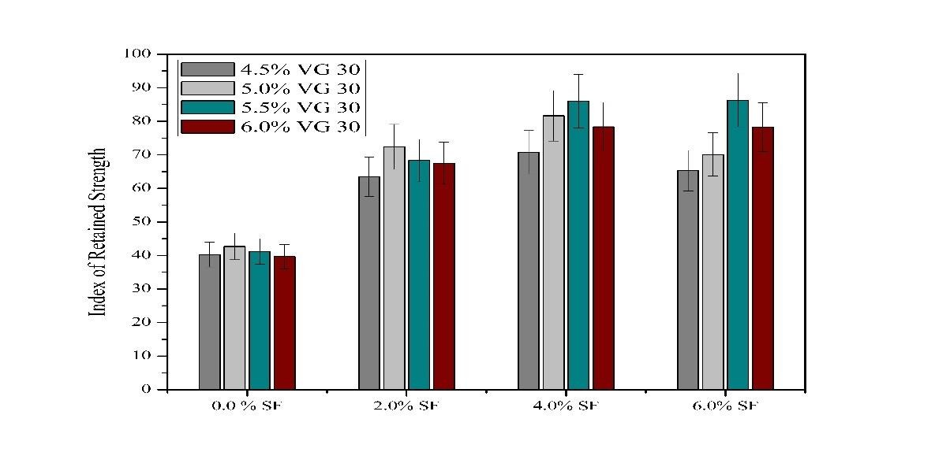

Figure 7: Effect of silica fume on the index of retained strength of the bituminous mix

The effect of silica fume on a Mean Marshall Stability Ratio of a bituminous mix is illustrated in Fig 6. The similar behavior of the bituminous mix has found, as observed during IRS results. The increment in the values has been observed. This test shows the long terms aging effect of the modified bituminous mix. The properties have shown significant improvement due to pozzolanic reaction of SF content for five days curing period. Stiffen bitumen mix gives more MSS than the initial curing period specimen, hence the effect of aging lies under the acceptable limit. The MSS decreased when the silica fume was not used in the bituminous mix, which shows with time bitumen hardened and cause loss in strength.
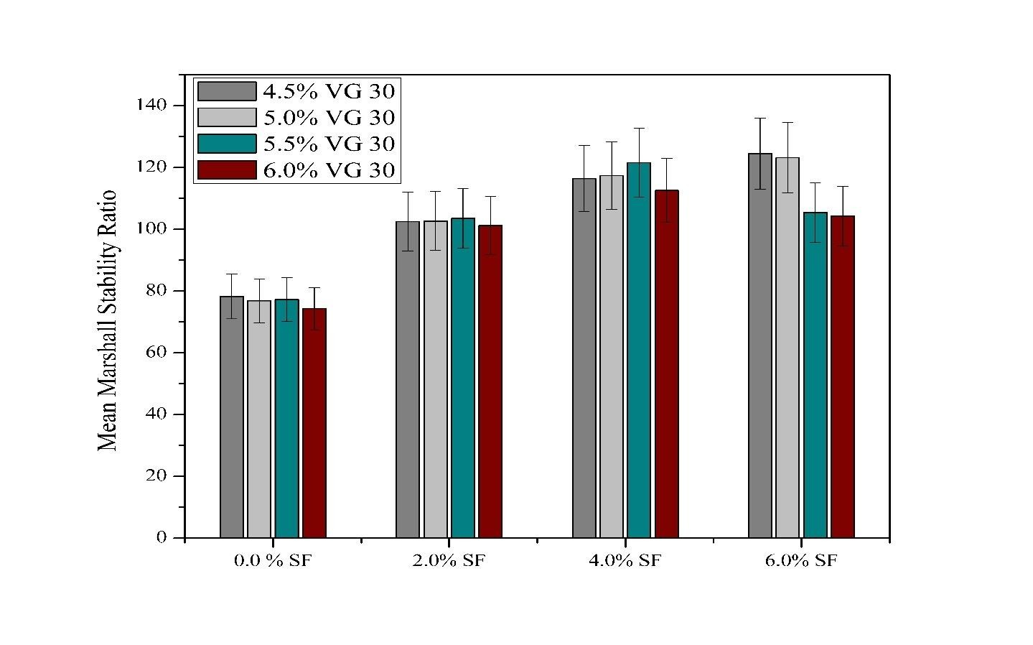

Figure 8: Effect of silica fume on the Mean Marshall stability ratio of bituminous mix

The effect of silica fume as a mineral filler on a water sensitivity of a bituminous mix shown in Fig. 7. With the inclusion of silica fume the average loss in the strength has been reduced due to moisture-induced damage. The results are expressed as loss in indirect tensile strength of the bitumen after 24 hrs. of submersion period. The loss of ITS value was observed 19.80%, 18.51% and 17.50% with the inclusion of 2.0%, 4.0%, and 6.0% SF content, respectively. These values of the ITS lies in the acceptable limit of maximum 20% loss of strength due to water sensitivity [65].
The higher content of silica fume content shows less reduction in the ITS loss due to pozzolanic action occurs during the curing period; however, the reduction caused due to the hardening of binder content. Bitumen mix losses strength up-to 40% without mineral filler content, which indicates less durability.
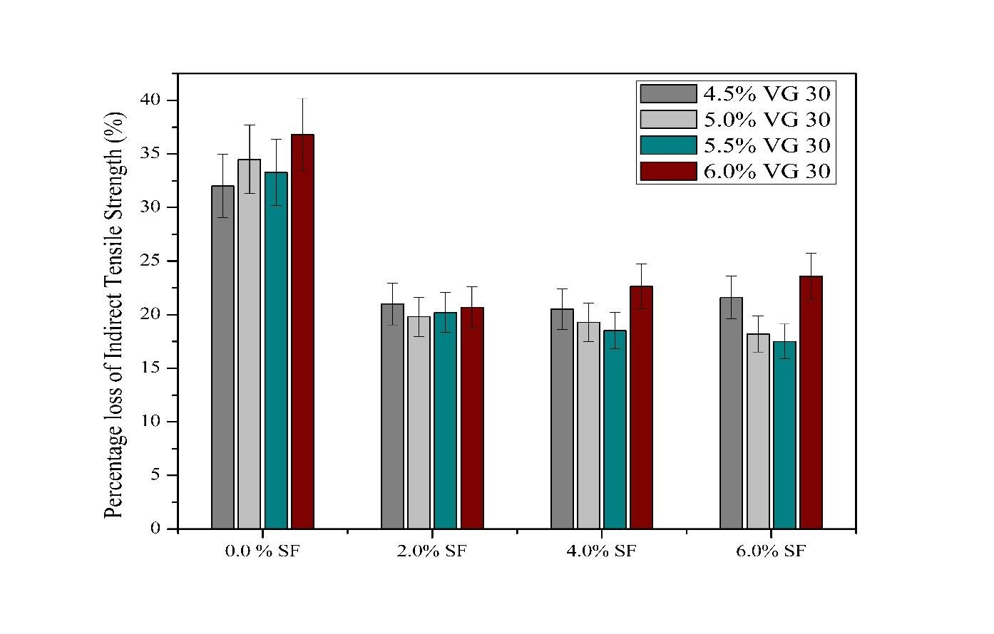
Figure 9: Effect of silica fume on water sensitivity test of bituminous mix

6.2 Silica Fume and polypropylene
Experiments with polypropylene is carried out by keeping optimum bitumen content 5.5 % by total weight constant and changing with polypropylene (2.0 %,4.0%,6.0% and 8.0%) with different silica fume (0%,2%,4% and 6%) content. Figure 10 shows the effect of mineral filler as silica fume and polypropylene on a) Bulk density b) Flow c) Marshall Stability d) Marshall quotient of the varying percentages of silica fume and bitumen content. From Fig. 10 (a) it can be observed that the bulk density of the bituminous mix increased with the addition of 2% and 4% polypropylene content and 6 % polypropylene content while slight decrease is observed with 8 % polypropylene content. Figure 10 (c) shows the effect of silica fume and polypropylene on marshall stability of bituminous mix, as noted with the inclusion of SF and polypropylene the bulk density has been increased, and flow (mm) has been decreasing; hence a significant amount of improvement in the
Marshall stability has been observed. Figure10 (d) depicts the effect of SF content on Marshall quotient of bituminous mix. As the Marshall stability value has been increased and stability flow has been decreased, as a result the Marshall quotient has been increased up to 3.07. As per the MoRTH [64] recommendation the MQ should be lies between 2 to 4 for the paved structures. Figure 11(c) shows the marshall stability value increase with increasing the polypropylene and mineral filler content. However, a higher concentration of mineral filler with low bituminous binder content produces a dry mix, whereas overfilling with a bituminous binder imparts fluid-like characteristics in the specimen, as a result the reduction in the stability strength was observed at high concentration.
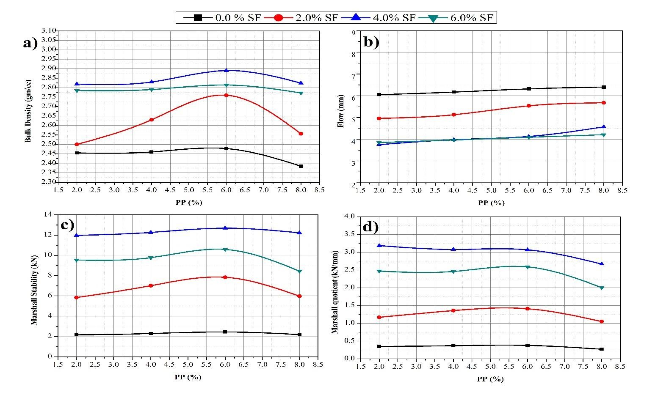

Figure 10: Effect of silica fume on a) Bulk density b) Flow c) Marshall stability d) Marshall quotient

The SF particles fill the air voids present in the specimen, but the values obtained are under specified limit 3% to 5% as given by MoRTH [64] for mineral filler. The bulk specific gravity is the air voids depended parameter, the minimum air voids reduce the bulk volume of the bituminous mix which significantly increases the specific gravity as shown in Fig. 10 (a). Figure. 11 shows the effect of silica fume on a) Air voids b) Voids in mineral filler. The air voids of the bituminous mix have been reduced from 13.85 % to 3.98 %. As shown in Fig 11 (a) and (b), with the addition of SF as filler material the void ratio and void in mineral aggregate have been reduced up to 4% SF content.
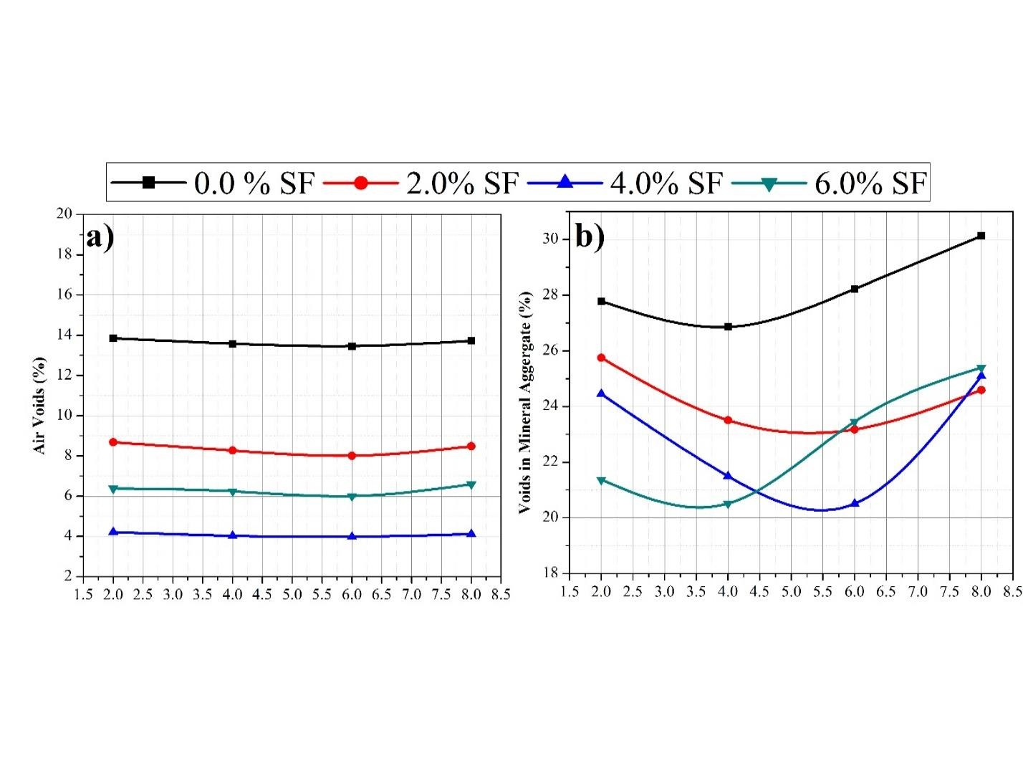

Figure 11: Effect of silica fume on a) Air voids b) Voids in mineral filler

Figure 12 shows the effect of silica fume on an ITS of a bituminous mix. It can be observed that with the inclusion of silica fume in the bituminous mix the ITS value of mixes increases significantly, however, the over dosses of silica fume content reduces the ITS value. The maximum value of ITS was observed at the 4.0 % silica fume and 6.0 % polypropylene mixed with 5.5% VG 30 grade of bitumen.
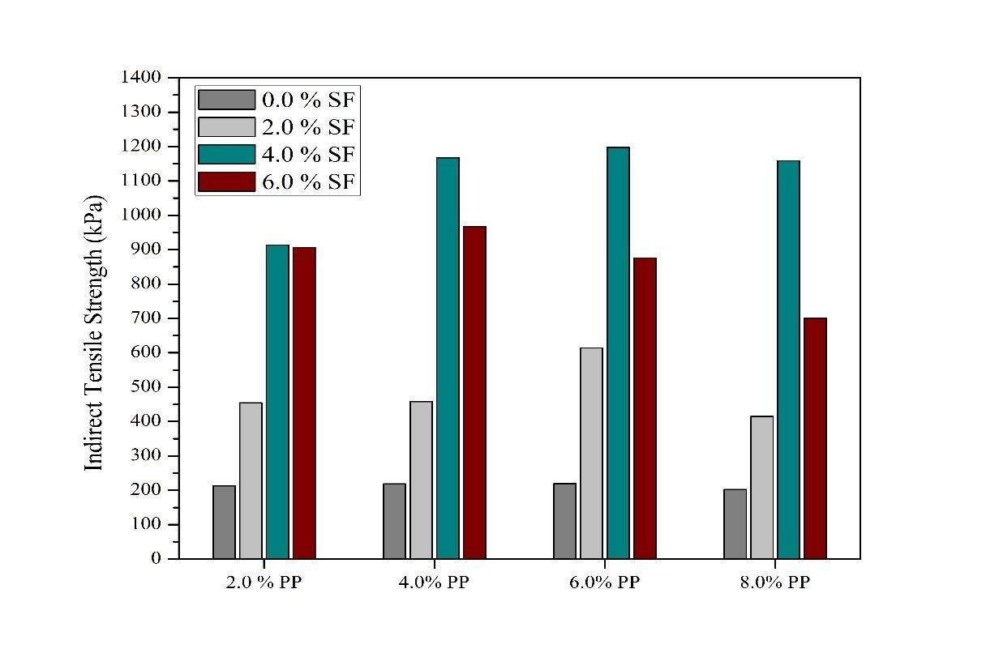

Figure 12: Effect of silica fume on indirect tensile strength of the bituminous mix
Figure 13 illustrated the effect of silica fume on the index of retained strength of a bituminous mix. It is clearly shown that there is less influence by moisture damage with the addition of silica fume in a bituminous mix. The IRS value has been increased from 40.86 % to 96.12 % with the addition of SF and polypropylene content. The maximum performance to the IRS was observed by 4.0% and 6.0 % SF with 6.0% and 4.0% polypropylene respectively.
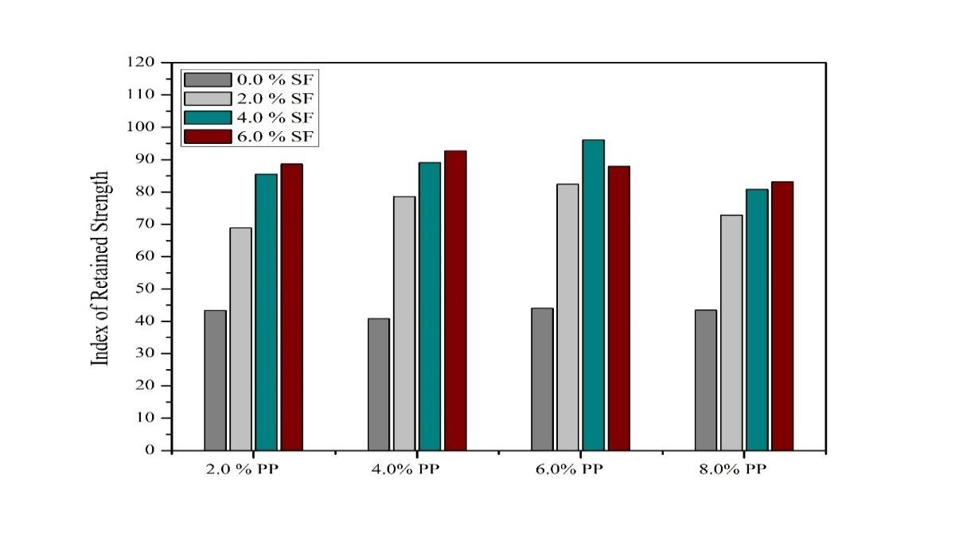

Figure 13: Effect of silica fume on the index of retained strength of the bituminous mix

The effect of silica fume on a Mean Marshall Stability Ratio of a bituminous mix is illustrated in Fig 14. As it can be observed that a slight increase in MMSR with extra addition of polypropylene with SF which shows very slight effect of polypropylene on aging of HMA.
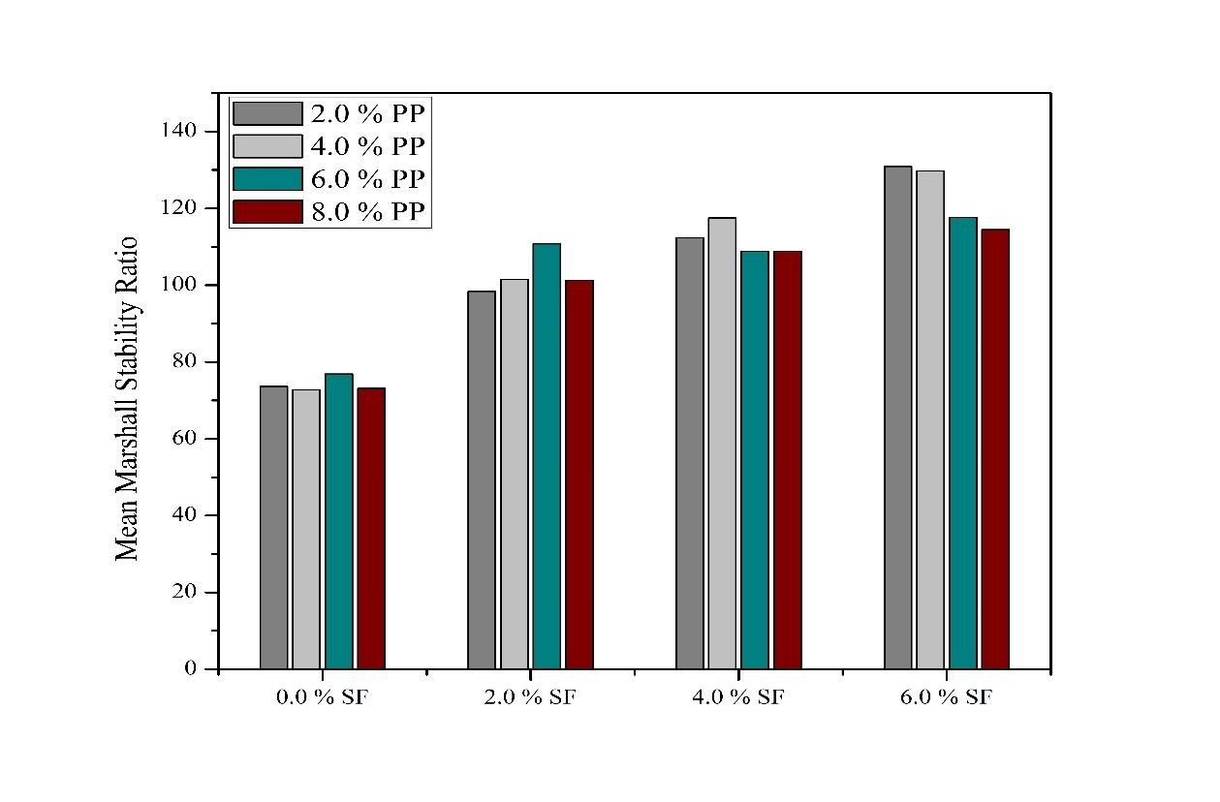

Figure 14: Effect of silica fume on the Mean Marshall stability ratio of bituminous mix

The effect of silica fume as a mineral filler on a water sensitivity of a bituminous mix shown in Fig. 15. With the inclusion of silica fume the average loss in the strength has been reduced due to moisture-induced damage. The results are expressed as loss in indirect tensile strength of the bitumen after 24 hrs. of submersion period. The loss of ITS value was observed 17.58%, 18.43% and 16.73% with the inclusion of 2.0%, 4.0%, and 6.0% SF content and 4%, 4% and 6% polypropylene respectively. These values of the ITS lies in the acceptable limit of maximum 20% loss of strength due to water sensitivity [65].
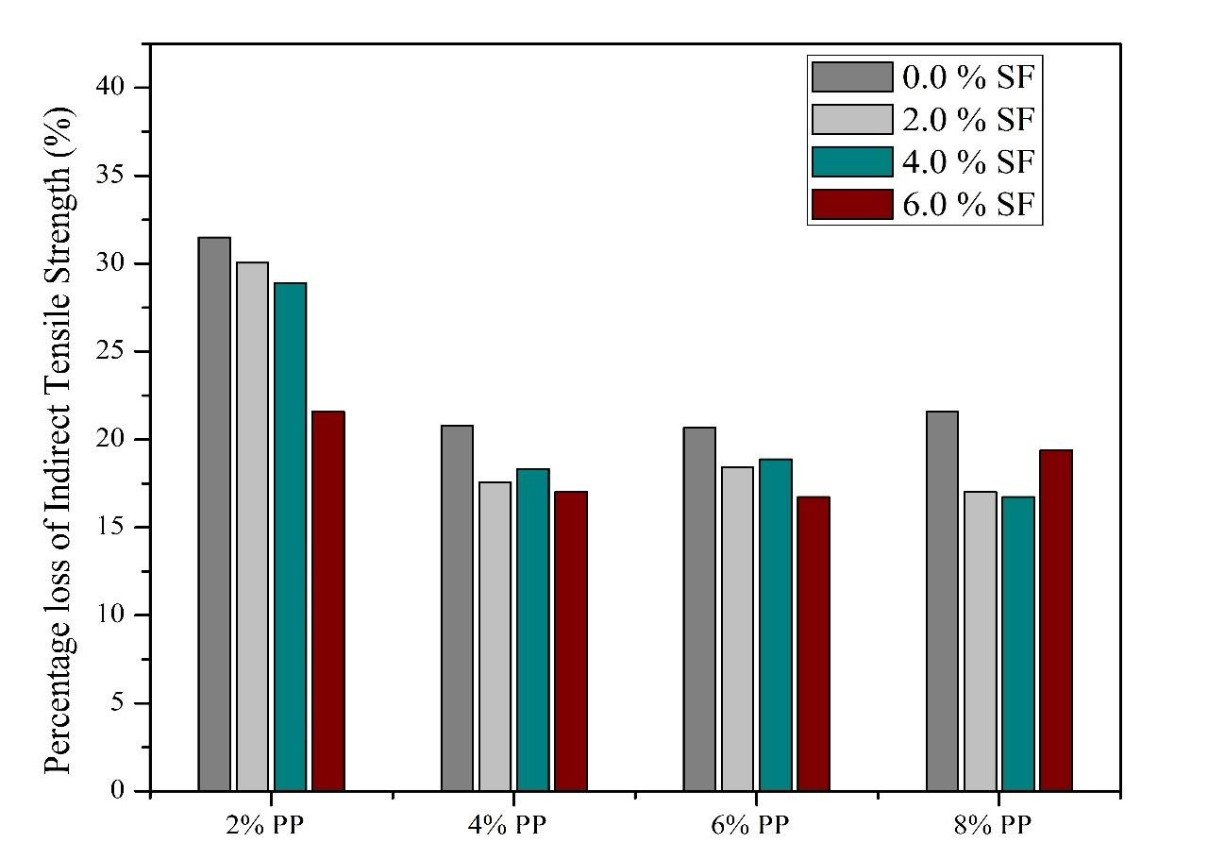

Figure 15: Effect of silica fume on water sensitivity test of bituminous mix

6.3 Numerical analysis
Values of Young’s Modulus for the three cases i.e. without mineral filler, with SF and with SF and polypropylene has been taken from ITS test of corresponding optimum composition. Young’s Modulus from software is coming out to be 247679.397 kN/m², 1363105.0 kN/m² and 1347830.95 kN/m² for HMA without mineral filler, with SF and with SF and polypropylene respectively. The conversion error for fatigue failure equation can be claimed from experimental and numerical analysis is coming out to be 30.59%, 24.17% and 26.478 % respectively.

Table 6: Summary of conversion error with ABAQUS
Parameters | Numerical value (without SF) | Experiment value (without SF) | Numerical value (with SF) | Experiment  Value  (with SF) | Numerical value (with SF +  PP) | Experiment  Value  (with SF +  PP)
E | 247679.39  𝑘𝑁/𝑚² | 221631.00  𝑘𝑁/𝑚² | 1363105.0  𝑘𝑁/𝑚² | 1193980.0  𝑘𝑁/𝑚² | 1347830.9  𝑘𝑁/𝑚² | 1197480.0  𝑘𝑁/𝑚²
ᵋt | 1.1e-05 | 1.27e-05 | 4.71e-07 | 2.63e-07 | 5.18e-07 | 3.56e-07
Nf | 5745.2347 sa | 3987.76 sa | 42.669 msa | 32.356 msa | 47.349 msa | 34.811 msa
Conversion  Error | 30.59% |  | 24.17 % |  | 26.478 %

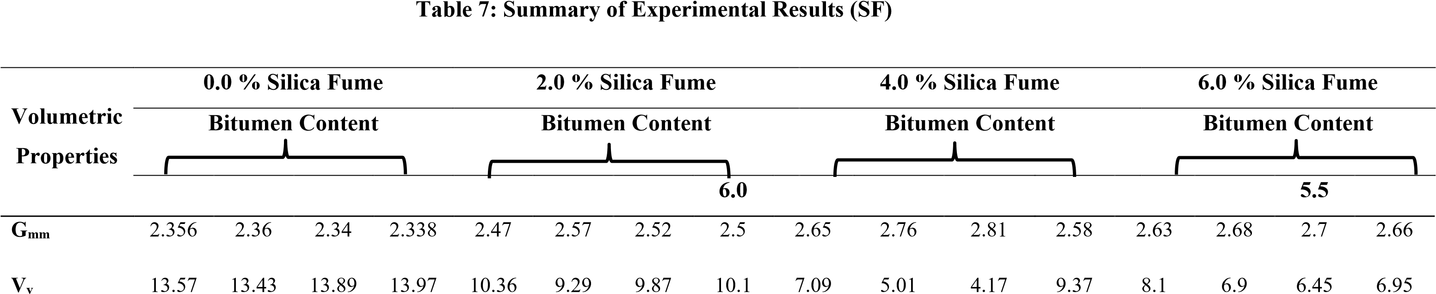4.5 5.0 5.5 6.0 4.5 5.0 5.5 4.5 5.0 5.5 6.0 4.5 5.0 6.0
VMA | 25.03 | 26.11 | 27.64 | 28.89 | 22.37 | 23.1 | 24.69 | 26.05 | 19.97 | 19.84 | 20.7 | 25.84 | 43.6 | 53.57 | 61.21 | 59.79
VFB | 55.63 | 62.49 | 60.65 | 59.2 | 62.52 | 74.4 | 72.22 | 65.28 | 47.65 | 59.65 | 79.85 | 68.22 | 43.6 | 53.57 | 61.21 | 59.79
V_{b} | 11.46 | 12.68 | 13.75 | 14.92 | 12.01 | 13.81 | 14.82 | 15.95 | 12.88 | 14.83 | 16.53 | 16.47 | 12.79 | 14.4 | 15.88 | 16.97
MS | 2.2 | 2.27 | 2.11 | 2.09 | 4.36 | 5.53 | 4.76 | 4.56 | 8.43 | 10.57 | 12.53 | 5.61 | 7.54 | 8.89 | 9.45 | 8.65
Flow | 4.12 | 5.78 | 6.2 | 8.17 | 3.91 | 3.99 | 5.03 | 5.45 | 3.04 | 3.51 | 3.89 | 4.92 | 2.84 | 3.43 | 3.78 | 4.48
MQ | 0.53 | 0.39 | 0.34 | 0.26 | 1.12 | 1.39 | 0.95 | 0.84 | 2.77 | 3.01 | 3.22 | 1.14 | 2.65 | 2.59 | 2.5 | 1.93
ITS | 209.64 | 216.31 | 201.06 | 199.16 | 415.46 | 526.95 | 453.58 | 434.52 | 803.29 | 1007.22 | 1193.98 | 534.58 | 718.49 | 847.13 | 900.49 | 824.26
MSS | 0.89 | 0.97 | 0.87 | 0.83 | 2.76 | 4.00 | 3.25 | 3.08 | 5.97 | 8.63 | 10.77 | 4.40 | 4.92 | 6.23 | 8.16 | 6.77
MMSR | 78.25 | 76.86 | 77.25 | 74.32 | 102.50 | 102.68 | 103.54 | 101.24 | 116.42 | 117.38 | 121.54 | 112.59 | 124.52 | 123.18 | 105.40 | 104.30
WS | 32.00 | 34.50 | 33.28 | 36.80 | 21.00 | 19.80 | 20.20 | 20.68 | 20.53 | 19.29 | 18.51 | 22.63 | 21.60 | 18.20 | 17.50 | 23.58
IRS | 40.25 | 42.68 | 41.21 | 39.64 | 63.40 | 72.40 | 68.30 | 67.50 | 70.80 | 81.65 | 85.96 | 78.36 | 65.30 | 70.10 | 86.30 | 78.24

- | P a g e

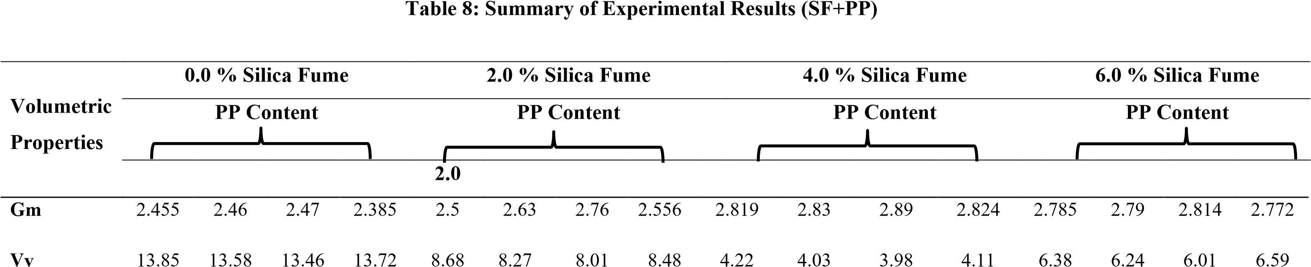2.0 4.0 6.0 8.0 4.0 6.0 8.0 2.0 4.0 6.0 8.0 2.0 4.0 6.0 8.0
VMA | 27.78 | 26.85 | 28.22 | 30.12 | 25.75 | 23.51 | 23.18 | 24.59 | 24.45 | 21.5 | 20.51 | 25.1 | 21.37 | 20.52 | 23.46 | 25.4
VFB | 50.14 | 53.14 | 52.3 | 54.44 | 66.29 | 64.82 | 65.44 | 65.51 | 82.74 | 81.25 | 80.59 | 83.62 | 70.14 | 69.59 | 74.38 | 70.05
V_{b} | 13.93 | 13.27 | 14.76 | 16.4 | 17.07 | 15.24 | 15.17 | 16.11 | 20.23 | 17.47 | 16.53 | 20.99 | 14.99 | 14.28 | 17.45 | 18.81
MS | 2.17 | 2.3 | 2.45 | 2.2 | 5.84 | 7.01 | 7.84 | 5.98 | 11.97 | 12.26 | 12.68 | 12.21 | 9.54 | 9.78 | 10.59 | 8.45
Flow | 6.05 | 6.17 | 6.32 | 6.4 | 4.96 | 5.13 | 5.54 | 5.68 | 3.75 | 3.98 | 4.13 | 4.57 | 3.85 | 3.97 | 4.09 | 4.21
MQ | 0.35 | 0.37 | 0.38 | 0.27 | 1.17 | 1.36 | 1.41 | 1.05 | 3.19 | 3.08 | 3.07 | 2.67 | 2.47 | 2.46 | 2.59 | 2.007
ITS | 212.73 | 218.54 | 219.00 | 202.16 | 454.48 | 457.99 | 613.98 | 414.72 | 913.69 | 1167.65 | 1197.48 | 1158.87 | 906.49 | 967.11 | 875.45 | 700.86
MS_{a} | 0.668 | 0.80 | 1.07 | 0.955 | 4.02 | 5.5 | 6.46 | 4.35 | 7.51 | 8.52 | 12.18 | 6.06 | 8.45 | 9.82 | 8.12 | 7.03
MMSR | 73.65 | 72.78 | 76.85 | 73.12 | 98.39 | 101.47 | 110.78 | 101.24 | 112.31 | 117.58 | 131.84 | 108.79 | 130.92 | 129.79 | 117.65 | 114.47
WS | 31.49 | 30.05 | 28.90 | 29.73 | 20.79 | 17.58 | 18.33 | 20.19 | 20.67 | 18.43 | 18.88 | 19.42 | 21.59 | 17.02 | 16.73 | 19.39
IRS | 43.39 | 40.86 | 44.01 | 43.42 | 68.86 | 78.59 | 82.39 | 72.84 | 85.46 | 89.03 | 96.12 | 80.79 | 88.63 | 92.76 | 87.88 | 83.19

- | P a g e

Chapter 7

Conclusion and Future work
This report presents the study of effective reuse of industrial waste silica fume as a mineral filler and polypropylene as a binder substitute in the bituminous mix to densify paved structures. Silica Fume, an industrial waste product, has an adverse impact on the environment if not disposed of safely. Its utilization in the construction industry can reduce the disposal problem of waste and use of conventional natural materials. The conventional mineral filler cement production emits large quantity of CO₂ which adversely affects the environment. On the other hand polypropylene being a plastic material and non-biodegradable substance, is somehow threat for the sustainable development. The comparative analysis by varying the SF and bitumen content and then with variable polypropylene content has been carried out. The following conclusion can be drawn based on durability and strength tests.
- Silica fume fulfills satisfactory properties to use as a mineral filler prescribed by MoRTH. Marshall stability strength of HMA increased with the inclusion of silica fume as a mineral filler. The 4.0% silica fume at 5.5% bitumen content gives more stability, which can be considered as an optimum limit for the filler and binder. The Marshall quotient has been increased up to 3.5%, and air voids of the bituminous mix have been reduced from 13.97% to 4.17 %. On the other hand with 6% polypropylene and 4.0% SF marshall stability strength gives it’s highest value, with which lies in the acceptable limit prescribe by the
MoRTH.
- Indirect Tensile strength of the bituminous mix exponentially increased with the addition of silica fume and then with polypropylene. The ITS value has been increased by 1193.98 kPa with the inclusion of 4.0 % silica fume at 5.5% VG 30-grade bitumen, and 1197.48 kPa with inclusion of 6.0% polypropylene and 4.0 % SF, which signifies the effect use of SF and polypropylene as a mineral filler and binder substitute respectively.
- Numerical analysis for variation of fatigue failure values (up to 20% crack) to use this constituent of HMA in the real field for the purpose of flexible pavement construction are showing values under 30% which concludes its usability in the actual field.
- | P a g e

Experiments do show a favorable reason to use SF as a mineral filler at 4.0 % by total weight but yet it is pozzolanic reactive substance it’s microscopic chemistry with bitumen content and HMA needs to be checked and a small flexible pavement demonstration should be taken to ensure its effective usability.

- | P a g e

References
- M.P. Wagoner, W.G. Buttlar, G.H. Paulino, P. Blankenship, M.P. Wagoner, W.G. Buttlar, G.H. Paulino, Investigation of the Fracture Resistance of Hot-Mix Asphalt Concrete Using a Disk-Shaped Compact Tension Test, 2005.
- S. Uzun, S. Terzi, Evaluation of andesite waste as mineral filler in asphaltic concrete mixture, (2012)
- M. Yilmaz, B.V. Kök, N. Kulolu, Effects of using asphaltite as filler on mechanical properties of hot mix asphalt, (2011)
- A.A. Butt, B. Birgisson, N. Kringos, Considering the benefits of asphalt modification using a new technical life cycle assessment framework, (2016)
- M. Soltani, T.B. Moghaddam, M.R. Karim, H. Baaj, Analysis of fatigue properties of unmodified and polyethylene terephthalate modified asphalt mixtures using response surface methodology, (2015)
- X. Qin, A. Shen, Y. Guo, Z. Li, Z. Lv, Characterization of asphalt mastics reinforced with basalt fibers (2018)
- A.E.A.E.M. Behiry, Fatigue and rutting lives in flexible pavement, (2012)
- A. Diab, M. Enieb, Investigating influence of mineral filler at asphalt mixture and mastic scales, (2018)
- F. Cardone, F. Frigio, G. Ferrotti, F. Canestrari, Influence of mineral fillers on the rheological response of polymer-modified bitumens and mastics, (2015)
- O.M. Ogundipe, Marshall Stability and Flow of Lime-modified Asphalt Concrete, in: Transp. Res. Procedia, 2016
- T.A. Abdel-Wahed, N.K. Rashwan, Application of Cement Dust and OPC as Mineral Filler in the binder Hot Mix Asphalt Improvement of mechanical properties of cold mix View project improvement of mechanical properties of HMA View project Application of Cement Dust and OPC as Mineral Filler i, in: 15th Annu. Int, 2016.
- S.J. Choi, S.S. Lee, P.J.M. Monteiro, Effect of Fly Ash Fineness on Temperature Rise,

Setting, and Strength Development of Mortar, 2012.
- J.L. Chrismer, S.A. Durham, High Volume Fly Ash Concrete for Highway Pavements, in: Green Streets Highw. 2010.
- S. Inkoom, J. Sobanjo, A. Barbu, X. Niu, Prediction of the crack condition of highway pavements using machine learning models, (2019)
- C. Silvani, E. Braun, G.B. Masuero, N.C. Consoli, Behavior of Soil-Fly Ash-Lime Blends under Different Curing Temperatures, (2016)
- J. Li, X. zhuang Cui, Q. Jin, J. wei Su, S. qiang Cui, Y. lin Wang, Laboratory investigation of the durability of a new smart geosynthetic material,(2018).
- A. Arulrajah, E. Yaghoubi, Y.C. Wong, S. Horpibulsuk, Recycled plastic granules and demolition wastes as construction materials: Resilient moduli and strength characteristics, (2017).
- E. AHMAdinia, M. Zargar, M.R. Karim, M. Abdelaziz, E. AHMAdinia, Performance evaluation of utilization of waste Polyethylene Terephthalate (PET) in stone mastic asphalt,(2012)
- K. Al-Adham, H. Al-Abdul Wahhab, Influence of temperature on Jnrvalues of polymer modified asphalt binders,(2018).
- G.H. Shafabakhsh, M. Sadeghnejad, Y. Sajed, Case study of rutting performance of HMA modified with waste rubber powder (2014).
- H.T. Tai Nguyen, T. Nhan Tran, Effects of crumb rubber content and curing time on the properties of asphalt concrete and stone mastic asphalt using dry process,(2018).
- J. Almeida de, A. Francisco, R.A. Battistelle, B.S. Bezerra, R. de Castro, Use of scrap tire rubber in place of SBS in modified asphalt as an environmentally correct alternative for Brazil, 2012.
- X. Liu, M. Zhang, L. Shao, Z. Chen, Effect of volcanic ash filler on thermal viscoelastic property of SBS modified asphalt mastic,(2018).
- S.S. Dash, M. Panda, Influence of mix parameters on design of cold bituminous mix,(2018)
.
- M. Chen, J. Lin, S. Wu, C. Liu, Utilization of recycled brick powder as alternative filler in asphalt mixture, (2011).
- A.C. Raposeiras, D. Movilla-Quesada, R. Bilbao-Novoa, C. Cifuentes, G. FerrerNorambuena, D. Castro-Fresno, The use of copper slags as an aggregate replacement in asphalt mixes with RAP: Physical-chemical and mechanical behavioral analysis, (2018)
- Y. Veytskin, C. Bobko, C. Castorena, Y.R. Kim, Nanoindentation investigation of asphalt binder and mastic cohesion, (2015)
- D. Lesueur, J. Petit, H.J. Ritter, The mechanisms of hydrated lime modification of asphalt mixtures: A state-of-the-art review, (2013)
- M. Arbabpour Bidgoli, K. Naderi, F. Moghadas Nejad, Effect of Filler Type on Moisture
Susceptibility of Asphalt Mixtures Using Mechanical and Thermodynamic Properties, (2019)
- Y. Xue, H. Hou, S. Zhu, J. Zha, Utilization of municipal solid waste incineration ash in stone mastic asphalt mixture: Pavement performance and environmental impact, (2009)
- G. Mazzoni, A. Virgili, F. Canestrari, Influence of different fillers and SBS modified bituminous blends on fatigue, self-healing and thixotropic performance of mastics, 2017.
- T. Wilberforce, A. Baroutaji, B. Soudan, A.H. Al-Alami, A.G. Olabi, Outlook of carbon capture technology and challenges, (2019)
- M. Mastali, Z. Abdollahnejad, Carbon dioxide sequestration on fly ash/waste glassalkalibased mortars with recycled aggregates: Compressive strength, hydration products, carbon footprint, and cost analysis, Carbon Dioxide Sequestration Cem. (2018)
- WBCSD, Getting the Numbers Right Project: Reporting CO2, World Bus. Counc. Sustain. Dev. (2016) 1. https://www.wbcsdcement.org/GNR-2016/ (accessed October 19, 2019).
- Y. Meng, T.C. Ling, K.H. Mo, W. Tian, Enhancement of high temperature performance of cement blocks via CO 2 curing, (2019)
- V.V.P. Kumar, D.R. Prasad, Influence of supplementary cementitious materials on strength and durability characteristics of concrete, (2019)
- S.K. Kaliyavaradhan, T.C. Ling, Potential of CO2 sequestration through construction and demolition (C&D) waste - An overview, J. CO2 Util. 20 (2017)
- M. Schneider, M. Romer, M. Tschudin, H. Bolio, Sustainable cement production-present and future, Cem. Concr. Res. 41 (2011).
- N.M. Katamine, Phosphate Waste in Mixtures to Improve Their Deformation, (2000)
- I. Asi, A. Assa’ad, Effect of Jordanian Oil Shale Fly Ash on Asphalt Mixes, (2005).
- D.-F. Lin, J.-D. Lin, S.-H. Chen, The application of baghouse fines in Taiwan,(2006)
- S. Jin, A.F. Yee, Preparation and characterization of maleimide terminated poly(oxy-1,4phenylene-sulfonyl-1,4-phenylene) oligomers of various molecular weights,, 1990.
- K. Yan, L. Li, kaigao Zheng, D. Ge, Research on properties of bitumen mortar containing municipal solid waste incineration fly ash, (2019)
- B. Huang, Q. Dong, E.G. Burdette, Laboratory evaluation of incorporating waste ceramic materials into Portland cement and asphaltic concrete, (2009)
- M.S.S. Lima, L.P. Thives, V. Haritonovs, K. Bajars, Red mud application in construction industry: Review of benefits and possibilities, 2017.
- Y.-R. Kim, D.N. Little, I. Song, Effect of Mineral Fillers on Fatigue Resistance and Fundamental Material Characteristics: Mechanistic Evaluation, (2003)
- W. Grabowski, J. Wilanowicz, The structure of mineral fillers and their stiffening properties in filler-bitumen mastics, (2008)
- E. Kalkan, S. Akbulut, The positive effects of silica fume on the permeability, swelling pressure and compressive strength of natural clay liners,(2004)
- T. Nochaiya, W. Wongkeo, A. Chaipanich, Utilization of fly ash with silica fume and properties of Portland cement-fly ash-silica fume concrete, (2010).
- S. Asavapisit, W. Nanthamontry, C. Polprasert, Influence of condensed silica fume on the properties of cement-based solidified wastes, (2001)
- J. Liu, Y. Li, P. Ouyang, Y. Yang, Hydration of the silica fume-Portland cement binary system at lower temperature, (2015)
- Z. Zhang, B. Zhang, P. Yan, Comparative study of effect of raw and densified silica fume in the paste, mortar and concrete, (2016)
- R. Miró, A.H. Martínez, F.E. Pérez-Jiménez, R. Botella, A. Álvarez, Effect of filler nature and content on the bituminous mastic behavior under cyclic loads, (2017)
- E. Kalkan, Impact of wetting-drying cycles on swelling behavior of clayey soils modified by silica fume, (2011)
- N.K. Rashwan, Hot Mix Asphalt (HMA) Performance as Affected by Limestone Powder Filler Content, (2016)
- ASTM, D6927-15 Standard Test Method for Marshall Stability and Flow of Asphalt Mixtures,2015.
- ASTM, Standard Test Method for Indirect Tensile (IDT) Strength of Asphalt Mixtures, 2017.
- ASTM, Standard Test Method for Thickness or Height of Compacted Asphalt Mixture Specimens, 2017.
- J. Kliewer, C. Bell, D. Sosnovske, Investigation of the Relationship Between Field Performance and Laboratory Aging Properties of Asphalt Mixtures, in: Eng. Prop. Asph. Mix. Relatsh. to Their Perform., ASTM International, 1995
- MoRTH, Specifications for Road and Bridges Works, V, 2013.
- C. Ronald J, The Superpave Mix Design Manual for New Construction and Overlays, Washington, DC, 1994. http://onlinepubs.trb.org/onlinepubs/shrp/SHRP-A-407.pdf (accessed October 3, 2019).
- Raja Mistry, Tapas Kumar Roy, Effect of fly ash as an alternative filler in hot mix asphalt,2016.
[63]Olumide Moses Ogundipe, Marshall stability and flow of lime modified asphalt concrete,2016
- Talaat Ali Abdel Wahed, Naglaa K Rashwan, Application of cement dust and OPC as a mineral filler in HMA,2017.
- Sasane B Neha, Gaikwad Harish, Jalindar Patil, S D Khandekar, Application of waste plastic as an effective construction material in flexible pavement,2015.
- Beena Sukumaran,Three Dimensional Finite element modeling of flexible pavements,2004.
- Romanoschi, Stefan Anton, "Characterization of Pavement Layer Interfaces." (1999). LSU Historical Dissertations and Theses.
- Rehman M T, Mahmud K, Ahsan S,Stress-Strain characteristics of flexible pavement using Finite Element Analysis,2011.
- Beena Sukumaran, Michael Willis, Nishanth Chamala, Three Dimensional Finite Element Modeling of Flexible Pavements,2005

