PROJECT REPORT

On

Advance Data Insight
Submitted to Rajasthan Technical University
In partial fulfilment of the requirement for the award of the degree of

B.TECH.
In

ARTIFICIAL INTELLIGENCE AND DATA SCIENCE

Submitted By
Manish Sharma (PIET22CA032)
Mo. Arman Khan (PIET22CR040)
Shad Ali (PIET22CA051)

Under the Guidance of Mr.Punit Kumar
at


POORNIMA INSTITUTE OF ENGINEERING & TECHNOLOGY, JAIPUR
RAJASTHAN TECHNICAL UNIVERSITY, KOTA

November 2025
CERTIFICATE

This is to be certified that the project entitled “Advance Data Insight” has been submitted for the Bachelor of Computer Engineering, Poornima Institute of Engineering & Technology, Jaipur during the academic year 2025-2026 is a Bonafide piece of project work carried out by “Shad Ali, Manish Sharma, Mo. Arman Khan” towards the partial fulfilment for the award of the Degree (B.Tech.) under the guidance of “Mr. Punit Kumar” and supervision and no part of there of has been submitted by them for any degree or diploma.

Project Guide Project Coordinator Prof. (Dr.) Budesh Kanwar

Mr. Punit Kumar Alka Rani (H.O.D AI & DS)
(Assistant Professor) (Assistant Professor)

CANDIDATE’S DECLARATION

We, Manish Sharma (PIET22CA032), Shad Ali (PIET22CA051), Mo. Arman Khan
(PIET22CA062) B.Tech (Semester- VIII) of “Poornima Institute of Engineering & Technology, Jaipur” hereby declare that the Project Report entitled “Advance Data insight” is an original work and data provided in the study is authentic to the best of our knowledge. This report has not been submitted to any other Institute for the award of any other degree.

Shad Ali Manish Sharma mo. Arman Khan (PIET22CA051) (PIET22CA032) (PIET22CR040)

Place: PIET
Date: 10.11.2025

ACKNOWLEDGEMENT

It is our pleasure to be indebted to various people, who directly or indirectly contributed in the development of this work and who influenced our thinking, behaviour and acts during the course of study.
We express our sincere gratitude to Prof. (Dr). Dinesh Goyal, Director, PIET for providing us an opportunity to undergo this Major Project as the part of the curriculum.
We are thankful to Mr. Punit Kumar for his support, cooperation, and motivation provided to us during the training for constant inspiration, presence and blessings.
We are thankful to Prof. (Dr). Budesh Kanwar for her support, cooperation, and motivation provided to us during the training for constant inspiration, presence and blessings.
We also extend our sincere appreciation to Ms. Alka Rani who provided her valuable suggestions and precious time in accomplishing our Project report.
Lastly, we would like to thank the almighty and our parents for their moral support and friends with whom we shared our day-to-day experience and received lots of suggestions that improved our quality of work.

Shad Ali Manish Sharma mo. Arman Khan (PIET22CA051) (PIET22CA032) (PIET22CR040)

TABLE OF CONTENTS

CHAPTER NO. | TOPICS | PAGE NO.
 | TITLE PAGE | I
 | CERTIFICATE | II
 | CANDIDATE'S DECLARATION | III
 | ACKNOWLEDGEMENT | IV
 | TABLE OF CONTENTS | V – VI
 | LIST OF TABLES | VII
 | ABSTRACT | VIII
1 | INTRODUCTION | 1
 | 1.1 Overview | 1
 | 1.2 Project Aim and Objectives | 1
 | 1.3 Problem Statement | 2
 | 1.4 Scope and Significance | 2
 | 1.5 Methodology Overview | 3
 | 1.6 Software Requirements | 3
 | 1.7 Hardware Requirements | 4
2 | LITERATURE SURVEY | 5
 | 2.1 Introduction | 5
 | 2.2 Challenges | 5
 | 2.3 Data Preprocessing and Cleaning questions | 6
 | 2.4 Machine Learning Techniques in Data Insight | 6
 | 2.5 Data Visualization Techniques | 7
 | 2.6 Data Integration and Data Warehousing | 7
 | 2.7 Big Data Analytics | 8
 | 2.8 Key Research Gaps Identified | 8
 | 2.9 Technologies Used in Existing Systems | 9
 | 2.10 Summary of Literature Review | 9
3 | PROJECT MANAGEMENT | 10
 | 3.1 Introduction | 10
 | 3.2 Project Integration Management | 10
 | 3.3 Project Scope Management | 10
 | 3.4 Project Cost Management | 11
 | 3.5 Project Quality Management | 11
 | 3.6 Project Human Resource Management | 12
 | 3.7 Project Communication Management | 12
 | 3.8 Project Risk Management | 12
4 | TECHNOLOGY APPLIED | 13
 | 4.1 Introduction | 13
 | 4.2 System Architecture | 13
 | 4.3 Technology Stack | 13

 | 4.4 Data Flow | 14
 | 4.5 Technology Selection Rationale | 14
 | 4.6 Algorithmic Logic | 15
 | 4.7 Diagnostic Confidence Scoring | 15
 | 4.8 Vision-Based Triage | 15
 | 4.9 Agile Technology Integration | 15
5 | PRODUCT BACKLOG DESIGN | 16
 | 5.1 Product Backlog | 16
 | 5.2 Sprint Backlog-1 | 19
 | 5.3 Sprint Backlog-2 | 20
 | 5.4 Sprint Backlog-3 | 21
 | 5.5 Sprint Backlog-4 | 22
6 | PROJECT IMPLEMENTATION | 24
 | 6.1 Introduction | 24
 | 6.2 System Architecture Overview | 24
 | 6.3 Module-Wise Implementation | 24
 | 6.4 Testing and Validation | 25
 | 6.5 System Workflow | 26
 | 6.6 Implementation Challenges and Solutions | 26
7 | RESULTS | 27
 | 7.1 Introduction | 27
 | 7.2 Outcomes | 27
 | 7.3 Benefits to Society | 28
 | 7.4 Future Scope | 28
 | REFERENCES | 29

LIST OF TABLES

TABLE NO. | TITLE | PAGE NO.
Table 1.1 | Software Requirements | 3
Table 1.2 | Hardware Requirements | 4
Table 3.1 | Project Cost Management | 10
Table 3.2 | Project Risk Management | 11
VI

ABSTRACT
In the contemporary digital era, the fast development of data produced by many different resources, such as social networking sites, businesses, sensor networks, and software programs on the Internet, has resulted in the formation of big data. Processing and analyzing this huge volume of data has become one of the most difficult tasks for companies. The conventional techniques used for data analysis are unable to meet the demands of handling such massive volumes of data. Hence, there is a demand for sophisticated data analysis tools.

The Advance Data Insight System is developed to address this issue. It is designed to provide an end-to-end solution for data collection, data preparation, data analysis and data visualization. The system exploits state of the art data analytics software and technology, basically consists of a set of Python modules with some helpful libraries such as Pandas, NumPy, Matplotlib, and Scikit-learn. After the data has been sourced from various locations the project starts with data collection. in order to get familiar with the data structure and bulkiness of the data. Sophisticated analytical methodologies, such as classification, regression, and clustering, are employed to acquire predictive insights. The output is displayed in the form of interactive visualizations e.g. graphs, charts, dashboards, which help in interpreting complex information and make it easier to read.

From all this, it can be seen that data analytics has become very important in our modern era. Through the Advance Data Insight Project, it can be observed that we have been able to create something scalable and efficient to deal with data sets.

CHAPTER 1

INTRODUCTION

1.1 Overview
The Advance Data Insight project will analyze huge amounts of data collected and make use of it to generate information useful in making sound decisions. In the light of the large amount of data produced in all spheres of activity, intelligent data interpretation tools become a necessity. This project aims at satisfying that need.

The system is concentrated on data acquisition from diverse sources, and then the data is preprocessed with cleaning, transforming, and integrating. After preprocessing, the data are statistically analyzed and subjected to machine learning techniques to find interesting patterns, trends, and relations. Such information is useful to analyze the p(behavior) of p and to estimate future values of p.

Visualization is important for this project as it provides a way to display complex information in the form of images, spreadsheets, and dashboards. This allows the user to understand the outputs without having to be a computer genius. This is a project of data visualization using software like Python and libraries such as Pandas, NumPy and Matplotlib. Advance Data Insight technique may be employed in diverse fields of business, healthcare, finance and marketing. This will allow companies to have better access to their resources and to reduce the risk associated with it and also gain competitive edge through analyzing data

1.2 Project Aim and Objectives

Purpose of Advance Data Insight
Objective The purpose of the ADI project is to design a scalable, efficient and intelligent data collection, analysis and processing system for airborne data that can provide meaningful and practical information. In particular, this initiative focuses on the use of advanced data analytics and machine learning (ML) techniques to transform raw data into information that can be used for decision making.

Specific Objectives:
- To collect data from multiple sources such databases, files, and online platforms.
- To clean and preprocess data by handling mising values, removing inconsistencies, and ensuring data quality.
- To perform are exploratory data analysis (EDA) to understand to patterns, trends, and relationships in the data.
- To apply statistical methods machine learning algorithms for data analysis and prediction.
- To visualize data using graphs, charts, and dashboards easy interpretation.
• To identify hidden pattrns, anomalies, and correlations within large datasets.
- To generate meaningful insights that support effective decision-making.
- the efficiency and acuracy of data analysis using modern tools technologies.
- To present the a structured and user-friendly format.

1.3 Problem Statement
In the modern age where data plays a crucial role, organizations collect huge amounts of data through different channels like business activities, online sources, and technological systems. Nevertheless, the collected data is usually in an unorganized format, making its analysis complicated. Consequently, it becomes challenging for organizations to make use of the data for decision-making purposes.

Many existing systems lack the capability to efficiently process to the large datasets, handle data inconsistencies, and present informations is in an easily understandable format. This leads to delays in decision-making, reduced operational efficiency, and missed opportunities for growth optimization.
The critical issue to be solved through the implementation of Advance Data Insight technology is the creation of an effective mechanism capable of managing huge amounts of data, their preprocessing, analysis, and visualization. The main goal of such mechanisms is to solve the issues associated with complexity, scalability, and interpretation of big data with the help of innovative data analytical approaches, thus allowing the user to extract useful information.

1.4 Scope and Significance
Advance Data Insight is a project that aims to design a highly effective process that will enable handling massive amounts of data and transforming them into valuable information. Its scope of work involves the extraction of data from various sources including databases, files, and websites. Another essential aspect of the project is data pre-processing activities such as cleaning, transformation, and integration.

In addition, the project incorporates exploratory data analysis (EDA), statistical analysis, and the use of machine learning techniques to analyze patterns, trends, and associations within the data set. The data visualization tool includes graphs, charts, and dashboard functionalities that enable users to comprehend complicated data more easily.

The importance of the project comes from its capability of converting the data into useful information that is crucial for making decisions. The project can assist an organization in achieving higher efficiency, reducing risks, and acquiring an edge over its competitors. The system can help convert complicated data into understandable information using visualization techniques.

1.5 Methodology Overview

The Advance Data Insight project utilizes a comprehensive methodological framework for processing data effectively. The process incorporates numerous steps that allow handling data and deriving valuable insights from it.
The first step is data collection, where data is gathered from various sources such as databases, files (CSV/Excel), APIs, or online platforms. This ensures that the system has sufficient and relevant data for analysis.
The first step is data acquisition, which involves obtaining data from various sources like databases, files (CSV/Excel), APIs, etc. The intent of the stage is to have for analysis enough data in the system.
After preprocessing, exploratory data analysis (EDA) is performed to understand the structure and characteristics of the data. Techniques such as statistical summaries and visualizations are used to identify patterns, trends, and relationships.
Data analysis can start only after data preprocessing since proper processing increases data quality. The next step of the process is exploratory data analysis (EDA). In this stage, the main aim is to comprehend the nature of data through visualization and statistical summary.
Following this, data visualization is carried out to represent the analyzed data in graphical formats such as charts, graphs, and dashboards. This helps users easily interpret complex information and draw conclusions.
Another stage of the process is data analysis and modeling, during which such actions as classifications, regressions, or clusterings are carried out using various approaches and algorithms. Finally, data visualization allows representing data in graphical forms such as charts, graphs, and dashboards.

1.6 Software Requirements
Category | Technologies
Operating System | Windows 10 / Linux / macOS
Frontend | React.js, HTML, CSS, JavaScript, Bootstrap
Backend | Python, Flask
Machine Learning | TensorFlow, Keras, CNN
AI Integration | Groq API
Authentication | Firebase (Google, Email/Password)
Tools | VS Code, Postman, Git, npm

1.7 Hardware Requirements

Component | Requirement
Processor | Intel Core i5 / AMD Ryzen 5 or higher
RAM | 8 GB or higher
Storage | 256 GB SSD or higher
Graphics | Integrated GPU or higher
Display | 1366 × 768 resolution or higher
Internet | 10 Mbps connection or higher

CHAPTER 2

LITERATURE SURVEY

2.1 Introduction
Effective conduct of a literature review becomes crucial to form an important base for conducting any research work by understanding the research conducted and techniques and technologies used to develop the system in question. It becomes important to understand the strengths and weaknesses of other similar systems as well in order to show the need for developing the current system. For the Advance Data Insight initiative, a literature review would entail reviewing several projects and progressions made in the field of analytics and data visualization.
Over the last ten years, there have been massive volumes of data being produced. This trend has driven a lot of scientists and organizations to explore different ways that would help analyze massive volumes of data to produce meaningful information. Traditional methods of data analysis could not analyze complex and large volumes of data, hence the development of complex data analysis methods such as big data analysis, artificial intelligence, and machine learning algorithms.
The importance of data preprocessing has been stressed by various studies because the data in its raw form may not always be accurate or may lack some values. Before carrying out any analysis, it needs to be preprocessed. Another important process that has been widely used is the Exploratory Data Analysis which helps in understanding the nature of data.
Classification, regression, and clustering are some of the machine learning algorithms that have been used extensively in academic studies to automate decisions and make predictions about future trends. In addition, data visualization is important in presenting the results of analysis in a simple and easy-to-understand manner.

2.2 Challenges
In the Advance Data Insight project, there is massive data handling and analysis for extracting useful knowledge. Despite its numerous advantages, certain issues need to be tackled for reliable and efficient implementation.

The first issue is the quality and consistency of data. In reality, there is a lot of data that is inaccurate or even missing, leading to poor results during analysis. Therefore, data cleansing is a very important process in the entire analysis process.
Another major challenge is the handling of large and complex datasets. As data volume increases, processing becomes more computationally intensive, requiring efficient algorithms and highperformance systems to manage scalability.
Another significant problem lies in the management of large and complex data sets. As the size of data sets grows, computational power also increases, and this calls for advanced methods of computation.
Data integration is another problem that comes with big data analysis. Data collected from various platforms is likely to be formatted differently from each other, hence making it a daunting task.
Selection of an appropriate method of data analysis is another problem. Selection of the right method of analysis is key, and choosing an unsuitable one results in inaccurate predictions.

2.3 Data Preprocessing and Cleaning
Data preprocessing and cleaning are crucial steps in the data analysis process, as the quality of input data directly affects the accuracy and reliability of the results. In real-world scenarios, data is often incomplete, inconsistent, noisy, or contains errors, making it unsuitable for direct analysis. Therefore, preprocessing is required to transform raw data into a clean and structured format.

2.4 Machine Learning Techniques in Data Insight
Machine Learning (ML) is one of the key elements in today’s data insight systems as it helps analyze large volumes of data automatically and make predictions. The system is capable of learning from past data without requiring programming. In the Advanced Data Insight project, ML algorithms can be employed to discover patterns and trends.
Machine learning techniques are broadly classified into three main categories: supervised learning, unsupervised learning, and semi-supervised learning.
Supervised learning In supervised learning, the algorithm learns from the input and output variables that are available. In this type of learning, the algorithms used are regression and classification. This is because regression algorithms are used in order to predict a particular value while the classification algorithm is used in order to predict which class a particular object belongs to. Some common algorithms are linear regression, decision trees, and support vector machines.
Unsupervised learning In unsupervised learning, the data that is fed is not labeled, i.e., the output is unknown. The model finds any kind of structure within the data set that may exist. Clustering algorithms are commonly used for this task.
Semi-supervised learning combines both labeled and unlabeled data, making it useful when labeled data is limited. It improves learning accuracy by leveraging a small amount of labeled data along with a large amount of unlabeled data.

2.5 Data Visualization Techniques
Data Visualization is one of the essential elements of a data insight system, as data visualization plays an important role in presenting complex data in a graphical form. In the context of Advance Data Insight system, the process of data visualization allows us to demonstrate the outcomes of analysis in such a manner that it becomes easy for us to comprehend the data and take a decision accordingly.
Some of the widely used visualization tools include bar charts and line graphs. Bar charts are often used to compare data categories, whereas line graphs are frequently used for demonstrating the trend of data.

2.6 Data Integration and Data Warehousing

Data integration and warehousing are essential components of any data vision system, as they enable the processes for capture, storage and management of heterogeneous data. Those protocols are crucial to the Advance Data Insight project as they make sure that all data is able to be used in the analysis.

Data integration is the process of pulling together data from disparate sources and providing a unified view. These sources can be databases, cloud platforms, APIs, spreadsheets, or web applications. Since data sourced from multiple places may exist in different formats, structures, and be of varying quality, the process of integration may require data transformation, normalization, and cleansing, among other tasks to bring the data to a consistent state.

Methods such as Extract, Transform, Load (ETL) are widely used to bring about data integration quickly. Data warehousing, in contrast, is the process of storing integrated data in the central repository (data warehouse). A data warehouse is optimized for query and reporting rather than transaction processing.

It retains a massive amount of historical data which helps users to analyze trend and take strategic decisions over time.

2.7 Big Data Analytics
Big Data Analytics is a process of examining large and complex data sets to uncover hidden patterns, unknown correlations, market trends, customer preferences, and other useful business information using traditional data processing applications.
Big Data Analytics is the process of examining an extremely large data set to unearth hidden patterns, unknown correlations and other useful business information. The Advance Data Insight (ADI) platform is built on big data analytics that adroitly handles large-scale data. Big data is often described with the following 5Vs: Volume, Velocity, Variety, Veracity, and Value. Volume is the total amount of data generated at a certain time, and the Velocity is the speed at which data is created, processed. Variety signifies different forms of data, for example, structured data, semi-structured data, and unstructured data.
Veracity includes the quality and the trustworthiness of data and Value includes the significance of deriving meaningful insights from the data. Although big data analytics offers great advantages, it also has its burning issues such as big data storage, big data processing, big data security and big data integration. Fortunately, recent advances in cloud computing and distributed computing are/assist to address these challenges.
184 words

2.8 Key Research Gaps Identified

After examining the literature in the areas of data analytics, machine learning, and big data systems, we have identified a number of research gaps that indicate a need for better and more effective solutions within the Advance Data Insight project. A lack of integrated solutions constitutes the most important gap; most of the existing solutions address one or two phases of the data pipeline and are a source of fragmentation and inefficiency. Another crucial gap lies in the challenge of real-time, large-scale data. Many classical systems are not well suited to high-velocity data streams, resulting in a delay in analysis and a degradation of performance as the size of the data increases.

2.9 Technologies Used in Existing Systems
The current data analysis and data insights solutions are constructed with the combination of modern technology to enable data processing, analyzing, visualization and learning through machine. These technologies depend on the type and complexity of the system.
The majority of legacy systems leverage the likes of Python and R as the programming language of choice given its extensive libraries and simple usability for the analysis of data. Python is the most popular choice, due to its vast ecosystem that contains libraries such as Pandas, NumPy, Matplotlib and Scikit-learn for data manipulation, visualization and machine learning.Both the backend and frontend use different programming languages (including Python) for developing a web application. Popular frameworks available for web backend development are Django and Flask; while HTML, CSS, and JavaScript (along with the JavaScript library React) provide the necessary tools to create an interactive and attractive user interface on the web frontend.

2.10 Summary of Literature Review
The Advance Data Insight project literature review is an in-depth overview of the research that is currently available on the topics of data analysis, machine learning, and large-scale data systems. The report shows that as data becomes increasingly important to the success of organizations today, advanced analytical methods are also being used to create valuable insights from large amounts of complicated data.
A review of current data analysis systems shows that the majority of analytical tools lack a fully integrated, end-to-end data analysis process; instead, most systems focus on one or two individual stages of data analysis processes, including Data Preprocessing, Machine Learning and Data Visualization. Additionally, the majority of today's current analytical systems experience challenges related to the quality of their input data (e.g., incomplete or inaccurate data)

CHAPTER 3

PROJECT MANAGEMENT

3.1 Introduction
Data is now the most valuable resource for organizations in all areas of business, especially in today’s digital age. Data is created at an incredible rate by many different types of sources including social media platforms, business transactions, sensors, internet-based services, and digital applications.
To overcome this challenge, advanced data analytics techniques are used to process, analyze, and extract meaningful insights from large datasets. These techniques help in identifying patterns, trends, and relationships within the data, which support effective and data-driven decision-making. The goal of the Advance Data Insight program is to provide a complete solution for managing, analyzing and interpreting huge volumes of data by providing the ability to gather, preprocess, perform machine learning on, and visualize the data all within one experience. The Advance Data Insight program will utilize modern technologies, including the Python programming language, machine learning libraries, and visualization applications, to turn generated data into useful insights that are actionable.

3.2 Project Integration Management
The integration management for the Advance Data Insight project will coordinate and combine multiple project components for a consistent, coordinated, and efficient delivery of the entire project.
As there are several technologies involved in this project including Python, Flask, React.js, and Machine Learning Libraries, proper Integration is critical for facilitating smooth communication between Front-end, Back-end and Data Processing. 3.3 Project Scope Management
The project covered the following key components:
In-Scope:
The following activities are included in the project scope:
- Frontend development using React.js
- Backend development using Flask

- Machine learning model implementation using TensorFlow/Keras
- Data analysis and visualization
- API integration and authentication using Firebase
Out-of-Scope:
The followings is not a includead in the currents project scopes:
- Hardware-level data processing systems
- Real-time IoT device integration (if not implemented)
- Large-scale distributed cloud deployment
- Mobile application development

3.4 Project Cost Management
The projects were developed using opened-source tools and free-tier cloud services. Basic costs were minimal and maximal, primaerily related to developmented time and efforts.

Resource | Cost
GitHub | Free
Render | Free tier
Firebase | Free tier
Groq API | Free tier
VS Code | Free

3.5 Project Quality Management
Quality Management for Projects ensures the development of the Advance Data Insight system at high levels of accuracy, reliability, efficiency, and usability. It works to maintain quality throughout the project timeline from data processing, to model development, to system integration, to final product output.

The purpose of QM is to have a system fulfilling the requirements of its user, giving the right information and being able to work efficiently also in the presence of large amount of data. Moreover, it will ensure the stability, safety and easiness of the system.

3.6 Project Human Resource Management
The projects was carried out the collaboreatively with clearly defineded roles:
- Data Handling: Dataset collection and image preprocessing
- Model Development: CNN design, training, and optimization
- Backend Development: Flask API and Groq API integration
- Frontend Development: React UI, responsive design, and dark mode
- Authentication: Firebase setup and integration
- Testing & Documentation: System testing and report preparation

3.7 Project Communication Management
Communication management is critical to the Advance Data Insight project's success, ensuring everyone involved can share information about the project. It helps bring together team members and allows for better collaboration while making sure activities happen without issues.

3.8 Project Risk Management

Risk | Mitigation Strategy
Poor or incomplete data qualities. | Develop data types such as handling missing values, removing duplicates and normalizing data.
Models inaccuracy in machine learning. | Enhance model selection, perform hyperparameter
Slow system performance  with large datasets | Optimize algorithms using efficient data structures and caching.
Groq API rate limits | Use of cache within the application
Deployment Delays | early testing of application and development

CHAPTER 4

TECHNOLOGY APPLIED

4.1 Introduction

There is a rapidly-growing volume of data generated every day, as a result of many different digital activities including social media use, business transactions, online platforms, sensor readings, and mobile apps. This large volume of unstructured, unorganized "Big Data" is very difficult to analyze using established methods and thus creates a great deal of need for making useable insight from the acquisition and processing of these data streams by sophisticated systems that can efficiently store, process, and analyze the data.

The goal of the Advanced Data Insight project is to provide a solution to this need through the creation of a Smart Data Analytics Platform that features a data collection, processing, and analysis and visualization component. The platform will utilize modern technologies – including Python, Flask, React.js, and machine learning frameworks – to convert raw data into usable and actionable insight.

4.2 System Architecture

The system incorporates layers and modules to meet the needs of a large user base with the ability to easily communicate between individual parts of the system. The various layers of the architecture consist of frontend, backend, machine learning models, database, and external API's which are all integrated together to produce useful insights from data.

1. Overall Architecture Design

The system follows a three-tiers of the architecture:

(i) Presentations Layer (Frontend)

This layer is responsible for user interaction and interface design.

• Developeds using React.js, HTML, CSS, JavaScript, Bootstrap
- Provides dashboaerds, charts, and inpout forms
- Sends user requests to the backend via REST APIs

(ii) Application Layer (Backend)

This layer handles the cores logic of the systeam.

• Built using Python with Flask framework
- Processes user requests and manages data flow
- Integrates machine learning models for analysis
- Communicates between frontend, database, and AI services

4.3 Technology Stack

The followingg technologies weres used in the development of SkinSight AI:
- Frontend: For the frontend, the user interface is built using React.js and has responsive design in both light and dark modes. The CSS and Bootstrap styling/layout components were also utilised.
- Backend: The backend used Flask (Python) to develop RESTful APIs that allow for prediction requests, serve the deep learning model, and send/receive to/from external APIs.
- Machine Learning: The deep learning CNN model was developed and loaded with the help of TensorFlow and Keras using training data on 10 classes of skin diseases.
- AI Integration: Groq API with Llama 3.1 model was used to genarate medical information including diseese description, symptoms, treetment options, and urgency level. Llama 4 Scout model was used for vision-based triage to validate skin imagees.
- Authentication: Firebase was used for user authentication supporting Google sign-in and email/password login.
- Image Processing: OpenCV and Pillow were utilised for preprocessing images, resizing the images, normalising the images, and detecting the skin.
- Version Control: The application utilized GitHub for code management and version control.
- API Testing: The APIs were tested with Postman.
- Deployment: Render was used to deploy the backend and frontend of the application.
- Code Editor: The primary development environment for this project was VS Code.

4.4 Data Flow

The flow of data in the Advanced Data Insights Project outlines each of the components of the system and how data travels through those components to create a final insight in a visualization format. The flow of information between all the different components, from the frontend, to the backend and machine learning models and databases, is executed in a structured and smooth manner.

The flow of data begins when the user interacts with the frontend application (built with React.js) to provide input or request analysis via dashboards or input forms. The request of the user is sent to the backend application via REST API in JSON format.

The request from the frontend is received by the backend built in Flask, and the request is processed. The first step in this processing is to validate the request before passing to the data processing layer. Once validated, the data is passed to the data processing layer where libraries such as Pandas and NumPy are used to clean, transform and prepare the data for analysis.

4.5 Technology Selection Rationale

The technology selection for the Advance Data Insight project is based on its performance, scalability, and ease of integration; each technology has been selected to allow for optimal system design and fluid operation across all modules, with a design goal of fulfilling the needs of data analytics, machine learning, and web development.
The front-end development has been done using React.js, HTML, CSS, JavaScript and Bootstrap. These make for a fast, responsive load, which results in an engaging User Experience (UX). React.js also provides the benefit of developing reusable components and dynamic dashboards to visualize data insights, which is crucial in presenting data insights to users. The application backend is implemented in Python with the Flask module. Python was chosen because of its general developer-friendliness and the great number of resources. To process and analyze the data, Pandas, NumPy, Matplotlib and Seaborn are used as they come handy when it comes to data manipulation, statistical analysis, and visualization. These libraries are used frequently in data science projects for high efficient processing of large data.

4.6 Algorithmic Logic

With the backend design and algorithmic logic of the Advance Data Insight project, the raw data is converted to meaningful and actionable insights through a structured and sequenced workflow. The first step is to capture and collect input data (either by CSV files, databases, or API) as the first phase of the project. Following data entry, the next stage is validation and storage in a location where it can be retrieved for the subsequent step (at any point in the workflow). When brought into the backend environment, the data will be pre-processed through Python scripts (to be exact developed for data manipulation).

4.7 Diagnostic Confidence Scoring

The confidence score for each prediction is calculated by the Diagnostic Capability module based on the output probabilities of the CNN model. The confidence score is the level of certainty of the model in the prediction (in percentage).

When the model attempts to make a prediction with a confidence score below 25%, the prediction will not be displayed to the user, and the system will prompt the user to provide a better quality image before a valid prediction will be made. This approach is designed to prevent users from viewing unreliable predictions.

4.8 Vision-Based Triage

Vision-Based Triage is an intelligent healthcare system that uses Computer Vision and Machine Learning technologies to assist the healthcare industry (via visual evaluation of images of patients' conditions) in determining which patients should receive treatments first. In an AI-based system, Vision-Based Triage focuses primarily on the automatic classification of the severity of a condition based on an image. This allows healthcare professionals to determine which treatments to prioritize and ultimately makes it possible for healthcare providers to make faster and more accurate decisions.

4.9 Agile Technology Integration

Agile Technology Integration during the Advance Data Insight project is the practice of applying Agile methodology to effectively manage the continued integration and delivery of the various components that comprise the overall system.

CHAPTER 5

Product Backlog Design

The backlog consists of both functional requirements (e.g., how to process data) and nonfunctional requirements (e.g., developing machine learning models, visualizations, authentication, and optimizing the system). Each item is prioritized based on its significance, complexity, and the extent of impact on the complete system; this prioritization allows the development team to focus on high-priority features first so that the system's most fundamental operations are implemented as early as feasible in the development process.
Moreover, the project lifecycle is characterized by the fact that the product backlog is updated on an ongoing basis as such time arrives when new functional specifications arise or on-going specifications change. The adaptability of the backlog, with regard to both functional and nonfunctional requirements, permits increased flexibility in generating the product and aligning it with project objectives and user needs. The product backlog will also be used to measure progress toward completing the project, effectively assigning workloads to team members, and promoting openness among team members as they proceed through to development.
In addition, each of the backlog items will be decomposed into sufficient detail that allows completion of a portion of each item during a sprint, which aids in improving organization and management of the overall development process.

5.1 Product Backlog

The Product Backlog was created collaboratively during initial requirement analysis and structured using the Excel dataset. Each user story follows the template:

Table 5.1: Master Product Backlog
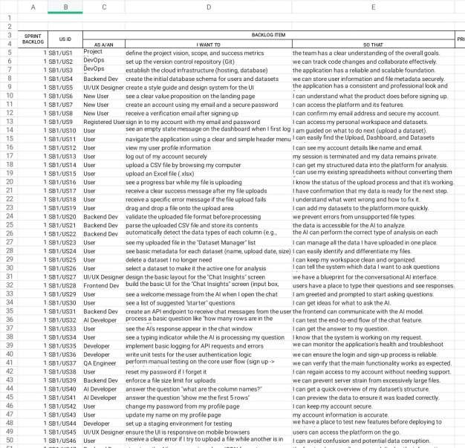
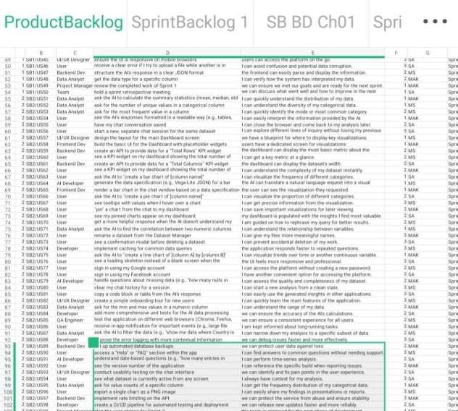

5.2 Sprint Backlog-1
Sprint 1: Dataset Preparation and Preprocessing
Goal: To prepare a clean and usable dataset for training.

Table 5.2: Sprint Backlog 1 Task Detail (Excerpt, full data available in ¹)
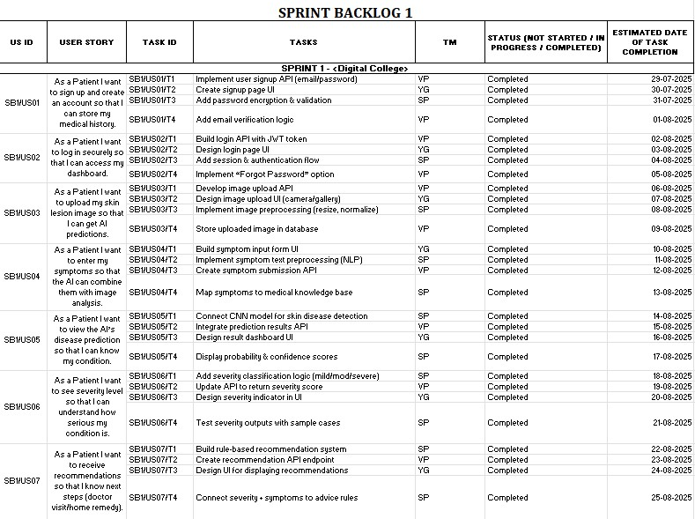

Sprint 1 Burn Down Chart
The progress of Sprint 1 was tracked using the following burn down data ¹:
Table 5.3: Sprint 1 Burn Down Chart Data

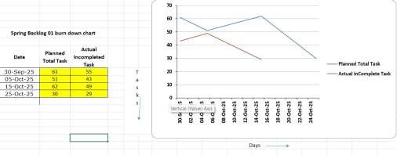

5.3 Sprint Backlog-2
Goal (Model Design): To design the CNN architecture.
Table 5.4: Sprint Backlog 2 Task Detail (Excerpt, full data available in ¹)

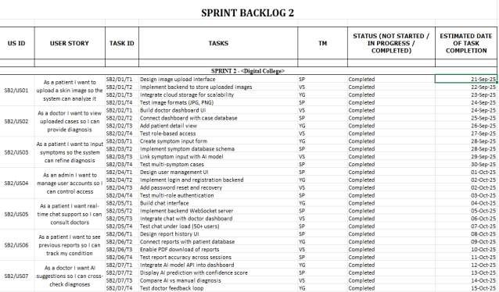

Sprint 2 Burn Down Chart
The progress of Sprint 2 was tracked using the following burn down data:

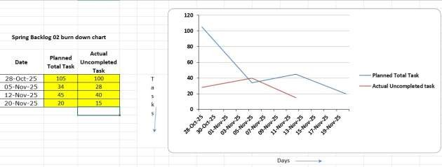

5.4 Sprint Backlog-3
Sprint 3: Model Training and Evaluation Goal: To train and evaluate the model.
Table 5.6: Sprint Backlog 3 Task Detail

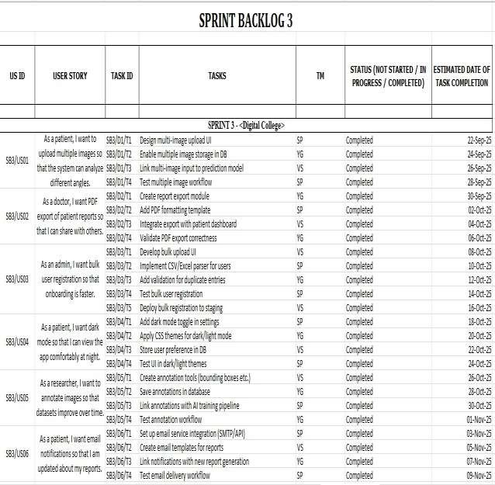

Sprint 3 Burn Down Chart

The progress of Sprint 3 was tracked using the following burn down data:
Table 5.7: Sprint 3 Burn Down Chart Data

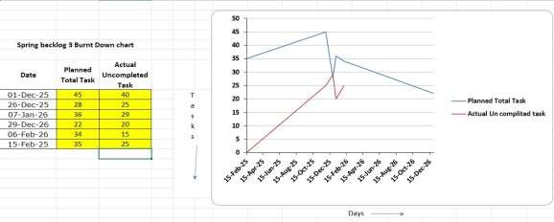

5.5 Sprint Backlog-4

Sprint 4: Deployment and Testing
Goal: To deploy the system and test functionality.
Table 5.8: Sprint Backlog 4 Task Detail

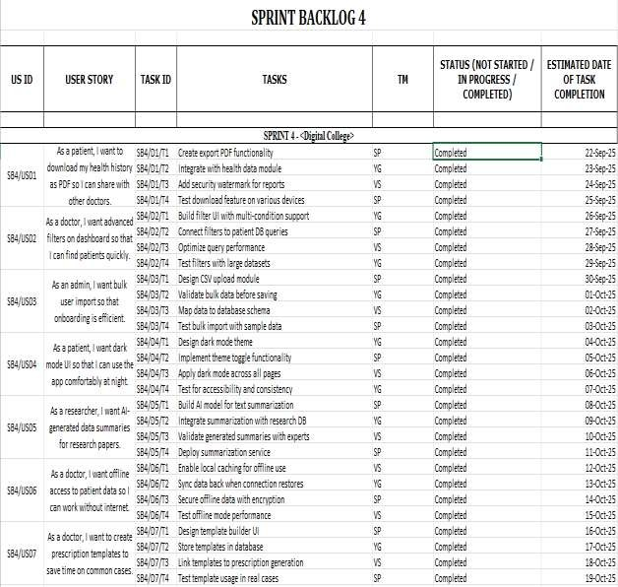

Sprint 4 Burn Down Chart
The Burn Down Chart is used to track the progress of tasks during each sprint. It compares the planned tasks with the actual completed tasks over time.
Table 5.9: Sprint 4 Burn Down Chart Data

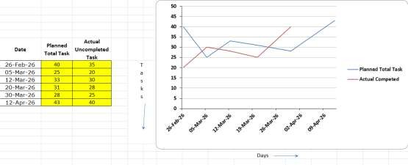
Observation:
- Tasks were completed consistently across all sprints

- The team maintained steady progress

- Final delivery was completed within the planned timeline

CHAPTER 6
Project Implementation (Advance Data Insight)

6.1 Introduction
Project Implementation is the final step in finalizing the newly developed Advance Data Insight System and will include the design and requirements created for the developed system used to create a functioning software application. This is done by developing, integrating, and testing each module of the entire system to make sure it is working properly and meets performance requirements.
During this phase, the system is fully coded and executed using the technologies chosen for use for the front-end, which is React.js; back-end (Flask); and database, and the final execution for completed data processing and machine learning is done using Python. In addition to these technologies, all databases, APIs, and AI services.

6.2 System Architecture Overview
The Advance Data Insight System Architecture Overview details the overall structure and interaction of multiple system components. All components of the front end, back end, data processing, machine learning, and database are unified into one system.
The system's architecture is a multi-tier (3-tier) architecture; the first tier (top layer) is the Presentation Layer, the second tier (middle layer) is the Application Layer or Backend (Core functionality) and the third tier (lowest layer) is the Data Layer. The frontend of the system is developed with React.js and includes HTML, CSS, Javascript.

The backend processing is implemented in Python and Flask and provides users with all the core functionalities of the system. The application processes requests from users, handles the APIs and performs the communication between the frontend, machine learning.

6.3 Module-Wise Implementation
The project Advance Data Insight consists of a modular system, in which each of the modules in the whole of the system's entire set of modules has their own individual functionality. In general, the functional modules develop and test themselves separate from each other, and later all of the modules are combined together to create one complete and effective system. ➢ User Authentication Module
The user authentication module is used to ensure that users have secure access to the system. The user authentication module leverages Firebase Authentication and allows users to log into the system through Google or email address and password. This module keeps the users' data secure, as they are able to access their data but cannot access any data that is not theirs.

➢ Data Preprocessing Module
This module follows a similar philosophy as the previous module and includes the same data preprocessing capabilities. It uses Pandas and NumPy to perform data handling tasks on missing values, duplicate entries, transforming their geometric forms, normalising the processed data to ensure its consistency throughout its journey to becoming useful for analysis. ➢ Data Analysis Module
This module has been created to perform exploratory data analysis (EDA) and to execute simple statistical techniques on the data set in order to identify all available patterns, as well as trends, and relationships within it. Visualization tools such as Matplotlib and Seaborn can be used to find all of the correct answers.

➢ . Machine Learning Module
The machine learning module contains functionality for developing new machine learning models through TensorFlow, Keras, or Scikit-learn using either supervised or unsupervised training to provide insights into how to build, test, and evaluate these models for the purpose of generating predictions. In addition, the CNN (Convolutional Neural Network) could be used if needed in order to recognise advanced patterns in this module.

➢ . AI Integration Module
AI application for Groq uses the API for Groq's AI-based intelligent insights. Therefore, this is an integral part of this module, as it allows for further improving predictions and the creation of more comprehensive analytical reporting capabilities.

➢ . Backend Module
The backend of the application is implemented using Python and Flask and serves as the managing body for business logic, API creation, and for managing communication and interaction.

6.4 Testing and Validation
In the Advance Data Insight project, testing and validation are key phases to confirm that the system performs as expected, generates correct results, and meets the requirements of all users. The goal of these two methods is to detect bugs, optimize system performance, and confirm system dependability before deployment. The testing procedure begins with unit tests of each module (data preprocessing, machine learning models, API endpoints, frontend modules). These unit tests ensures that every one of the modules work. After unit testing, integration testing is conducted to check that all the modules (frontend, backend, database, machine learning modules) are working together as a single entity without any problems in communication among them.

6.5 System Workflow

The System Workflow of the Advance Data Insight project outlines a detailed step-by-step outline of how data flows through the system, and how the data will convert into useful insights. It will illustrate how all parts of the entire system will work together to give an accurate and efficient end result

6.6 Implementation Challenges and Solutions
Advance Data Insight faced numerous technical and operational difficulties during the project’s development and implementation, including the merger of numerous different technology areas (data processing, machine learning, website development and AI services). It was important to identify the many challenges and resolve them quickly and efficiently so that the system could have a smooth development cycle and perform at an acceptable level.

One of the major issues was dealing with extremely large amounts of data that were not organised well. Raw data can often include missing or irrelevant information, which would result in inaccurate analysis. This issue was addressed through the use of good data preprocessing methods (using pandas and numpy libraries), including cleaning, normalising and transforming the data in preparation for the actual analysis itself.

A second challenge was integrating the various components on the front end (website user interface), back end (database and server) and machine-learning modules in order to ensure that data transfer occurred smoothly between all three areas. As these three areas used semicompatible technologies (front end using React.js; back end using Flask, and machine-learning libraries for Machine Learning), there was great difficulty achieving the level of data exchange needed to achieve proper communication (via REST APIs with consistent use of JSON).

CHAPTER 7

Results

7.1 Introduction

Presents results from the application of the Advance Data Insight System’s implementation effort. Emphasis will be placed on how well the development system performs in processing data and producing meaningful insight(s) has been evaluated. Additionally, performance of the system in the field and whether the system met the intended goal(s) as defined during early stages of the project are also discussed in this chapter.

7.2 Outcomes

The Advance Data Insight project meets its objective of converting raw data into valuable and actionable insights with an integrated efficient system. The results of our project demonstrate how the combination of data processing, machine learning, and visualization on one platform can be highly successful.

One of the major outcome areas was the efficient handling and preprocessing of data. Specifically, raw datasets were cleaned, transformed, and structured to enable effective analysis, therefore providing high-quality data and improving the accuracy of results. The system's ability to work with data from multiple sources makes it a very flexible and usable system for a variety of endusers.

Successful implementation of machine learning algorithms for prediction, classification and clustering—based on the ability to identify patterns and trends through data—provides a basis for making reliable, data-driven decisions and allows for the evaluation of their performance via metrics such as accuracy, precision/recall and F1-score.

Effective data visualization of complex analytical results through the use of charts, graphs and dashboards, the platform provides users with a better understanding of the analysis performed without requiring an in-depth technical background in order to make improved decisions.

By integrating AI via the Groq API, the system will provide intelligent, quicker insight to improve the function and usability of the platform. In addition, by implementing secure user authentication and data management using Firebase, the platform adds a level of security and reliability.

7.3 Benefits to Society
As a result of being a Advance Data Insight Program, society is now earned better from analyzing the data which can result in better decisions in every aspect. As the world gets more and more data driven, the ability to draw insight from massive data is key to making everyone more productive and efficient.

The Advance Data Insight System is relevant to enterprises and sectors in that their entities answer under-bidding customer purchasing preferences, market trends, and operational data. This will enable organizations to make better long-term decisions, increase their level of service to customers, and grow profit margins.

In the field of healthcare, advance data insight systems can assist healthcare professionals in examining patient data, monitoring patterns of diseases, and identifying early diagnosis and treatment. Ultimately this helps in providing a better quality of care and improved patient health care outcomes. Advantages of the project also include Eduction Sector in the manner that the Institutions can track the performance of students, identify areas where they are weak and enhance their teaching methods.
The project will improve the quality of education in general by facilitating personalized learning. Governments and public services may also make use of data insights for policy-making, resource distribution and extending or upgrading public infrastructure. This results in enhanced planning and public resource management in an effective manner.
The other major advantage is to simplify the intricate data. The solution delivers data visualization (e.g. charts, graphs, dashboards) so that even non-technical users can understand and leverage data to inform decisions.

7.4 Future Scope

Long-Term Potential. The Advance Data Insight project has significant growth and potential enhancements for future expansion opportunities. With the increase of large volumes of data being generated daily, there is an abundance of opportunities to increase the system's capabilities and broaden its application into new areas.

The implementation of real-time data processing can greatly enhance the ability of a system to perform instantaneously by allowing for an analysis of continuously flowing data. Areas of application include: financial evaluation, prediction of stock market behaviour, and on-line monitoring systems Another improvement to the system will be the integration of advanced machine learning as well as deep learning methods such as Natural Language Processing (NLP) and Reinforcement Learning so that even greater complexity of data can be handled and accurate predictions made.

A mobile application may also greatly improve system accessibility for a greater variety of users. The information will be available for users whenever/wherever they need. In Also, big data tools like Hadoop and Apache Spark can be integrated into the project, enabling processing of massive datasets more efficiently and scaling up the system. As for the user experience UX, there is-a growing number of interactive visualisation dashboards being developed with tools such as Power BI or Tableau, which will enable users to query the data in a more efficient and productive way.

REFERENCES
- TensorFlow Documentation. Deep Learning Model Development. Available: https://www.tensorflow.org
- Groq Documentation. Llama 3.1 and Llama 4 Scout Models. Available: https://console.groq.com/docs 3. Firebase Documentation. User Authentication. Available: https://firebase.google.com/docs
- Flask Documentation. Web Framework.
Available: https://flask.palletsprojects.com
- React Documentation. Frontend Development. Available: https://react.dev
- OpenCV Documentation. Image Processing. Available: https://opencv.org
- Kaggle. Skin Disease Image Datasets. Available: https://www.kaggle.com
- Chollet, F. Deep Learning with Python. Manning Publications, 2018.
- Esteva, A., et al. "Dermatologist-level classification of skin cancer with deep neural networks." Nature, vol. 542, pp. 115-118, 2017.
- Tschandl, P., et al. "The HAM10000 dataset: Multi-source dermatoscopic images of pigmented skin lesions." Scientific Data, vol. 5, 2018.

