MICROTEK COLLEGE OF MANAGEMENT
AND TECHNOLOGY
Affiliated to Mahatma Gandhi Kashi Vidyapith
LIBRARY MANAGEMENT SYSTEM
FINAL YEAR MAJOR PROJECT REPORT
Submitted in partial fulfilment of the requirements for the
Bachelor of Computer Applications (BCA)
SUBMITTED BY
Alisha Gupta
Sweta Srivastava
PROJECT GUIDE
Mr. Ravi Bhushan Tiwari
BCA SESSION 2024–2026

PROJECT CERTIFICATE
For institutional review and completion
This is to certify that the project report entitled “Library Management System” has been submitted by Alisha Gupta and Sweta Srivastava, students of the BCA session 2024–2026 at Microtek College of Management and Technology, affiliated to Mahatma Gandhi Kashi Vidyapith, as a final-year major project under the guidance of Mr. Ravi Bhushan Tiwari.
The certificate, approval wording, and signatures on this page are to be reviewed and completed by the college according to its prescribed format.

Project Guide | Head of Department | External Examiner
Signature: __________________ | Signature: __________________ | Signature: __________________

Date: ____________________________ Place: ____________________________

ABSTRACT
The Library Management System is a browser-based application for maintaining a library book catalogue, student records, and book circulation. It provides a dashboard for operational counts, forms and lists for managing books and students, issue and return workflows, an overdue-books view, and date-wise reports. Catalogue and student lists support search and pagination, while form validation helps enforce required data and uniqueness rules.
The application is implemented with Java 21 and Spring Boot 3.5.7. Spring MVC controllers handle browser requests, service classes apply circulation rules, Spring Data JPA repositories access MySQL, and Thymeleaf renders the web pages. The database contains books, students, and issued-book records. When a book is issued, its available-copy count decreases; when it is returned, the return date and status are updated and availability increases.
The project was developed as a BCA final-year major project for the 2024–2026 session by Alisha Gupta and Sweta Srivastava at Microtek College of Management and Technology, affiliated to Mahatma Gandhi Kashi Vidyapith, under the guidance of Mr. Ravi Bhushan Tiwari.
Keywords: Library management, Spring Boot, Java, MySQL, book circulation, Thymeleaf

CONTENTS
- Abstract
- Chapter 1 - Introduction
- Chapter 2 - System Analysis and Requirements
- Chapter 3 - System Design
- Chapter 4 - Database Design
- Chapter 5 - Implementation
- Chapter 6 - Testing and Verification
- Chapter 7 - Installation and User Operation
- Chapter 8 - Conclusion and Future Scope
- References
- Appendix A - Interface Screenshots

CHAPTER 1 INTRODUCTION
Libraries maintain books, student members, and records of borrowing and returns. This project provides a single web application for recording these activities and viewing current circulation information.

1.1 Background
A library needs reliable records of the books it owns, the students who borrow them, and the dates associated with each loan. The Library Management System represents these records in a relational database and exposes them through browser-based forms, tables, and summary views.

1.2 Problem Statement
The project addresses the need to keep catalogue, student, and circulation records together and to make common tasks such as searching, issuing, returning, and checking overdue books available through a consistent interface.

1.3 Objectives
- Maintain book details, quantities, and available copies.
- Maintain student records with validation and duplicate checks.
- Record book issue and return events and update availability consistently.
- Search and paginate book, student, and issue records.
- Display overdue circulation records and date-wise issue/return reports.
- Summarize key library counts on a dashboard.

1.4 Project Scope
The implemented scope includes the dashboard, Books and Students modules, issue/return processing, issued-book search and status filtering, overdue records, and Reports & Analytics. The application uses a server-rendered web interface and a MySQL database. This report describes these implemented modules.

CHAPTER 2 SYSTEM ANALYSIS AND REQUIREMENTS
This chapter summarizes the user-facing work supported by the current application and the principal operating requirements.

2.1 User and Operating Context
The application is operated through a web browser by a library staff member. Staff maintain catalogue and student records, record circulation activity, and review dashboard and report information. The described routes do not include a separate sign-in workflow.

2.2 Functional Requirements
Module | Supported operations
Dashboard | View book/student/issue/return/overdue counts and recent circulation.
Books | Create, browse, edit, delete, search by title/author/ISBN, and paginate.
Students | Create, browse, edit, delete, search by name/roll/email, and paginate.
Circulation | Issue a book, record returns, search/filter issue records, and paginate.
Overdue | View currently issued records with a due date before the current date.
Reports | View summary metrics and date-wise ALL, ISSUED, or RETURNED results.

2.3 Validation Requirements
- Book title, author, and ISBN are required; ISBN is unique. Quantity must be at least one.
- Student name, roll number, and email are required; roll number and email are unique.
- Email must be valid. A supplied phone number must contain ten digits.
- A book can be issued only when copies are available and the due date is today or later.
- A returned circulation record cannot be returned a second time.
- A report start date cannot be after its end date.

2.4 Quality and Operating Requirements
The application runs as a Spring Boot web service and persists records in MySQL. Thymeleaf produces HTML views, and Bootstrap 5.3.3 provides layout and styling. Pagination controllers constrain page size to between 1 and 100 records.

CHAPTER 3 SYSTEM DESIGN
The application follows a layered structure in which browser requests are handled by controllers, business operations are performed by services, and repositories persist JPA entities in MySQL.

3.1 Architecture
Layer | Responsibility | Components
Presentation | Renders pages and collects input. | Thymeleaf templates and browser
Web controller | Maps requests, validates form input, builds page models. | BookController, StudentController, IssuedBookController, DashboardController, ReportController
Service | Applies rules and coordinates operations. | BookService, StudentService, IssuedBookService
Persistence | Loads and saves entities through JPA. | BookRepository, StudentRepository, IssuedBookRepository
Database | Stores catalogue, student, circulation records. | MySQL: books, students, issued_books

3.2 Main Data Flow
- A staff member submits a form or opens a list/report page in the browser.
- A Spring MVC controller maps the request, validates input, and calls a service.
- The service loads or updates entities through Spring Data JPA repositories.
- Hibernate maps entities to MySQL records; the controller returns a Thymeleaf view with results or feedback.

3.3 Entity Relationships
Relationship | Meaning
STUDENTS 1 to many ISSUED_BOOKS | A student can have multiple circulation records; each record belongs to one student.
BOOKS 1 to many ISSUED_BOOKS | A book can appear in multiple circulation records; each record refers to one book.

The detailed ER diagram is in ER_DIAGRAM.md. The application data flows are documented in DFD_DIAGRAMS.md.

3.4 Issue and Return State Flow
Action | Circulation record | Book availability
Issue | Create record with issue date, due date, status ISSUED. | Decrease copies by one.
Return | Set return date and status RETURNED. | Increase copies by one.

CHAPTER 4 DATABASE DESIGN
The persistence model contains three JPA entities mapped to the MySQL database named library_management.

4.1 Books Table
Field | Purpose and constraints
id | Generated primary key.
title | Required; maximum 100 characters.
author | Required; maximum 100 characters.
isbn | Required and unique.
category | Optional.
quantity | Required; validation minimum is 1.
availableCopies | Available count; validation minimum is 0.

4.2 Students Table
Field | Purpose and constraints
id | Generated primary key.
name | Required; maximum 100 characters.
rollNumber | Required, unique, maximum 30 characters.
email | Required, unique, email-validated.
phone | Optional; when supplied, ten digits.
course | Optional.

4.3 Issued Books Table
Field | Purpose and constraints
id | Generated primary key.
student_id | Required foreign key to a student.
book_id | Required foreign key to a book.
issueDate | Issue date.
dueDate | Expected return date.
returnDate | Actual return date; empty until returned.
status | String status used by filters and reports.

4.4 Schema Management
The application uses spring.jpa.hibernate.ddl-auto=update. Hibernate updates mapped schema at startup. This is convenient for project setup; important deployments should use reviewed migrations and backups. The repository contains no versioned migration set.

CHAPTER 5 IMPLEMENTATION
The application is implemented as a Spring Boot 3.5.7 Maven project using Java 21, Spring MVC, Spring Data JPA, Thymeleaf, MySQL Connector/J, and validation support.

5.1 Implemented Modules
Module | Implementation summary
Dashboard | Counts from services plus recent issue records.
Books | CRUD, duplicate ISBN checks, case-insensitive search, pagination.
Students | CRUD, duplicate roll/email checks, validation, search, pagination.
Issued books | Issue/return transactions, keyword/status filters, pagination.
Overdue | ISSUED records with due date before today.
Reports | Summary metrics and date-range queries for ALL, ISSUED, RETURNED.

5.2 Main Routes
Route | Purpose
/ | Dashboard
/books and /books/search | Book list and search
/students and /students/search | Student list and search
/issued-books and /issued-books/search | Circulation list and search/filter
/issued-books/issue | Issue form
/issued-books/overdue | Overdue list
/reports | Summary metrics and date-wise report

5.3 Reporting Rules
- ALL selects records by issue date in the selected range, independent of current status.
- ISSUED selects status ISSUED and filters by issue date.
- RETURNED selects status RETURNED and filters by return date.
- The initial report range defaults to the prior 30 days through today.

CHAPTER 6 TESTING AND VERIFICATION
The project team reports that the application was tested earlier and that all features worked correctly. The individual test date, application revision, and case-by-case results were not supplied.

6.1 Manual Verification Areas
- Book/student create, edit, delete, search, pagination, and validation.
- Duplicate ISBN, roll number, and email handling.
- Issuing with available stock and a valid due date; stock decrement.
- Return date/status update, stock increment, and prevention of repeat returns.
- Status and keyword filtering, overdue behavior, report date/type filtering, dashboard counts.

6.2 Automated Test Coverage
The repository contains LibraryManagementSystemApplicationTests.contextLoads(), a Spring Boot context-load smoke test. It does not exercise feature workflows. No automated test command was run while preparing this report. The repeatable manual checklist is in TESTING.md.

6.3 Test Record
Record item | Available information
Reported outcome | Project team reports prior testing found the application features working.
Date and revision | Not provided.
Individual results | No case-by-case test log provided.
Documentation review | Repository source and supplied screenshots reviewed for this report.

CHAPTER 7 INSTALLATION AND USER OPERATION
The application requires Java 21, Maven, and a reachable MySQL server. Full setup and end-user walkthroughs are available in README.md and USER_MANUAL.md.

7.1 Installation Summary
- Install JDK 21, Maven, and MySQL Server.
- Create the library_management database.
- Configure local MySQL URL and credentials through environment variables or local uncommitted configuration.
- From the project root, run mvn spring-boot:run.
- Open http://localhost:8080 in a browser.
The project does not include Maven Wrapper scripts. See README.md for full commands and database configuration.

7.2 User Workflow Summary
- Create book and student records before recording circulation.
- Choose a student and available book, enter a valid due date, and issue the book.
- Monitor status in Issued Books and record a return when the book is received.
- Review overdue items and generate reports for a chosen date range.

CHAPTER 8 CONCLUSION AND FUTURE SCOPE
The Library Management System brings catalogue, student, circulation, and reporting tasks into a browser-based project built with Java and Spring Boot.

8.1 Conclusion
The implemented modules support book and student record management, issue and return processing, availability tracking, overdue identification, and date-wise reporting. The layered design separates web routing, service logic, data access, and persistence. The result provides a functional academic project for demonstrating web application development and relational data handling.

8.2 Current Boundaries
- The project routes do not include sign-in or role-management workflows.
- Schema management relies on Hibernate update rather than versioned migrations.
- The repository test suite contains a context-load smoke test rather than feature-level automated tests.
- Bootstrap CSS is loaded from an external CDN.

8.3 Possible Future Enhancements
Future versions could add staff accounts and roles, migration-based schema changes, and automated feature-level tests. These are suggestions for later work and are not part of the current implementation.

CHAPTER 9 REFERENCES
- Project Maven configuration: pom.xml.
- Application properties: src/main/resources/application.properties.
- Application source: src/main/java/com/library/library/management/system/.
- Thymeleaf views: src/main/resources/templates/.
- Database model: DATABASE.md; entity diagram: ER_DIAGRAM.md; data flows: DFD_DIAGRAMS.md.
- Testing checklist: TESTING.md; user instructions: USER_MANUAL.md.

CHAPTER A INTERFACE SCREENSHOTS
The selected supplied screenshots show representative application screens. The complete local screenshot gallery is documented in SCREENSHOTS.md.

A.1 Dashboard
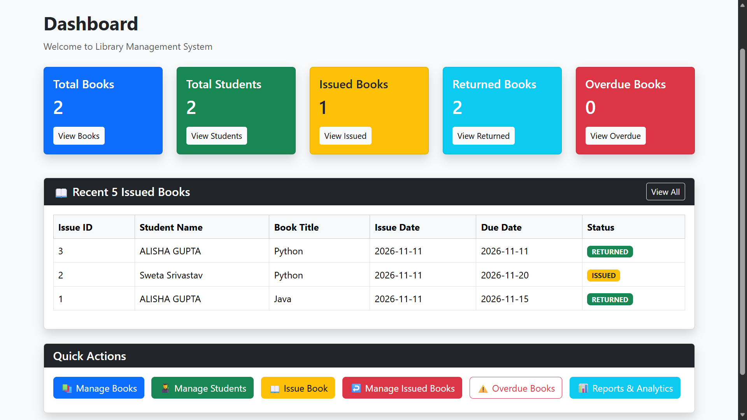
Dashboard summary cards, recent issue records, and quick actions.

A.2 Book Catalogue
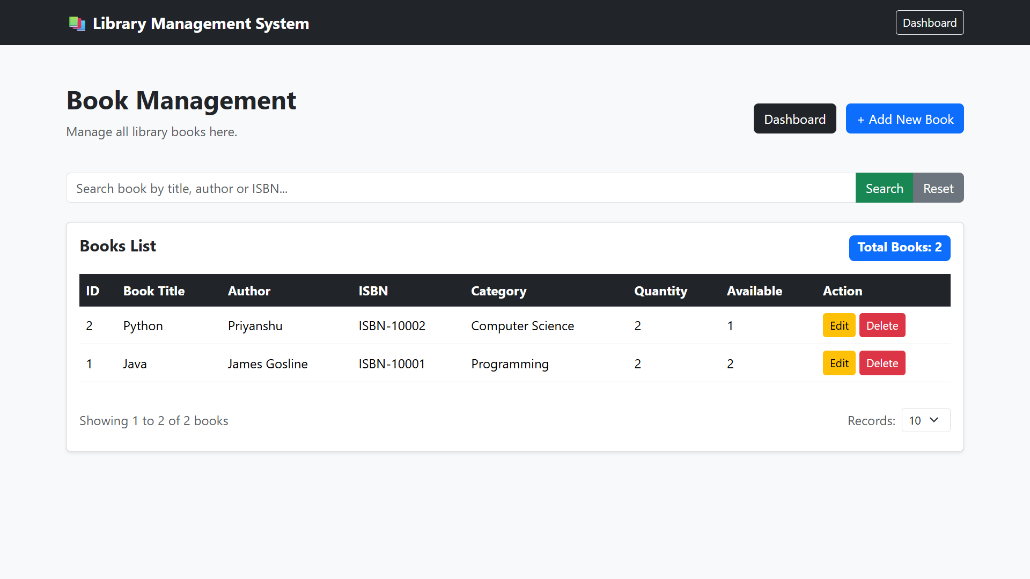
Book search, catalogue fields, available-copy counts, and record actions.

A.3 Add Book Form
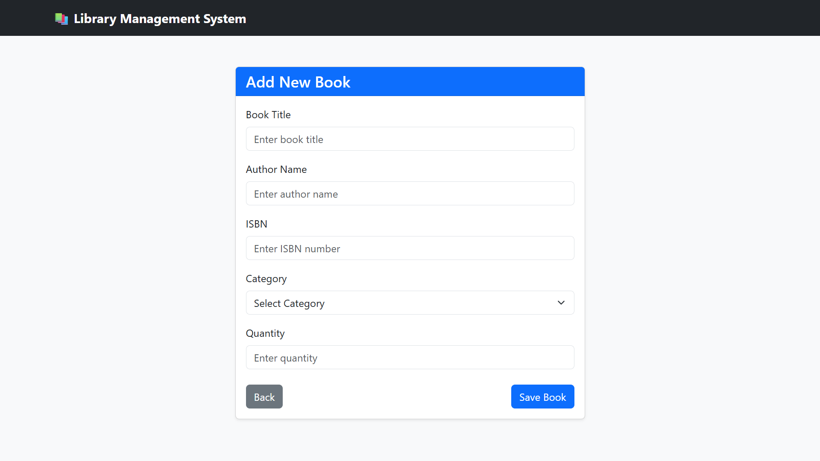
Book entry fields and save action.

A.4 Student Registration Form
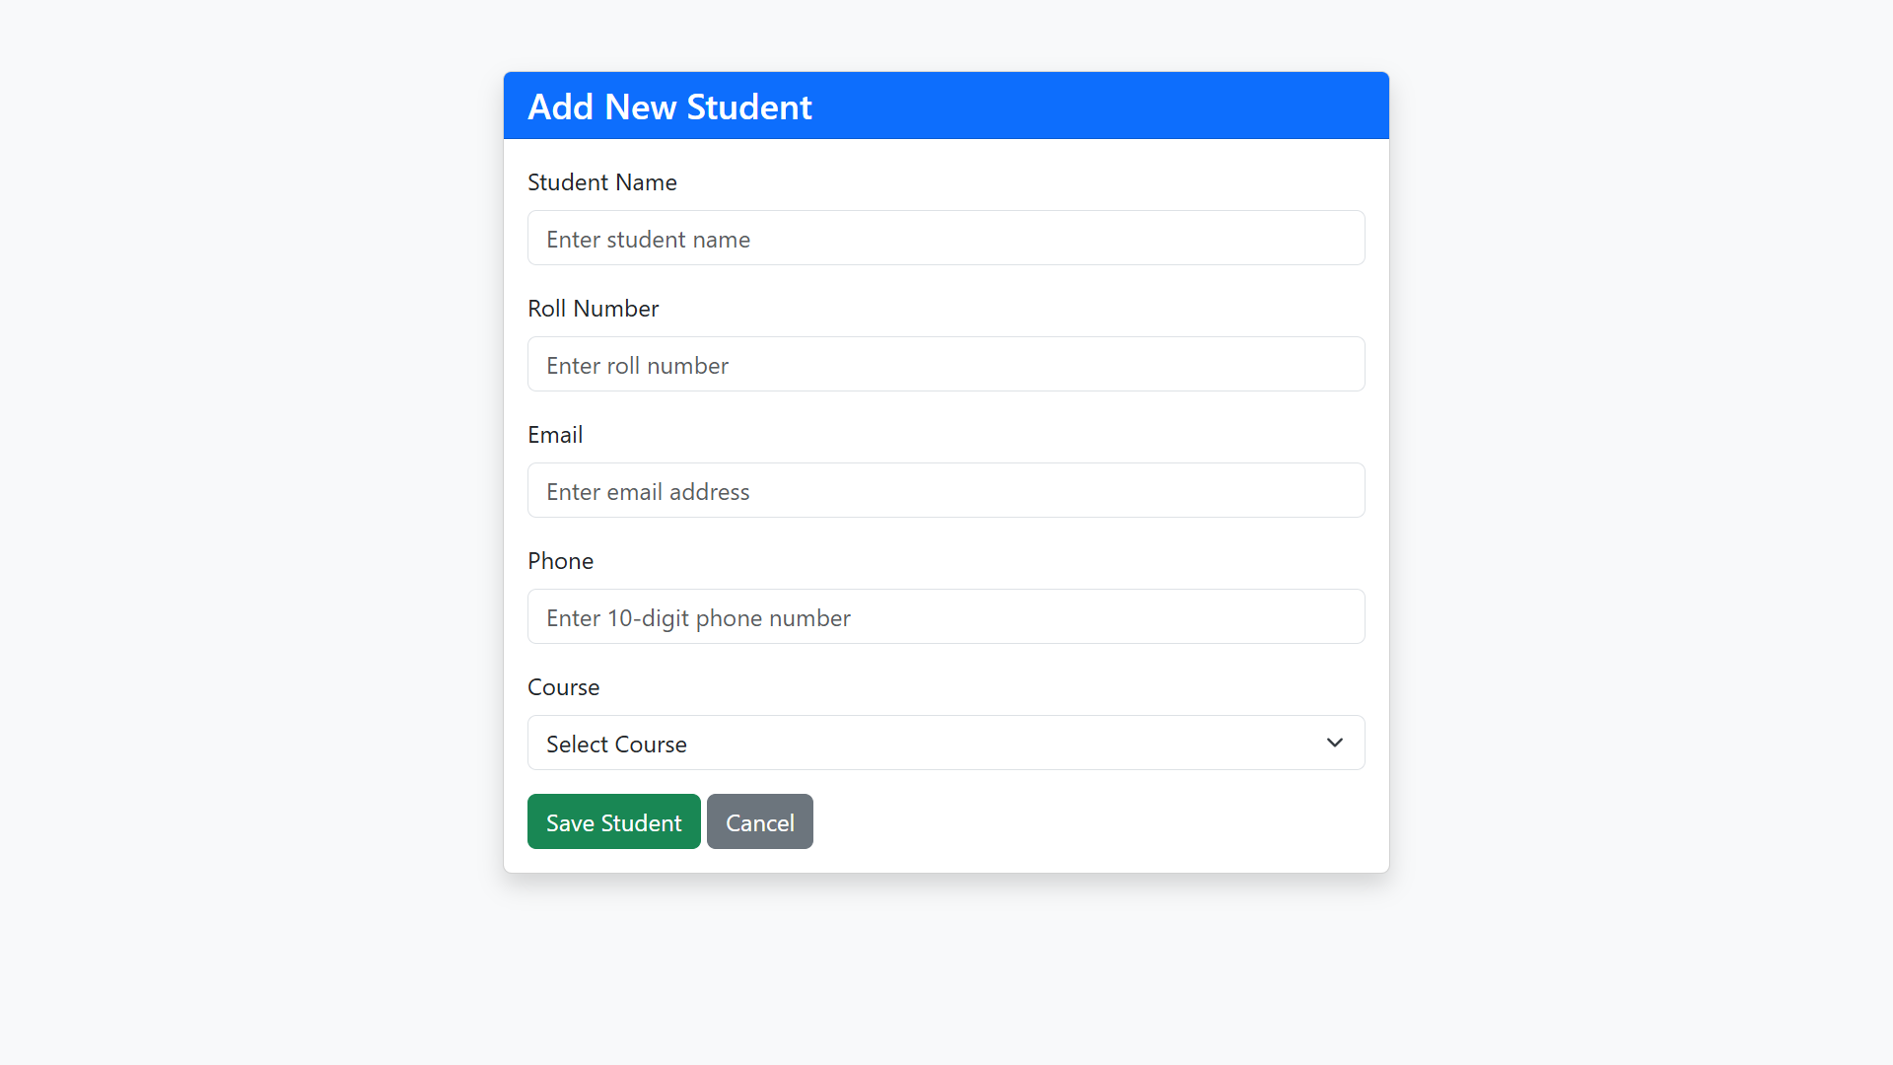
Student entry form with contact and course fields.

A.5 Issue Book Form
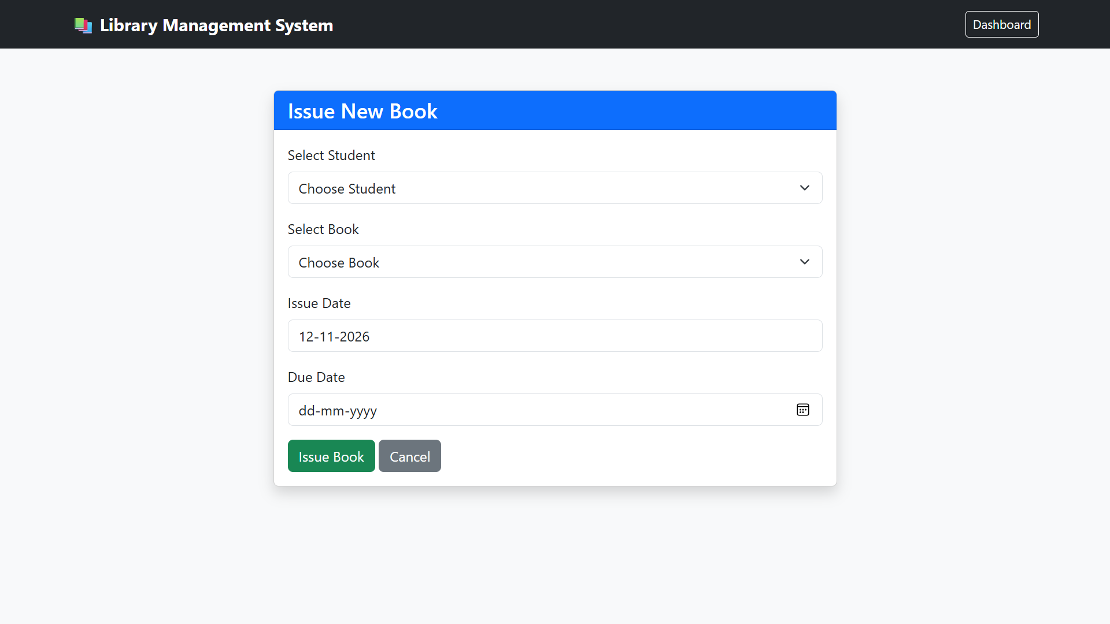
Student and book selection with issue and due-date fields.

A.6 Issued Books
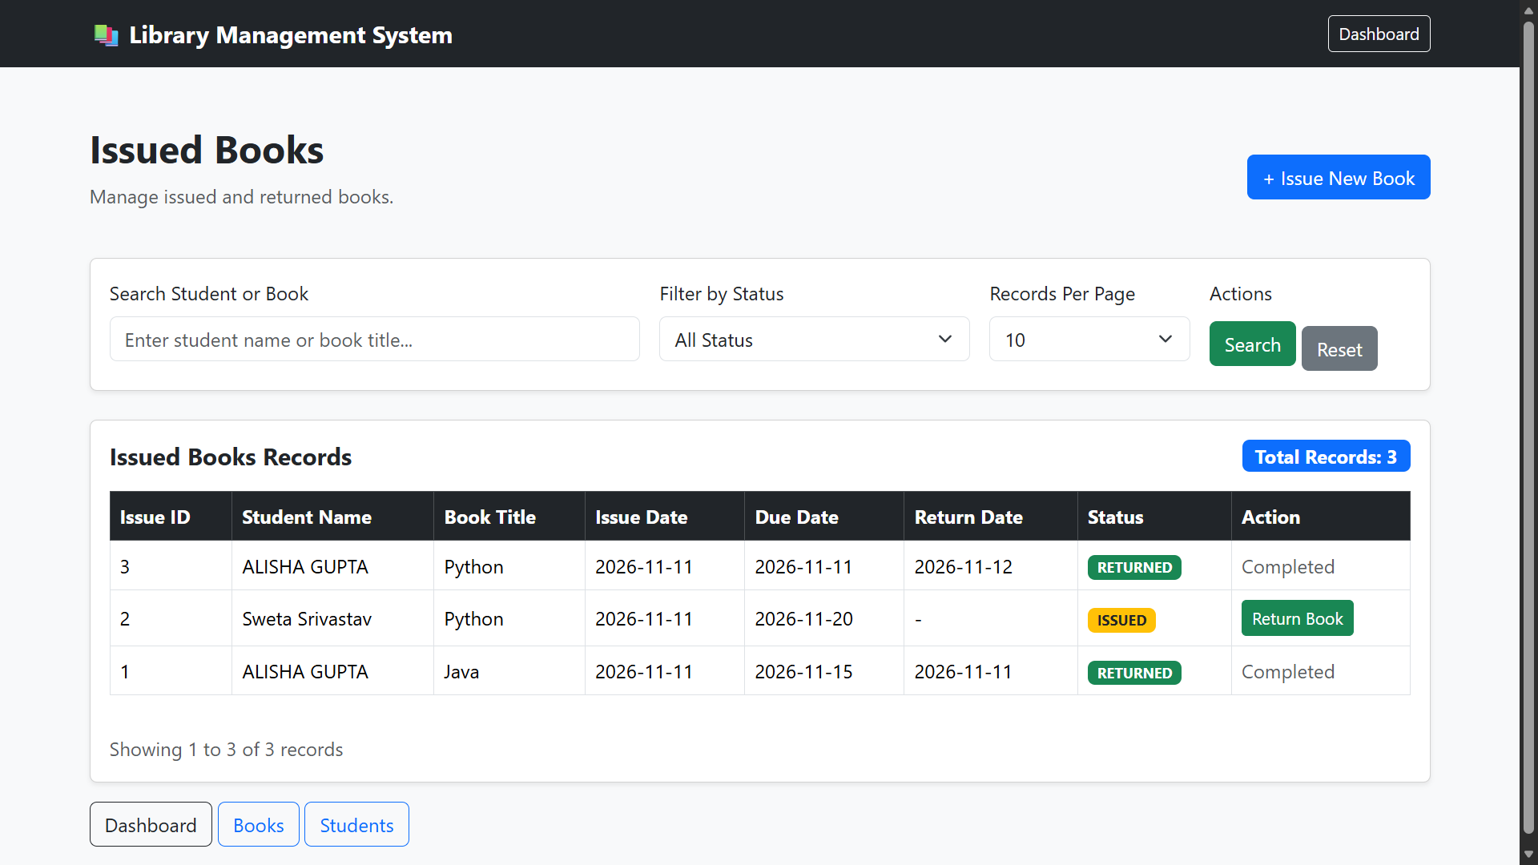
Circulation records with issued and returned status.

A.7 Overdue Books
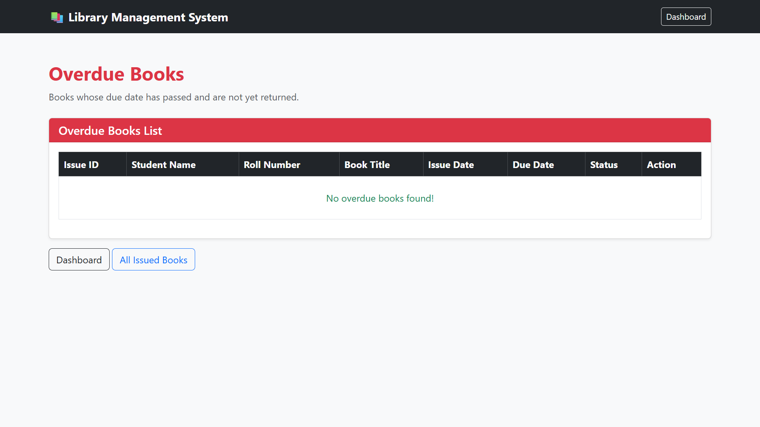
Overdue view showing the empty state in the supplied demonstration data.

