**Conditions:**

The condition is the factor that state that the house is in which condition it is ranked, good, normal, worst respectively. Stating the condition overall accordingly with the price.

The percentage of the resultant is showing the condition of the house as on the dependent factor of price

The tables is showing the result of different cases according to the conditions.

|  |  |
| --- | --- |
| Condition | Houses |
| 1 | 30 |
| 2 | 172 |
| 3 | 14031 |
| 4 | 5679 |
| 5 | 1701 |

**Descriptive Statistics:**

Below table indicates the statistics details obtained as following the prices according to conditions.

|  |  |  |  |  |  |  |
| --- | --- | --- | --- | --- | --- | --- |
|  | 1 | | 2 | 3 | 4 | 5 |
| Mean | 3,34431666667E+005 | | 3,27287145349E+005 | 5,42012578148E+005 | 5,21200390033E+005 | 6,12418089359E+005 |
| Median | 2,62500000000E+005 | | 2,79000000000E+005 | 4,50000000000E+005 | 4,40000000000E+005 | 5,26000000000E+005 |
| Variance | 73534690083,333 | | 60230197547,213 | 132823119042,811 | 128533888141,560 | 168897921116,148 |
| Std. Deviation | | 2,711728048373E+005 | 2,454184132196E+005 | 3,644490623432E+005 | 3,585162313502E+005 | 4,109719225399E+005 |
| Minimum | 7,800000000E+004 | | 8,000000000E+004 | 7,500000000E+004 | 8,900000000E+004 | 1,100000000E+005 |
| Maximum | 1,500000000E+006 | | 2,555000000E+006 | 7,062500000E+006 | 7,700000000E+006 | 3,650000000E+006 |
| Range | 1,422000000E+006 | | 2,475000000E+006 | 6,987500000E+006 | 7,611000000E+006 | 3,540000000E+006 |

**Histograms:**

We can analyze the results through graphical annotations as by conditions depending on prices so as from below histogram we can analyze that house with condition 1 are 30 and prices 500000$.

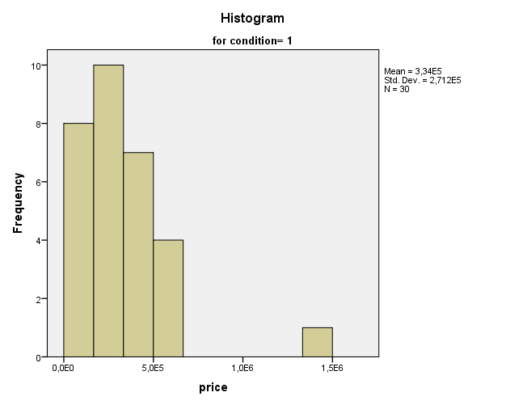

Below histogram is for condition 2 and the median prices are 80% frequency with approx. mean of 327000$ and number of houses are 172.

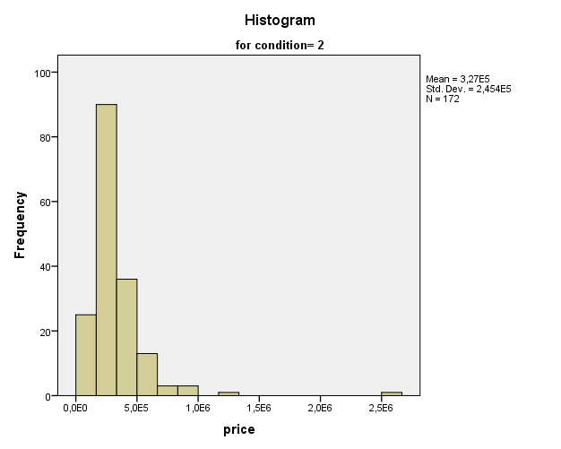

As we can analyze from the histogram the bar are elevating because of the conditions of the houses as large number of houses are in good conditions in this case 3 the house number range to 14031 and prices 120000$ there frequency at this prices is almost 3000.

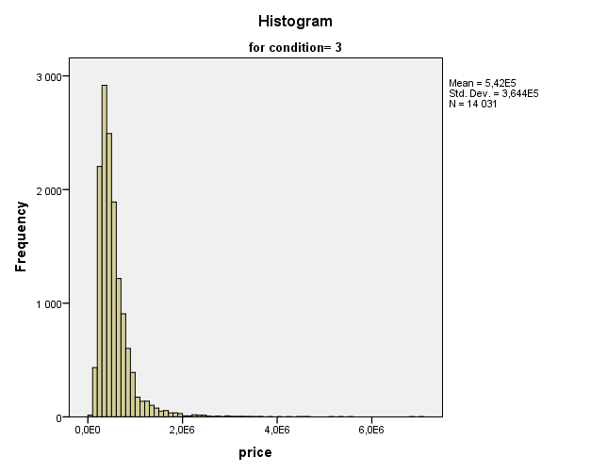

The below histogram illustrates condition 4 which show that number of houses available at this condition having the prices in between 1,80000$ having frequency of 1600 number of houses are 5679.

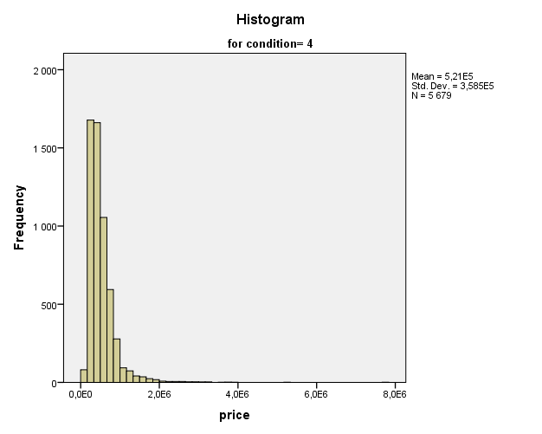

Below histogram is of condition 5 having the frequency of available houses number are 300 and N = 1701, while prices at this range are 180000$.

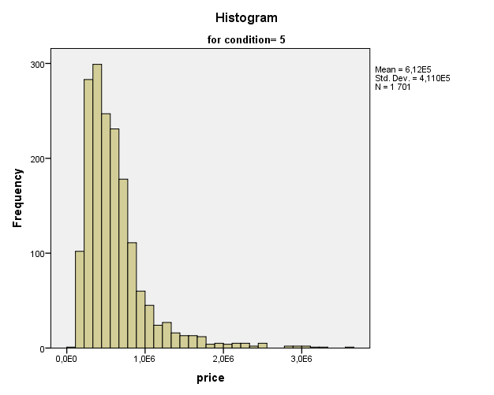

**Outliers:**

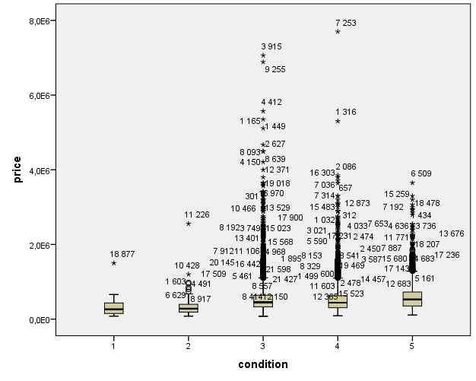

Above graph of outliers shows the conditions most of prices factors are uprising which illustrates less error in the analysis. The maximum prices are at 80,000 00$ at condition of 4 and number of houses at this range are 7253 total.