* Visual Binning.
*yr_built.
RECODE yr_built (MISSING=COPY) (LO THRU 1900=1) (LO THRU 1920=2) (LO THRU 1940=3) (LO THRU 1960=4)
(LO THRU 1980=5) (LO THRU 2000=6) (LO THRU HI=7) (ELSE=SYSMIS) INTO yr_built_int.
VARIABLE LABELS yr_built_int 'yr_built (Binned)'.
FORMATS yr_built_int (F5.0).
VALUE LABELS yr_built_int 1 '' 2 '' 3 '' 4 '' 5 '' 6 '' 7 ''.
VARIABLE LEVEL yr_built_int (ORDINAL).
EXECUTE.
EXAMINE VARIABLES=price BY yr_built_int
/PLOT BOXPLOT HISTOGRAM
/COMPARE GROUPS
/STATISTICS DESCRIPTIVES EXTREME
/CINTERVAL 95
/MISSING LISTWISE
/NOTOTAL.

Explore

Notes
Output Created |  | 17-OCT-2017 16:12:10
Comments
Input | Data | C:\Users\Mathurin\Documents\Cours Winter 20172018\Data Mining\Project\House Sales in King County, USA\data.sav
Input | Active Dataset | DataSet1
Input | Filter | <none>
Input | Weight | <none>
Input | Split File | <none>
Input | N of Rows in Working Data File | 21613
Missing Value Handling | Definition of Missing | User-defined missing values for dependent variables are treated as missing.
Missing Value Handling | Cases Used | Statistics are based on cases with no missing values for any dependent variable or factor used.
Syntax |  | EXAMINE VARIABLES=price BY yr_built_int  /PLOT BOXPLOT HISTOGRAM  /COMPARE GROUPS  /STATISTICS DESCRIPTIVES EXTREME  /CINTERVAL 95  /MISSING LISTWISE  /NOTOTAL.
Resources | Processor Time | 00:00:01,53
Resources | Elapsed Time | 00:00:01,53

yr_built (Binned)

Case Processing Summary
 | yr_built (Binned) | Cases
 | yr_built (Binned) | Valid |  | Missing |  | Total
 | yr_built (Binned) | N | Percent | N | Percent | N | Percent
price | 1 | 87 | 100,0% | 0 | 0,0% | 87 | 100,0%
price | 2 | 1462 | 100,0% | 0 | 0,0% | 1462 | 100,0%
price | 3 | 1780 | 100,0% | 0 | 0,0% | 1780 | 100,0%
price | 4 | 4308 | 100,0% | 0 | 0,0% | 4308 | 100,0%
price | 5 | 4937 | 100,0% | 0 | 0,0% | 4937 | 100,0%
price | 6 | 4498 | 100,0% | 0 | 0,0% | 4498 | 100,0%
price | 7 | 4541 | 100,0% | 0 | 0,0% | 4541 | 100,0%

Descriptives
 | yr_built (Binned) |  |  | Statistic | Std. Error
price | 1 | Mean |  | 5,81387206897E+005 | 3,155925261762E+004
price | 1 | 95% Confidence Interval for Mean | Lower Bound | 5,18649489095E+005
price | 1 | 95% Confidence Interval for Mean | Upper Bound | 6,44124924698E+005
price | 1 | 5% Trimmed Mean |  | 5,57806990421E+005
price | 1 | Median |  | 5,49000000000E+005
price | 1 | Variance |  | 86650819043,096
price | 1 | Std. Deviation |  | 2,943651117967E+005
price | 1 | Minimum |  | 1,300000000E+005
price | 1 | Maximum |  | 1,695000000E+006
price | 1 | Range |  | 1,565000000E+006
price | 1 | Interquartile Range |  | 3,035000000E+005
price | 1 | Skewness |  | 1,222 | ,258
price | 1 | Kurtosis |  | 2,254 | ,511
price | 2 | Mean |  | 6,00575231190E+005 | 1,093315108403E+004
price | 2 | 95% Confidence Interval for Mean | Lower Bound | 5,79128881864E+005
price | 2 | 95% Confidence Interval for Mean | Upper Bound | 6,22021580516E+005
price | 2 | 5% Trimmed Mean |  | 5,53413509652E+005
price | 2 | Median |  | 5,25500000000E+005
price | 2 | Variance |  | 174758404819,511
price | 2 | Std. Deviation |  | 4,180411520646E+005
price | 2 | Minimum |  | 8,000000000E+004
price | 2 | Maximum |  | 7,700000000E+006
price | 2 | Range |  | 7,620000000E+006
price | 2 | Interquartile Range |  | 3,363750000E+005
price | 2 | Skewness |  | 5,285 | ,064
price | 2 | Kurtosis |  | 63,495 | ,128
price | 3 | Mean |  | 6,02723170225E+005 | 9,917267947748E+003
price | 3 | 95% Confidence Interval for Mean | Lower Bound | 5,83272448837E+005
price | 3 | 95% Confidence Interval for Mean | Upper Bound | 6,22173891612E+005
price | 3 | 5% Trimmed Mean |  | 5,53042918851E+005
price | 3 | Median |  | 5,25000000000E+005
price | 3 | Variance |  | 175066922314,416
price | 3 | Std. Deviation |  | 4,184099930862E+005
price | 3 | Minimum |  | 8,500000000E+004
price | 3 | Maximum |  | 7,062500000E+006
price | 3 | Range |  | 6,977500000E+006
price | 3 | Interquartile Range |  | 3,250000000E+005
price | 3 | Skewness |  | 4,309 | ,058
price | 3 | Kurtosis |  | 40,214 | ,116
price | 4 | Mean |  | 4,61646746286E+005 | 4,571110564093E+003
price | 4 | 95% Confidence Interval for Mean | Lower Bound | 4,52685015774E+005
price | 4 | 95% Confidence Interval for Mean | Upper Bound | 4,70608476798E+005
price | 4 | 5% Trimmed Mean |  | 4,26768537089E+005
price | 4 | Median |  | 3,90500000000E+005
price | 4 | Variance |  | 90015883107,729
price | 4 | Std. Deviation |  | 3,000264706784E+005
price | 4 | Minimum |  | 7,800000000E+004
price | 4 | Maximum |  | 3,600000000E+006
price | 4 | Range |  | 3,522000000E+006
price | 4 | Interquartile Range |  | 2,775000000E+005
price | 4 | Skewness |  | 3,125 | ,037
price | 4 | Kurtosis |  | 17,029 | ,075
price | 5 | Mean |  | 4,75887376544E+005 | 4,224253938492E+003
price | 5 | 95% Confidence Interval for Mean | Lower Bound | 4,67605960272E+005
price | 5 | 95% Confidence Interval for Mean | Upper Bound | 4,84168792817E+005
price | 5 | 5% Trimmed Mean |  | 4,40642580740E+005
price | 5 | Median |  | 4,06500000000E+005
price | 5 | Variance |  | 88097414440,096
price | 5 | Std. Deviation |  | 2,968120860748E+005
price | 5 | Minimum |  | 7,500000000E+004
price | 5 | Maximum |  | 3,850000000E+006
price | 5 | Range |  | 3,775000000E+006
price | 5 | Interquartile Range |  | 2,768750000E+005
price | 5 | Skewness |  | 3,048 | ,035
price | 5 | Kurtosis |  | 16,437 | ,070
price | 6 | Mean |  | 5,64491082259E+005 | 5,533817510747E+003
price | 6 | 95% Confidence Interval for Mean | Lower Bound | 5,53642079252E+005
price | 6 | 95% Confidence Interval for Mean | Upper Bound | 5,75340085266E+005
price | 6 | 5% Trimmed Mean |  | 5,19985921150E+005
price | 6 | Median |  | 4,75100000000E+005
price | 6 | Variance |  | 137742866817,652
price | 6 | Std. Deviation |  | 3,711372614245E+005
price | 6 | Minimum |  | 1,150000000E+005
price | 6 | Maximum |  | 5,300000000E+006
price | 6 | Range |  | 5,185000000E+006
price | 6 | Interquartile Range |  | 3,550625000E+005
price | 6 | Skewness |  | 3,657 | ,037
price | 6 | Kurtosis |  | 25,348 | ,073
price | 7 | Mean |  | 6,15314917639E+005 | 6,264304275079E+003
price | 7 | 95% Confidence Interval for Mean | Lower Bound | 6,03033832748E+005
price | 7 | 95% Confidence Interval for Mean | Upper Bound | 6,27596002531E+005
price | 7 | 5% Trimmed Mean |  | 5,59940795224E+005
price | 7 | Median |  | 5,00000000000E+005
price | 7 | Variance |  | 178195688058,543
price | 7 | Std. Deviation |  | 4,221323110809E+005
price | 7 | Minimum |  | 1,550000000E+005
price | 7 | Maximum |  | 6,885000000E+006
price | 7 | Range |  | 6,730000000E+006
price | 7 | Interquartile Range |  | 3,400500000E+005
price | 7 | Skewness |  | 4,163 | ,036
price | 7 | Kurtosis |  | 31,366 | ,073

Extreme Values
 | yr_built (Binned) |  |  | Case Number | Value
price | 1 | Highest | 1 | 18076 | 1,695000000E+006
price | 1 | Highest | 2 | 11696 | 1,400000000E+006
price | 1 | Highest | 3 | 15298 | 1,330000000E+006
price | 1 | Highest | 4 | 5161 | 1,297000000E+006
price | 1 | Highest | 5 | 12034 | 1,260000000E+006
price | 1 | Lowest | 1 | 14002 | 1,300000000E+005
price | 1 | Lowest | 2 | 7850 | 1,699000000E+005
price | 1 | Lowest | 3 | 19138 | 1,790000000E+005
price | 1 | Lowest | 4 | 11535 | 1,925000000E+005
price | 1 | Lowest | 5 | 5237 | 1,999990000E+005
price | 2 | Highest | 1 | 7253 | 7,700000000E+006
price | 2 | Highest | 2 | 18478 | 3,300000000E+006
price | 2 | Highest | 3 | 7192 | 3,200000000E+006
price | 2 | Highest | 4 | 15259 | 3,065000000E+006
price | 2 | Highest | 5 | 2900 | 3,000000000E+006
price | 2 | Lowest | 1 | 466 | 8,000000000E+004
price | 2 | Lowest | 2 | 18469 | 8,300000000E+004
price | 2 | Lowest | 3 | 7993 | 9,000000000E+004
price | 2 | Lowest | 4 | 14582 | 9,500000000E+004
price | 2 | Lowest | 5 | 3806 | 9,500000000E+004
price | 3 | Highest | 1 | 3915 | 7,062500000E+006
price | 3 | Highest | 2 | 6509 | 3,650000000E+006
price | 3 | Highest | 3 | 10447 | 3,400000000E+006
price | 3 | Highest | 4 | 7908 | 3,200000000E+006
price | 3 | Highest | 5 | 11976 | 3,000000000E+006
price | 3 | Lowest | 1 | 10254 | 8,500000000E+004
price | 3 | Lowest | 2 | 5640 | 1,000000000E+005
price | 3 | Lowest | 3 | 13762 | 1,025000000E+005
price | 3 | Lowest | 4 | 13629 | 1,055000000E+005
price | 3 | Lowest | 5 | 14738 | 1,100000000E+005ª
price | 4 | Highest | 1 | 2865 | 3,600000000E+006
price | 4 | Highest | 2 | 13968 | 3,395000000E+006
price | 4 | Highest | 3 | 18200 | 3,300000000E+006
price | 4 | Highest | 4 | 657 | 3,070000000E+006
price | 4 | Highest | 5 | 14053 | 2,750000000E+006
price | 4 | Lowest | 1 | 15294 | 7,800000000E+004
price | 4 | Lowest | 2 | 16199 | 8,100000000E+004
price | 4 | Lowest | 3 | 8275 | 8,200000000E+004
price | 4 | Lowest | 4 | 2142 | 8,250000000E+004
price | 4 | Lowest | 5 | 3768 | 8,400000000E+004
price | 5 | Highest | 1 | 2086 | 3,850000000E+006
price | 5 | Highest | 2 | 7036 | 3,800000000E+006
price | 5 | Highest | 3 | 14557 | 2,888000000E+006
price | 5 | Highest | 4 | 5450 | 2,850000000E+006
price | 5 | Highest | 5 | 13711 | 2,600000000E+006^{b}
price | 5 | Lowest | 1 | 1150 | 7,500000000E+004
price | 5 | Lowest | 2 | 5867 | 8,900000000E+004
price | 5 | Lowest | 3 | 18940 | 9,000000000E+004
price | 5 | Lowest | 4 | 12552 | 9,000000000E+004
price | 5 | Lowest | 5 | 1219 | 1,000000000E+005
price | 6 | Highest | 1 | 1316 | 5,300000000E+006
price | 6 | Highest | 2 | 1165 | 5,110800000E+006
price | 6 | Highest | 3 | 8093 | 4,668000000E+006
price | 6 | Highest | 4 | 19018 | 3,800000000E+006
price | 6 | Highest | 5 | 16303 | 3,710000000E+006
price | 6 | Lowest | 1 | 14422 | 1,150000000E+005
price | 6 | Lowest | 2 | 10106 | 1,395000000E+005
price | 6 | Lowest | 3 | 15611 | 1,400000000E+005
price | 6 | Lowest | 4 | 2882 | 1,499000000E+005
price | 6 | Lowest | 5 | 3494 | 1,500000000E+005
price | 7 | Highest | 1 | 9255 | 6,885000000E+006
price | 7 | Highest | 2 | 4412 | 5,570000000E+006
price | 7 | Highest | 3 | 1449 | 5,350000000E+006
price | 7 | Highest | 4 | 2627 | 4,500000000E+006
price | 7 | Highest | 5 | 8639 | 4,489000000E+006
price | 7 | Lowest | 1 | 19651 | 1,550000000E+005
price | 7 | Lowest | 2 | 20404 | 1,607970000E+005
price | 7 | Lowest | 3 | 20613 | 1,638000000E+005
price | 7 | Lowest | 4 | 19976 | 1,750030000E+005
price | 7 | Lowest | 5 | 20808 | 1,825680000E+005

a. Only a partial list of cases with the value 1,100000000E+005 are shown in the table of lower extremes.
b. Only a partial list of cases with the value 2,600000000E+006 are shown in the table of upper extremes.

price

Histograms

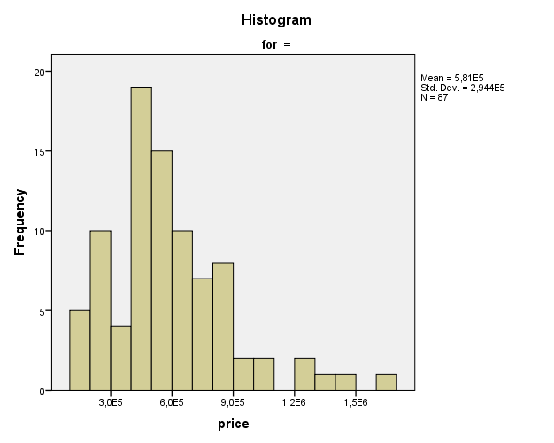

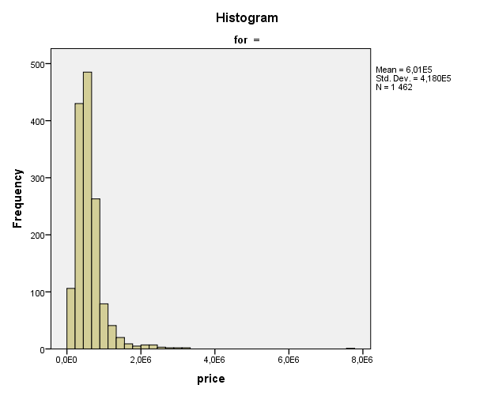

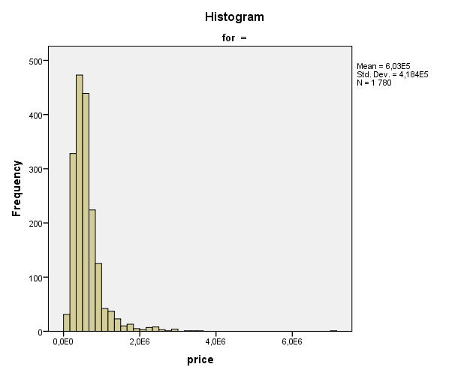

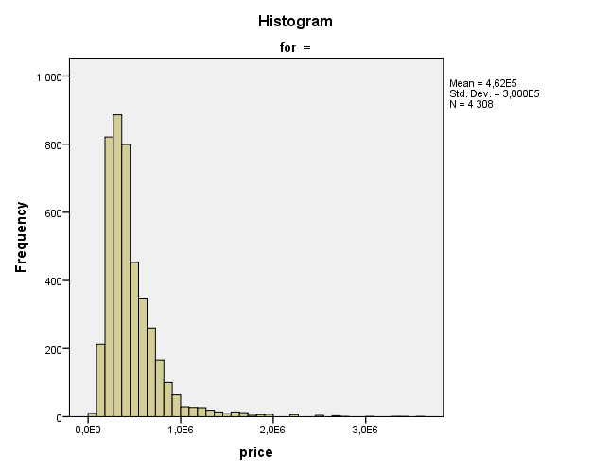

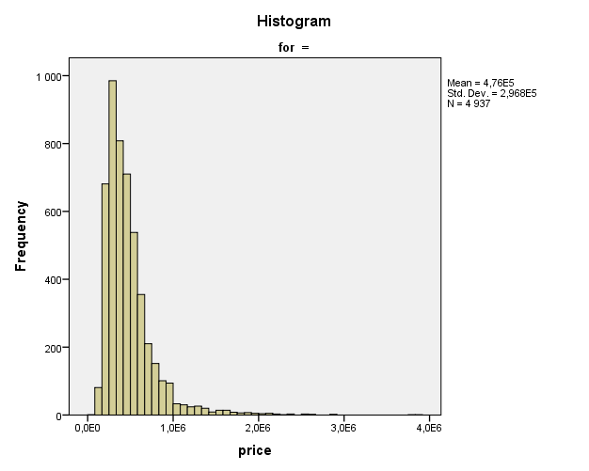

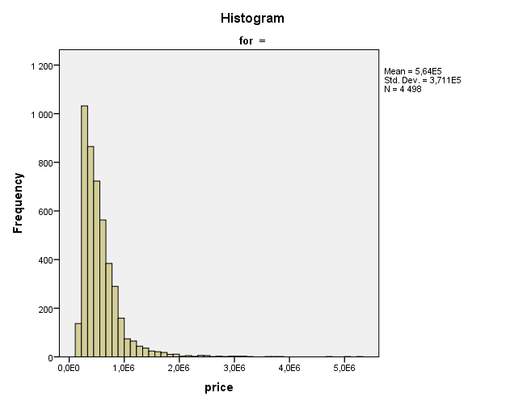

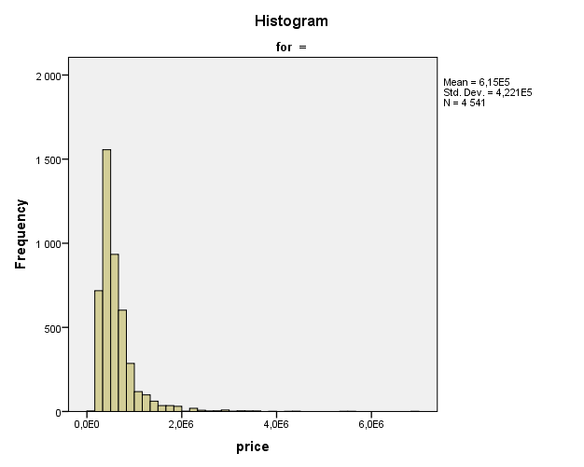

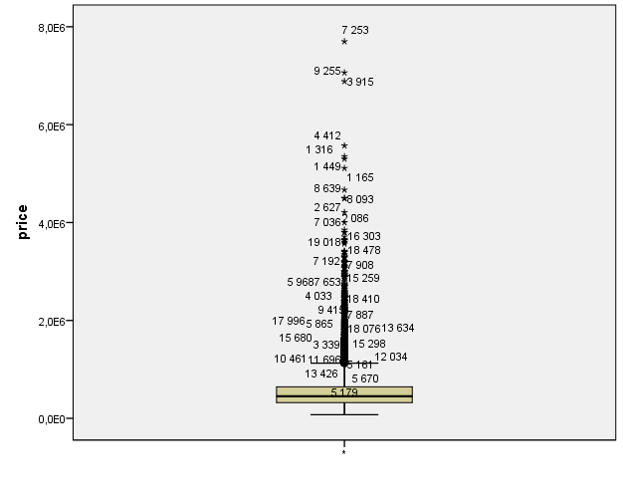

FREQUENCIES VARIABLES=yr_built_int
/STATISTICS=RANGE MINIMUM MAXIMUM MEDIAN MEAN MODE
/ORDER=ANALYSIS.

Frequencies

Notes
Output Created |  | 17-OCT-2017 16:14:12
Comments
Input | Data | C:\Users\Mathurin\Documents\Cours Winter 20172018\Data Mining\Project\House Sales in King County, USA\data.sav
Input | Active Dataset | DataSet1
Input | Filter | <none>
Input | Weight | <none>
Input | Split File | <none>
Input | N of Rows in Working Data File | 21613
Missing Value Handling | Definition of Missing | User-defined missing values are treated as missing.
Missing Value Handling | Cases Used | Statistics are based on all cases with valid data.
Syntax |  | FREQUENCIES VARIABLES=yr_built_int  /STATISTICS=RANGE MINIMUM MAXIMUM MEDIAN MEAN MODE  /ORDER=ANALYSIS.
Resources | Processor Time | 00:00:00,02
Resources | Elapsed Time | 00:00:00,02

Statistics
yr_built (Binned)
N | Valid | 21613
N | Missing | 0
Mean |  | 5,05
Median |  | 5,00
Mode |  | 5
Range |  | 6
Minimum |  | 1
Maximum |  | 7

yr_built (Binned)
 |  | Frequency | Percent | Valid Percent | Cumulative Percent
Valid | 1 | 87 | ,4 | ,4 | ,4
Valid | 2 | 1462 | 6,8 | 6,8 | 7,2
Valid | 3 | 1780 | 8,2 | 8,2 | 15,4
Valid | 4 | 4308 | 19,9 | 19,9 | 35,3
Valid | 5 | 4937 | 22,8 | 22,8 | 58,2
Valid | 6 | 4498 | 20,8 | 20,8 | 79,0
Valid | 7 | 4541 | 21,0 | 21,0 | 100,0
Valid | Total | 21613 | 100,0 | 100,0

FREQUENCIES VARIABLES=yr_built_int
/STATISTICS=RANGE MINIMUM MAXIMUM MEDIAN MEAN MODE
/ORDER=ANALYSIS.

Frequencies

Notes
Output Created |  | 17-OCT-2017 16:14:51
Comments
Input | Data | C:\Users\Mathurin\Documents\Cours Winter 20172018\Data Mining\Project\House Sales in King County, USA\data.sav
Input | Active Dataset | DataSet1
Input | Filter | <none>
Input | Weight | <none>
Input | Split File | <none>
Input | N of Rows in Working Data File | 21613
Missing Value Handling | Definition of Missing | User-defined missing values are treated as missing.
Missing Value Handling | Cases Used | Statistics are based on all cases with valid data.
Syntax |  | FREQUENCIES VARIABLES=yr_built_int  /STATISTICS=RANGE MINIMUM MAXIMUM MEDIAN MEAN MODE  /ORDER=ANALYSIS.
Resources | Processor Time | 00:00:00,02
Resources | Elapsed Time | 00:00:00,02

Statistics
yr_built (Binned)
N | Valid | 21613
N | Missing | 0
Mean |  | 5,05
Median |  | 5,00
Mode |  | 5
Range |  | 6
Minimum |  | 1
Maximum |  | 7

yr_built (Binned)
 |  | Frequency | Percent | Valid Percent | Cumulative Percent
Valid | 1 | 87 | ,4 | ,4 | ,4
Valid | 2 | 1462 | 6,8 | 6,8 | 7,2
Valid | 3 | 1780 | 8,2 | 8,2 | 15,4
Valid | 4 | 4308 | 19,9 | 19,9 | 35,3
Valid | 5 | 4937 | 22,8 | 22,8 | 58,2
Valid | 6 | 4498 | 20,8 | 20,8 | 79,0
Valid | 7 | 4541 | 21,0 | 21,0 | 100,0
Valid | Total | 21613 | 100,0 | 100,0

* Visual Binning.
*yr_built.
RECODE yr_built (MISSING=COPY) (LO THRU 1900=1) (LO THRU 1920=2) (LO THRU 1940=3) (LO THRU 1960=4)
(LO THRU 1980=5) (LO THRU 2000=6) (LO THRU HI=7) (ELSE=SYSMIS) INTO yr_built_int.
VARIABLE LABELS yr_built_int 'yr_built (Binned)'.
FORMATS yr_built_int (F5.0).
VALUE LABELS yr_built_int 1 '<= 1900' 2 '1901 - 1920' 3 '1921 - 1940' 4 '1941 - 1960' 5 '1961 - '+
'1980' 6 '1981 - 2000' 7 '2001+'.
VARIABLE LEVEL yr_built_int (ORDINAL).
EXECUTE.
FREQUENCIES VARIABLES=yr_built_int
/STATISTICS=RANGE MINIMUM MAXIMUM MEDIAN MEAN MODE
/ORDER=ANALYSIS.

Frequencies

Notes
Output Created |  | 17-OCT-2017 16:16:33
Comments
Input | Data | C:\Users\Mathurin\Documents\Cours Winter 20172018\Data Mining\Project\House Sales in King County, USA\data.sav
Input | Active Dataset | DataSet1
Input | Filter | <none>
Input | Weight | <none>
Input | Split File | <none>
Input | N of Rows in Working Data File | 21613
Missing Value Handling | Definition of Missing | User-defined missing values are treated as missing.
Missing Value Handling | Cases Used | Statistics are based on all cases with valid data.
Syntax |  | FREQUENCIES VARIABLES=yr_built_int  /STATISTICS=RANGE MINIMUM MAXIMUM MEDIAN MEAN MODE  /ORDER=ANALYSIS.
Resources | Processor Time | 00:00:00,03
Resources | Elapsed Time | 00:00:00,03

Statistics
yr_built (Binned)
N | Valid | 21613
N | Missing | 0
Mean |  | 5,05
Median |  | 5,00
Mode |  | 5
Range |  | 6
Minimum |  | 1
Maximum |  | 7

yr_built (Binned)
 |  | Frequency | Percent | Valid Percent | Cumulative Percent
Valid | <= 1900 | 87 | ,4 | ,4 | ,4
Valid | 1901 - 1920 | 1462 | 6,8 | 6,8 | 7,2
Valid | 1921 - 1940 | 1780 | 8,2 | 8,2 | 15,4
Valid | 1941 - 1960 | 4308 | 19,9 | 19,9 | 35,3
Valid | 1961 - 1980 | 4937 | 22,8 | 22,8 | 58,2
Valid | 1981 - 2000 | 4498 | 20,8 | 20,8 | 79,0
Valid | 2001+ | 4541 | 21,0 | 21,0 | 100,0
Valid | Total | 21613 | 100,0 | 100,0

EXAMINE VARIABLES=price BY yr_built_int
/PLOT BOXPLOT HISTOGRAM
/COMPARE GROUPS
/STATISTICS DESCRIPTIVES EXTREME
/CINTERVAL 95
/MISSING LISTWISE
/NOTOTAL.

Explore

Notes
Output Created |  | 17-OCT-2017 16:16:50
Comments
Input | Data | C:\Users\Mathurin\Documents\Cours Winter 20172018\Data Mining\Project\House Sales in King County, USA\data.sav
Input | Active Dataset | DataSet1
Input | Filter | <none>
Input | Weight | <none>
Input | Split File | <none>
Input | N of Rows in Working Data File | 21613
Missing Value Handling | Definition of Missing | User-defined missing values for dependent variables are treated as missing.
Missing Value Handling | Cases Used | Statistics are based on cases with no missing values for any dependent variable or factor used.
Syntax |  | EXAMINE VARIABLES=price BY yr_built_int  /PLOT BOXPLOT HISTOGRAM  /COMPARE GROUPS  /STATISTICS DESCRIPTIVES EXTREME  /CINTERVAL 95  /MISSING LISTWISE  /NOTOTAL.
Resources | Processor Time | 00:00:01,70
Resources | Elapsed Time | 00:00:01,70

yr_built (Binned)

Case Processing Summary
 | yr_built (Binned) | Cases
 | yr_built (Binned) | Valid |  | Missing |  | Total
 | yr_built (Binned) | N | Percent | N | Percent | N | Percent
price | <= 1900 | 87 | 100,0% | 0 | 0,0% | 87 | 100,0%
price | 1901 - 1920 | 1462 | 100,0% | 0 | 0,0% | 1462 | 100,0%
price | 1921 - 1940 | 1780 | 100,0% | 0 | 0,0% | 1780 | 100,0%
price | 1941 - 1960 | 4308 | 100,0% | 0 | 0,0% | 4308 | 100,0%
price | 1961 - 1980 | 4937 | 100,0% | 0 | 0,0% | 4937 | 100,0%
price | 1981 - 2000 | 4498 | 100,0% | 0 | 0,0% | 4498 | 100,0%
price | 2001+ | 4541 | 100,0% | 0 | 0,0% | 4541 | 100,0%

Descriptives
 | yr_built (Binned) |  |  | Statistic | Std. Error
price | <= 1900 | Mean |  | 5,81387206897E+005 | 3,155925261762E+004
price | <= 1900 | 95% Confidence Interval for Mean | Lower Bound | 5,18649489095E+005
price | <= 1900 | 95% Confidence Interval for Mean | Upper Bound | 6,44124924698E+005
price | <= 1900 | 5% Trimmed Mean |  | 5,57806990421E+005
price | <= 1900 | Median |  | 5,49000000000E+005
price | <= 1900 | Variance |  | 86650819043,096
price | <= 1900 | Std. Deviation |  | 2,943651117967E+005
price | <= 1900 | Minimum |  | 1,300000000E+005
price | <= 1900 | Maximum |  | 1,695000000E+006
price | <= 1900 | Range |  | 1,565000000E+006
price | <= 1900 | Interquartile Range |  | 3,035000000E+005
price | <= 1900 | Skewness |  | 1,222 | ,258
price | <= 1900 | Kurtosis |  | 2,254 | ,511
price | 1901 - 1920 | Mean |  | 6,00575231190E+005 | 1,093315108403E+004
price | 1901 - 1920 | 95% Confidence Interval for Mean | Lower Bound | 5,79128881864E+005
price | 1901 - 1920 | 95% Confidence Interval for Mean | Upper Bound | 6,22021580516E+005
price | 1901 - 1920 | 5% Trimmed Mean |  | 5,53413509652E+005
price | 1901 - 1920 | Median |  | 5,25500000000E+005
price | 1901 - 1920 | Variance |  | 174758404819,511
price | 1901 - 1920 | Std. Deviation |  | 4,180411520646E+005
price | 1901 - 1920 | Minimum |  | 8,000000000E+004
price | 1901 - 1920 | Maximum |  | 7,700000000E+006
price | 1901 - 1920 | Range |  | 7,620000000E+006
price | 1901 - 1920 | Interquartile Range |  | 3,363750000E+005
price | 1901 - 1920 | Skewness |  | 5,285 | ,064
price | 1901 - 1920 | Kurtosis |  | 63,495 | ,128
price | 1921 - 1940 | Mean |  | 6,02723170225E+005 | 9,917267947748E+003
price | 1921 - 1940 | 95% Confidence Interval for Mean | Lower Bound | 5,83272448837E+005
price | 1921 - 1940 | 95% Confidence Interval for Mean | Upper Bound | 6,22173891612E+005
price | 1921 - 1940 | 5% Trimmed Mean |  | 5,53042918851E+005
price | 1921 - 1940 | Median |  | 5,25000000000E+005
price | 1921 - 1940 | Variance |  | 175066922314,416
price | 1921 - 1940 | Std. Deviation |  | 4,184099930862E+005
price | 1921 - 1940 | Minimum |  | 8,500000000E+004
price | 1921 - 1940 | Maximum |  | 7,062500000E+006
price | 1921 - 1940 | Range |  | 6,977500000E+006
price | 1921 - 1940 | Interquartile Range |  | 3,250000000E+005
price | 1921 - 1940 | Skewness |  | 4,309 | ,058
price | 1921 - 1940 | Kurtosis |  | 40,214 | ,116
price | 1941 - 1960 | Mean |  | 4,61646746286E+005 | 4,571110564093E+003
price | 1941 - 1960 | 95% Confidence Interval for Mean | Lower Bound | 4,52685015774E+005
price | 1941 - 1960 | 95% Confidence Interval for Mean | Upper Bound | 4,70608476798E+005
price | 1941 - 1960 | 5% Trimmed Mean |  | 4,26768537089E+005
price | 1941 - 1960 | Median |  | 3,90500000000E+005
price | 1941 - 1960 | Variance |  | 90015883107,729
price | 1941 - 1960 | Std. Deviation |  | 3,000264706784E+005
price | 1941 - 1960 | Minimum |  | 7,800000000E+004
price | 1941 - 1960 | Maximum |  | 3,600000000E+006
price | 1941 - 1960 | Range |  | 3,522000000E+006
price | 1941 - 1960 | Interquartile Range |  | 2,775000000E+005
price | 1941 - 1960 | Skewness |  | 3,125 | ,037
price | 1941 - 1960 | Kurtosis |  | 17,029 | ,075
price | 1961 - 1980 | Mean |  | 4,75887376544E+005 | 4,224253938492E+003
price | 1961 - 1980 | 95% Confidence Interval for Mean | Lower Bound | 4,67605960272E+005
price | 1961 - 1980 | 95% Confidence Interval for Mean | Upper Bound | 4,84168792817E+005
price | 1961 - 1980 | 5% Trimmed Mean |  | 4,40642580740E+005
price | 1961 - 1980 | Median |  | 4,06500000000E+005
price | 1961 - 1980 | Variance |  | 88097414440,096
price | 1961 - 1980 | Std. Deviation |  | 2,968120860748E+005
price | 1961 - 1980 | Minimum |  | 7,500000000E+004
price | 1961 - 1980 | Maximum |  | 3,850000000E+006
price | 1961 - 1980 | Range |  | 3,775000000E+006
price | 1961 - 1980 | Interquartile Range |  | 2,768750000E+005
price | 1961 - 1980 | Skewness |  | 3,048 | ,035
price | 1961 - 1980 | Kurtosis |  | 16,437 | ,070
price | 1981 - 2000 | Mean |  | 5,64491082259E+005 | 5,533817510747E+003
price | 1981 - 2000 | 95% Confidence Interval for Mean | Lower Bound | 5,53642079252E+005
price | 1981 - 2000 | 95% Confidence Interval for Mean | Upper Bound | 5,75340085266E+005
price | 1981 - 2000 | 5% Trimmed Mean |  | 5,19985921150E+005
price | 1981 - 2000 | Median |  | 4,75100000000E+005
price | 1981 - 2000 | Variance |  | 137742866817,652
price | 1981 - 2000 | Std. Deviation |  | 3,711372614245E+005
price | 1981 - 2000 | Minimum |  | 1,150000000E+005
price | 1981 - 2000 | Maximum |  | 5,300000000E+006
price | 1981 - 2000 | Range |  | 5,185000000E+006
price | 1981 - 2000 | Interquartile Range |  | 3,550625000E+005
price | 1981 - 2000 | Skewness |  | 3,657 | ,037
price | 1981 - 2000 | Kurtosis |  | 25,348 | ,073
price | 2001+ | Mean |  | 6,15314917639E+005 | 6,264304275079E+003
price | 2001+ | 95% Confidence Interval for Mean | Lower Bound | 6,03033832748E+005
price | 2001+ | 95% Confidence Interval for Mean | Upper Bound | 6,27596002531E+005
price | 2001+ | 5% Trimmed Mean |  | 5,59940795224E+005
price | 2001+ | Median |  | 5,00000000000E+005
price | 2001+ | Variance |  | 178195688058,543
price | 2001+ | Std. Deviation |  | 4,221323110809E+005
price | 2001+ | Minimum |  | 1,550000000E+005
price | 2001+ | Maximum |  | 6,885000000E+006
price | 2001+ | Range |  | 6,730000000E+006
price | 2001+ | Interquartile Range |  | 3,400500000E+005
price | 2001+ | Skewness |  | 4,163 | ,036
price | 2001+ | Kurtosis |  | 31,366 | ,073

Extreme Values
 | yr_built (Binned) |  |  | Case Number | Value
price | <= 1900 | Highest | 1 | 18076 | 1,695000000E+006
price | <= 1900 | Highest | 2 | 11696 | 1,400000000E+006
price | <= 1900 | Highest | 3 | 15298 | 1,330000000E+006
price | <= 1900 | Highest | 4 | 5161 | 1,297000000E+006
price | <= 1900 | Highest | 5 | 12034 | 1,260000000E+006
price | <= 1900 | Lowest | 1 | 14002 | 1,300000000E+005
price | <= 1900 | Lowest | 2 | 7850 | 1,699000000E+005
price | <= 1900 | Lowest | 3 | 19138 | 1,790000000E+005
price | <= 1900 | Lowest | 4 | 11535 | 1,925000000E+005
price | <= 1900 | Lowest | 5 | 5237 | 1,999990000E+005
price | 1901 - 1920 | Highest | 1 | 7253 | 7,700000000E+006
price | 1901 - 1920 | Highest | 2 | 18478 | 3,300000000E+006
price | 1901 - 1920 | Highest | 3 | 7192 | 3,200000000E+006
price | 1901 - 1920 | Highest | 4 | 15259 | 3,065000000E+006
price | 1901 - 1920 | Highest | 5 | 2900 | 3,000000000E+006
price | 1901 - 1920 | Lowest | 1 | 466 | 8,000000000E+004
price | 1901 - 1920 | Lowest | 2 | 18469 | 8,300000000E+004
price | 1901 - 1920 | Lowest | 3 | 7993 | 9,000000000E+004
price | 1901 - 1920 | Lowest | 4 | 14582 | 9,500000000E+004
price | 1901 - 1920 | Lowest | 5 | 3806 | 9,500000000E+004
price | 1921 - 1940 | Highest | 1 | 3915 | 7,062500000E+006
price | 1921 - 1940 | Highest | 2 | 6509 | 3,650000000E+006
price | 1921 - 1940 | Highest | 3 | 10447 | 3,400000000E+006
price | 1921 - 1940 | Highest | 4 | 7908 | 3,200000000E+006
price | 1921 - 1940 | Highest | 5 | 11976 | 3,000000000E+006
price | 1921 - 1940 | Lowest | 1 | 10254 | 8,500000000E+004
price | 1921 - 1940 | Lowest | 2 | 5640 | 1,000000000E+005
price | 1921 - 1940 | Lowest | 3 | 13762 | 1,025000000E+005
price | 1921 - 1940 | Lowest | 4 | 13629 | 1,055000000E+005
price | 1921 - 1940 | Lowest | 5 | 14738 | 1,100000000E+005ª
price | 1941 - 1960 | Highest | 1 | 2865 | 3,600000000E+006
price | 1941 - 1960 | Highest | 2 | 13968 | 3,395000000E+006
price | 1941 - 1960 | Highest | 3 | 18200 | 3,300000000E+006
price | 1941 - 1960 | Highest | 4 | 657 | 3,070000000E+006
price | 1941 - 1960 | Highest | 5 | 14053 | 2,750000000E+006
price | 1941 - 1960 | Lowest | 1 | 15294 | 7,800000000E+004
price | 1941 - 1960 | Lowest | 2 | 16199 | 8,100000000E+004
price | 1941 - 1960 | Lowest | 3 | 8275 | 8,200000000E+004
price | 1941 - 1960 | Lowest | 4 | 2142 | 8,250000000E+004
price | 1941 - 1960 | Lowest | 5 | 3768 | 8,400000000E+004
price | 1961 - 1980 | Highest | 1 | 2086 | 3,850000000E+006
price | 1961 - 1980 | Highest | 2 | 7036 | 3,800000000E+006
price | 1961 - 1980 | Highest | 3 | 14557 | 2,888000000E+006
price | 1961 - 1980 | Highest | 4 | 5450 | 2,850000000E+006
price | 1961 - 1980 | Highest | 5 | 13711 | 2,600000000E+006^{b}
price | 1961 - 1980 | Lowest | 1 | 1150 | 7,500000000E+004
price | 1961 - 1980 | Lowest | 2 | 5867 | 8,900000000E+004
price | 1961 - 1980 | Lowest | 3 | 18940 | 9,000000000E+004
price | 1961 - 1980 | Lowest | 4 | 12552 | 9,000000000E+004
price | 1961 - 1980 | Lowest | 5 | 1219 | 1,000000000E+005
price | 1981 - 2000 | Highest | 1 | 1316 | 5,300000000E+006
price | 1981 - 2000 | Highest | 2 | 1165 | 5,110800000E+006
price | 1981 - 2000 | Highest | 3 | 8093 | 4,668000000E+006
price | 1981 - 2000 | Highest | 4 | 19018 | 3,800000000E+006
price | 1981 - 2000 | Highest | 5 | 16303 | 3,710000000E+006
price | 1981 - 2000 | Lowest | 1 | 14422 | 1,150000000E+005
price | 1981 - 2000 | Lowest | 2 | 10106 | 1,395000000E+005
price | 1981 - 2000 | Lowest | 3 | 15611 | 1,400000000E+005
price | 1981 - 2000 | Lowest | 4 | 2882 | 1,499000000E+005
price | 1981 - 2000 | Lowest | 5 | 3494 | 1,500000000E+005
price | 2001+ | Highest | 1 | 9255 | 6,885000000E+006
price | 2001+ | Highest | 2 | 4412 | 5,570000000E+006
price | 2001+ | Highest | 3 | 1449 | 5,350000000E+006
price | 2001+ | Highest | 4 | 2627 | 4,500000000E+006
price | 2001+ | Highest | 5 | 8639 | 4,489000000E+006
price | 2001+ | Lowest | 1 | 19651 | 1,550000000E+005
price | 2001+ | Lowest | 2 | 20404 | 1,607970000E+005
price | 2001+ | Lowest | 3 | 20613 | 1,638000000E+005
price | 2001+ | Lowest | 4 | 19976 | 1,750030000E+005
price | 2001+ | Lowest | 5 | 20808 | 1,825680000E+005

a. Only a partial list of cases with the value 1,100000000E+005 are shown in the table of lower extremes.
b. Only a partial list of cases with the value 2,600000000E+006 are shown in the table of upper extremes.

price

Histograms

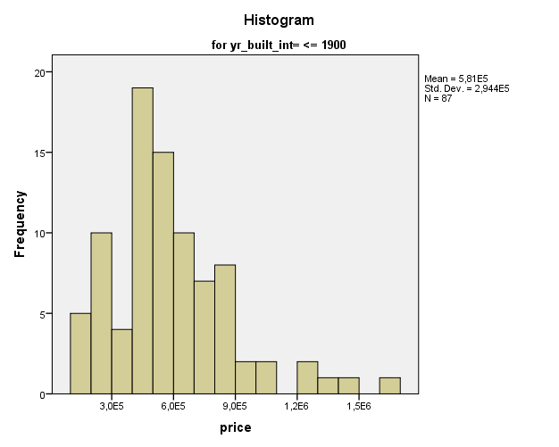

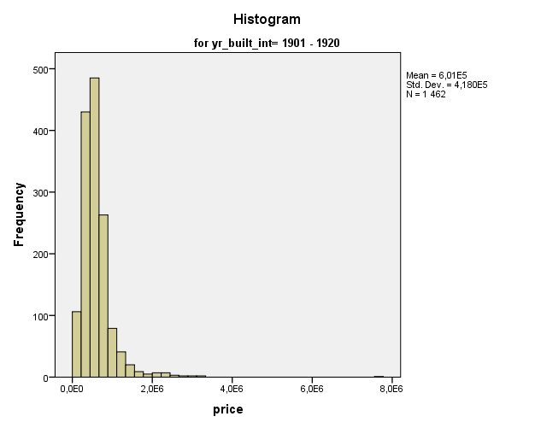

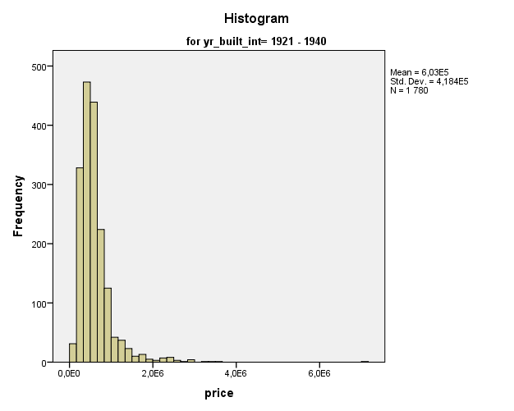

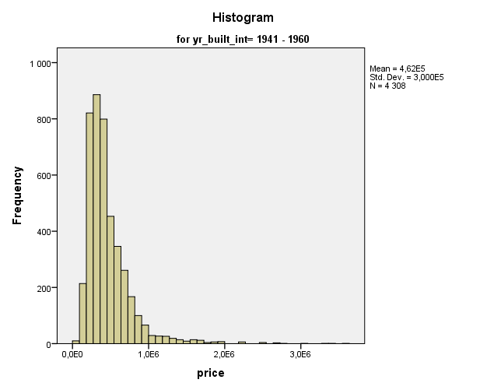

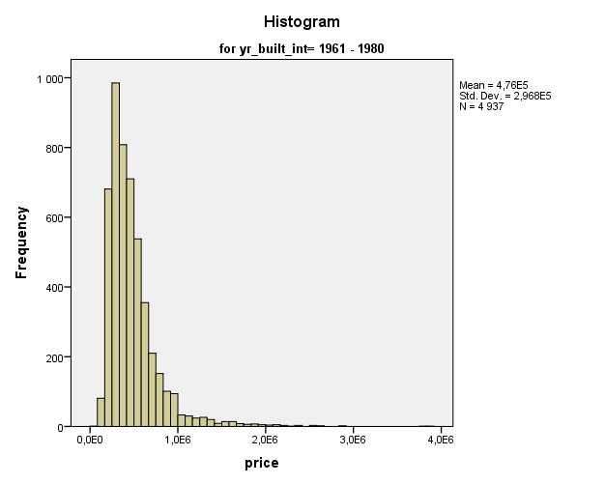

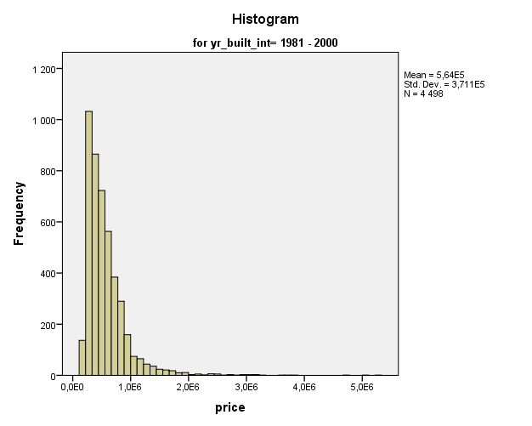

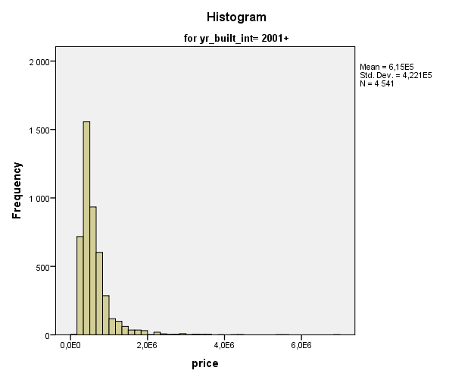

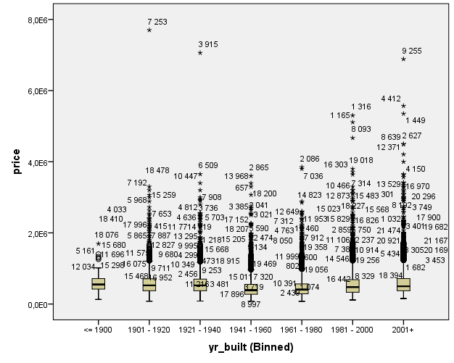

* Visual Binning.
*sqft_living.
RECODE sqft_living (MISSING=COPY) (LO THRU 200=1) (LO THRU 466.8=2) (LO THRU 733.6=3) (LO THRU
1000.4=4) (LO THRU 1267.2=5) (LO THRU 1534=6) (LO THRU 1800.8=7) (LO THRU 2067.6=8) (LO THRU
2334.4=9) (LO THRU 2601.2=10) (LO THRU 2868=11) (LO THRU 3134.8=12) (LO THRU 3401.6=13) (LO THRU
3668.4=14) (LO THRU 3935.2=15) (LO THRU 4202=16) (LO THRU 4468.8=17) (LO THRU 4735.6=18) (LO THRU
5002.40000000000=19) (LO THRU 5269.2=20) (LO THRU 5536=21) (LO THRU 5802.8=22) (LO THRU 6069.6=23)
(LO THRU 6336.40000000000=24) (LO THRU 6603.20000000000=25) (LO THRU 6870=26) (LO THRU 7136.8=27)
(LO THRU 7403.6=28) (LO THRU 7670.40000000000=29) (LO THRU 7937.20000000000=30) (LO THRU 8204=31)
(LO THRU 8470.80000000000=32) (LO THRU 8737.6=33) (LO THRU 9004.4=34) (LO THRU 9271.2=35) (LO THRU
9538=36) (LO THRU 9804.80000000000=37) (LO THRU 10071.6=38) (LO THRU 10338.4=39) (LO THRU
10605.2=40) (LO THRU 10872=41) (LO THRU 11138.8000000000=42) (LO THRU 11405.6=43) (LO THRU
11672.4=44) (LO THRU 11939.2=45) (LO THRU 12206=46) (LO THRU 12472.8000000000=47) (LO THRU
12739.6=48) (LO THRU 13006.4000000000=49) (LO THRU 13273.2=50) (LO THRU HI=51) (ELSE=SYSMIS) INTO
sqfl_living_intv.
VARIABLE LABELS sqfl_living_intv 'sqft_living (Binned)'.
FORMATS sqfl_living_intv (F5.0).
VALUE LABELS sqfl_living_intv 1 '<= 200' 2 '201 - 467' 3 '468 - 734' 4 '735 - 1000' 5 '1001 - '+
'1267' 6 '1268 - 1534' 7 '1535 - 1801' 8 '1802 - 2068' 9 '2069 - 2334' 10 '2335 - 2601' 11
'2602 - 2868' 12 '2869 - 3135' 13 '3136 - 3402' 14 '3403 - 3668' 15 '3669 - 3935' 16 '3936 - 4202'
17 '4203 - 4469' 18 '4470 - 4736' 19 '4737 - 5002' 20 '5003 - 5269' 21 '5270 - 5536' 22 '5537 - '+
'5803' 23 '5804 - 6070' 24 '6071 - 6336' 25 '6337 - 6603' 26 '6604 - 6870' 27 '6871 - 7137' 28
'7138 - 7404' 29 '7405 - 7670' 30 '7671 - 7937' 31 '7938 - 8204' 32 '8205 - 8471' 33 '8472 - 8738'
34 '8739 - 9004' 35 '9005 - 9271' 36 '9272 - 9538' 37 '9539 - 9805' 38 '9806 - 10072' 39 '10073 '+
'- 10338' 40 '10339 - 10605' 41 '10606 - 10872' 42 '10873 - 11139' 43 '11140 - 11406' 44
'11407 - 11672' 45 '11673 - 11939' 46 '11940 - 12206' 47 '12207 - 12473' 48 '12474 - 12740' 49
'12741 - 13006' 50 '13007 - 13273' 51 '13274+'.
VARIABLE LEVEL sqfl_living_intv (ORDINAL).
EXECUTE.
EXAMINE VARIABLES=price BY sqfl_living_intv
/PLOT BOXPLOT HISTOGRAM
/COMPARE GROUPS
/STATISTICS DESCRIPTIVES EXTREME
/CINTERVAL 95
/MISSING LISTWISE
/NOTOTAL.

Explore

Notes
Output Created |  | 17-OCT-2017 16:21:16
Comments
Input | Data | C:\Users\Mathurin\Documents\Cours Winter 20172018\Data Mining\Project\House Sales in King County, USA\data.sav
Input | Active Dataset | DataSet1
Input | Filter | <none>
Input | Weight | <none>
Input | Split File | <none>
Input | N of Rows in Working Data File | 21613
Missing Value Handling | Definition of Missing | User-defined missing values for dependent variables are treated as missing.
Missing Value Handling | Cases Used | Statistics are based on cases with no missing values for any dependent variable or factor used.
Syntax |  | EXAMINE VARIABLES=price BY sqfl_living_intv  /PLOT BOXPLOT HISTOGRAM  /COMPARE GROUPS  /STATISTICS DESCRIPTIVES EXTREME  /CINTERVAL 95  /MISSING LISTWISE  /NOTOTAL.
Resources | Processor Time | 00:00:03,95
Resources | Elapsed Time | 00:00:03,95

Warnings
price is constant when sqft_living (Binned) = 8472 - 8738. It will be included in any boxplots produced but other output will be omitted.
price is constant when sqft_living (Binned) = 9005 - 9271. It will be included in any boxplots produced but other output will be omitted.
price is constant when sqft_living (Binned) = 9539 - 9805. It will be included in any boxplots produced but other output will be omitted.
price is constant when sqft_living (Binned) = 11940 - 12206. It will be included in any boxplots produced but other output will be omitted.
price is constant when sqft_living (Binned) = 13274+. It will be included in any boxplots produced but other output will be omitted.

sqft_living (Binned)

Case Processing Summary
 | sqft_living (Binned) | Cases
 | sqft_living (Binned) | Valid |  | Missing |  | Total
 | sqft_living (Binned) | N | Percent | N | Percent | N | Percent
price | 201 - 467 | 12 | 100,0% | 0 | 0,0% | 12 | 100,0%
price | 468 - 734 | 252 | 100,0% | 0 | 0,0% | 252 | 100,0%
price | 735 - 1000 | 1230 | 100,0% | 0 | 0,0% | 1230 | 100,0%
price | 1001 - 1267 | 2242 | 100,0% | 0 | 0,0% | 2242 | 100,0%
price | 1268 - 1534 | 2926 | 100,0% | 0 | 0,0% | 2926 | 100,0%
price | 1535 - 1801 | 3021 | 100,0% | 0 | 0,0% | 3021 | 100,0%
price | 1802 - 2068 | 2594 | 100,0% | 0 | 0,0% | 2594 | 100,0%
price | 2069 - 2334 | 2379 | 100,0% | 0 | 0,0% | 2379 | 100,0%
price | 2335 - 2601 | 1904 | 100,0% | 0 | 0,0% | 1904 | 100,0%
price | 2602 - 2868 | 1392 | 100,0% | 0 | 0,0% | 1392 | 100,0%
price | 2869 - 3135 | 1069 | 100,0% | 0 | 0,0% | 1069 | 100,0%
price | 3136 - 3402 | 817 | 100,0% | 0 | 0,0% | 817 | 100,0%
price | 3403 - 3668 | 529 | 100,0% | 0 | 0,0% | 529 | 100,0%
price | 3669 - 3935 | 394 | 100,0% | 0 | 0,0% | 394 | 100,0%
price | 3936 - 4202 | 253 | 100,0% | 0 | 0,0% | 253 | 100,0%
price | 4203 - 4469 | 202 | 100,0% | 0 | 0,0% | 202 | 100,0%
price | 4470 - 4736 | 122 | 100,0% | 0 | 0,0% | 122 | 100,0%
price | 4737 - 5002 | 64 | 100,0% | 0 | 0,0% | 64 | 100,0%
price | 5003 - 5269 | 47 | 100,0% | 0 | 0,0% | 47 | 100,0%
price | 5270 - 5536 | 47 | 100,0% | 0 | 0,0% | 47 | 100,0%
price | 5537 - 5803 | 32 | 100,0% | 0 | 0,0% | 32 | 100,0%
price | 5804 - 6070 | 22 | 100,0% | 0 | 0,0% | 22 | 100,0%
price | 6071 - 6336 | 12 | 100,0% | 0 | 0,0% | 12 | 100,0%
price | 6337 - 6603 | 12 | 100,0% | 0 | 0,0% | 12 | 100,0%
price | 6604 - 6870 | 6 | 100,0% | 0 | 0,0% | 6 | 100,0%
price | 6871 - 7137 | 9 | 100,0% | 0 | 0,0% | 9 | 100,0%
price | 7138 - 7404 | 6 | 100,0% | 0 | 0,0% | 6 | 100,0%
price | 7405 - 7670 | 4 | 100,0% | 0 | 0,0% | 4 | 100,0%
price | 7671 - 7937 | 4 | 100,0% | 0 | 0,0% | 4 | 100,0%
price | 7938 - 8204 | 3 | 100,0% | 0 | 0,0% | 3 | 100,0%
price | 8472 - 8738 | 1 | 100,0% | 0 | 0,0% | 1 | 100,0%
price | 9005 - 9271 | 1 | 100,0% | 0 | 0,0% | 1 | 100,0%
price | 9539 - 9805 | 1 | 100,0% | 0 | 0,0% | 1 | 100,0%
price | 9806 - 10072 | 2 | 100,0% | 0 | 0,0% | 2 | 100,0%
price | 11940 - 12206 | 1 | 100,0% | 0 | 0,0% | 1 | 100,0%
price | 13274+ | 1 | 100,0% | 0 | 0,0% | 1 | 100,0%

Descriptives^{a,b,c,d,e}
 | sqft_living (Binned) |  |  | Statistic | Std. Error
price | 201 - 467 | Mean |  | 2,37670833333E+005 | 1,921721968737E+004
price | 201 - 467 | 95% Confidence Interval for Mean | Lower Bound | 1,95374017983E+005
price | 201 - 467 | 95% Confidence Interval for Mean | Upper Bound | 2,79967648683E+005
price | 201 - 467 | 5% Trimmed Mean |  | 2,41578703704E+005
price | 201 - 467 | Median |  | 2,46000000000E+005
price | 201 - 467 | Variance |  | 4431618390,152
price | 201 - 467 | Std. Deviation |  | 6,657040175747E+004
price | 201 - 467 | Minimum |  | 8,000000000E+004
price | 201 - 467 | Maximum |  | 3,250000000E+005
price | 201 - 467 | Range |  | 2,450000000E+005
price | 201 - 467 | Interquartile Range |  | 5,073750000E+004
price | 201 - 467 | Skewness |  | -1,418 | ,637
price | 201 - 467 | Kurtosis |  | 2,172 | 1,232
price | 468 - 734 | Mean |  | 2,65585706349E+005 | 6,316131727514E+003
price | 468 - 734 | 95% Confidence Interval for Mean | Lower Bound | 2,53146336122E+005
price | 468 - 734 | 95% Confidence Interval for Mean | Upper Bound | 2,78025076576E+005
price | 468 - 734 | 5% Trimmed Mean |  | 2,63759029982E+005
price | 468 - 734 | Median |  | 2,58750000000E+005
price | 468 - 734 | Variance |  | 10053167039,826
price | 468 - 734 | Std. Deviation |  | 1,002654827936E+005
price | 468 - 734 | Minimum |  | 7,500000000E+004
price | 468 - 734 | Maximum |  | 5,700000000E+005
price | 468 - 734 | Range |  | 4,950000000E+005
price | 468 - 734 | Interquartile Range |  | 1,472500000E+005
price | 468 - 734 | Skewness |  | ,263 | ,153
price | 468 - 734 | Kurtosis |  | -,555 | ,306
price | 735 - 1000 | Mean |  | 3,05595169106E+005 | 3,418236538950E+003
price | 735 - 1000 | 95% Confidence Interval for Mean | Lower Bound | 2,98888944172E+005
price | 735 - 1000 | 95% Confidence Interval for Mean | Upper Bound | 3,12301394039E+005
price | 735 - 1000 | 5% Trimmed Mean |  | 3,00598855465E+005
price | 735 - 1000 | Median |  | 2,90150000000E+005
price | 735 - 1000 | Variance |  | 14371739474,538
price | 735 - 1000 | Std. Deviation |  | 1,198821899806E+005
price | 735 - 1000 | Minimum |  | 7,800000000E+004
price | 735 - 1000 | Maximum |  | 7,470000000E+005
price | 735 - 1000 | Range |  | 6,690000000E+005
price | 735 - 1000 | Interquartile Range |  | 1,700025000E+005
price | 735 - 1000 | Skewness |  | ,629 | ,070
price | 735 - 1000 | Kurtosis |  | ,171 | ,139
price | 1001 - 1267 | Mean |  | 3,42275008029E+005 | 2,829805882104E+003
price | 1001 - 1267 | 95% Confidence Interval for Mean | Lower Bound | 3,36725693258E+005
price | 1001 - 1267 | 95% Confidence Interval for Mean | Upper Bound | 3,47824322799E+005
price | 1001 - 1267 | 5% Trimmed Mean |  | 3,33564608980E+005
price | 1001 - 1267 | Median |  | 3,25000000000E+005
price | 1001 - 1267 | Variance |  | 17953490582,742
price | 1001 - 1267 | Std. Deviation |  | 1,339906361756E+005
price | 1001 - 1267 | Minimum |  | 9,500000000E+004
price | 1001 - 1267 | Maximum |  | 9,400000000E+005
price | 1001 - 1267 | Range |  | 8,450000000E+005
price | 1001 - 1267 | Interquartile Range |  | 1,842500000E+005
price | 1001 - 1267 | Skewness |  | ,999 | ,052
price | 1001 - 1267 | Kurtosis |  | 1,362 | ,103
price | 1268 - 1534 | Mean |  | 3,81194377307E+005 | 2,605014264092E+003
price | 1268 - 1534 | 95% Confidence Interval for Mean | Lower Bound | 3,76086529558E+005
price | 1268 - 1534 | 95% Confidence Interval for Mean | Upper Bound | 3,86302225056E+005
price | 1268 - 1534 | 5% Trimmed Mean |  | 3,72923175742E+005
price | 1268 - 1534 | Median |  | 3,65125000000E+005
price | 1268 - 1534 | Variance |  | 19856126598,978
price | 1268 - 1534 | Std. Deviation |  | 1,409117688448E+005
price | 1268 - 1534 | Minimum |  | 1,247400000E+005
price | 1268 - 1534 | Maximum |  | 1,050000000E+006
price | 1268 - 1534 | Range |  | 9,252600000E+005
price | 1268 - 1534 | Interquartile Range |  | 1,952000000E+005
price | 1268 - 1534 | Skewness |  | ,891 | ,045
price | 1268 - 1534 | Kurtosis |  | 1,005 | ,090
price | 1535 - 1801 | Mean |  | 4,25179832837E+005 | 2,924965642353E+003
price | 1535 - 1801 | 95% Confidence Interval for Mean | Lower Bound | 4,19444706997E+005
price | 1535 - 1801 | 95% Confidence Interval for Mean | Upper Bound | 4,30914958677E+005
price | 1535 - 1801 | 5% Trimmed Mean |  | 4,15007972710E+005
price | 1535 - 1801 | Median |  | 4,05000000000E+005
price | 1535 - 1801 | Variance |  | 25845935931,017
price | 1535 - 1801 | Std. Deviation |  | 1,607667127580E+005
price | 1535 - 1801 | Minimum |  | 1,489000000E+005
price | 1535 - 1801 | Maximum |  | 1,300000000E+006
price | 1535 - 1801 | Range |  | 1,151100000E+006
price | 1535 - 1801 | Interquartile Range |  | 2,310000000E+005
price | 1535 - 1801 | Skewness |  | 1,015 | ,045
price | 1535 - 1801 | Kurtosis |  | 1,644 | ,089
price | 1802 - 2068 | Mean |  | 4,57210602544E+005 | 3,453598590693E+003
price | 1802 - 2068 | 95% Confidence Interval for Mean | Lower Bound | 4,50438512628E+005
price | 1802 - 2068 | 95% Confidence Interval for Mean | Upper Bound | 4,63982692461E+005
price | 1802 - 2068 | 5% Trimmed Mean |  | 4,44913219824E+005
price | 1802 - 2068 | Median |  | 4,30000000000E+005
price | 1802 - 2068 | Variance |  | 30939528327,301
price | 1802 - 2068 | Std. Deviation |  | 1,758963567767E+005
price | 1802 - 2068 | Minimum |  | 1,620000000E+005
price | 1802 - 2068 | Maximum |  | 1,500000000E+006
price | 1802 - 2068 | Range |  | 1,338000000E+006
price | 1802 - 2068 | Interquartile Range |  | 2,360500000E+005
price | 1802 - 2068 | Skewness |  | 1,235 | ,048
price | 1802 - 2068 | Kurtosis |  | 2,779 | ,096
price | 2069 - 2334 | Mean |  | 5,18199588903E+005 | 4,112210190658E+003
price | 2069 - 2334 | 95% Confidence Interval for Mean | Lower Bound | 5,10135700675E+005
price | 2069 - 2334 | 95% Confidence Interval for Mean | Upper Bound | 5,26263477130E+005
price | 2069 - 2334 | 5% Trimmed Mean |  | 5,03041958573E+005
price | 2069 - 2334 | Median |  | 4,85000000000E+005
price | 2069 - 2334 | Variance |  | 40229538639,468
price | 2069 - 2334 | Std. Deviation |  | 2,005730257025E+005
price | 2069 - 2334 | Minimum |  | 1,942500000E+005
price | 2069 - 2334 | Maximum |  | 1,565000000E+006
price | 2069 - 2334 | Range |  | 1,370750000E+006
price | 2069 - 2334 | Interquartile Range |  | 2,650000000E+005
price | 2069 - 2334 | Skewness |  | 1,215 | ,050
price | 2069 - 2334 | Kurtosis |  | 2,298 | ,100
price | 2335 - 2601 | Mean |  | 5,79799167542E+005 | 5,227579747733E+003
price | 2335 - 2601 | 95% Confidence Interval for Mean | Lower Bound | 5,69546778757E+005
price | 2335 - 2601 | 95% Confidence Interval for Mean | Upper Bound | 5,90051556328E+005
price | 2335 - 2601 | 5% Trimmed Mean |  | 5,62241662582E+005
price | 2335 - 2601 | Median |  | 5,50000000000E+005
price | 2335 - 2601 | Variance |  | 52031731395,995
price | 2335 - 2601 | Std. Deviation |  | 2,281046500973E+005
price | 2335 - 2601 | Minimum |  | 2,100000000E+005
price | 2335 - 2601 | Maximum |  | 1,950000000E+006
price | 2335 - 2601 | Range |  | 1,740000000E+006
price | 2335 - 2601 | Interquartile Range |  | 2,940375000E+005
price | 2335 - 2601 | Skewness |  | 1,356 | ,056
price | 2335 - 2601 | Kurtosis |  | 3,361 | ,112
price | 2602 - 2868 | Mean |  | 6,53469543822E+005 | 7,054152630671E+003
price | 2602 - 2868 | 95% Confidence Interval for Mean | Lower Bound | 6,39631617972E+005
price | 2602 - 2868 | 95% Confidence Interval for Mean | Upper Bound | 6,67307469672E+005
price | 2602 - 2868 | 5% Trimmed Mean |  | 6,30695253033E+005
price | 2602 - 2868 | Median |  | 6,15000000000E+005
price | 2602 - 2868 | Variance |  | 69267408516,835
price | 2602 - 2868 | Std. Deviation |  | 2,631870219385E+005
price | 2602 - 2868 | Minimum |  | 2,500000000E+005
price | 2602 - 2868 | Maximum |  | 2,000000000E+006
price | 2602 - 2868 | Range |  | 1,750000000E+006
price | 2602 - 2868 | Interquartile Range |  | 3,000000000E+005
price | 2602 - 2868 | Skewness |  | 1,422 | ,066
price | 2602 - 2868 | Kurtosis |  | 3,100 | ,131
price | 2869 - 3135 | Mean |  | 7,49302118803E+005 | 9,666092207605E+003
price | 2869 - 3135 | 95% Confidence Interval for Mean | Lower Bound | 7,30335431673E+005
price | 2869 - 3135 | 95% Confidence Interval for Mean | Upper Bound | 7,68268805932E+005
price | 2869 - 3135 | 5% Trimmed Mean |  | 7,20203993868E+005
price | 2869 - 3135 | Median |  | 7,10000000000E+005
price | 2869 - 3135 | Variance |  | 99880238926,972
price | 2869 - 3135 | Std. Deviation |  | 3,160383504054E+005
price | 2869 - 3135 | Minimum |  | 2,570000000E+005
price | 2869 - 3135 | Maximum |  | 2,400000000E+006
price | 2869 - 3135 | Range |  | 2,143000000E+006
price | 2869 - 3135 | Interquartile Range |  | 3,211500000E+005
price | 2869 - 3135 | Skewness |  | 1,564 | ,075
price | 2869 - 3135 | Kurtosis |  | 3,437 | ,149
price | 3136 - 3402 | Mean |  | 8,03219656059E+005 | 1,136067542653E+004
price | 3136 - 3402 | 95% Confidence Interval for Mean | Lower Bound | 7,80920065472E+005
price | 3136 - 3402 | 95% Confidence Interval for Mean | Upper Bound | 8,25519246645E+005
price | 3136 - 3402 | 5% Trimmed Mean |  | 7,75587203862E+005
price | 3136 - 3402 | Median |  | 7,60000000000E+005
price | 3136 - 3402 | Variance |  | 105446061002,008
price | 3136 - 3402 | Std. Deviation |  | 3,247245925427E+005
price | 3136 - 3402 | Minimum |  | 2,930000000E+005
price | 3136 - 3402 | Maximum |  | 2,575000000E+006
price | 3136 - 3402 | Range |  | 2,282000000E+006
price | 3136 - 3402 | Interquartile Range |  | 3,275000000E+005
price | 3136 - 3402 | Skewness |  | 1,654 | ,086
price | 3136 - 3402 | Kurtosis |  | 4,634 | ,171
price | 3403 - 3668 | Mean |  | 9,36937551985E+005 | 1,725532108590E+004
price | 3403 - 3668 | 95% Confidence Interval for Mean | Lower Bound | 9,03040042030E+005
price | 3403 - 3668 | 95% Confidence Interval for Mean | Upper Bound | 9,70835061940E+005
price | 3403 - 3668 | 5% Trimmed Mean |  | 8,99905965133E+005
price | 3403 - 3668 | Median |  | 8,53000000000E+005
price | 3403 - 3668 | Variance |  | 157507689956,335
price | 3403 - 3668 | Std. Deviation |  | 3,968723849757E+005
price | 3403 - 3668 | Minimum |  | 3,200000000E+005
price | 3403 - 3668 | Maximum |  | 2,600000000E+006
price | 3403 - 3668 | Range |  | 2,280000000E+006
price | 3403 - 3668 | Interquartile Range |  | 3,650000000E+005
price | 3403 - 3668 | Skewness |  | 1,568 | ,106
price | 3403 - 3668 | Kurtosis |  | 3,012 | ,212
price | 3669 - 3935 | Mean |  | 1,02834012690E+006 | 2,326436793045E+004
price | 3669 - 3935 | 95% Confidence Interval for Mean | Lower Bound | 9,82601946488E+005
price | 3669 - 3935 | 95% Confidence Interval for Mean | Upper Bound | 1,07407830732E+006
price | 3669 - 3935 | 5% Trimmed Mean |  | 9,88344289340E+005
price | 3669 - 3935 | Median |  | 9,18602000000E+005
price | 3669 - 3935 | Variance |  | 213244941190,101
price | 3669 - 3935 | Std. Deviation |  | 4,617845181360E+005
price | 3669 - 3935 | Minimum |  | 3,600000000E+005
price | 3669 - 3935 | Maximum |  | 3,100000000E+006
price | 3669 - 3935 | Range |  | 2,740000000E+006
price | 3669 - 3935 | Interquartile Range |  | 4,890000000E+005
price | 3669 - 3935 | Skewness |  | 1,550 | ,123
price | 3669 - 3935 | Kurtosis |  | 3,331 | ,245
price | 3936 - 4202 | Mean |  | 1,14244426087E+006 | 3,023007945315E+004
price | 3936 - 4202 | 95% Confidence Interval for Mean | Lower Bound | 1,08290846629E+006
price | 3936 - 4202 | 95% Confidence Interval for Mean | Upper Bound | 1,20198005545E+006
price | 3936 - 4202 | 5% Trimmed Mean |  | 1,10392840580E+006
price | 3936 - 4202 | Median |  | 9,98000000000E+005
price | 3936 - 4202 | Variance |  | 231205999047,154
price | 3936 - 4202 | Std. Deviation |  | 4,808388493530E+005
price | 3936 - 4202 | Minimum |  | 4,040000000E+005
price | 3936 - 4202 | Maximum |  | 3,065000000E+006
price | 3936 - 4202 | Range |  | 2,661000000E+006
price | 3936 - 4202 | Interquartile Range |  | 5,610000000E+005
price | 3936 - 4202 | Skewness |  | 1,264 | ,153
price | 3936 - 4202 | Kurtosis |  | 1,631 | ,305
price | 4203 - 4469 | Mean |  | 1,34685173762E+006 | 4,216841575183E+004
price | 4203 - 4469 | 95% Confidence Interval for Mean | Lower Bound | 1,26370251601E+006
price | 4203 - 4469 | 95% Confidence Interval for Mean | Upper Bound | 1,43000095924E+006
price | 4203 - 4469 | 5% Trimmed Mean |  | 1,30819472497E+006
price | 4203 - 4469 | Median |  | 1,20250000000E+006
price | 4203 - 4469 | Variance |  | 359191407977,886
price | 4203 - 4469 | Std. Deviation |  | 5,993257945207E+005
price | 4203 - 4469 | Minimum |  | 4,190000000E+005
price | 4203 - 4469 | Maximum |  | 3,400000000E+006
price | 4203 - 4469 | Range |  | 2,981000000E+006
price | 4203 - 4469 | Interquartile Range |  | 7,553750000E+005
price | 4203 - 4469 | Skewness |  | 1,000 | ,171
price | 4203 - 4469 | Kurtosis |  | ,908 | ,341
price | 4470 - 4736 | Mean |  | 1,43672203279E+006 | 6,121033254923E+004
price | 4470 - 4736 | 95% Confidence Interval for Mean | Lower Bound | 1,31554003452E+006
price | 4470 - 4736 | 95% Confidence Interval for Mean | Upper Bound | 1,55790403106E+006
price | 4470 - 4736 | 5% Trimmed Mean |  | 1,39103267760E+006
price | 4470 - 4736 | Median |  | 1,24000000000E+006
price | 4470 - 4736 | Variance |  | 457097986916,032
price | 4470 - 4736 | Std. Deviation |  | 6,760902209883E+005
price | 4470 - 4736 | Minimum |  | 4,900000000E+005
price | 4470 - 4736 | Maximum |  | 3,395000000E+006
price | 4470 - 4736 | Range |  | 2,905000000E+006
price | 4470 - 4736 | Interquartile Range |  | 8,650000000E+005
price | 4470 - 4736 | Skewness |  | 1,042 | ,219
price | 4470 - 4736 | Kurtosis |  | ,392 | ,435
price | 4737 - 5002 | Mean |  | 1,50444078125E+006 | 8,674424649946E+004
price | 4737 - 5002 | 95% Confidence Interval for Mean | Lower Bound | 1,33109623664E+006
price | 4737 - 5002 | 95% Confidence Interval for Mean | Upper Bound | 1,67778532586E+006
price | 4737 - 5002 | 5% Trimmed Mean |  | 1,45066597222E+006
price | 4737 - 5002 | Median |  | 1,37000000000E+006
price | 4737 - 5002 | Variance |  | 481572115248,586
price | 4737 - 5002 | Std. Deviation |  | 6,939539719957E+005
price | 4737 - 5002 | Minimum |  | 4,870000000E+005
price | 4737 - 5002 | Maximum |  | 3,640900000E+006
price | 4737 - 5002 | Range |  | 3,153900000E+006
price | 4737 - 5002 | Interquartile Range |  | 6,700000000E+005
price | 4737 - 5002 | Skewness |  | 1,281 | ,299
price | 4737 - 5002 | Kurtosis |  | 1,753 | ,590
price | 5003 - 5269 | Mean |  | 1,84942361702E+006 | 1,147305297792E+005
price | 5003 - 5269 | 95% Confidence Interval for Mean | Lower Bound | 1,61848303857E+006
price | 5003 - 5269 | 95% Confidence Interval for Mean | Upper Bound | 2,08036419548E+006
price | 5003 - 5269 | 5% Trimmed Mean |  | 1,82176501182E+006
price | 5003 - 5269 | Median |  | 1,68000000000E+006
price | 5003 - 5269 | Variance |  | 618665439780,111
price | 5003 - 5269 | Std. Deviation |  | 7,865528842869E+005
price | 5003 - 5269 | Minimum |  | 4,520000000E+005
price | 5003 - 5269 | Maximum |  | 3,650000000E+006
price | 5003 - 5269 | Range |  | 3,198000000E+006
price | 5003 - 5269 | Interquartile Range |  | 1,082500000E+006
price | 5003 - 5269 | Skewness |  | ,571 | ,347
price | 5003 - 5269 | Kurtosis |  | -,324 | ,681
price | 5270 - 5536 | Mean |  | 1,79264787234E+006 | 1,314688437795E+005
price | 5270 - 5536 | 95% Confidence Interval for Mean | Lower Bound | 1,52801481530E+006
price | 5270 - 5536 | 95% Confidence Interval for Mean | Upper Bound | 2,05728092938E+006
price | 5270 - 5536 | 5% Trimmed Mean |  | 1,75253427896E+006
price | 5270 - 5536 | Median |  | 1,56500000000E+006
price | 5270 - 5536 | Variance |  | 812350673582,331
price | 5270 - 5536 | Std. Deviation |  | 9,013049836666E+005
price | 5270 - 5536 | Minimum |  | 5,450000000E+005
price | 5270 - 5536 | Maximum |  | 3,800000000E+006
price | 5270 - 5536 | Range |  | 3,255000000E+006
price | 5270 - 5536 | Interquartile Range |  | 1,447500000E+006
price | 5270 - 5536 | Skewness |  | ,683 | ,347
price | 5270 - 5536 | Kurtosis |  | -,533 | ,681
price | 5537 - 5803 | Mean |  | 1,76871468750E+006 | 1,422133536899E+005
price | 5537 - 5803 | 95% Confidence Interval for Mean | Lower Bound | 1,47866864039E+006
price | 5537 - 5803 | 95% Confidence Interval for Mean | Upper Bound | 2,05876073461E+006
price | 5537 - 5803 | 5% Trimmed Mean |  | 1,70919687500E+006
price | 5537 - 5803 | Median |  | 1,57625000000E+006
price | 5537 - 5803 | Variance |  | 647188414967,641
price | 5537 - 5803 | Std. Deviation |  | 8,044802141555E+005
price | 5537 - 5803 | Minimum |  | 7,400000000E+005
price | 5537 - 5803 | Maximum |  | 3,850000000E+006
price | 5537 - 5803 | Range |  | 3,110000000E+006
price | 5537 - 5803 | Interquartile Range |  | 1,219000000E+006
price | 5537 - 5803 | Skewness |  | 1,044 | ,414
price | 5537 - 5803 | Kurtosis |  | ,597 | ,809
price | 5804 - 6070 | Mean |  | 1,57253181818E+006 | 9,303898856581E+004
price | 5804 - 6070 | 95% Confidence Interval for Mean | Lower Bound | 1,37904664946E+006
price | 5804 - 6070 | 95% Confidence Interval for Mean | Upper Bound | 1,76601698690E+006
price | 5804 - 6070 | 5% Trimmed Mean |  | 1,57061616162E+006
price | 5804 - 6070 | Median |  | 1,55000000000E+006
price | 5804 - 6070 | Variance |  | 190437574653,680
price | 5804 - 6070 | Std. Deviation |  | 4,363915382471E+005
price | 5804 - 6070 | Minimum |  | 7,845000000E+005
price | 5804 - 6070 | Maximum |  | 2,400000000E+006
price | 5804 - 6070 | Range |  | 1,615500000E+006
price | 5804 - 6070 | Interquartile Range |  | 6,821000000E+005
price | 5804 - 6070 | Skewness |  | ,170 | ,491
price | 5804 - 6070 | Kurtosis |  | -,608 | ,953
price | 6071 - 6336 | Mean |  | 2,08741666667E+006 | 2,278544677192E+005
price | 6071 - 6336 | 95% Confidence Interval for Mean | Lower Bound | 1,58591236456E+006
price | 6071 - 6336 | 95% Confidence Interval for Mean | Upper Bound | 2,58892096878E+006
price | 6071 - 6336 | 5% Trimmed Mean |  | 2,07046296296E+006
price | 6071 - 6336 | Median |  | 1,78450000000E+006
price | 6071 - 6336 | Variance |  | 623011901515,152
price | 6071 - 6336 | Std. Deviation |  | 7,893110296424E+005
price | 6071 - 6336 | Minimum |  | 1,180000000E+006
price | 6071 - 6336 | Maximum |  | 3,300000000E+006
price | 6071 - 6336 | Range |  | 2,120000000E+006
price | 6071 - 6336 | Interquartile Range |  | 1,522500000E+006
price | 6071 - 6336 | Skewness |  | ,439 | ,637
price | 6071 - 6336 | Kurtosis |  | -1,550 | 1,232
price | 6337 - 6603 | Mean |  | 2,11548750000E+006 | 2,526387290757E+005
price | 6337 - 6603 | 95% Confidence Interval for Mean | Lower Bound | 1,55943340644E+006
price | 6337 - 6603 | 95% Confidence Interval for Mean | Upper Bound | 2,67154159356E+006
price | 6337 - 6603 | 5% Trimmed Mean |  | 2,02893055556E+006
price | 6337 - 6603 | Median |  | 1,86125000000E+006
price | 6337 - 6603 | Variance |  | 765915929147,727
price | 6337 - 6603 | Std. Deviation |  | 8,751662294374E+005
price | 6337 - 6603 | Minimum |  | 1,300000000E+006
price | 6337 - 6603 | Maximum |  | 4,489000000E+006
price | 6337 - 6603 | Range |  | 3,189000000E+006
price | 6337 - 6603 | Interquartile Range |  | 9,392625000E+005
price | 6337 - 6603 | Skewness |  | 1,987 | ,637
price | 6337 - 6603 | Kurtosis |  | 4,823 | 1,232
price | 6604 - 6870 | Mean |  | 2,71916666667E+006 | 4,695929028898E+005
price | 6604 - 6870 | 95% Confidence Interval for Mean | Lower Bound | 1,51203968036E+006
price | 6604 - 6870 | 95% Confidence Interval for Mean | Upper Bound | 3,92629365297E+006
price | 6604 - 6870 | 5% Trimmed Mean |  | 2,70240740741E+006
price | 6604 - 6870 | Median |  | 2,73850000000E+006
price | 6604 - 6870 | Variance |  | 1323104966666,667
price | 6604 - 6870 | Std. Deviation |  | 1,150262998912E+006
price | 6604 - 6870 | Minimum |  | 1,240000000E+006
price | 6604 - 6870 | Maximum |  | 4,500000000E+006
price | 6604 - 6870 | Range |  | 3,260000000E+006
price | 6604 - 6870 | Interquartile Range |  | 1,908500000E+006
price | 6604 - 6870 | Skewness |  | ,368 | ,845
price | 6604 - 6870 | Kurtosis |  | -,010 | 1,741
price | 6871 - 7137 | Mean |  | 2,59422222222E+006 | 3,845649337519E+005
price | 6871 - 7137 | 95% Confidence Interval for Mean | Lower Bound | 1,70741389474E+006
price | 6871 - 7137 | 95% Confidence Interval for Mean | Upper Bound | 3,48103054971E+006
price | 6871 - 7137 | 5% Trimmed Mean |  | 2,61024691358E+006
price | 6871 - 7137 | Median |  | 3,10000000000E+006
price | 6871 - 7137 | Variance |  | 1331011694444,444
price | 6871 - 7137 | Std. Deviation |  | 1,153694801256E+006
price | 6871 - 7137 | Minimum |  | 9,000000000E+005
price | 6871 - 7137 | Maximum |  | 4,000000000E+006
price | 6871 - 7137 | Range |  | 3,100000000E+006
price | 6871 - 7137 | Interquartile Range |  | 2,188500000E+006
price | 6871 - 7137 | Skewness |  | -,442 | ,717
price | 6871 - 7137 | Kurtosis |  | -1,453 | 1,400
price | 7138 - 7404 | Mean |  | 2,45119000000E+006 | 6,386291437655E+005
price | 7138 - 7404 | 95% Confidence Interval for Mean | Lower Bound | 8,09541523342E+005
price | 7138 - 7404 | 95% Confidence Interval for Mean | Upper Bound | 4,09283847666E+006
price | 7138 - 7404 | 5% Trimmed Mean |  | 2,36743333333E+006
price | 7138 - 7404 | Median |  | 2,08944500000E+006
price | 7138 - 7404 | Variance |  | 2447083099600,000
price | 7138 - 7404 | Std. Deviation |  | 1,564315537096E+006
price | 7138 - 7404 | Minimum |  | 1,110000000E+006
price | 7138 - 7404 | Maximum |  | 5,300000000E+006
price | 7138 - 7404 | Range |  | 4,190000000E+006
price | 7138 - 7404 | Interquartile Range |  | 2,433312500E+006
price | 7138 - 7404 | Skewness |  | 1,445 | ,845
price | 7138 - 7404 | Kurtosis |  | 2,196 | 1,741
price | 7405 - 7670 | Mean |  | 2,15950000000E+006 | 7,256263386436E+005
price | 7405 - 7670 | 95% Confidence Interval for Mean | Lower Bound | -1,49766860433E+005
price | 7405 - 7670 | 95% Confidence Interval for Mean | Upper Bound | 4,46876686043E+006
price | 7405 - 7670 | 5% Trimmed Mean |  | 2,12122222222E+006
price | 7405 - 7670 | Median |  | 1,81500000000E+006
price | 7405 - 7670 | Variance |  | 2106134333333,333
price | 7405 - 7670 | Std. Deviation |  | 1,451252677287E+006
price | 7405 - 7670 | Minimum |  | 8,000000000E+005
price | 7405 - 7670 | Maximum |  | 4,208000000E+006
price | 7405 - 7670 | Range |  | 3,408000000E+006
price | 7405 - 7670 | Interquartile Range |  | 2,623500000E+006
price | 7405 - 7670 | Skewness |  | 1,301 | 1,014
price | 7405 - 7670 | Kurtosis |  | 2,341 | 2,619
price | 7671 - 7937 | Mean |  | 2,58375000000E+006 | 2,880348286232E+005
price | 7671 - 7937 | 95% Confidence Interval for Mean | Lower Bound | 1,66709462386E+006
price | 7671 - 7937 | 95% Confidence Interval for Mean | Upper Bound | 3,50040537614E+006
price | 7671 - 7937 | 5% Trimmed Mean |  | 2,58083333333E+006
price | 7671 - 7937 | Median |  | 2,55750000000E+006
price | 7671 - 7937 | Variance |  | 331856250000,000
price | 7671 - 7937 | Std. Deviation |  | 5,760696572464E+005
price | 7671 - 7937 | Minimum |  | 1,920000000E+006
price | 7671 - 7937 | Maximum |  | 3,300000000E+006
price | 7671 - 7937 | Range |  | 1,380000000E+006
price | 7671 - 7937 | Interquartile Range |  | 1,106250000E+006
price | 7671 - 7937 | Skewness |  | ,250 | 1,014
price | 7671 - 7937 | Kurtosis |  | ,371 | 2,619
price | 7938 - 8204 | Mean |  | 4,58693333333E+006 | 6,471610343990E+005
price | 7938 - 8204 | 95% Confidence Interval for Mean | Lower Bound | 1,80242414209E+006
price | 7938 - 8204 | 95% Confidence Interval for Mean | Upper Bound | 7,37144252458E+006
price | 7938 - 8204 | 5% Trimmed Mean |  | .
price | 7938 - 8204 | Median |  | 5,11080000000E+006
price | 7938 - 8204 | Variance |  | 1256452213333,333
price | 7938 - 8204 | Std. Deviation |  | 1,120915792258E+006
price | 7938 - 8204 | Minimum |  | 3,300000000E+006
price | 7938 - 8204 | Maximum |  | 5,350000000E+006
price | 7938 - 8204 | Range |  | 2,050000000E+006
price | 7938 - 8204 | Interquartile Range |  | .
price | 7938 - 8204 | Skewness |  | -1,644 | 1,225
price | 7938 - 8204 | Kurtosis |  | . | .
price | 9806 - 10072 | Mean |  | 6,97375000000E+006 | 8,875000000000E+004
price | 9806 - 10072 | 95% Confidence Interval for Mean | Lower Bound | 5,84607432966E+006
price | 9806 - 10072 | 95% Confidence Interval for Mean | Upper Bound | 8,10142567034E+006
price | 9806 - 10072 | 5% Trimmed Mean |  | .
price | 9806 - 10072 | Median |  | 6,97375000000E+006
price | 9806 - 10072 | Variance |  | 15753125000,000
price | 9806 - 10072 | Std. Deviation |  | 1,255114536606E+005
price | 9806 - 10072 | Minimum |  | 6,885000000E+006
price | 9806 - 10072 | Maximum |  | 7,062500000E+006
price | 9806 - 10072 | Range |  | 1,775000000E+005
price | 9806 - 10072 | Interquartile Range |  | .
price | 9806 - 10072 | Skewness |  | . | .
price | 9806 - 10072 | Kurtosis |  | . | .

a. price is constant when sqft_living (Binned) = 8472 - 8738. It has been omitted.
b. price is constant when sqft_living (Binned) = 9005 - 9271. It has been omitted.
c. price is constant when sqft_living (Binned) = 9539 - 9805. It has been omitted.
d. price is constant when sqft_living (Binned) = 11940 - 12206. It has been omitted.
e. price is constant when sqft_living (Binned) = 13274+. It has been omitted.

Extreme Values^{e,f,g,h,i,j}
 | sqft_living (Binned) |  |  | Case Number | Value
price | 201 - 467 | Highest | 1 | 8624 | 3,250000000E+005
price | 201 - 467 | Highest | 2 | 1169 | 2,900000000E+005
price | 201 - 467 | Highest | 3 | 14467 | 2,800000000E+005
price | 201 - 467 | Highest | 4 | 15382 | 2,760000000E+005
price | 201 - 467 | Highest | 5 | 18380 | 2,650000000E+005
price | 201 - 467 | Lowest | 1 | 466 | 8,000000000E+004
price | 201 - 467 | Lowest | 2 | 19453 | 1,420000000E+005
price | 201 - 467 | Lowest | 3 | 4869 | 2,280000000E+005
price | 201 - 467 | Lowest | 4 | 11501 | 2,290500000E+005
price | 201 - 467 | Lowest | 5 | 21333 | 2,450000000E+005ª
price | 468 - 734 | Highest | 1 | 18598 | 5,700000000E+005
price | 468 - 734 | Highest | 2 | 14056 | 5,100000000E+005
price | 468 - 734 | Highest | 3 | 14184 | 5,000000000E+005
price | 468 - 734 | Highest | 4 | 10482 | 4,840000000E+005
price | 468 - 734 | Highest | 5 | 18243 | 4,800000000E+005
price | 468 - 734 | Lowest | 1 | 1150 | 7,500000000E+004
price | 468 - 734 | Lowest | 2 | 16199 | 8,100000000E+004
price | 468 - 734 | Lowest | 3 | 2142 | 8,250000000E+004
price | 468 - 734 | Lowest | 4 | 3768 | 8,400000000E+004
price | 468 - 734 | Lowest | 5 | 3109 | 8,995000000E+004
price | 735 - 1000 | Highest | 1 | 17303 | 7,470000000E+005
price | 735 - 1000 | Highest | 2 | 7677 | 7,250000000E+005
price | 735 - 1000 | Highest | 3 | 14800 | 7,250000000E+005
price | 735 - 1000 | Highest | 4 | 14099 | 7,150000000E+005
price | 735 - 1000 | Highest | 5 | 3288 | 7,000000000E+005
price | 735 - 1000 | Lowest | 1 | 15294 | 7,800000000E+004
price | 735 - 1000 | Lowest | 2 | 8275 | 8,200000000E+004
price | 735 - 1000 | Lowest | 3 | 18469 | 8,300000000E+004
price | 735 - 1000 | Lowest | 4 | 16715 | 8,500000000E+004
price | 735 - 1000 | Lowest | 5 | 10254 | 8,500000000E+004
price | 1001 - 1267 | Highest | 1 | 4079 | 9,400000000E+005
price | 1001 - 1267 | Highest | 2 | 7531 | 9,350000000E+005
price | 1001 - 1267 | Highest | 3 | 9315 | 9,030000000E+005
price | 1001 - 1267 | Highest | 4 | 1031 | 9,000000000E+005
price | 1001 - 1267 | Highest | 5 | 7197 | 9,000000000E+005
price | 1001 - 1267 | Lowest | 1 | 10586 | 9,500000000E+004
price | 1001 - 1267 | Lowest | 2 | 5640 | 1,000000000E+005
price | 1001 - 1267 | Lowest | 3 | 11933 | 1,049500000E+005
price | 1001 - 1267 | Lowest | 4 | 17198 | 1,100000000E+005
price | 1001 - 1267 | Lowest | 5 | 5480 | 1,113000000E+005
price | 1268 - 1534 | Highest | 1 | 6244 | 1,050000000E+006
price | 1268 - 1534 | Highest | 2 | 7069 | 1,038000000E+006
price | 1268 - 1534 | Highest | 3 | 8832 | 1,010000000E+006
price | 1268 - 1534 | Highest | 4 | 4961 | 1,000000000E+006
price | 1268 - 1534 | Highest | 5 | 7320 | 9,700000000E+005
price | 1268 - 1534 | Lowest | 1 | 17234 | 1,247400000E+005
price | 1268 - 1534 | Lowest | 2 | 15675 | 1,280000000E+005
price | 1268 - 1534 | Lowest | 3 | 15811 | 1,330000000E+005
price | 1268 - 1534 | Lowest | 4 | 10388 | 1,340000000E+005
price | 1268 - 1534 | Lowest | 5 | 13520 | 1,350000000E+005^{b}
price | 1535 - 1801 | Highest | 1 | 8338 | 1,300000000E+006
price | 1535 - 1801 | Highest | 2 | 4524 | 1,236000000E+006
price | 1535 - 1801 | Highest | 3 | 8540 | 1,208000000E+006
price | 1535 - 1801 | Highest | 4 | 2076 | 1,200000000E+006
price | 1535 - 1801 | Highest | 5 | 16521 | 1,180500000E+006
price | 1535 - 1801 | Lowest | 1 | 18263 | 1,489000000E+005
price | 1535 - 1801 | Lowest | 2 | 3786 | 1,490000000E+005
price | 1535 - 1801 | Lowest | 3 | 14994 | 1,525000000E+005
price | 1535 - 1801 | Lowest | 4 | 6111 | 1,549500000E+005
price | 1535 - 1801 | Lowest | 5 | 5578 | 1,585500000E+005
price | 1802 - 2068 | Highest | 1 | 18877 | 1,500000000E+006
price | 1802 - 2068 | Highest | 2 | 6824 | 1,430000000E+006
price | 1802 - 2068 | Highest | 3 | 10178 | 1,400000000E+006
price | 1802 - 2068 | Highest | 4 | 1585 | 1,375000000E+006
price | 1802 - 2068 | Highest | 5 | 12706 | 1,350000000E+006
price | 1802 - 2068 | Lowest | 1 | 12501 | 1,620000000E+005
price | 1802 - 2068 | Lowest | 2 | 12186 | 1,700000000E+005
price | 1802 - 2068 | Lowest | 3 | 8201 | 1,700000000E+005
price | 1802 - 2068 | Lowest | 4 | 17134 | 1,750000000E+005
price | 1802 - 2068 | Lowest | 5 | 3541 | 1,750000000E+005
price | 2069 - 2334 | Highest | 1 | 10983 | 1,565000000E+006
price | 2069 - 2334 | Highest | 2 | 8164 | 1,452000000E+006
price | 2069 - 2334 | Highest | 3 | 11218 | 1,450000000E+006
price | 2069 - 2334 | Highest | 4 | 16107 | 1,425000000E+006
price | 2069 - 2334 | Highest | 5 | 19601 | 1,410000000E+006
price | 2069 - 2334 | Lowest | 1 | 18591 | 1,942500000E+005
price | 2069 - 2334 | Lowest | 2 | 15443 | 1,950000000E+005
price | 2069 - 2334 | Lowest | 3 | 442 | 1,960000000E+005
price | 2069 - 2334 | Lowest | 4 | 5129 | 1,980000000E+005
price | 2069 - 2334 | Lowest | 5 | 6524 | 1,999500000E+005
price | 2335 - 2601 | Highest | 1 | 16253 | 1,950000000E+006
price | 2335 - 2601 | Highest | 2 | 15136 | 1,770000000E+006
price | 2335 - 2601 | Highest | 3 | 9609 | 1,755000000E+006
price | 2335 - 2601 | Highest | 4 | 4409 | 1,705000000E+006
price | 2335 - 2601 | Highest | 5 | 2141 | 1,700000000E+006
price | 2335 - 2601 | Lowest | 1 | 2267 | 2,100000000E+005
price | 2335 - 2601 | Lowest | 2 | 1667 | 2,200000000E+005
price | 2335 - 2601 | Lowest | 3 | 7793 | 2,250000000E+005
price | 2335 - 2601 | Lowest | 4 | 12669 | 2,270000000E+005
price | 2335 - 2601 | Lowest | 5 | 19145 | 2,350000000E+005^{c}
price | 2602 - 2868 | Highest | 1 | 15040 | 2,000000000E+006
price | 2602 - 2868 | Highest | 2 | 3230 | 1,901000000E+006
price | 2602 - 2868 | Highest | 3 | 19985 | 1,898000000E+006
price | 2602 - 2868 | Highest | 4 | 5590 | 1,880000000E+006
price | 2602 - 2868 | Highest | 5 | 4763 | 1,850000000E+006
price | 2602 - 2868 | Lowest | 1 | 1386 | 2,500000000E+005
price | 2602 - 2868 | Lowest | 2 | 1927 | 2,550000000E+005
price | 2602 - 2868 | Lowest | 3 | 7222 | 2,580000000E+005
price | 2602 - 2868 | Lowest | 4 | 13208 | 2,590000000E+005
price | 2602 - 2868 | Lowest | 5 | 9705 | 2,600000000E+005
price | 2869 - 3135 | Highest | 1 | 4014 | 2,400000000E+006
price | 2869 - 3135 | Highest | 2 | 1283 | 2,260000000E+006
price | 2869 - 3135 | Highest | 3 | 19324 | 2,160000000E+006
price | 2869 - 3135 | Highest | 4 | 22 | 2,000000000E+006
price | 2869 - 3135 | Highest | 5 | 10469 | 2,000000000E+006
price | 2869 - 3135 | Lowest | 1 | 13826 | 2,570000000E+005
price | 2869 - 3135 | Lowest | 2 | 15775 | 2,650000000E+005
price | 2869 - 3135 | Lowest | 3 | 327 | 2,749750000E+005
price | 2869 - 3135 | Lowest | 4 | 4424 | 2,750000000E+005
price | 2869 - 3135 | Lowest | 5 | 17871 | 2,850000000E+005
price | 3136 - 3402 | Highest | 1 | 7433 | 2,575000000E+006
price | 3136 - 3402 | Highest | 2 | 7312 | 2,500000000E+006
price | 3136 - 3402 | Highest | 3 | 9488 | 2,375000000E+006
price | 3136 - 3402 | Highest | 4 | 13021 | 2,300000000E+006
price | 3136 - 3402 | Highest | 5 | 16945 | 2,300000000E+006
price | 3136 - 3402 | Lowest | 1 | 18803 | 2,930000000E+005
price | 3136 - 3402 | Lowest | 2 | 12424 | 3,020000000E+005
price | 3136 - 3402 | Lowest | 3 | 21187 | 3,035000000E+005
price | 3136 - 3402 | Lowest | 4 | 19033 | 3,100000000E+005
price | 3136 - 3402 | Lowest | 5 | 6769 | 3,110000000E+005
price | 3403 - 3668 | Highest | 1 | 14823 | 2,600000000E+006
price | 3403 - 3668 | Highest | 2 | 17152 | 2,500000000E+006
price | 3403 - 3668 | Highest | 3 | 4636 | 2,485000000E+006
price | 3403 - 3668 | Highest | 4 | 247 | 2,400000000E+006
price | 3403 - 3668 | Highest | 5 | 5618 | 2,400000000E+006
price | 3403 - 3668 | Lowest | 1 | 12801 | 3,200000000E+005
price | 3403 - 3668 | Lowest | 2 | 4856 | 3,300000000E+005
price | 3403 - 3668 | Lowest | 3 | 1655 | 3,300000000E+005
price | 3403 - 3668 | Lowest | 4 | 2785 | 3,400000000E+005
price | 3403 - 3668 | Lowest | 5 | 9115 | 3,500000000E+005
price | 3669 - 3935 | Highest | 1 | 7314 | 3,100000000E+006
price | 3669 - 3935 | Highest | 2 | 657 | 3,070000000E+006
price | 3669 - 3935 | Highest | 3 | 18557 | 2,950000000E+006
price | 3669 - 3935 | Highest | 4 | 6403 | 2,903000000E+006
price | 3669 - 3935 | Highest | 5 | 6772 | 2,700000000E+006
price | 3669 - 3935 | Lowest | 1 | 402 | 3,600000000E+005
price | 3669 - 3935 | Lowest | 2 | 21103 | 3,630000000E+005
price | 3669 - 3935 | Lowest | 3 | 14566 | 3,800000000E+005
price | 3669 - 3935 | Lowest | 4 | 13263 | 3,920000000E+005
price | 3669 - 3935 | Lowest | 5 | 15461 | 4,050000000E+005
price | 3936 - 4202 | Highest | 1 | 15259 | 3,065000000E+006
price | 3936 - 4202 | Highest | 2 | 11447 | 2,750000000E+006
price | 3936 - 4202 | Highest | 3 | 19237 | 2,720000000E+006
price | 3936 - 4202 | Highest | 4 | 13257 | 2,546000000E+006
price | 3936 - 4202 | Highest | 5 | 7507 | 2,500000000E+006
price | 3936 - 4202 | Lowest | 1 | 4829 | 4,040000000E+005
price | 3936 - 4202 | Lowest | 2 | 19732 | 4,420000000E+005
price | 3936 - 4202 | Lowest | 3 | 8547 | 4,500000000E+005
price | 3936 - 4202 | Lowest | 4 | 1212 | 4,600000000E+005
price | 3936 - 4202 | Lowest | 5 | 11362 | 4,950000000E+005
price | 4203 - 4469 | Highest | 1 | 10447 | 3,400000000E+006
price | 4203 - 4469 | Highest | 2 | 18200 | 3,300000000E+006
price | 4203 - 4469 | Highest | 3 | 13529 | 3,168750000E+006
price | 4203 - 4469 | Highest | 4 | 20326 | 3,000000000E+006
price | 4203 - 4469 | Highest | 5 | 20155 | 2,945000000E+006
price | 4203 - 4469 | Lowest | 1 | 13121 | 4,190000000E+005
price | 4203 - 4469 | Lowest | 2 | 15071 | 4,300000000E+005
price | 4203 - 4469 | Lowest | 3 | 15891 | 4,425000000E+005
price | 4203 - 4469 | Lowest | 4 | 10964 | 4,650000000E+005
price | 4203 - 4469 | Lowest | 5 | 10617 | 4,720000000E+005^{d}
price | 4470 - 4736 | Highest | 1 | 13968 | 3,395000000E+006
price | 4470 - 4736 | Highest | 2 | 11536 | 3,200000000E+006
price | 4470 - 4736 | Highest | 3 | 10466 | 3,120000000E+006
price | 4470 - 4736 | Highest | 4 | 301 | 3,075000000E+006
price | 4470 - 4736 | Highest | 5 | 11976 | 3,000000000E+006
price | 4470 - 4736 | Lowest | 1 | 9544 | 4,900000000E+005
price | 4470 - 4736 | Lowest | 2 | 19462 | 5,500000000E+005
price | 4470 - 4736 | Lowest | 3 | 11160 | 5,750000000E+005
price | 4470 - 4736 | Lowest | 4 | 1932 | 5,988000000E+005
price | 4470 - 4736 | Lowest | 5 | 11946 | 6,000000000E+005
price | 4737 - 5002 | Highest | 1 | 15256 | 3,640900000E+006
price | 4737 - 5002 | Highest | 2 | 21577 | 3,567000000E+006
price | 4737 - 5002 | Highest | 3 | 20296 | 3,204000000E+006
price | 4737 - 5002 | Highest | 4 | 11258 | 3,000000000E+006
price | 4737 - 5002 | Highest | 5 | 2975 | 2,950000000E+006
price | 4737 - 5002 | Lowest | 1 | 2412 | 4,870000000E+005
price | 4737 - 5002 | Lowest | 2 | 3205 | 5,370000000E+005
price | 4737 - 5002 | Lowest | 3 | 9460 | 5,699500000E+005
price | 4737 - 5002 | Lowest | 4 | 5030 | 6,000000000E+005
price | 4737 - 5002 | Lowest | 5 | 437 | 7,225000000E+005
price | 5003 - 5269 | Highest | 1 | 18483 | 3,650000000E+006
price | 5003 - 5269 | Highest | 2 | 2865 | 3,600000000E+006
price | 5003 - 5269 | Highest | 3 | 7990 | 3,400000000E+006
price | 5003 - 5269 | Highest | 4 | 16970 | 3,100000000E+006
price | 5003 - 5269 | Highest | 5 | 21531 | 3,000000000E+006
price | 5003 - 5269 | Lowest | 1 | 8345 | 4,520000000E+005
price | 5003 - 5269 | Lowest | 2 | 2384 | 6,500000000E+005
price | 5003 - 5269 | Lowest | 3 | 7546 | 9,150000000E+005
price | 5003 - 5269 | Lowest | 4 | 13908 | 9,250000000E+005
price | 5003 - 5269 | Lowest | 5 | 12018 | 9,360000000E+005
price | 5270 - 5536 | Highest | 1 | 19018 | 3,800000000E+006
price | 5270 - 5536 | Highest | 2 | 6509 | 3,650000000E+006
price | 5270 - 5536 | Highest | 3 | 19149 | 3,635000000E+006
price | 5270 - 5536 | Highest | 4 | 5881 | 3,418800000E+006
price | 5270 - 5536 | Highest | 5 | 20461 | 3,345000000E+006
price | 5270 - 5536 | Lowest | 1 | 10981 | 5,450000000E+005
price | 5270 - 5536 | Lowest | 2 | 1623 | 6,100000000E+005
price | 5270 - 5536 | Lowest | 3 | 3955 | 7,000000000E+005
price | 5270 - 5536 | Lowest | 4 | 8363 | 7,820000000E+005
price | 5270 - 5536 | Lowest | 5 | 20893 | 7,900000000E+005
price | 5537 - 5803 | Highest | 1 | 2086 | 3,850000000E+006
price | 5537 - 5803 | Highest | 2 | 16303 | 3,710000000E+006
price | 5537 - 5803 | Highest | 3 | 3814 | 2,890000000E+006
price | 5537 - 5803 | Highest | 4 | 4191 | 2,880500000E+006
price | 5537 - 5803 | Highest | 5 | 18410 | 2,630000000E+006
price | 5537 - 5803 | Lowest | 1 | 1922 | 7,400000000E+005
price | 5537 - 5803 | Lowest | 2 | 1808 | 9,300000000E+005
price | 5537 - 5803 | Lowest | 3 | 1056 | 9,350000000E+005
price | 5537 - 5803 | Lowest | 4 | 9715 | 9,375000000E+005
price | 5537 - 5803 | Lowest | 5 | 20297 | 9,500000000E+005
price | 5804 - 6070 | Highest | 1 | 6196 | 2,400000000E+006
price | 5804 - 6070 | Highest | 2 | 6234 | 2,200000000E+006
price | 5804 - 6070 | Highest | 3 | 11749 | 2,200000000E+006
price | 5804 - 6070 | Highest | 4 | 14233 | 2,200000000E+006
price | 5804 - 6070 | Highest | 5 | 16449 | 1,875000000E+006
price | 5804 - 6070 | Lowest | 1 | 18415 | 7,845000000E+005
price | 5804 - 6070 | Lowest | 2 | 578 | 9,300000000E+005
price | 5804 - 6070 | Lowest | 3 | 9841 | 1,140000000E+006
price | 5804 - 6070 | Lowest | 4 | 20924 | 1,149000000E+006
price | 5804 - 6070 | Lowest | 5 | 15223 | 1,150000000E+006
price | 6071 - 6336 | Highest | 1 | 14084 | 3,300000000E+006
price | 6071 - 6336 | Highest | 2 | 7192 | 3,200000000E+006
price | 6071 - 6336 | Highest | 3 | 3872 | 2,950000000E+006
price | 6071 - 6336 | Highest | 4 | 2268 | 2,750000000E+006
price | 6071 - 6336 | Highest | 5 | 6042 | 2,385000000E+006
price | 6071 - 6336 | Lowest | 1 | 20579 | 1,180000000E+006
price | 6071 - 6336 | Lowest | 2 | 20839 | 1,275000000E+006
price | 6071 - 6336 | Lowest | 3 | 3122 | 1,320000000E+006
price | 6071 - 6336 | Lowest | 4 | 420 | 1,550000000E+006
price | 6071 - 6336 | Lowest | 5 | 1101 | 1,570000000E+006
price | 6337 - 6603 | Highest | 1 | 8639 | 4,489000000E+006
price | 6337 - 6603 | Highest | 2 | 5968 | 2,725000000E+006
price | 6337 - 6603 | Highest | 3 | 5703 | 2,466350000E+006
price | 6337 - 6603 | Highest | 4 | 17900 | 2,458000000E+006
price | 6337 - 6603 | Highest | 5 | 19216 | 2,000000000E+006
price | 6337 - 6603 | Lowest | 1 | 1540 | 1,300000000E+006
price | 6337 - 6603 | Lowest | 2 | 2126 | 1,325000000E+006
price | 6337 - 6603 | Lowest | 3 | 3101 | 1,500000000E+006
price | 6337 - 6603 | Lowest | 4 | 20453 | 1,600000000E+006
price | 6337 - 6603 | Lowest | 5 | 20472 | 1,800000000E+006
price | 6604 - 6870 | Highest | 1 | 2627 | 4,500000000E+006
price | 6604 - 6870 | Highest | 2 | 2445 | 3,278000000E+006
price | 6604 - 6870 | Highest | 3 | 20442 | 2,998000000E+006
price | 6604 - 6870 | Lowest | 1 | 18976 | 1,240000000E+006
price | 6604 - 6870 | Lowest | 2 | 11106 | 1,820000000E+006
price | 6604 - 6870 | Lowest | 3 | 4812 | 2,479000000E+006
price | 6871 - 7137 | Highest | 1 | 4150 | 4,000000000E+006
price | 6871 - 7137 | Highest | 2 | 7036 | 3,800000000E+006
price | 6871 - 7137 | Highest | 3 | 7908 | 3,200000000E+006
price | 6871 - 7137 | Highest | 4 | 15483 | 3,200000000E+006
price | 6871 - 7137 | Lowest | 1 | 21051 | 9,000000000E+005
price | 6871 - 7137 | Lowest | 2 | 11686 | 1,135000000E+006
price | 6871 - 7137 | Lowest | 3 | 21345 | 1,488000000E+006
price | 6871 - 7137 | Lowest | 4 | 3021 | 2,525000000E+006
price | 7138 - 7404 | Highest | 1 | 1316 | 5,300000000E+006
price | 7138 - 7404 | Highest | 2 | 10374 | 2,983000000E+006
price | 7138 - 7404 | Highest | 3 | 21507 | 2,238890000E+006
price | 7138 - 7404 | Lowest | 1 | 2714 | 1,110000000E+006
price | 7138 - 7404 | Lowest | 2 | 18595 | 1,135250000E+006
price | 7138 - 7404 | Lowest | 3 | 6502 | 1,940000000E+006
price | 7405 - 7670 | Highest | 1 | 12371 | 4,208000000E+006
price | 7405 - 7670 | Highest | 2 | 11872 | 1,950000000E+006
price | 7405 - 7670 | Lowest | 1 | 4025 | 8,000000000E+005
price | 7405 - 7670 | Lowest | 2 | 14033 | 1,680000000E+006
price | 7671 - 7937 | Highest | 1 | 18478 | 3,300000000E+006
price | 7671 - 7937 | Highest | 2 | 19859 | 2,700000000E+006
price | 7671 - 7937 | Lowest | 1 | 16774 | 1,920000000E+006
price | 7671 - 7937 | Lowest | 2 | 13412 | 2,415000000E+006
price | 7938 - 8204 | Highest | 1 | 1449 | 5,350000000E+006
price | 7938 - 8204 | Lowest | 1 | 18303 | 3,300000000E+006
price | 9806 - 10072 | Highest | 1 | 3915 | 7,062500000E+006
price | 9806 - 10072 | Lowest | 1 | 9255 | 6,885000000E+006

a. Only a partial list of cases with the value 2,450000000E+005 are shown in the table of lower extremes.
b. Only a partial list of cases with the value 1,350000000E+005 are shown in the table of lower extremes.
c. Only a partial list of cases with the value 2,350000000E+005 are shown in the table of lower extremes.
d. Only a partial list of cases with the value 4,720000000E+005 are shown in the table of lower extremes.
e. The requested number of extreme values exceeds the number of data points. A smaller number of extremes is displayed.
f. price is constant when sqft_living (Binned) = 8472 - 8738. It has been omitted.
g. price is constant when sqft_living (Binned) = 9005 - 9271. It has been omitted.
h. price is constant when sqft_living (Binned) = 9539 - 9805. It has been omitted.
i. price is constant when sqft_living (Binned) = 11940 - 12206. It has been omitted.
j. price is constant when sqft_living (Binned) = 13274+. It has been omitted.

price

Histograms

