* Visual Binning.
*yr_built.
RECODE yr_built (MISSING=COPY) (LO THRU 1900=1) (LO THRU 1920=2) (LO THRU 1940=3) (LO THRU 1960=4)
(LO THRU 1980=5) (LO THRU 2000=6) (LO THRU HI=7) (ELSE=SYSMIS) INTO yr_built_int.
VARIABLE LABELS yr_built_int 'yr_built (Binned)'.
FORMATS yr_built_int (F5.0).
VALUE LABELS yr_built_int 1 '' 2 '' 3 '' 4 '' 5 '' 6 '' 7 ''.
VARIABLE LEVEL yr_built_int (ORDINAL).
EXECUTE.
EXAMINE VARIABLES=price BY yr_built_int
/PLOT BOXPLOT HISTOGRAM
/COMPARE GROUPS
/STATISTICS DESCRIPTIVES EXTREME
/CINTERVAL 95
/MISSING LISTWISE
/NOTOTAL.

Explore

Notes
Output Created |  | 17-OCT-2017 16:12:10
Comments
Input | Data | C:\Users\Mathurin\Documents\Cours Winter 20172018\Data Mining\Project\House Sales in King County, USA\data.sav
Input | Active Dataset | DataSet1
Input | Filter | <none>
Input | Weight | <none>
Input | Split File | <none>
Input | N of Rows in Working Data File | 21613
Missing Value Handling | Definition of Missing | User-defined missing values for dependent variables are treated as missing.
Missing Value Handling | Cases Used | Statistics are based on cases with no missing values for any dependent variable or factor used.
Syntax |  | EXAMINE VARIABLES=price BY yr_built_int  /PLOT BOXPLOT HISTOGRAM  /COMPARE GROUPS  /STATISTICS DESCRIPTIVES EXTREME  /CINTERVAL 95  /MISSING LISTWISE  /NOTOTAL.
Resources | Processor Time | 00:00:01,53
Resources | Elapsed Time | 00:00:01,53

yr_built (Binned)

Case Processing Summary
 | yr_built (Binned) | Cases
 | yr_built (Binned) | Valid |  | Missing |  | Total
 | yr_built (Binned) | N | Percent | N | Percent | N | Percent
price | 1 | 87 | 100,0% | 0 | 0,0% | 87 | 100,0%
price | 2 | 1462 | 100,0% | 0 | 0,0% | 1462 | 100,0%
price | 3 | 1780 | 100,0% | 0 | 0,0% | 1780 | 100,0%
price | 4 | 4308 | 100,0% | 0 | 0,0% | 4308 | 100,0%
price | 5 | 4937 | 100,0% | 0 | 0,0% | 4937 | 100,0%
price | 6 | 4498 | 100,0% | 0 | 0,0% | 4498 | 100,0%
price | 7 | 4541 | 100,0% | 0 | 0,0% | 4541 | 100,0%

Descriptives
 | yr_built (Binned) |  |  | Statistic | Std. Error
price | 1 | Mean |  | 5,81387206897E+005 | 3,155925261762E+004
price | 1 | 95% Confidence Interval for Mean | Lower Bound | 5,18649489095E+005
price | 1 | 95% Confidence Interval for Mean | Upper Bound | 6,44124924698E+005
price | 1 | 5% Trimmed Mean |  | 5,57806990421E+005
price | 1 | Median |  | 5,49000000000E+005
price | 1 | Variance |  | 86650819043,096
price | 1 | Std. Deviation |  | 2,943651117967E+005
price | 1 | Minimum |  | 1,300000000E+005
price | 1 | Maximum |  | 1,695000000E+006
price | 1 | Range |  | 1,565000000E+006
price | 1 | Interquartile Range |  | 3,035000000E+005
price | 1 | Skewness |  | 1,222 | ,258
price | 1 | Kurtosis |  | 2,254 | ,511
price | 2 | Mean |  | 6,00575231190E+005 | 1,093315108403E+004
price | 2 | 95% Confidence Interval for Mean | Lower Bound | 5,79128881864E+005
price | 2 | 95% Confidence Interval for Mean | Upper Bound | 6,22021580516E+005
price | 2 | 5% Trimmed Mean |  | 5,53413509652E+005
price | 2 | Median |  | 5,25500000000E+005
price | 2 | Variance |  | 174758404819,511
price | 2 | Std. Deviation |  | 4,180411520646E+005
price | 2 | Minimum |  | 8,000000000E+004
price | 2 | Maximum |  | 7,700000000E+006
price | 2 | Range |  | 7,620000000E+006
price | 2 | Interquartile Range |  | 3,363750000E+005
price | 2 | Skewness |  | 5,285 | ,064
price | 2 | Kurtosis |  | 63,495 | ,128
price | 3 | Mean |  | 6,02723170225E+005 | 9,917267947748E+003
price | 3 | 95% Confidence Interval for Mean | Lower Bound | 5,83272448837E+005
price | 3 | 95% Confidence Interval for Mean | Upper Bound | 6,22173891612E+005
price | 3 | 5% Trimmed Mean |  | 5,53042918851E+005
price | 3 | Median |  | 5,25000000000E+005
price | 3 | Variance |  | 175066922314,416
price | 3 | Std. Deviation |  | 4,184099930862E+005
price | 3 | Minimum |  | 8,500000000E+004
price | 3 | Maximum |  | 7,062500000E+006
price | 3 | Range |  | 6,977500000E+006
price | 3 | Interquartile Range |  | 3,250000000E+005
price | 3 | Skewness |  | 4,309 | ,058
price | 3 | Kurtosis |  | 40,214 | ,116
price | 4 | Mean |  | 4,61646746286E+005 | 4,571110564093E+003
price | 4 | 95% Confidence Interval for Mean | Lower Bound | 4,52685015774E+005
price | 4 | 95% Confidence Interval for Mean | Upper Bound | 4,70608476798E+005
price | 4 | 5% Trimmed Mean |  | 4,26768537089E+005
price | 4 | Median |  | 3,90500000000E+005
price | 4 | Variance |  | 90015883107,729
price | 4 | Std. Deviation |  | 3,000264706784E+005
price | 4 | Minimum |  | 7,800000000E+004
price | 4 | Maximum |  | 3,600000000E+006
price | 4 | Range |  | 3,522000000E+006
price | 4 | Interquartile Range |  | 2,775000000E+005
price | 4 | Skewness |  | 3,125 | ,037
price | 4 | Kurtosis |  | 17,029 | ,075
price | 5 | Mean |  | 4,75887376544E+005 | 4,224253938492E+003
price | 5 | 95% Confidence Interval for Mean | Lower Bound | 4,67605960272E+005
price | 5 | 95% Confidence Interval for Mean | Upper Bound | 4,84168792817E+005
price | 5 | 5% Trimmed Mean |  | 4,40642580740E+005
price | 5 | Median |  | 4,06500000000E+005
price | 5 | Variance |  | 88097414440,096
price | 5 | Std. Deviation |  | 2,968120860748E+005
price | 5 | Minimum |  | 7,500000000E+004
price | 5 | Maximum |  | 3,850000000E+006
price | 5 | Range |  | 3,775000000E+006
price | 5 | Interquartile Range |  | 2,768750000E+005
price | 5 | Skewness |  | 3,048 | ,035
price | 5 | Kurtosis |  | 16,437 | ,070
price | 6 | Mean |  | 5,64491082259E+005 | 5,533817510747E+003
price | 6 | 95% Confidence Interval for Mean | Lower Bound | 5,53642079252E+005
price | 6 | 95% Confidence Interval for Mean | Upper Bound | 5,75340085266E+005
price | 6 | 5% Trimmed Mean |  | 5,19985921150E+005
price | 6 | Median |  | 4,75100000000E+005
price | 6 | Variance |  | 137742866817,652
price | 6 | Std. Deviation |  | 3,711372614245E+005
price | 6 | Minimum |  | 1,150000000E+005
price | 6 | Maximum |  | 5,300000000E+006
price | 6 | Range |  | 5,185000000E+006
price | 6 | Interquartile Range |  | 3,550625000E+005
price | 6 | Skewness |  | 3,657 | ,037
price | 6 | Kurtosis |  | 25,348 | ,073
price | 7 | Mean |  | 6,15314917639E+005 | 6,264304275079E+003
price | 7 | 95% Confidence Interval for Mean | Lower Bound | 6,03033832748E+005
price | 7 | 95% Confidence Interval for Mean | Upper Bound | 6,27596002531E+005
price | 7 | 5% Trimmed Mean |  | 5,59940795224E+005
price | 7 | Median |  | 5,00000000000E+005
price | 7 | Variance |  | 178195688058,543
price | 7 | Std. Deviation |  | 4,221323110809E+005
price | 7 | Minimum |  | 1,550000000E+005
price | 7 | Maximum |  | 6,885000000E+006
price | 7 | Range |  | 6,730000000E+006
price | 7 | Interquartile Range |  | 3,400500000E+005
price | 7 | Skewness |  | 4,163 | ,036
price | 7 | Kurtosis |  | 31,366 | ,073

Extreme Values
 | yr_built (Binned) |  |  | Case Number | Value
price | 1 | Highest | 1 | 18076 | 1,695000000E+006
price | 1 | Highest | 2 | 11696 | 1,400000000E+006
price | 1 | Highest | 3 | 15298 | 1,330000000E+006
price | 1 | Highest | 4 | 5161 | 1,297000000E+006
price | 1 | Highest | 5 | 12034 | 1,260000000E+006
price | 1 | Lowest | 1 | 14002 | 1,300000000E+005
price | 1 | Lowest | 2 | 7850 | 1,699000000E+005
price | 1 | Lowest | 3 | 19138 | 1,790000000E+005
price | 1 | Lowest | 4 | 11535 | 1,925000000E+005
price | 1 | Lowest | 5 | 5237 | 1,999990000E+005
price | 2 | Highest | 1 | 7253 | 7,700000000E+006
price | 2 | Highest | 2 | 18478 | 3,300000000E+006
price | 2 | Highest | 3 | 7192 | 3,200000000E+006
price | 2 | Highest | 4 | 15259 | 3,065000000E+006
price | 2 | Highest | 5 | 2900 | 3,000000000E+006
price | 2 | Lowest | 1 | 466 | 8,000000000E+004
price | 2 | Lowest | 2 | 18469 | 8,300000000E+004
price | 2 | Lowest | 3 | 7993 | 9,000000000E+004
price | 2 | Lowest | 4 | 14582 | 9,500000000E+004
price | 2 | Lowest | 5 | 3806 | 9,500000000E+004
price | 3 | Highest | 1 | 3915 | 7,062500000E+006
price | 3 | Highest | 2 | 6509 | 3,650000000E+006
price | 3 | Highest | 3 | 10447 | 3,400000000E+006
price | 3 | Highest | 4 | 7908 | 3,200000000E+006
price | 3 | Highest | 5 | 11976 | 3,000000000E+006
price | 3 | Lowest | 1 | 10254 | 8,500000000E+004
price | 3 | Lowest | 2 | 5640 | 1,000000000E+005
price | 3 | Lowest | 3 | 13762 | 1,025000000E+005
price | 3 | Lowest | 4 | 13629 | 1,055000000E+005
price | 3 | Lowest | 5 | 14738 | 1,100000000E+005ª
price | 4 | Highest | 1 | 2865 | 3,600000000E+006
price | 4 | Highest | 2 | 13968 | 3,395000000E+006
price | 4 | Highest | 3 | 18200 | 3,300000000E+006
price | 4 | Highest | 4 | 657 | 3,070000000E+006
price | 4 | Highest | 5 | 14053 | 2,750000000E+006
price | 4 | Lowest | 1 | 15294 | 7,800000000E+004
price | 4 | Lowest | 2 | 16199 | 8,100000000E+004
price | 4 | Lowest | 3 | 8275 | 8,200000000E+004
price | 4 | Lowest | 4 | 2142 | 8,250000000E+004
price | 4 | Lowest | 5 | 3768 | 8,400000000E+004
price | 5 | Highest | 1 | 2086 | 3,850000000E+006
price | 5 | Highest | 2 | 7036 | 3,800000000E+006
price | 5 | Highest | 3 | 14557 | 2,888000000E+006
price | 5 | Highest | 4 | 5450 | 2,850000000E+006
price | 5 | Highest | 5 | 13711 | 2,600000000E+006^{b}
price | 5 | Lowest | 1 | 1150 | 7,500000000E+004
price | 5 | Lowest | 2 | 5867 | 8,900000000E+004
price | 5 | Lowest | 3 | 18940 | 9,000000000E+004
price | 5 | Lowest | 4 | 12552 | 9,000000000E+004
price | 5 | Lowest | 5 | 1219 | 1,000000000E+005
price | 6 | Highest | 1 | 1316 | 5,300000000E+006
price | 6 | Highest | 2 | 1165 | 5,110800000E+006
price | 6 | Highest | 3 | 8093 | 4,668000000E+006
price | 6 | Highest | 4 | 19018 | 3,800000000E+006
price | 6 | Highest | 5 | 16303 | 3,710000000E+006
price | 6 | Lowest | 1 | 14422 | 1,150000000E+005
price | 6 | Lowest | 2 | 10106 | 1,395000000E+005
price | 6 | Lowest | 3 | 15611 | 1,400000000E+005
price | 6 | Lowest | 4 | 2882 | 1,499000000E+005
price | 6 | Lowest | 5 | 3494 | 1,500000000E+005
price | 7 | Highest | 1 | 9255 | 6,885000000E+006
price | 7 | Highest | 2 | 4412 | 5,570000000E+006
price | 7 | Highest | 3 | 1449 | 5,350000000E+006
price | 7 | Highest | 4 | 2627 | 4,500000000E+006
price | 7 | Highest | 5 | 8639 | 4,489000000E+006
price | 7 | Lowest | 1 | 19651 | 1,550000000E+005
price | 7 | Lowest | 2 | 20404 | 1,607970000E+005
price | 7 | Lowest | 3 | 20613 | 1,638000000E+005
price | 7 | Lowest | 4 | 19976 | 1,750030000E+005
price | 7 | Lowest | 5 | 20808 | 1,825680000E+005

a. Only a partial list of cases with the value 1,100000000E+005 are shown in the table of lower extremes.
b. Only a partial list of cases with the value 2,600000000E+006 are shown in the table of upper extremes.

price

Histograms

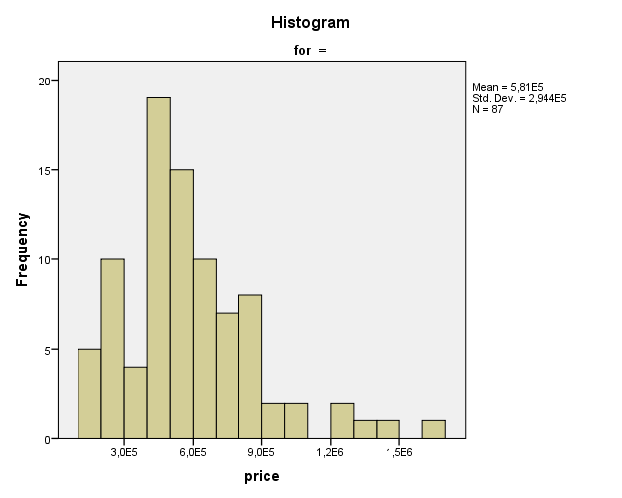

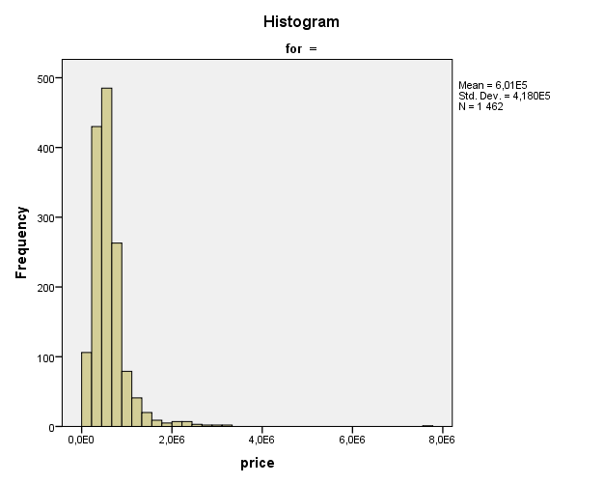

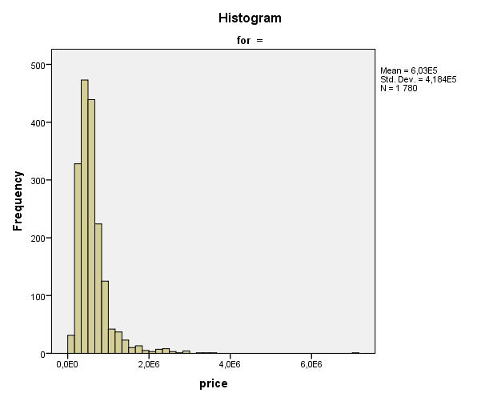

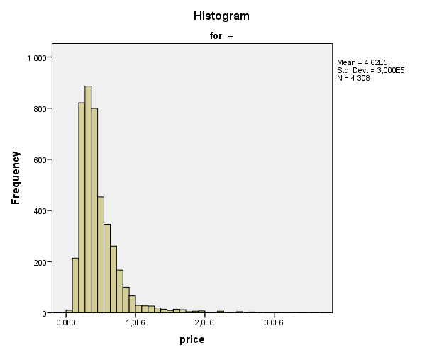

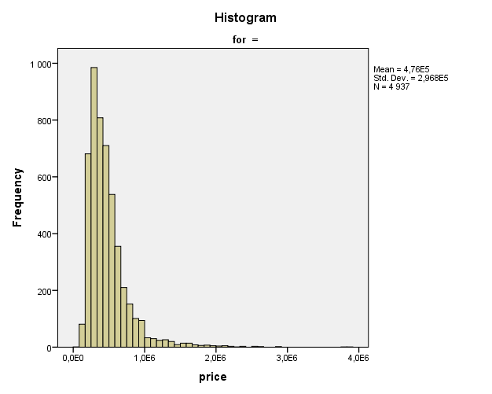

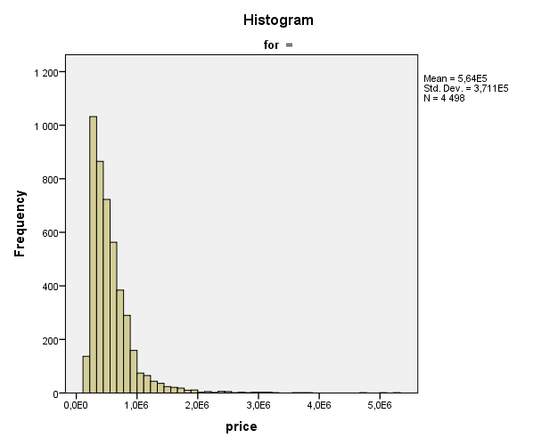

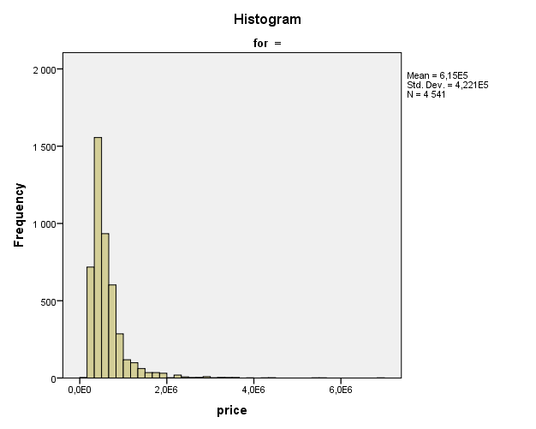

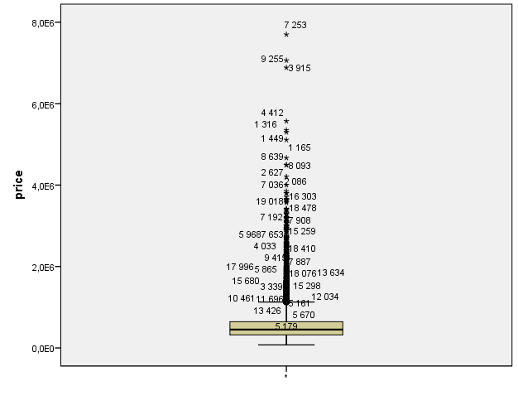

FREQUENCIES VARIABLES=yr_built_int
/STATISTICS=RANGE MINIMUM MAXIMUM MEDIAN MEAN MODE
/ORDER=ANALYSIS.

Frequencies

Notes
Output Created |  | 17-OCT-2017 16:14:12
Comments
Input | Data | C:\Users\Mathurin\Documents\Cours Winter 20172018\Data Mining\Project\House Sales in King County, USA\data.sav
Input | Active Dataset | DataSet1
Input | Filter | <none>
Input | Weight | <none>
Input | Split File | <none>
Input | N of Rows in Working Data File | 21613
Missing Value Handling | Definition of Missing | User-defined missing values are treated as missing.
Missing Value Handling | Cases Used | Statistics are based on all cases with valid data.
Syntax |  | FREQUENCIES VARIABLES=yr_built_int  /STATISTICS=RANGE MINIMUM MAXIMUM MEDIAN MEAN MODE  /ORDER=ANALYSIS.
Resources | Processor Time | 00:00:00,02
Resources | Elapsed Time | 00:00:00,02

Statistics
yr_built (Binned)
N | Valid | 21613
N | Missing | 0
Mean |  | 5,05
Median |  | 5,00
Mode |  | 5
Range |  | 6
Minimum |  | 1
Maximum |  | 7

yr_built (Binned)
 |  | Frequency | Percent | Valid Percent | Cumulative Percent
Valid | 1 | 87 | ,4 | ,4 | ,4
Valid | 2 | 1462 | 6,8 | 6,8 | 7,2
Valid | 3 | 1780 | 8,2 | 8,2 | 15,4
Valid | 4 | 4308 | 19,9 | 19,9 | 35,3
Valid | 5 | 4937 | 22,8 | 22,8 | 58,2
Valid | 6 | 4498 | 20,8 | 20,8 | 79,0
Valid | 7 | 4541 | 21,0 | 21,0 | 100,0
Valid | Total | 21613 | 100,0 | 100,0

FREQUENCIES VARIABLES=yr_built_int
/STATISTICS=RANGE MINIMUM MAXIMUM MEDIAN MEAN MODE
/ORDER=ANALYSIS.

Frequencies

Notes
Output Created |  | 17-OCT-2017 16:14:51
Comments
Input | Data | C:\Users\Mathurin\Documents\Cours Winter 20172018\Data Mining\Project\House Sales in King County, USA\data.sav
Input | Active Dataset | DataSet1
Input | Filter | <none>
Input | Weight | <none>
Input | Split File | <none>
Input | N of Rows in Working Data File | 21613
Missing Value Handling | Definition of Missing | User-defined missing values are treated as missing.
Missing Value Handling | Cases Used | Statistics are based on all cases with valid data.
Syntax |  | FREQUENCIES VARIABLES=yr_built_int  /STATISTICS=RANGE MINIMUM MAXIMUM MEDIAN MEAN MODE  /ORDER=ANALYSIS.
Resources | Processor Time | 00:00:00,02
Resources | Elapsed Time | 00:00:00,02

Statistics
yr_built (Binned)
N | Valid | 21613
N | Missing | 0
Mean |  | 5,05
Median |  | 5,00
Mode |  | 5
Range |  | 6
Minimum |  | 1
Maximum |  | 7

yr_built (Binned)
 |  | Frequency | Percent | Valid Percent | Cumulative Percent
Valid | 1 | 87 | ,4 | ,4 | ,4
Valid | 2 | 1462 | 6,8 | 6,8 | 7,2
Valid | 3 | 1780 | 8,2 | 8,2 | 15,4
Valid | 4 | 4308 | 19,9 | 19,9 | 35,3
Valid | 5 | 4937 | 22,8 | 22,8 | 58,2
Valid | 6 | 4498 | 20,8 | 20,8 | 79,0
Valid | 7 | 4541 | 21,0 | 21,0 | 100,0
Valid | Total | 21613 | 100,0 | 100,0

* Visual Binning.
*yr_built.
RECODE yr_built (MISSING=COPY) (LO THRU 1900=1) (LO THRU 1920=2) (LO THRU 1940=3) (LO THRU 1960=4)
(LO THRU 1980=5) (LO THRU 2000=6) (LO THRU HI=7) (ELSE=SYSMIS) INTO yr_built_int.
VARIABLE LABELS yr_built_int 'yr_built (Binned)'.
FORMATS yr_built_int (F5.0).
VALUE LABELS yr_built_int 1 '<= 1900' 2 '1901 - 1920' 3 '1921 - 1940' 4 '1941 - 1960' 5 '1961 - '+
'1980' 6 '1981 - 2000' 7 '2001+'.
VARIABLE LEVEL yr_built_int (ORDINAL).
EXECUTE.
FREQUENCIES VARIABLES=yr_built_int
/STATISTICS=RANGE MINIMUM MAXIMUM MEDIAN MEAN MODE
/ORDER=ANALYSIS.

Frequencies

Notes
Output Created |  | 17-OCT-2017 16:16:33
Comments
Input | Data | C:\Users\Mathurin\Documents\Cours Winter 20172018\Data Mining\Project\House Sales in King County, USA\data.sav
Input | Active Dataset | DataSet1
Input | Filter | <none>
Input | Weight | <none>
Input | Split File | <none>
Input | N of Rows in Working Data File | 21613
Missing Value Handling | Definition of Missing | User-defined missing values are treated as missing.
Missing Value Handling | Cases Used | Statistics are based on all cases with valid data.
Syntax |  | FREQUENCIES VARIABLES=yr_built_int  /STATISTICS=RANGE MINIMUM MAXIMUM MEDIAN MEAN MODE  /ORDER=ANALYSIS.
Resources | Processor Time | 00:00:00,03
Resources | Elapsed Time | 00:00:00,03

Statistics
yr_built (Binned)
N | Valid | 21613
N | Missing | 0
Mean |  | 5,05
Median |  | 5,00
Mode |  | 5
Range |  | 6
Minimum |  | 1
Maximum |  | 7

yr_built (Binned)
 |  | Frequency | Percent | Valid Percent | Cumulative Percent
Valid | <= 1900 | 87 | ,4 | ,4 | ,4
Valid | 1901 - 1920 | 1462 | 6,8 | 6,8 | 7,2
Valid | 1921 - 1940 | 1780 | 8,2 | 8,2 | 15,4
Valid | 1941 - 1960 | 4308 | 19,9 | 19,9 | 35,3
Valid | 1961 - 1980 | 4937 | 22,8 | 22,8 | 58,2
Valid | 1981 - 2000 | 4498 | 20,8 | 20,8 | 79,0
Valid | 2001+ | 4541 | 21,0 | 21,0 | 100,0
Valid | Total | 21613 | 100,0 | 100,0

EXAMINE VARIABLES=price BY yr_built_int
/PLOT BOXPLOT HISTOGRAM
/COMPARE GROUPS
/STATISTICS DESCRIPTIVES EXTREME
/CINTERVAL 95
/MISSING LISTWISE
/NOTOTAL.

Explore

Notes
Output Created |  | 17-OCT-2017 16:16:50
Comments
Input | Data | C:\Users\Mathurin\Documents\Cours Winter 20172018\Data Mining\Project\House Sales in King County, USA\data.sav
Input | Active Dataset | DataSet1
Input | Filter | <none>
Input | Weight | <none>
Input | Split File | <none>
Input | N of Rows in Working Data File | 21613
Missing Value Handling | Definition of Missing | User-defined missing values for dependent variables are treated as missing.
Missing Value Handling | Cases Used | Statistics are based on cases with no missing values for any dependent variable or factor used.
Syntax |  | EXAMINE VARIABLES=price BY yr_built_int  /PLOT BOXPLOT HISTOGRAM  /COMPARE GROUPS  /STATISTICS DESCRIPTIVES EXTREME  /CINTERVAL 95  /MISSING LISTWISE  /NOTOTAL.
Resources | Processor Time | 00:00:01,70
Resources | Elapsed Time | 00:00:01,70

yr_built (Binned)

Case Processing Summary
 | yr_built (Binned) | Cases
 | yr_built (Binned) | Valid |  | Missing |  | Total
 | yr_built (Binned) | N | Percent | N | Percent | N | Percent
price | <= 1900 | 87 | 100,0% | 0 | 0,0% | 87 | 100,0%
price | 1901 - 1920 | 1462 | 100,0% | 0 | 0,0% | 1462 | 100,0%
price | 1921 - 1940 | 1780 | 100,0% | 0 | 0,0% | 1780 | 100,0%
price | 1941 - 1960 | 4308 | 100,0% | 0 | 0,0% | 4308 | 100,0%
price | 1961 - 1980 | 4937 | 100,0% | 0 | 0,0% | 4937 | 100,0%
price | 1981 - 2000 | 4498 | 100,0% | 0 | 0,0% | 4498 | 100,0%
price | 2001+ | 4541 | 100,0% | 0 | 0,0% | 4541 | 100,0%

Descriptives
 | yr_built (Binned) |  |  | Statistic | Std. Error
price | <= 1900 | Mean |  | 5,81387206897E+005 | 3,155925261762E+004
price | <= 1900 | 95% Confidence Interval for Mean | Lower Bound | 5,18649489095E+005
price | <= 1900 | 95% Confidence Interval for Mean | Upper Bound | 6,44124924698E+005
price | <= 1900 | 5% Trimmed Mean |  | 5,57806990421E+005
price | <= 1900 | Median |  | 5,49000000000E+005
price | <= 1900 | Variance |  | 86650819043,096
price | <= 1900 | Std. Deviation |  | 2,943651117967E+005
price | <= 1900 | Minimum |  | 1,300000000E+005
price | <= 1900 | Maximum |  | 1,695000000E+006
price | <= 1900 | Range |  | 1,565000000E+006
price | <= 1900 | Interquartile Range |  | 3,035000000E+005
price | <= 1900 | Skewness |  | 1,222 | ,258
price | <= 1900 | Kurtosis |  | 2,254 | ,511
price | 1901 - 1920 | Mean |  | 6,00575231190E+005 | 1,093315108403E+004
price | 1901 - 1920 | 95% Confidence Interval for Mean | Lower Bound | 5,79128881864E+005
price | 1901 - 1920 | 95% Confidence Interval for Mean | Upper Bound | 6,22021580516E+005
price | 1901 - 1920 | 5% Trimmed Mean |  | 5,53413509652E+005
price | 1901 - 1920 | Median |  | 5,25500000000E+005
price | 1901 - 1920 | Variance |  | 174758404819,511
price | 1901 - 1920 | Std. Deviation |  | 4,180411520646E+005
price | 1901 - 1920 | Minimum |  | 8,000000000E+004
price | 1901 - 1920 | Maximum |  | 7,700000000E+006
price | 1901 - 1920 | Range |  | 7,620000000E+006
price | 1901 - 1920 | Interquartile Range |  | 3,363750000E+005
price | 1901 - 1920 | Skewness |  | 5,285 | ,064
price | 1901 - 1920 | Kurtosis |  | 63,495 | ,128
price | 1921 - 1940 | Mean |  | 6,02723170225E+005 | 9,917267947748E+003
price | 1921 - 1940 | 95% Confidence Interval for Mean | Lower Bound | 5,83272448837E+005
price | 1921 - 1940 | 95% Confidence Interval for Mean | Upper Bound | 6,22173891612E+005
price | 1921 - 1940 | 5% Trimmed Mean |  | 5,53042918851E+005
price | 1921 - 1940 | Median |  | 5,25000000000E+005
price | 1921 - 1940 | Variance |  | 175066922314,416
price | 1921 - 1940 | Std. Deviation |  | 4,184099930862E+005
price | 1921 - 1940 | Minimum |  | 8,500000000E+004
price | 1921 - 1940 | Maximum |  | 7,062500000E+006
price | 1921 - 1940 | Range |  | 6,977500000E+006
price | 1921 - 1940 | Interquartile Range |  | 3,250000000E+005
price | 1921 - 1940 | Skewness |  | 4,309 | ,058
price | 1921 - 1940 | Kurtosis |  | 40,214 | ,116
price | 1941 - 1960 | Mean |  | 4,61646746286E+005 | 4,571110564093E+003
price | 1941 - 1960 | 95% Confidence Interval for Mean | Lower Bound | 4,52685015774E+005
price | 1941 - 1960 | 95% Confidence Interval for Mean | Upper Bound | 4,70608476798E+005
price | 1941 - 1960 | 5% Trimmed Mean |  | 4,26768537089E+005
price | 1941 - 1960 | Median |  | 3,90500000000E+005
price | 1941 - 1960 | Variance |  | 90015883107,729
price | 1941 - 1960 | Std. Deviation |  | 3,000264706784E+005
price | 1941 - 1960 | Minimum |  | 7,800000000E+004
price | 1941 - 1960 | Maximum |  | 3,600000000E+006
price | 1941 - 1960 | Range |  | 3,522000000E+006
price | 1941 - 1960 | Interquartile Range |  | 2,775000000E+005
price | 1941 - 1960 | Skewness |  | 3,125 | ,037
price | 1941 - 1960 | Kurtosis |  | 17,029 | ,075
price | 1961 - 1980 | Mean |  | 4,75887376544E+005 | 4,224253938492E+003
price | 1961 - 1980 | 95% Confidence Interval for Mean | Lower Bound | 4,67605960272E+005
price | 1961 - 1980 | 95% Confidence Interval for Mean | Upper Bound | 4,84168792817E+005
price | 1961 - 1980 | 5% Trimmed Mean |  | 4,40642580740E+005
price | 1961 - 1980 | Median |  | 4,06500000000E+005
price | 1961 - 1980 | Variance |  | 88097414440,096
price | 1961 - 1980 | Std. Deviation |  | 2,968120860748E+005
price | 1961 - 1980 | Minimum |  | 7,500000000E+004
price | 1961 - 1980 | Maximum |  | 3,850000000E+006
price | 1961 - 1980 | Range |  | 3,775000000E+006
price | 1961 - 1980 | Interquartile Range |  | 2,768750000E+005
price | 1961 - 1980 | Skewness |  | 3,048 | ,035
price | 1961 - 1980 | Kurtosis |  | 16,437 | ,070
price | 1981 - 2000 | Mean |  | 5,64491082259E+005 | 5,533817510747E+003
price | 1981 - 2000 | 95% Confidence Interval for Mean | Lower Bound | 5,53642079252E+005
price | 1981 - 2000 | 95% Confidence Interval for Mean | Upper Bound | 5,75340085266E+005
price | 1981 - 2000 | 5% Trimmed Mean |  | 5,19985921150E+005
price | 1981 - 2000 | Median |  | 4,75100000000E+005
price | 1981 - 2000 | Variance |  | 137742866817,652
price | 1981 - 2000 | Std. Deviation |  | 3,711372614245E+005
price | 1981 - 2000 | Minimum |  | 1,150000000E+005
price | 1981 - 2000 | Maximum |  | 5,300000000E+006
price | 1981 - 2000 | Range |  | 5,185000000E+006
price | 1981 - 2000 | Interquartile Range |  | 3,550625000E+005
price | 1981 - 2000 | Skewness |  | 3,657 | ,037
price | 1981 - 2000 | Kurtosis |  | 25,348 | ,073
price | 2001+ | Mean |  | 6,15314917639E+005 | 6,264304275079E+003
price | 2001+ | 95% Confidence Interval for Mean | Lower Bound | 6,03033832748E+005
price | 2001+ | 95% Confidence Interval for Mean | Upper Bound | 6,27596002531E+005
price | 2001+ | 5% Trimmed Mean |  | 5,59940795224E+005
price | 2001+ | Median |  | 5,00000000000E+005
price | 2001+ | Variance |  | 178195688058,543
price | 2001+ | Std. Deviation |  | 4,221323110809E+005
price | 2001+ | Minimum |  | 1,550000000E+005
price | 2001+ | Maximum |  | 6,885000000E+006
price | 2001+ | Range |  | 6,730000000E+006
price | 2001+ | Interquartile Range |  | 3,400500000E+005
price | 2001+ | Skewness |  | 4,163 | ,036
price | 2001+ | Kurtosis |  | 31,366 | ,073

Extreme Values
 | yr_built (Binned) |  |  | Case Number | Value
price | <= 1900 | Highest | 1 | 18076 | 1,695000000E+006
price | <= 1900 | Highest | 2 | 11696 | 1,400000000E+006
price | <= 1900 | Highest | 3 | 15298 | 1,330000000E+006
price | <= 1900 | Highest | 4 | 5161 | 1,297000000E+006
price | <= 1900 | Highest | 5 | 12034 | 1,260000000E+006
price | <= 1900 | Lowest | 1 | 14002 | 1,300000000E+005
price | <= 1900 | Lowest | 2 | 7850 | 1,699000000E+005
price | <= 1900 | Lowest | 3 | 19138 | 1,790000000E+005
price | <= 1900 | Lowest | 4 | 11535 | 1,925000000E+005
price | <= 1900 | Lowest | 5 | 5237 | 1,999990000E+005
price | 1901 - 1920 | Highest | 1 | 7253 | 7,700000000E+006
price | 1901 - 1920 | Highest | 2 | 18478 | 3,300000000E+006
price | 1901 - 1920 | Highest | 3 | 7192 | 3,200000000E+006
price | 1901 - 1920 | Highest | 4 | 15259 | 3,065000000E+006
price | 1901 - 1920 | Highest | 5 | 2900 | 3,000000000E+006
price | 1901 - 1920 | Lowest | 1 | 466 | 8,000000000E+004
price | 1901 - 1920 | Lowest | 2 | 18469 | 8,300000000E+004
price | 1901 - 1920 | Lowest | 3 | 7993 | 9,000000000E+004
price | 1901 - 1920 | Lowest | 4 | 14582 | 9,500000000E+004
price | 1901 - 1920 | Lowest | 5 | 3806 | 9,500000000E+004
price | 1921 - 1940 | Highest | 1 | 3915 | 7,062500000E+006
price | 1921 - 1940 | Highest | 2 | 6509 | 3,650000000E+006
price | 1921 - 1940 | Highest | 3 | 10447 | 3,400000000E+006
price | 1921 - 1940 | Highest | 4 | 7908 | 3,200000000E+006
price | 1921 - 1940 | Highest | 5 | 11976 | 3,000000000E+006
price | 1921 - 1940 | Lowest | 1 | 10254 | 8,500000000E+004
price | 1921 - 1940 | Lowest | 2 | 5640 | 1,000000000E+005
price | 1921 - 1940 | Lowest | 3 | 13762 | 1,025000000E+005
price | 1921 - 1940 | Lowest | 4 | 13629 | 1,055000000E+005
price | 1921 - 1940 | Lowest | 5 | 14738 | 1,100000000E+005ª
price | 1941 - 1960 | Highest | 1 | 2865 | 3,600000000E+006
price | 1941 - 1960 | Highest | 2 | 13968 | 3,395000000E+006
price | 1941 - 1960 | Highest | 3 | 18200 | 3,300000000E+006
price | 1941 - 1960 | Highest | 4 | 657 | 3,070000000E+006
price | 1941 - 1960 | Highest | 5 | 14053 | 2,750000000E+006
price | 1941 - 1960 | Lowest | 1 | 15294 | 7,800000000E+004
price | 1941 - 1960 | Lowest | 2 | 16199 | 8,100000000E+004
price | 1941 - 1960 | Lowest | 3 | 8275 | 8,200000000E+004
price | 1941 - 1960 | Lowest | 4 | 2142 | 8,250000000E+004
price | 1941 - 1960 | Lowest | 5 | 3768 | 8,400000000E+004
price | 1961 - 1980 | Highest | 1 | 2086 | 3,850000000E+006
price | 1961 - 1980 | Highest | 2 | 7036 | 3,800000000E+006
price | 1961 - 1980 | Highest | 3 | 14557 | 2,888000000E+006
price | 1961 - 1980 | Highest | 4 | 5450 | 2,850000000E+006
price | 1961 - 1980 | Highest | 5 | 13711 | 2,600000000E+006^{b}
price | 1961 - 1980 | Lowest | 1 | 1150 | 7,500000000E+004
price | 1961 - 1980 | Lowest | 2 | 5867 | 8,900000000E+004
price | 1961 - 1980 | Lowest | 3 | 18940 | 9,000000000E+004
price | 1961 - 1980 | Lowest | 4 | 12552 | 9,000000000E+004
price | 1961 - 1980 | Lowest | 5 | 1219 | 1,000000000E+005
price | 1981 - 2000 | Highest | 1 | 1316 | 5,300000000E+006
price | 1981 - 2000 | Highest | 2 | 1165 | 5,110800000E+006
price | 1981 - 2000 | Highest | 3 | 8093 | 4,668000000E+006
price | 1981 - 2000 | Highest | 4 | 19018 | 3,800000000E+006
price | 1981 - 2000 | Highest | 5 | 16303 | 3,710000000E+006
price | 1981 - 2000 | Lowest | 1 | 14422 | 1,150000000E+005
price | 1981 - 2000 | Lowest | 2 | 10106 | 1,395000000E+005
price | 1981 - 2000 | Lowest | 3 | 15611 | 1,400000000E+005
price | 1981 - 2000 | Lowest | 4 | 2882 | 1,499000000E+005
price | 1981 - 2000 | Lowest | 5 | 3494 | 1,500000000E+005
price | 2001+ | Highest | 1 | 9255 | 6,885000000E+006
price | 2001+ | Highest | 2 | 4412 | 5,570000000E+006
price | 2001+ | Highest | 3 | 1449 | 5,350000000E+006
price | 2001+ | Highest | 4 | 2627 | 4,500000000E+006
price | 2001+ | Highest | 5 | 8639 | 4,489000000E+006
price | 2001+ | Lowest | 1 | 19651 | 1,550000000E+005
price | 2001+ | Lowest | 2 | 20404 | 1,607970000E+005
price | 2001+ | Lowest | 3 | 20613 | 1,638000000E+005
price | 2001+ | Lowest | 4 | 19976 | 1,750030000E+005
price | 2001+ | Lowest | 5 | 20808 | 1,825680000E+005

a. Only a partial list of cases with the value 1,100000000E+005 are shown in the table of lower extremes.
b. Only a partial list of cases with the value 2,600000000E+006 are shown in the table of upper extremes.

price

Histograms

