**Assumptions before starting with solution**

1. file has only get api details, with doesn’t required any authentication
2. response status code of both api are same then only both are eligible for comparison
3. both files has same number of lines without any blank line.
4. In case we are getting any exception while hitting api, always show both response are not equal. Eg abc from file 1 is not equal to abc from file 2.
5. Using trim to remove the unwanted spaces, before hitting the get api.

**Brief about approach –**

1. created class APIHelper to store the definite location of all resources.
2. Store data file name from json file and pass the to test cases at runtime
3. DataReader class to read the json file into map to pass that to test methods
4. FileReader class to read file, and store each line into string array
5. ResponseComparator class – this has all logic to do comparison of json, it has one recursive method to compare expected vs actual.
6. Response validator class to have the assertion and print the logs
7. RestUtil class to get rest assured response using url.

Tests are stored in testgojeck class. Right now it has one test case with filenames are coming from testdata.json.

**How to execute all test –**

1. Open Project folder – where pom.xml reside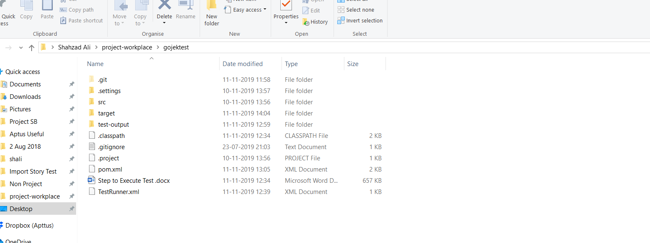
2. Open folder path in CMD

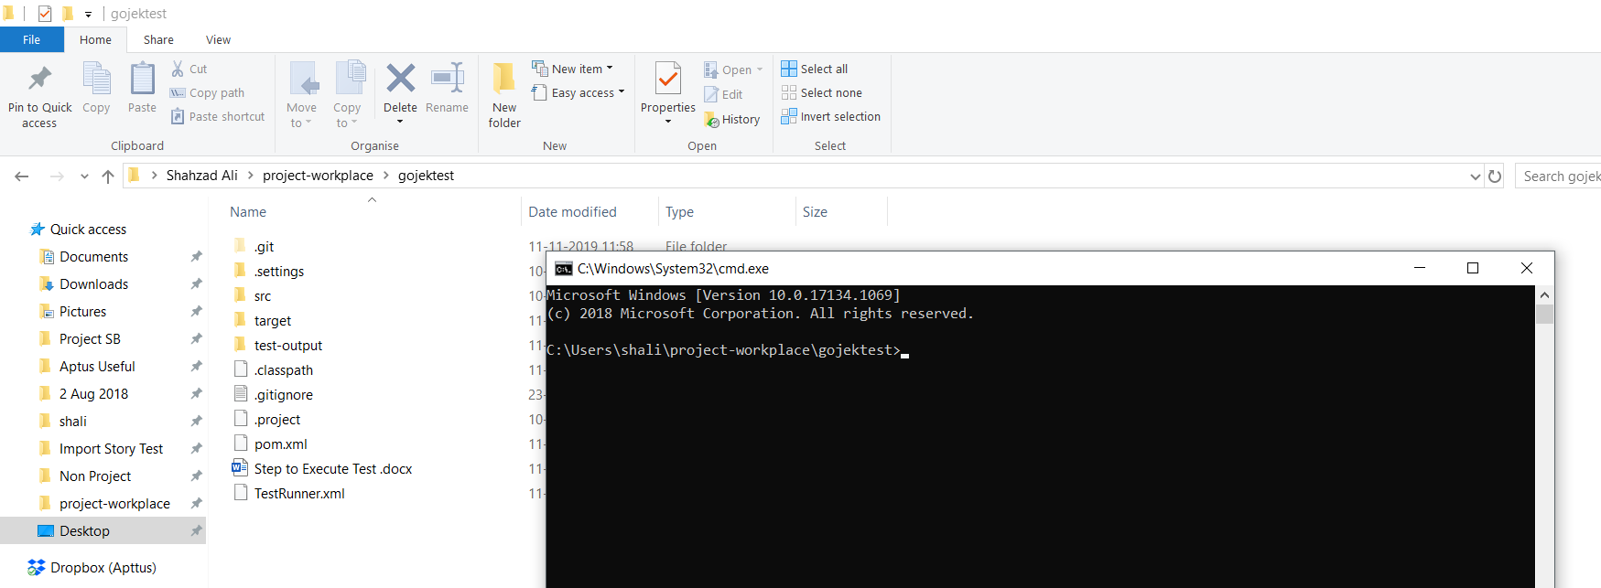

1. Run maven command – mvn clean install test

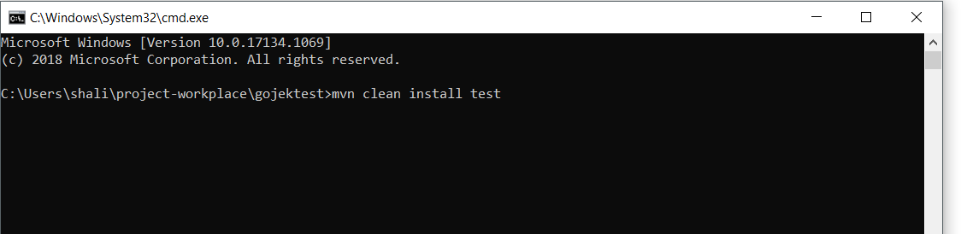

1. Execution log can be seen on console

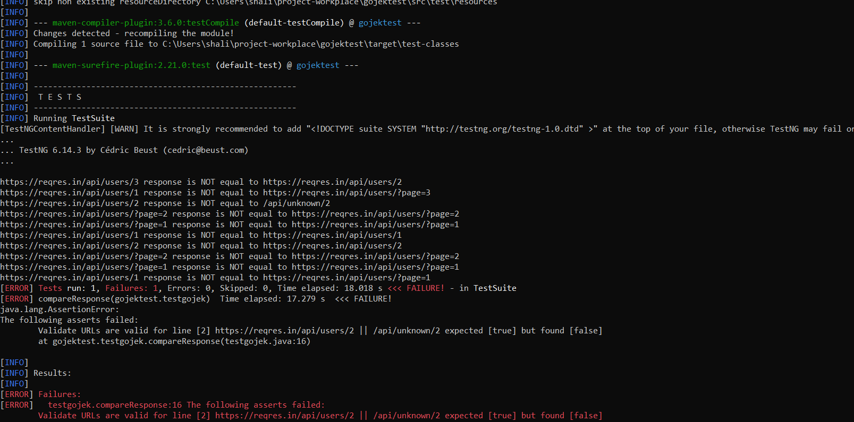

**How to see report of executed test**

Select the console output, you will see all the executed test like as below



To see html report from test run-

Navigate to test-output folder, look for email ‘emailable-report.html’, open it in any browser

Report will look like below

