**Ali Shalbayev**

**Home Work 3**

**Report**

For the web scraping task, I chose Sulpak.kz as my target website. Particularly I decided to scrape the laptops page.

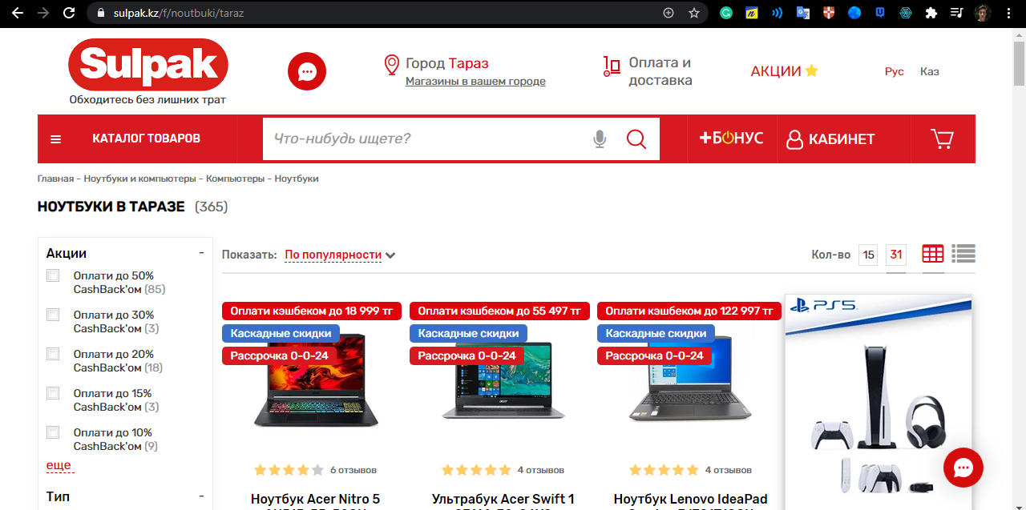

Here I am importing the libraries for the beginning.

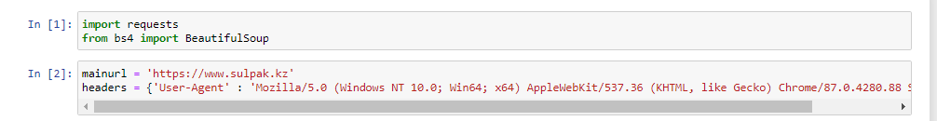

My first task was to gather the links for each of these laptops.

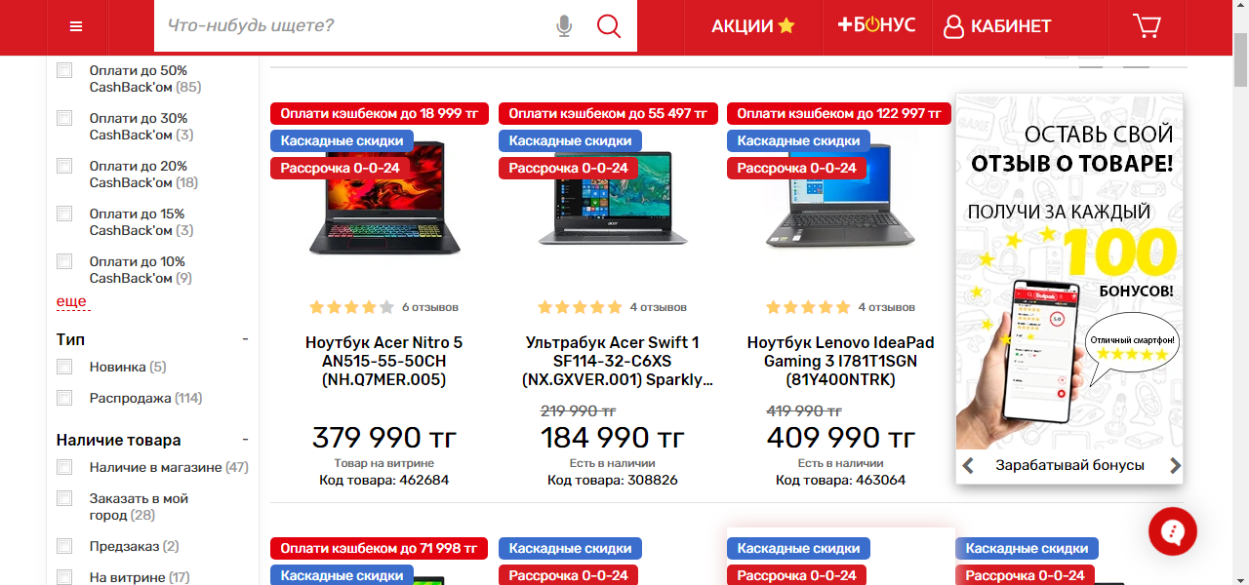

By hotkey ctrl+shift+i I identified the parent tag

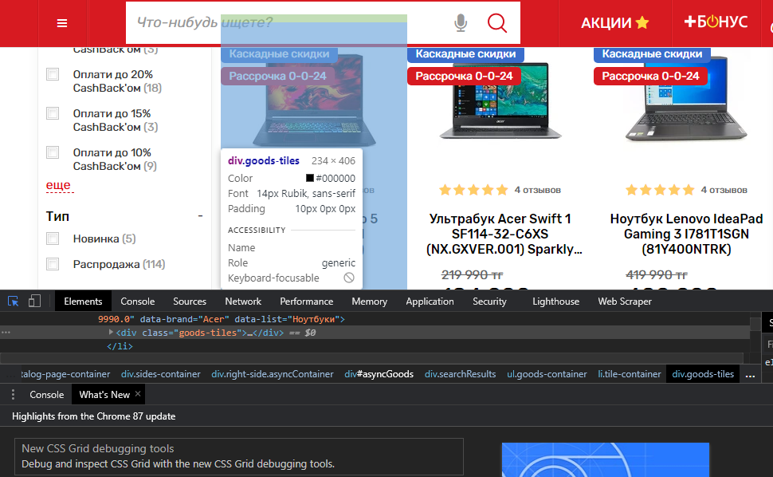

The next task was to determine where links are located.

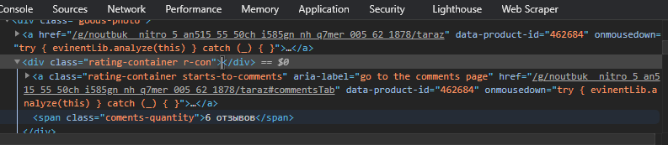

Then I wrote the loop for collecting these links since there were 3 links per each product, I was forced to get rid of them.

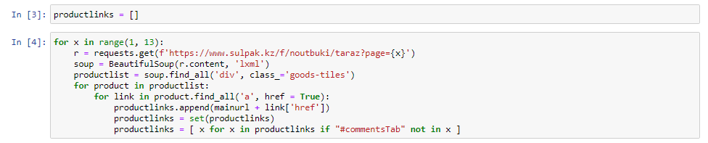

There I am checking is everything fine.

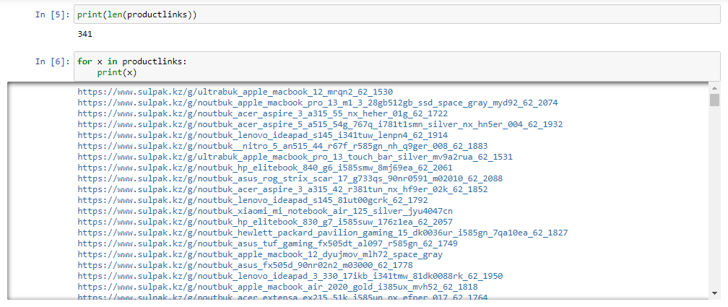

The next step was to detect where name, price and reviews are laid out.

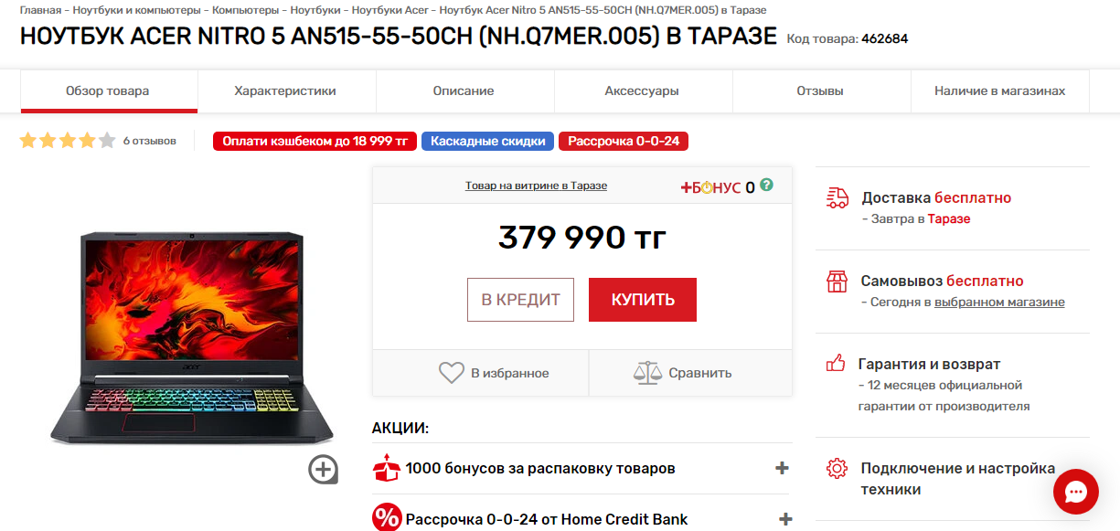

Again using hotkey ctrl+shift+i I started inspecting the page and found out where they are.

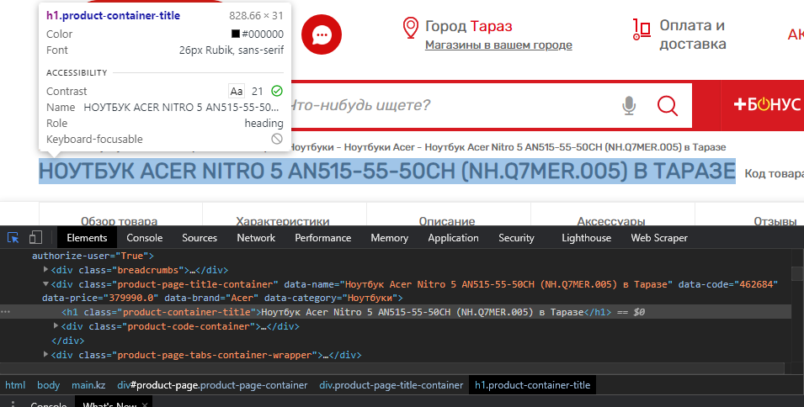

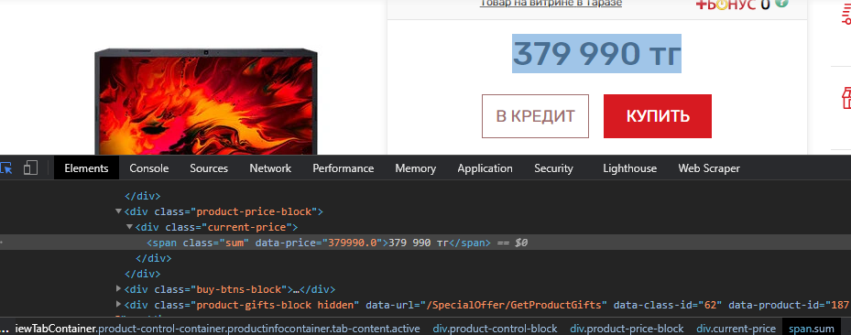

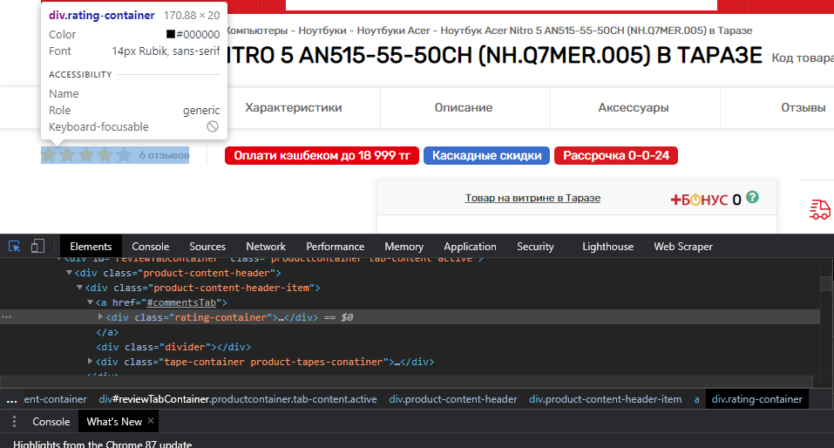

To identify how many stars a product gained I counted how many times a string "fa fa-star active" did appear.

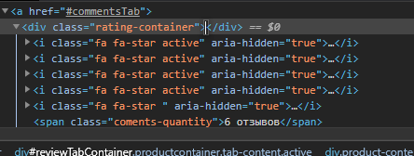

So here is my code for all these steps.

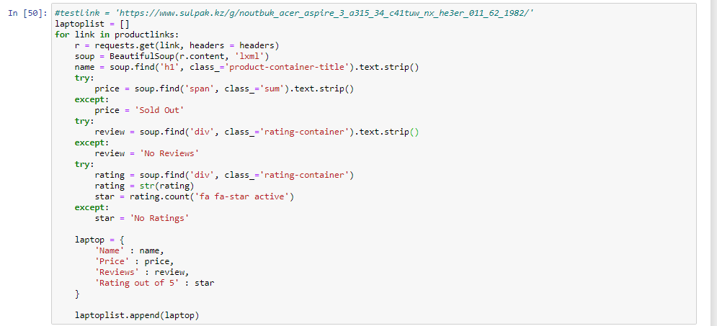

This is a scraped data frame that we finally got.

