Case BcONTfWxfgdPwcNq8718 Details

**Demographics**

* 37-year-old white female; teacher

**Chief complaint**

* blurred vision

**History of present illness**

* Character/signs/symptoms:blurred vision at distance
* Location:OD, OS
* Severity:mild
* Nature of onset:gradual
* Duration:1 year
* Frequency:constant
* Exacerbations/remissions:none
* Relationship to activity or function:none
* Accompanying signs/symptoms:difficulty driving at night due to glare from oncoming headlights

**Secondary complaints/symptoms**

* none

**Patient ocular history**

* last eye exam 1 year ago; was told she had "early cataracts"

**Family ocular history**

* mother: macular degeneration

**Patient medical history**

* arthritis, hyperlipidemia, hypertension

**Medications taken by patient**

* hydrochlorothiazide, simvastatin, nabumetone

**Patient allergy history**

* NKDA

**Family medical history**

* mother: hypertension, father: type II diabetes

**Review of systems**

* Constitutional/general health:denies
* Ear/nose/throat:denies
* Cardiovascular:denies
* Pulmonary:denies
* Dermatological:denies
* Gastrointestinal:denies
* Genitourinary:denies
* Musculoskeletal:occasional joint pain
* Neuropsychiatric:denies
* Endocrine:denies
* Hematologic:denies
* Immunologic:denies

**Mental status**

* Orientation:oriented to time, place, and person
* Mood:appropriate
* Affect:appropriate

**Clinical findings**

**Habitual spectacle Rx**

* OD:+7.25 -1.25 x 170; VA distance: 20/25
* OS:+7.25 -0.25 x 008; VA distance: 20/40

**Pupils:**

* PERRL, negative APD

**EOMs:**

* full, no restrictions OU

**Confrontation fields:**

* full to finger counting OD, OS

**Subjective refraction**

* OD:+7.00 -1.50 x 162; VA distance: 20/20
* OS:+7.00 -0.75 x 015; VA distance: 20/30

**Slit lamp**

* lids/lashes/adnexa:unremarkable OD, OS
* conjunctiva:normal OD, OS
* cornea:1+ arcus OD, OS
* anterior chamber:deep and quiet OD, OS
* iris:normal OD, OS
* lens:tr anterior cortical cataract OD, OS
* vitreous:clear OD, OS

**IOPs:**

* OD: 18 mmHg, OS: 17 mmHg @ 2:35 pm by Goldmann applanation tonometry

**Fundus OD**

* C/D:0.30 H/0.30 V
* macula:see images 1 & 2
* posterior pole:see images 1 & 2
* periphery:unremarkable

**Fundus OS**

* C/D:0.30 H/0.30 V
* macula:see image 3 & 4
* posterior pole:see image 3 & 4
* periphery:unremarkable

**Blood pressure:**

* 128/84 mmHg, right arm, sitting

**Pulse:**

* 68 bpm, regular

**Amsler grid**

* OD:(-) metamorphopsia, (-) scotoma
* OS:(+) central metamorphopsia

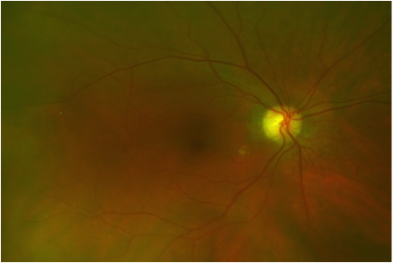

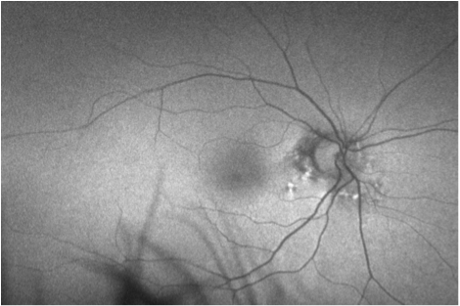

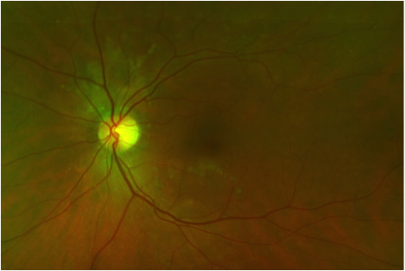

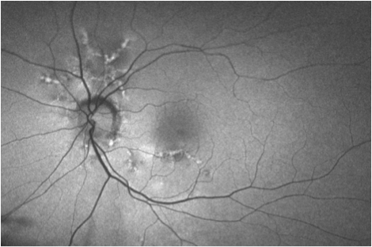

## Question 1 / 6

Which of the following represents the MOST appropriate diagnosis of the patient's retinal condition?

a) Angioid streaks

b) Choroideremia

c) Choroidal folds

d) Hyperopic chorioretinal degeneration

e) Choroidal rupture

## Question 2 / 6

Which of the following systemic diseases is MOST commonly associated with this patient’s diagnosis?

a) Marfan syndrome

b) Ehlers-Danlos syndrome

c) Paget disease

d) Sickle cell disease

e) Pseudoxanthoma elasticum

## Question 3 / 6

Which of the following BEST describes the pathophysiology of this patient’s retinal condition?

a) Breaks in the choriocapillaris, Bruch's membrane, and retinal pigment epithelium

b) Atrophy and thinning of the choroid and retinal pigment epithelium

c) Small dehiscences in the collagenous and elastic portions of Bruch's membrane

d) Grooves or striae involving the inner choroid, Bruch's membrane, and the outer sensory retina

## Question 4 / 6

Which 2 of the following ocular findings are commonly observed in association with this patient’s retinal condition? (Select 2)

a) Peau d'orange

b) Congenital cataracts

c) Arteriolar attenuation

d) Optic nerve pallor

e) Optic disc drusen

f) Peripheral intraretinal hemorrhages

## Question 5 / 6

What is the MOST common cause of vision loss in patients diagnosed with this retinal condition?

a) Retinal pigment epithelial atrophy

b) Choroidal neovascular membrane

c) Macular edema

d) Intraretinal hemorrhaging

e) Retinal detachment

## Question 6 / 6

What is the MOST appropriate next step in the management of this patient?

a) Fluorescein angiography

b) Vitrectomy

c) Photodynamic therapy

d) Avastin® injection

e) Monitor condition only

f) Thermal photocoagulation