Case CWLmUwGjsKmqdrcm5004 Details

**Demographics**

* 18-year-old white female; student

**Chief complaint**

* red eyes

**History of present illness**

* Character/signs/symptoms:eyes are red and irritated; discharge
* Location:OD, OS
* Severity:moderate
* Nature of onset:acute; started in right eye first, then moved to left eye yesterday
* Duration:3 days
* Frequency:constant
* Exacerbations/remissions:worse in the morning
* Relationship to activity or function:none
* Accompanying signs/symptoms:wakes up with eyelids stuck shut in the morning

**Secondary complaints/symptoms**

* none

**Patient ocular history**

* last eye exam 2 years ago; wears glasses for reading

**Family ocular history**

* mother: strabismus

**Patient medical history**

* unremarkable

**Medications taken by patient**

* oral contraceptives

**Patient allergy history**

* fluoroquinolones, macrolides, penicillin

**Family medical history**

* mother: pituitary adenoma, father: gout, hyperlipidemia

**Review of systems**

* Constitutional/general health:denies
* Ear/nose/throat:denies
* Cardiovascular:denies
* Pulmonary:denies
* Dermatological:denies
* Gastrointestinal:denies
* Genitourinary:denies
* Musculoskeletal:denies
* Neuropsychiatric:denies
* Endocrine:denies
* Hematologic:denies
* Immunologic:denies

**Mental status**

* Orientation:oriented to time, place, and person
* Mood:appropriate
* Affect:appropriate

**Clinical findings**

**Uncorrected visual acuity**

* OD:distance: 20/20
* OS:distance: 20/20

**Pupils:**

* PERRL, negative APD

**EOMs:**

* full, no restrictions OU

**Confrontation fields:**

* full to finger counting OD, OS

**Slit lamp**

* lids/lashes/adnexa:see image 1 OD, OS similar to OD
* conjunctiva:see image 1 OD, OS similar to OD
* cornea:clear OD, OS
* anterior chamber:deep and quiet OD, OS
* iris:normal OD, OS
* lens:clear OD, OS
* vitreous:clear OD, OS

**Preauricular nodes:**

* negative lymphadenopathy (bilaterally)

**IOPs:**

* OD: 17 mmHg, OS: 17 mmHg @ 12:00 pm by Goldmann applanation tonometry

**Fundus OD**

* C/D:0.25 H/0.25 V
* macula:normal
* posterior pole:normal
* periphery:unremarkable

**Fundus OS**

* C/D:0.25 H/0.25 V
* macula:normal
* posterior pole:normal
* periphery:unremarkable

**Blood pressure:**

* 113/74 mmHg, right arm, sitting

**Pulse:**

* 68 bpm, regular

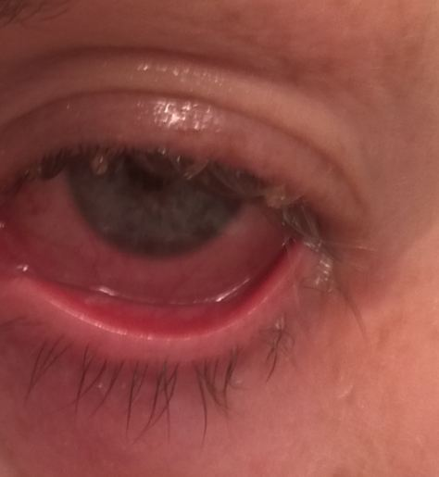

## Question 1 / 6

What is the MOST likely diagnosis of the patient's anterior segment condition?

a) Allergic conjunctivitis

b) Gonococcal conjunctivitis

c) Bacterial conjunctivitis

d) Epidemic keratoconjunctivitis (EKC)

e) Superficial punctate keratitis

## Question 2 / 6

What is the MOST appropriate treatment for this patient's anterior segment condition?

a) Polytrim® q.i.d. OU for 7 days

b) AzaSite® b.i.d. for 2 days then q.h.s. for 5 days

c) Erythromycin ung b.i.d. OU for 7 days

d) Preservative-free artificial tears q.i.d. OU for 7 days

e) Moxeza® q.i.d. OU for 7 days

f) Pataday® q.d. for 2 weeks

## Question 3 / 6

After the initiation of treatment, when is an appropriate time to follow up with the patient?

a) 3 days

b) Annually

c) 2 weeks

d) 1 day

e) 6 weeks

f) 1 month

## Question 4 / 6

What patient education should be included during the initial visit with the patient?

a) The patient needs to avoid dairy products while using the prescribed medication as calcium will interfere with its effectiveness

b) The condition is contagious and precautions (i.e. frequent hand washing) must be taken to ensure that it is not spread to others

c) The patient cannot eat iron-rich foods while taking the prescribed medication

d) The patient should not wear glasses as the lenses can serve as reservoirs for the pathogens

e) The patient should be evaluated by her primary care physician for associated systemic disease

## Question 5 / 6

This patient’s diagnosis is frequently observed in children in conjunction with which of the following conditions?

a) Pharyngitis

b) Frequent nose bleeds

c) Otitis media

d) Atopy

e) Onycholysis

## Question 6 / 6

The patient returns to your office for a follow-up examination and you notice a new presentation of several peripheral subepithelial marginal infiltrates in both eyes. Which of the following medications would be the MOST appropriate addition to your original treatment plan?

a) Sulfacetamide

b) Trifluridine

c) Fluorometholone

d) Ketorolac

e) Olopatadine