Case DJbYODwRSYFeVIHSx104 Details

**Demographics**

* 28-year-old Indian male; administrative assistant

**Chief complaint**

* eye pain

**History of present illness**

* Character/signs/symptoms:eye is very painful and sensitive to light, cannot open it
* Location:OD
* Severity:severe
* Nature of onset:acute
* Duration:started this morning
* Frequency:constant
* Exacerbations/remissions:none
* Relationship to activity or function:none
* Accompanying signs/symptoms:excessive tearing

**Secondary complaints/symptoms**

* none

**Patient ocular history**

* last eye exam 3 months ago, was treated for corneal abrasion OD after being struck in the eye with a tree branch while biking; wears SVD glasses for driving

**Family ocular history**

* mother: glaucoma suspect

**Patient medical history**

* unremarkable

**Medications taken by patient**

* Tums® PRN

**Patient allergy history**

* tree nuts; NKDA

**Family medical history**

* mother: pituitary tumor, father: hypertension, hypercholesterolemia

**Review of systems**

* Constitutional/general health:denies
* Ear/nose/throat:denies
* Cardiovascular:denies
* Pulmonary:denies
* Dermatological:denies
* Gastrointestinal:occasional heartburn
* Genitourinary:denies
* Musculoskeletal:denies
* Neuropsychiatric:denies
* Endocrine:denies
* Hematologic:denies
* Immunologic:denies

**Mental status**

* Orientation:oriented to time, place, and person
* Mood:appropriate
* Affect:appropriate

**Clinical findings**

* *following 1 drop of proparacaine 0.5% OD

**Habitual spectacle Rx**

* OD:-1.00 DS; VA distance: 20/40 (PHNI)
* OS:-1.25 DS; VA distance: 20/20

**Pupils:**

* PERRL, negative APD

**Slit lamp**

* lids/lashes/adnexa:1+ upper eyelid edema OD, unremarkable OS
* conjunctiva:2+ injection OD, normal OS
* cornea:see image 1 OD, see image 2 OS
* anterior chamber:deep and quiet OD, OS
* iris:normal OD, OS
* lens:clear OD, OS
* vitreous:clear OD, OS

**IOPs:**

* OD: 15 mmHg, OS: 14 mmHg @ 9:00 am by non-contact tonometry

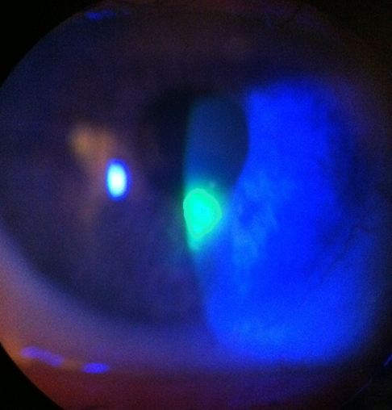

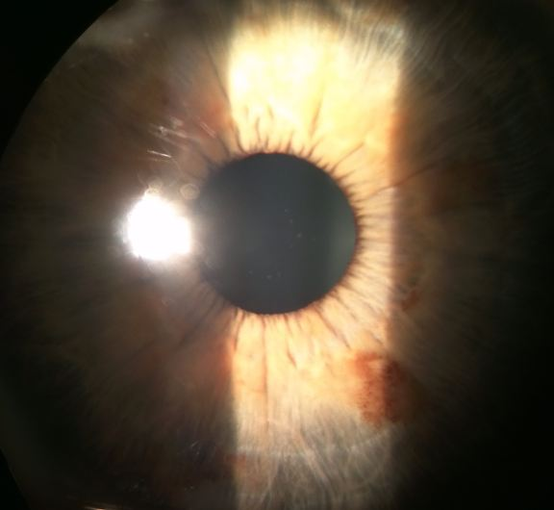

## Question 1 / 5

What is the MOST likely diagnosis of the patient's right eye anterior segment condition?

a) Keratoconjunctivitis sicca

b) Herpes simplex keratitis

c) Corneal abrasion

d) Bacterial corneal ulcer

e) Radiation keratitis

f) Recurrent corneal erosion

## Question 2 / 5

Which of the following represents the MOST appropriate initial topical treatment for the patient's condition?

a) Zirgan® ophthalmic gel 5 times daily, preservative-free artificial tears every 2 hours

b) FML® suspension 4 times daily, preservative-free artificial tears every 2 hours

c) Polytrim® solution 4 times daily, Patanol® solution twice daily

d) Tetracaine ophthalmic solution every 4 hours

e) Erythromycin ointment 4 times daily, preservative-free artificial tears every 2 hours

## Question 3 / 5

After treatment is initiated, when should the patient follow-up with you?

a) 1 month

b) 1 day

c) 1 week

d) 2 weeks

e) 5 days

## Question 4 / 5

After his initial follow-up, the patient returns to your office stating that there is no improvement in his eye. Biomicroscopy reveals a corneal defect with loose epithelium and areas of heaping around the edges. What is the MOST appropriate treatment at this time?

a) Add a preservative-free lubricating ointment to the current treatment regimen

b) Continue the current treatment regimen for a longer period of time

c) A bandage contact lens

d) Corneal debridement

## Question 5 / 5

The patient calls your office to ask for the name of a good allergy drop for him and his wife to use because their eyes have been itchy. As the treating doctor, the call is forwarded to you and you speak directly to the patient. After naming several over-the-counter options to the patient, what 2 actions should you then take? (Select 2)

a) Follow-up with the patient via a phone call in 3 days

b) Charge the patient for an emergency phone consultation

c) Write the day, time, advice given, and method of contact in the patient's chart

d) Call the pharmacy to ensure that the patient purchased the appropriate drops

e) Call the patient's primary care physician to notify them of the addition to the patient's current treatment regimen