Case FtDuHLCQpPfeNIIB7535 Details

**Demographics**

* 31-year-old white male; architect

**Chief complaint**

* blurry vision

**History of present illness**

* Character/signs/symptoms:blurred distance vision
* Location:OD
* Severity:mild
* Nature of onset:gradual
* Duration:1 year
* Frequency:constant
* Exacerbations/remissions:worse at night; better with squinting
* Relationship to activity or function:none
* Accompanying signs/symptoms:none

**Secondary complaints/symptoms**

* none

**Patient ocular history**

* last eye exam 2 years ago; does not wear correction

**Family ocular history**

* father: herpes simplex keratitis

**Patient medical history**

* unremarkable

**Medications taken by patient**

* none

**Patient allergy history**

* NKDA

**Family medical history**

* father: hypercholesterolemia

**Review of systems**

* Constitutional/general health:denies
* Ear/nose/throat:denies
* Cardiovascular:denies
* Pulmonary:denies
* Dermatological:denies
* Gastrointestinal:denies
* Genitourinary:denies
* Musculoskeletal:denies
* Neuropsychiatric:denies
* Endocrine:denies
* Hematologic:denies
* Immunologic:denies

**Mental status**

* Orientation:oriented to time, place, and person
* Mood:appropriate
* Affect:appropriate

**Clinical findings**

**Uncorrected visual acuity**

* OD:VA distance: 20/30, VA near: 20/20 @ 40 cm
* OS:VA distance: 20/20, VA near: 20/20 @ 40 cm

**Pupils:**

* PERRL, negative APD

**EOMs:**

* full, no restrictions OU

**Cover test:**

* distance: orthophoria, near: 4 exophoria

**Confrontation fields:**

* full to finger counting OD, OS

**Subjective refraction**

* OD:-0.75 -0.25 x 168; VA distance: 20/20
* OS:+0.50 DS; VA near: 20/20

**Slit lamp**

* lids/lashes/adnexa:unremarkable OD, OS
* conjunctiva:normal OD, OS
* cornea:see image 1 OD, see image 2 OS
* anterior chamber:deep and quiet OD, OS
* iris:normal OD, OS
* lens:clear OD, OS
* vitreous:clear OD, OS

**IOPs:**

* OD: 12 mmHg, OS: 12 mmHg @ 12:15 pm by Goldmann applanation tonometry

**Fundus OD**

* C/D:see image 3
* macula:normal
* posterior pole:normal
* periphery:unremarkable

**Fundus OS**

* C/D:see image 4
* macula:normal
* posterior pole:normal
* periphery:unremarkable

**Blood pressure:**

* 118/79 mmHg, right arm, sitting

**Pulse:**

* 68 bpm, regular

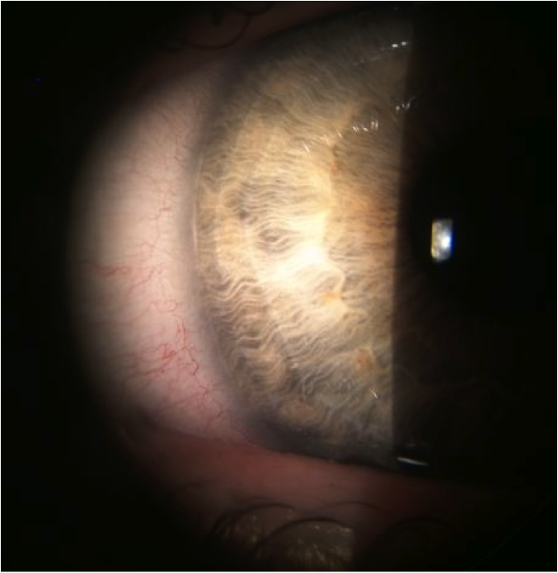

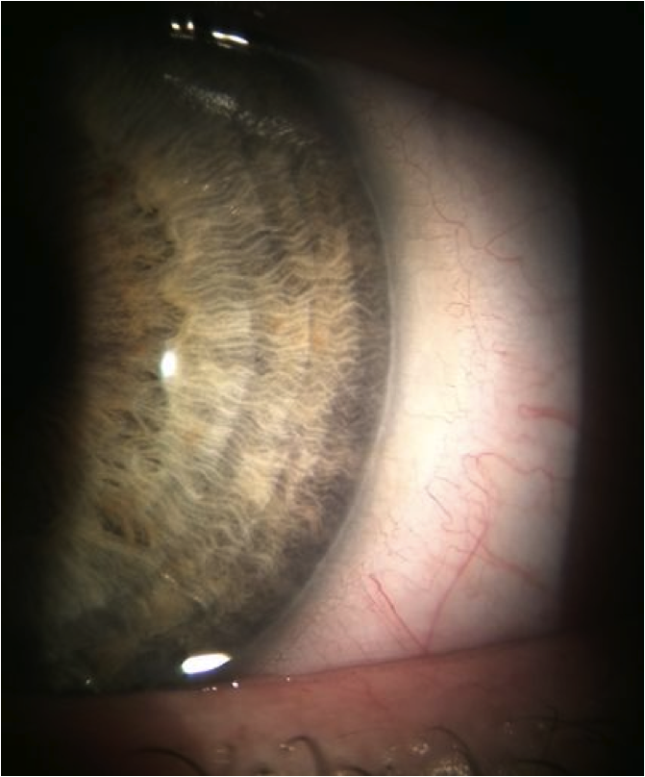

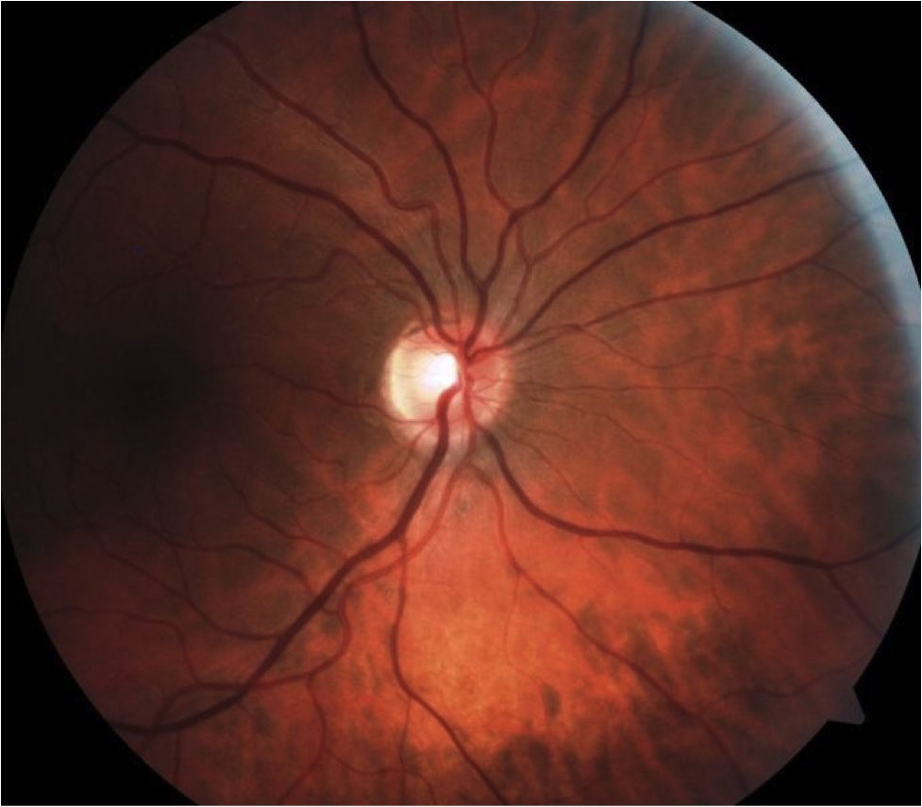

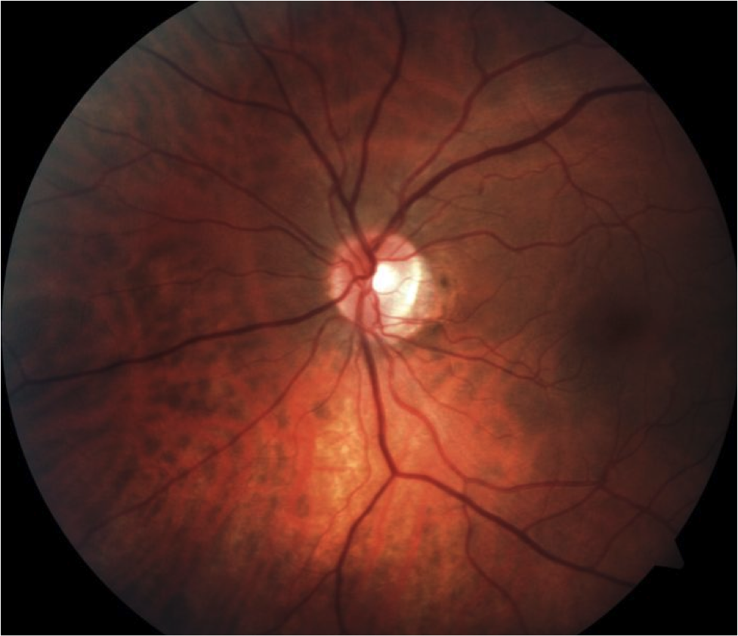

## Question 1 / 5

What is the MOST appropriate diagnosis of the patient's peripheral corneal findings observed in images 1 and 2?

a) Axenfeld anomaly

b) Peters anomaly

c) Posterior embryotoxon

d) Rieger anomaly

## Question 2 / 5

What is the MOST appropriate treatment for the patient's corneal findings?

a) Lumigan® ophthalmic solution, 1 gtt q.h.s. OU

b) No treatment is necessary at this time

c) Pred Forte® ophthalmic suspension 1 gtt q.i.d. OU x 2 weeks

d) Refer for laser peripheral iridotomy OU

e) Muro 128® ophthalmic solution, 1 gtt q.h.s OU

## Question 3 / 5

Which of the following represents the MOST appropriate follow-up for this patient?

a) RTC 1 week for follow-up exam

b) RTC 2 months for follow-up exam

c) RTC 1 day for follow-up exam

d) RTC 1 month for follow-up exam

e) RTC 1 year for comprehensive exam

## Question 4 / 5

Which of the following BEST describes this patient's refractive error?

a) Amblyogenic

b) Antimetropia

c) Aniseikonia

d) Simple astigmatism

## Question 5 / 5

The ocular condition observed in images 1 and 2 is MOST frequently associated with individuals of what descent?

a) There is no racial predilection

b) Caucasian

c) African-American

d) Hispanic

e) American-Indian

f) Asian