Case GosNTRksFOWOFZi10335 Details

**Demographics**

* 48-year-old black female; homemaker

**Chief complaint**

* blurred and distorted vision

**History of present illness**

* Character/signs/symptoms:vision is blurry at all distances and straight lines appear wavy
* Location:OD, OS (OS worse than OD)
* Severity:moderate
* Nature of onset:gradual
* Duration:2 weeks
* Frequency:constant
* Exacerbations/remissions:none
* Relationship to activity or function:none
* Accompanying signs/symptoms:headaches and eye fatigue with prolonged reading

**Secondary complaints/symptoms**

* none

**Patient ocular history**

* last eye exam 3 years ago; wore glasses for reading but lost them last year

**Family ocular history**

* mother: cataracts

**Patient medical history**

* appendectomy (1 year ago)

**Medications taken by patient**

* Tylenol® PRN

**Patient allergy history**

* NKDA

**Family medical history**

* mother: scoliosis, father: prostate cancer

**Review of systems**

* Constitutional/general health:denies
* Ear/nose/throat:denies
* Cardiovascular:denies
* Pulmonary:denies
* Dermatological:denies
* Gastrointestinal:denies
* Genitourinary:denies
* Musculoskeletal:denies
* Neuropsychiatric:denies
* Endocrine:denies
* Hematologic:denies
* Immunologic:denies

**Mental status**

* Orientation:oriented to time, place, and person
* Mood:appropriate
* Affect:appropriate

**Clinical findings**

**Uncorrected visual acuity**

* OD:VA distance: 20/25
* OS:VA distance: 20/100 (PHNI)

**Pupils:**

* PERRL, negative APD

**EOMs:**

* full, no restrictions OU

**Confrontation fields:**

* full to finger counting OD, OS

**Subjective refraction**

* OD:-0.25 -0.25 x 120; VA distance: 20/25
* OS:-0.50 DS; VA distance: 20/100

**Slit lamp**

* lids/lashes/adnexa:unremarkable OD, OS
* conjunctiva:nasal pinguecula OD, OS
* cornea:crocodile shagreen OD, OS
* anterior chamber:deep and quiet OD, OS
* iris:normal OD, OS
* lens:clear OD, OS
* vitreous:clear OD, OS

**IOPs:**

* OD: 16 mmHg, OS: 14 mmHg @ 2:15 pm by Goldmann applanation tonometry

**Fundus OD**

* C/D:0.20 H/0.20 V
* macula:normal
* posterior pole:similar to image 1
* periphery:unremarkable

**Fundus OS**

* C/D:see image 1
* macula:pigment epithelial detachment, see image 1
* posterior pole:reddish-orange polyp-like lesion in peripapillary region, see image 1
* periphery:unremarkable

**Blood pressure:**

* 102/78 mmHg, right arm, sitting

**Pulse:**

* 56 bpm, regular

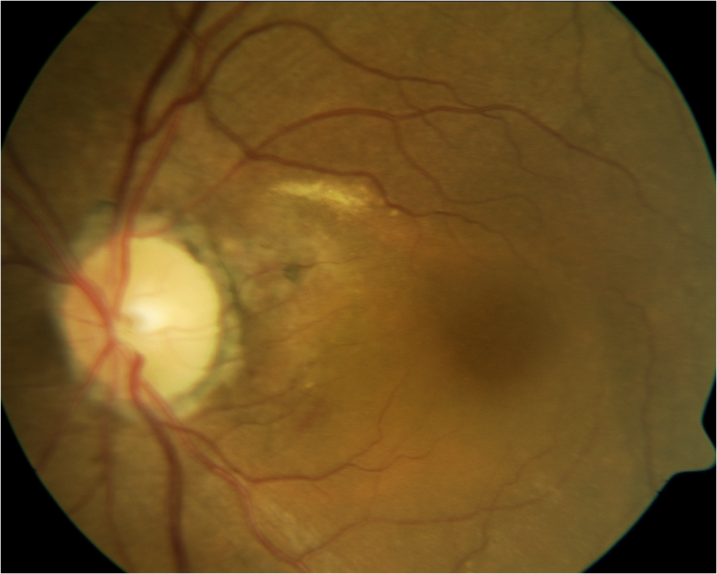

## Question 1 / 5

Given the clinical findings and the associated image, what is the MOST likely diagnosis of the patient's retinal condition?

a) Exudative macular degeneration

b) Polypoidal choroidal vasculopathy

c) Central serous retinopathy

d) Age-related peripapillary choroidal neovascularization

## Question 2 / 5

Which of the following systemic conditions is MOST commonly observed in association with this retinal condition and may increase its severity?

a) Hypertension

b) Hyperthyroidism

c) Diabetes

d) Hyperlipidemia

e) Multiple sclerosis

## Question 3 / 5

Which of the following imaging techniques will allow for the best diagnostic evaluation of the lesions associated with this condition?

a) Fluorescein angiography

b) A-scan ultrasonography

c) Indocyanine green angiography

d) B-scan ultrasonography

## Question 4 / 5

Which 2 of the following populations have the highest predilection for developing this retinal condition? (Select 2)

a) Asian

b) American-Indian

c) Eastern European

d) Hispanic

e) African-American

f) Caucasian

## Question 5 / 5

An elderly patient visits your office and you suspect that he is being abused. Which of the following actions should you take as an optometrist?

a) Report your suspicions to the patient's caretaker

b) Inform the appropriate agencies as dictated by state law

c) Confront your patient and directly ask him if he is being abused

d) Take no action as your suspicions may be unwarranted

e) Reports your suspicions to the patient’s next of kin

f) Teach the patient how to protect himself