Case HfikswiBKkfkUygXLp82 Details

**Demographics**

* 15-year-old Filipino male; student

**Chief complaint**

* headaches and double vision

**History of present illness**

* Character/signs/symptoms:binocular horizontal diplopia and headaches
* Location:frontal headaches; diplopia at near
* Severity:moderate
* Nature of onset:gradual
* Duration:6 months
* Frequency:daily
* Exacerbations/remissions:worse after prolonged near work and at the end of the day, resolves with rest
* Relationship to activity or function:reading, computer
* Accompanying signs/symptoms:eyes feel like they are "pulling" when he reads; gets very sleepy when reading

**Secondary complaints/symptoms**

* none

**Patient ocular history**

* 1st eye exam

**Family ocular history**

* mother: congenital cataracts

**Patient medical history**

* unremarkable

**Medications taken by patient**

* OTC multivitamins

**Patient allergy history**

* cat dander, NKDA

**Family medical history**

* unremarkable

**Review of systems**

* Constitutional/general health:denies
* Ear/nose/throat:denies
* Cardiovascular:denies
* Pulmonary:denies
* Dermatological:denies
* Gastrointestinal:denies
* Genitourinary:denies
* Musculoskeletal:denies
* Neuropsychiatric:denies
* Endocrine:denies
* Hematologic:denies
* Immunologic:denies

**Mental status**

* Orientation:oriented to time, place, and person
* Mood:appropriate
* Affect:appropriate

**Clinical findings**

**Uncorrected visual acuity**

* OD:distance: 20/20, near: 20/20 @ 40 cm
* OS:distance: 20/20, near: 20/20 @ 40 cm

**Habitual spectacle Rx**

* single vision near
* OD:+0.50 DS, VA near: 20/20 @ 40 cm
* OS:+0.50 DS, VA near: 20/20 @ 40 cm

**Pupils:**

* PERRL, negative APD

**EOMs:**

* full, no restrictions OU

**Cover test:**

* distance: 2 exophoria, near: 12 exophoria

**Confrontation fields:**

* full to finger counting OD, OS

**Oculomotor system**

* Pursuits:normal
* Saccades:normal
* Fixations:none

**Subjective refraction**

* OD:-0.25 DS, VA distance: 20/20
* OS:-0.25 DS, VA distance: 20/20

**Accommodative system**

* Amplitudes:OD: 14 D, OS: 14 D, OU: 14 D
* Facility (+/- 2.00):OD: 11 cycles/minute, OS: 11 cycles/minute, OU: 3 cycles per minute (difficulty clearing plus lenses binocularly)
* NRA/PRA:+1.25 / -2.25
* Monocular estimation method (MEM):OD: +0.50, OS: +0.50

**Vergence system**

* NPC:10 cm
* Vergences:NFV @ distance: x / 6 / 3, NFV @ near: 12 / 22 / 15; PFV @ distance: 11 / 19 / 11, PFV @ near: x / 9 / 3
* Facility:8 base-out/8 base-in: 3 cycles/minute @ 40 cm (difficulty with base-out)

**Sensory system**

* Worth 4 dot:far: no suppression, near: no suppression
* Stereopsis:50" @ near

**DEM test (percentile rank):**

* horizontal: 60%, vertical: 60%, ratio: 55%, errors: 98%

**Slit lamp**

* lids/lashes/adnexa:unremarkable OD, OS
* conjunctiva:tr injection OD, OS
* cornea:see image 1 OD, see image 2 OS
* anterior chamber:deep and quiet OD, OS
* iris:normal OD, OS
* lens:clear OD, OS
* vitreous:clear OD, OS

**IOPs:**

* OD: 22 mmHg, OS: 21 mmHg @ 2:32 pm by Goldmann applanation tonometry

**Fundus OD**

* C/D:0.20 H/0.20 V
* macula:normal
* posterior pole:normal
* periphery:unremarkable

**Fundus OS**

* C/D:0.20 H/0.20 V
* macula:normal
* posterior pole:normal
* periphery:unremarkable

**Blood pressure:**

* 101/71 mmHg, right arm, sitting

**Pulse:**

* 70 bpm, regular

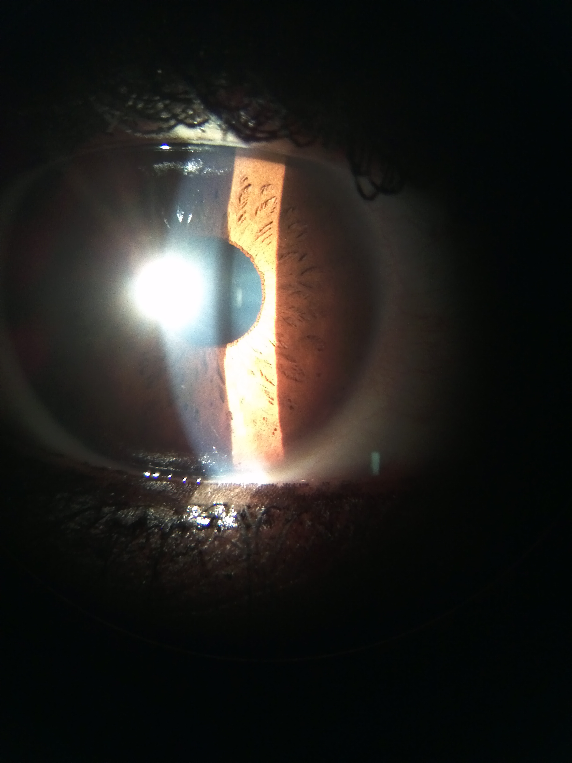

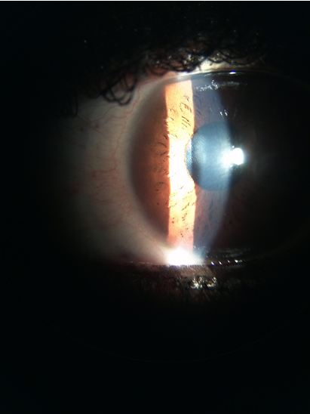

## Question 1 / 6

Based on the examination findings, what is the MOST likely cause of this patient's symptoms associated with prolonged near work?

a) Basic exophoria

b) Accommodative infacility

c) Accommodative insufficiency

d) Divergence excess

e) Convergence insufficiency

## Question 2 / 6

According to Sheard's criterion, which of the following fusional vergence ranges would allow the above patient to be asymptomatic?

a) PFV @ near: 18 / 24 / 16

b) PFV @ near: 12 / 18 / 12

c) NFV @ near: 26 / 32 / 18

d) PFV @ near: 24 / 28 / 18

e) NFV @ near: 20 / 24 / 16

f) NFV @ near: 12 / 30 / 16

## Question 3 / 6

If vision therapy was prescribed for 8 weeks and the patient was compliant with his home training, how would you expect his near phoria to change after this 8 week period?

a) The near phoria should be eliminated

b) The near phoria should remain the same

c) The near phoria should decrease by roughly 6-8 prism diopters

d) The near phoria should decrease by roughly 2-4 prism diopters

e) The near phoria should decrease by roughly 4-6 prism diopters

## Question 4 / 6

Which 3 of the following vision therapy exercises would be MOST beneficial for your patient? (Select 3)

a) Hart chart saccades

b) Monocular lens clearing and sorting

c) Hart chart accommodative therapy

d) Brock string

e) Pencil saccades

f) Pencil push-ups

g) Eccentric circles free-space fusion cards

## Question 5 / 6

What is the MOST likely reason that this patient performed better monocularly than binocularly on accommodative facility testing?

a) The patient's abnormal saccadic eye movements cause a disruption of the binocular system

b) The accommodative system can overcompensate for any observed phoria when tested monocularly

c) The patient's accommodative capabilities are deficient, causing an increase in difficulty when both eyes view the targets together

d) The vergence system is incorporated when testing binocular accommodative facility

## Question 6 / 6

How can the traditional manner of evaluating the near point of convergence (NPC) be altered to aid in the detection of subtle cases similar to the above patient's condition?

a) Add red/green glasses and use a penlight as the near target

b) Increase the size of the accommodative target from 20/20 to 20/40

c) Add 4 base-out prism in front of the patient's dominant eye

d) Increase the room illumination

e) Add +0.50 loose lenses OU over the patient’s habitual Rx