Case IAiyAEnbPrWGnXjz3341 Details

**Demographics**

* 15-year-old Asian male; student

**Chief complaint**

* headaches and double vision

**History of present illness**

* Character/signs/symptoms:headaches and binocular horizontal diplopia
* Location:frontal headaches; diplopia at distance and near
* Severity:moderate
* Nature of onset:gradual
* Duration:several years, but worse over the past 6 months
* Frequency:daily
* Exacerbations/remissions:worse after prolonged distance or near work and when tired; resolves after resting
* Relationship to activity or function:computer, tablet, reading, television, taking notes from the board in school
* Accompanying signs/symptoms:eyes feel like they are "pulling" when he reads, gets tired easily

**Secondary complaints/symptoms**

* confuses colors

**Patient ocular history**

* 1st eye exam

**Family ocular history**

* father: retinal scarring from toxoplasmosis

**Patient medical history**

* unremarkable

**Medications taken by patient**

* OTC multivitamins

**Patient allergy history**

* pollen, NKDA

**Family medical history**

* unremarkable

**Review of systems**

* Constitutional/general health:denies
* Ear/nose/throat:denies
* Cardiovascular:denies
* Pulmonary:denies
* Dermatological:denies
* Gastrointestinal:denies
* Genitourinary:denies
* Musculoskeletal:denies
* Neuropsychiatric:denies
* Endocrine:denies
* Hematologic:denies
* Immunologic:denies

**Mental status**

* Orientation:oriented to time, place, and person
* Mood:appropriate
* Affect:appropriate

**Clinical findings**

**Uncorrected visual acuity**

* OD:distance: 20/20, near: 20/20 @ 40 cm
* OS:distance: 20/20, near: 20/20 @ 40 cm

**Pupils:**

* PERRL, negative APD

**EOMs:**

* full, no restrictions OU

**Cover test:**

* distance: 12 exophoria, near: 14 exophoria

**Confrontation fields:**

* full to finger counting OD, OS

**Stereo test:**

* 70" (Random dot)

**Subjective refraction**

* OD:+0.50 -0.50 x 170; VA distance: 20/20
* OS:+0.25 -0.50 x 010; VA distance: 20/20

**Vergence system**

* NPC:10 cm
* Vergences:NFV @ distance: x / 10 / 6, NFV @ near: 12 / 22 / 15; PFV @ distance: 4 / 8 / 2, PVF @ near: x / 9 / 3
* Facility:8 base-out/8 base-in: 3 cycles/minute @ 40 cm (difficulty with base-out)

**Slit lamp**

* lids/lashes/adnexa:unremarkable OD, OS
* conjunctiva:normal OD, OS
* cornea:clear OD, OS
* anterior chamber:deep and quiet OD, OS
* iris:normal OD, OS
* lens:clear OD, OS
* vitreous:clear OD, OS

**IOPs:**

* OD: 12 mmHg, OS: 13 mmHg @ 2:41 pm by Goldmann applanation tonometry

**Fundus OD**

* C/D:see image 1
* macula:see image 1
* posterior pole:see image 1
* periphery:unremarkable

**Fundus OS**

* C/D:see image 2
* macula:see image 2
* posterior pole:see image 2
* periphery:unremarkable

**Blood pressure:**

* 99/69 mmHg, right arm, sitting

**Pulse:**

* 65 bpm, regular

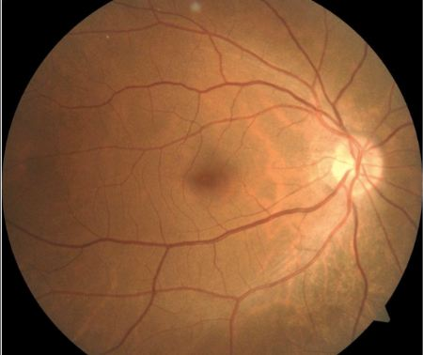

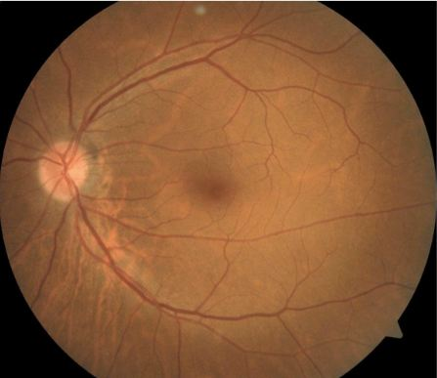

## Question 1 / 5

Based on this patient’s examination findings, what is the MOST likely cause of his symptoms associated with prolonged distance and near work?

a) Accommodative insufficiency

b) Divergence excess

c) Basic exophoria

d) Accommodative infacility

e) Convergence insufficiency

f) Basic esophoria

## Question 2 / 5

If you were to perform the Worth 4 dot test on the above patient (when symptomatic) with the red lens placed over his right eye, which of the following observations would you MOST likely expect him to report?

a) 3 green circles only

b) 5 circles, with two red circles to the left of the 3 green circles

c) 5 circles, with two red circles to the right of the 3 green circles

d) 4 circles, with 2 red circles to the left of 2 green circles

e) 4 circles, with 2 red circles to the right of 2 green circles

f) 2 red circles only

## Question 3 / 5

Using the Von Graefe method to determine any amount of vertical phoria present, your patient reports that the targets are lined up horizontally with 2 base-up prism before the left eye. What can you conclude from these results?

a) He has a right hypodeviation or a left hyperdeviation

b) He has a left hypodeviation or a right hyperdeviation

c) He has a right hypodeviation

d) He has a left hypodeviation

e) He has a right hyperdeviation

f) He has a left hyperdeviation

## Question 4 / 5

The patient reports that he has been told that he is color blind, but he is unsure what type of color vision deficit he suffers from. Which of the following color vision tests is able to differentiate between a dichromat and an anomalous trichromat?

a) Ishihara color test

b) Farnsworth dichotomous test

c) Desaturated D-15 test

d) Anomaloscope

e) Pseudoisochromatic plates

## Question 5 / 5

Assuming no refractive error, a patient with which of the following color vision anomalies would possess the POOREST level of acuity?

a) Achromatopsia

b) Deuteranomaly

c) Protanomaly

d) Deuteranopia

e) Tritanopia

f) Tritanomaly

g) Protanopia