Case IZiCIAnIkqiHnjXi7675 Details

**Demographics**

* 38-year-old Asian male; business analyst

**Chief complaint**

* itchy eyes

**History of present illness**

* Character/signs/symptoms:red, itchy eyes and swollen eyelids
* Location:OD, OS
* Severity:severe
* Nature of onset:acute
* Duration:2 hours
* Frequency:constant
* Exacerbations/remissions:none
* Relationship to activity or function:none
* Accompanying signs/symptoms:none

**Secondary complaints/symptoms**

* none

**Patient ocular history**

* last eye exam 3 years ago; unremarkable; does not wear vision correction

**Family ocular history**

* father: LASIK

**Patient medical history**

* unremarkable

**Medications taken by patient**

* none

**Patient allergy history**

* NKDA

**Family medical history**

* father: prostate cancer

**Review of systems**

* Constitutional/general health:denies
* Ear/nose/throat:denies
* Cardiovascular:denies
* Pulmonary:denies
* Dermatological:itching and swelling of eyelids
* Gastrointestinal:denies
* Genitourinary:denies
* Musculoskeletal:denies
* Neuropsychiatric:denies
* Endocrine:denies
* Hematologic:denies
* Immunologic:denies

**Mental status**

* Orientation:oriented to time, place, and person
* Mood:appropriate
* Affect:appropriate

**Clinical findings**

**Uncorrected visual acuity**

* OD:VA distance: 20/20-2
* OS:VA distance: 20/20-2

**Pupils:**

* PERRL, negative APD

**EOMs:**

* full, no restrictions OU

**Confrontation fields:**

* full to finger counting OD, OS

**Slit lamp**

* lids/lashes/adnexa:see image 1 OD, see image 2 OS
* conjunctiva:1+ chemosis OD, OS
* cornea:clear OD, OS
* anterior chamber:deep and quiet OD, OS
* iris:normal OD, OS
* lens:clear OD, OS
* vitreous:clear OD, OS

**IOPs:**

* OD: 11 mmHg, OS: 11 mmHg @ 1:30 pm by Goldmann applanation tonometry

**Fundus OD**

* C/D:0.30 H/0.30 V
* macula:normal
* posterior pole:normal
* periphery:unremarkable

**Fundus OS**

* C/D:0.30 H/0.30 V
* macula:normal
* posterior pole:normal
* periphery:unremarkable

**Blood pressure:**

* 122/82 mmHg, right arm, sitting

**Pulse:**

* 78 bpm, regular

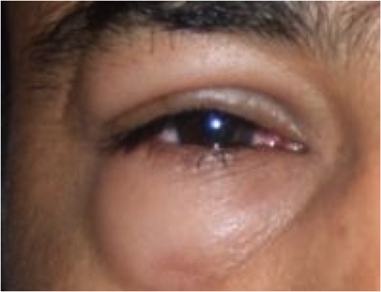

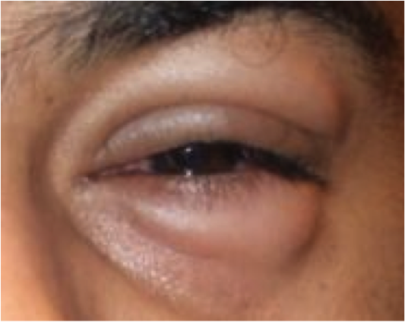

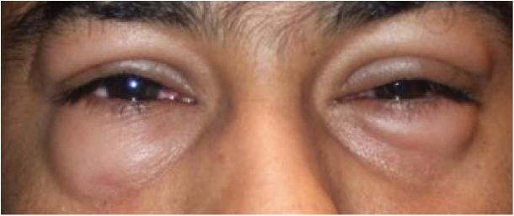

## Question 1 / 5

What is the MOST appropriate diagnosis of the patient's ocular condition?

a) Bilateral chalazia

b) Blepharitis

c) Contact dermatitis

d) Angioedema

e) Bacterial conjunctivitis

## Question 2 / 5

What is the MOST appropriate treatment of this patient's ocular condition?

a) Ocuflox® q.i.d. OU for seven days

b) Warm compresses and eyelid massage q.i.d.

c) Blephamide® q.i.d. OU for seven days

d) Zyrtec® q.d. and cool compresses

e) Prednisolone acetate q.i.d. OU for seven days

## Question 3 / 5

After the initiation of treatment, when should the patient follow-up with you?

a) A follow-up appointment is not needed unless symptoms worsen

b) 3-4 weeks

c) 2-3 months

d) 1 year

e) 2-3 days

f) 6 months

## Question 4 / 5

The patient's blood pressure measurement at this visit is categorized as which of the following?

a) Hypertensive crisis

b) Stage II hypertension

c) Normal

d) Stage I hypertension

e) Pre-hypertension

## Question 5 / 5

Which of the following situations requires the need for a compounding pharmacist?

a) The patient needs counsel on the medication that you prescribed

b) The patient requires a medication but is allergic to one of the inactive ingredients

c) The patient needs to switch to a generic medication

d) The patient is a minor and needs his/her parent present to pick up the prescribed medication