Case KtSrqwyuERNQhMO10541 Details

**Demographics**

* 21-year-old white male; student

**Chief complaint**

* blurred vision at night

**History of present illness**

* Character/signs/symptoms:difficulty with vision at night; trouble seeing street signs
* Location:OD, OS
* Severity:mild
* Nature of onset:gradual
* Duration:6 months
* Frequency:every night
* Exacerbations/remissions:occurs at night only; better/asymptomatic during the day
* Relationship to activity or function:most noticeable when driving at night
* Accompanying signs/symptoms:glare, issues with depth perception

**Secondary complaints/symptoms**

* none

**Patient ocular history**

* last eye exam 1 year ago, does not wear glasses or contact lenses

**Family ocular history**

* father: glaucoma suspect

**Patient medical history**

* depression

**Medications taken by patient**

* Wellbutrin®

**Patient allergy history**

* monoamine oxidase inhibitors

**Family medical history**

* father: hepatitis C

**Review of systems**

* Constitutional/general health:denies
* Ear/nose/throat:denies
* Cardiovascular:denies
* Pulmonary:denies
* Dermatological:denies
* Gastrointestinal:denies
* Genitourinary:denies
* Musculoskeletal:denies
* Neuropsychiatric:depression
* Endocrine:denies
* Hematologic:denies
* Immunologic:denies

**Mental status**

* Orientation:oriented to time, place, and person
* Mood:appropriate
* Affect:appropriate

**Clinical findings**

**Uncorrected visual acuity**

* OD:distance: 20/20; near: 20/20 @ 40 cm
* OS:distance: 20/20; near: 20/20 @ 40 cm

**Pupils:**

* PERRL, negative APD

**EOMs:**

* full, no restrictions OU

**Cover test:**

* distance: 4 exophoria, near: 4 exophoria

**Confrontation fields:**

* full to finger counting OD, OS

**Subjective refraction**

* OD:plano - 0.25 x 178; VA distance: 20/20, VA: near: 20/20 @ 40 cm
* OS:plano DS; VA distance: 20/20, VA near: 20/20 @ 40 cm

**Keratometry**

* OD:43.50 @ 080 / 43.75 @ 170; no distortion of mires
* OS:43.75 @ 180 / 44.00 @ 090; no distortion of mires

**Dark room retinoscopy**

* OD:-0.75 -0.25 x 180; VA distance: 20/20
* OS:-0.75 DS; VA distance: 20/20

**Slit lamp**

* lids/lashes/adnexa:unremarkable OD, OS
* conjunctiva:normal OD, OS
* cornea:clear OD, OS
* anterior chamber:deep and quiet OD, OS
* iris:normal OD, OS
* lens:clear OD, OS
* vitreous:clear OD, OS

**IOPs:**

* OD: 12 mmHg, OS: 13 mmHg @ 5:50 pm by Goldmann applanation tonometry

**Fundus OD**

* C/D:see image 1
* macula:see image 1
* posterior pole:see image 1
* periphery:unremarkable

**Fundus OS**

* C/D:see image 2
* macula:see image 2
* posterior pole:see image 2
* periphery:unremarkable

**Blood pressure:**

* 104/70 mmHg, right arm, sitting

**Pulse:**

* 68 bpm, regular

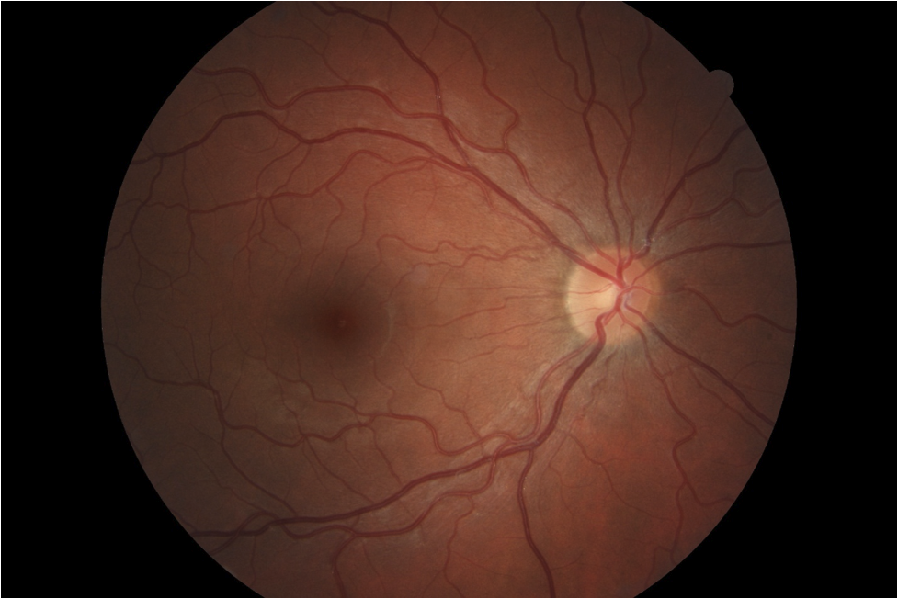

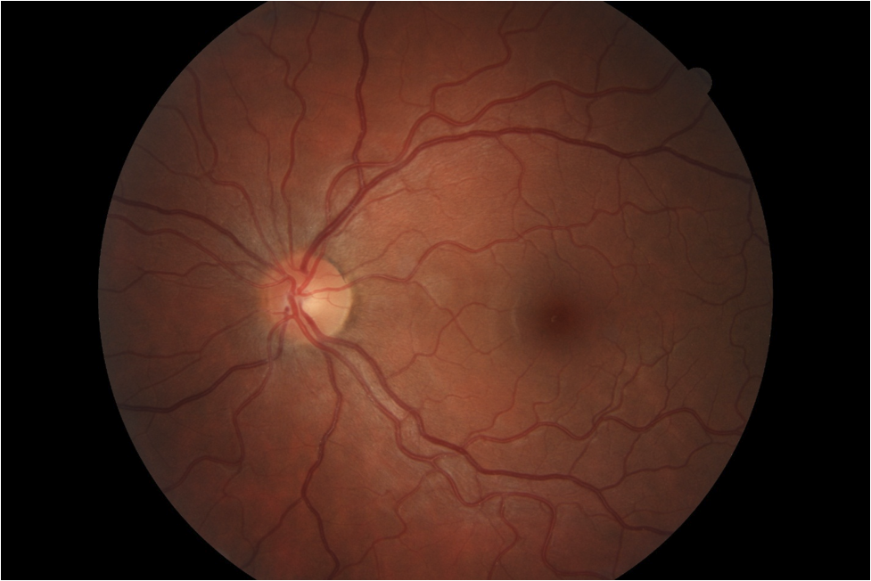

## Question 1 / 5

Which of the following represents the MOST appropriate diagnosis for the patient's complaint of decreased vision?

a) Accommodative infacility

b) Degenerative myopia

c) Uncorrected astigmatism

d) Induced myopia

e) Accommodative insufficiency

f) Nocturnal myopia

g) Pseudomyopia

## Question 2 / 5

Which of the following describes the MOST appropriate treatment for this patient's chief concerns?

a) Discontinue current systemic medication

b) Vision therapy with emphasis on accommodation treatments

c) Treatment of the underlying systemic condition

d) Single vision distance glasses for full-time wear

e) Single vision distance glasses for night driving

f) Bifocal lenses to reduce the rate of myopia progression

g) Single vision near glasses to relax the accommodative system

## Question 3 / 5

Which of the following types of aberrations contributes the MOST to the patient's complaint of reduced visual acuity?

a) Trefoil

b) Radial astigmatism

c) Distortion

d) Spherical aberration

e) Coma

## Question 4 / 5

This patient currently uses Wellbutrin® to help manage his depression. Which of the following side effects is MOST commonly associated with this medication?

a) Thoughts of suicide

b) Deep vein thrombosis

c) Alopecia

d) Bloody sputum

e) Urinary incontinence

f) Hypotension

## Question 5 / 5

The patient recently lost his mother in a car accident and began crying during the exam and asked you for a tissue. What is the MOST appropriate method to dispose of his soiled tissue?

a) In a designated biohazard bin

b) In a properly labeled medical waste container

c) In an incinerator

d) In a regular trash can

e) In an autoclave machine