Case LhzDZhPKklfllYMQ8648 Details

**Demographics**

* 76-year-old Asian female; retired

**Chief complaint**

* blurred vision

**History of present illness**

* Character/signs/symptoms:blurry vision in the right eye at all distances
* Location:OD
* Severity:severe
* Nature of onset:acute
* Duration:5 days
* Frequency:constant
* Exacerbations/remissions:none
* Relationship to activity or function:none
* Accompanying signs/symptoms:none

**Secondary complaints/symptoms**

* none

**Patient ocular history**

* cataract surgery OU 2 years ago; YAG capsulotomy OD 2 weeks ago

**Family ocular history**

* mother: cataracts, father: primary open angle glaucoma

**Patient medical history**

* hypothyroid, hypertension

**Medications taken by patient**

* levothyroxine, atenolol

**Patient allergy history**

* penicillin

**Family medical history**

* unremarkable

**Review of systems**

* Constitutional/general health:denies
* Ear/nose/throat:denies
* Cardiovascular:denies
* Pulmonary:denies
* Dermatological:denies
* Gastrointestinal:denies
* Genitourinary:denies
* Musculoskeletal:denies
* Neuropsychiatric:denies
* Endocrine:denies
* Hematologic:denies
* Immunologic:denies

**Mental status**

* Orientation:oriented to time, place, and person
* Mood:appropriate
* Affect:appropriate

**Clinical findings**

**Habitual spectacle Rx**

* OD:+0.50 -0.75 x 165 add: +2.50; VA distance: 20/150 (PHNI)
* OS:+0.25 -1.00 x 070 add: +2.50; VA distance: 20/30

**Pupils:**

* PERRL, negative APD

**EOMs:**

* full, no restrictions OU

**Confrontation fields:**

* full to finger counting OD, OS

**Slit lamp**

* lids/lashes/adnexa:dermatochalasis OD, OS
* conjunctiva:normal OD, OS
* cornea:1+ guttata OD, OS
* anterior chamber:deep and quiet OD, OS
* iris:normal OD, OS
* lens:PCIOL, centered with open posterior capsule OD, PCIOL, centered with 2+ posterior capsular opacification OS
* vitreous:syneresis OD, OS

**IOPs:**

* OD: 16 mmHg, OS: 16 mmHg @ 9:15 am by Goldmann applanation tonometry

**Fundus OD**

* C/D:0.40 H/0.40 V
* macula:see image 1
* posterior pole:normal
* periphery:unremarkable

**Fundus OS**

* C/D:0.40 H/0.40 V
* macula:see image 2
* posterior pole:normal
* periphery:unremarkable

**Blood pressure:**

* 116/72 mmHg, right arm, sitting

**Pulse:**

* 62 bpm, regular

**Amsler grid**

* OD:central metamorphopsia
* OS:(-) metamorphopsia, (-) scotomas

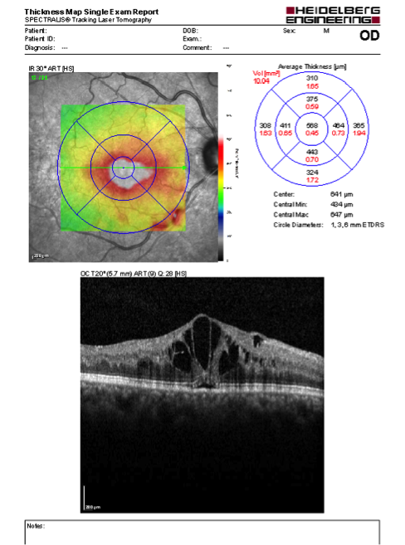

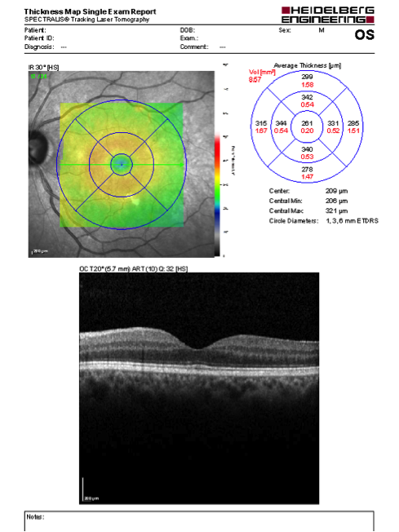

## Question 1 / 6

What is the BEST diagnosis for the patient's right eye retinal condition?

a) Irvine-Gass syndrome

b) Cystoid macular edema

c) Central serous retinopathy

d) Epiretinal membrane with vitreomacular traction

e) Choroidal neovascular membrane

## Question 2 / 6

Which of the following macular conditions may form if this patient’s ocular condition remains unresolved?

a) Retinal detachment

b) Lamellar macular hole

c) Geographic atrophy

d) Choroidal neovascular membrane

e) Full thickness macular hole

## Question 3 / 6

Which of the following BEST describes the classic fluorescein angiography pattern typically observed in patients with this retinal condition?

a) Small hyperfluorescent spots in the early phase with "flower-petal" pattern of hyperfluorescence in the late stage

b) Single early spot of hyperfluorescence with expansion up and out in a smoke-stack appearance

c) Single early spot of hypofluorescence with expansion up and out in a smoke-stack appearance

d) No visible abnormal leakage of dye, hyperfluorescence, or hypofluorescence will be observed

e) Small hypofluorescent spots in the early phase with "flower-petal" pattern of hypofluorescence in the late stage

f) A well delineated area of lacy hyperfluorescence in the early phase with prominent leakage in the late phase

## Question 4 / 6

Which of the following hereditary retinal diseases is MOST commonly associated with this patient’s diagnosis?

a) Juvenile Best disease

b) Adult vitelliform dystrophy

c) Leber congenital amaurosis

d) Stargardt disease

e) Retinitis pigmentosa

## Question 5 / 6

What is the BEST initial treatment for the patient's right eye?

a) Refer for vitrectomy

b) No treatment is necessary, monitor the condition only at this time

c) Indomethacin 25 mg p.o. t.i.d.

d) Refer for Avastin® injection

e) Acetazolamide 500 mg p.o. q.d.

f) Refer for laser photocoagulation

g) 1 gtt ketorolac OD q.i.d. and 1 gtt prednisolone acetate OD q.i.d.

## Question 6 / 6

If one of your paraoptometrics breaches a patient's confidentiality, who would be considered liable for a malpractice action in a court of law?

a) Both the optometrist and the paraoptometric

b) The paraoptometric

c) No one; this is not considered a malpractice claim

d) The optometrist