Case MRowPbPTXxyvFOMs9152 Details

**Demographics**

* 31-year-old white male; financial advisor

**Chief complaint**

* severe headaches

**History of present illness**

* Character/signs/symptoms:extremely painful headaches
* Location:right side of the head, behind the right eye
* Severity:severe
* Nature of onset:rapid
* Duration:episodes last 30-45 minutes
* Frequency:2-3 attacks per day over the past week
* Exacerbations/remissions:episodes occur around the same times every day; pain wakes him up at night
* Relationship to activity or function:none
* Accompanying signs/symptoms:redness and tearing of his right eye during an attack

**Secondary complaints/symptoms**

* none

**Patient ocular history**

* last eye exam 2 years ago; wears single vision glasses full time

**Family ocular history**

* father: glaucoma suspect

**Patient medical history**

* seasonal allergies

**Medications taken by patient**

* Claritin®

**Patient allergy history**

* sulfa-based medications

**Family medical history**

* father: hypercholesterolemia

**Review of systems**

* Constitutional/general health:denies
* Ear/nose/throat:occasional runny nose and itchy throat
* Cardiovascular:denies
* Pulmonary:denies
* Dermatological:denies
* Gastrointestinal:denies
* Genitourinary:denies
* Musculoskeletal:denies
* Neuropsychiatric:severe headaches
* Endocrine:denies
* Hematologic:denies
* Immunologic:denies

**Mental status**

* Orientation:oriented to time, place, and person
* Mood:appropriate
* Affect:appropriate

**Clinical findings**

**Habitual spectacle Rx**

* OD:-2.25 -0.25 x 087; VA distance: 20/20
* OS:-2.50 DS: VA distance: 20/20

**Pupils:**

* PERRL, negative APD

**EOMs:**

* full, no restrictions OU

**Confrontation fields:**

* full to finger counting OD, OS

**Slit lamp**

* lids/lashes/adnexa:unremarkable OD, OS
* conjunctiva:normal OD, OS
* cornea:clear OD, OS
* anterior chamber:deep and quiet OD, OS
* iris:normal OD, OS
* lens:clear OD, OS
* vitreous:clear OD, OS

**IOPs:**

* OD: 15 mmHg, OS: 15mmmHg @ 8:10 am by Goldmann applanation tonometry

**Fundus OD**

* C/D:see image 1
* macula:see image 1
* posterior pole:see image 1
* periphery:unremarkable

**Fundus OS**

* C/D:see image 2
* macula:see image 2
* posterior pole:see image 2
* periphery:unremarkable

**Blood pressure:**

* 112/68 mmHg, right arm, sitting

**Pulse:**

* 76 bpm, regular

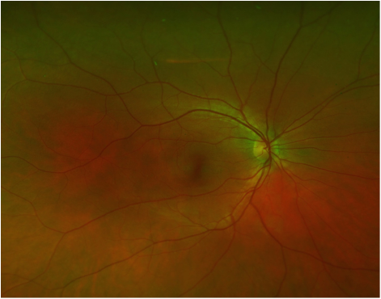

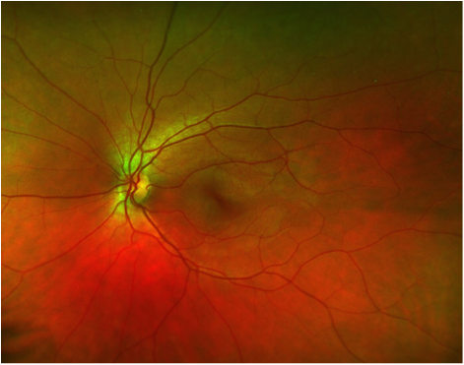

## Question 1 / 6

What is the MOST likely type of headache this patient is suffering from?

a) Migraine headache

b) Sinus headache

c) Cluster headache

d) Tension headache

## Question 2 / 6

Which of the following BEST describes the pathophysiology of the pain and ocular symptoms produced by this type of headache?

a) Inflammation of the paranasal sinuses

b) Activation of the trigeminal nerve

c) Neurotransmitter imbalance

d) Fluctuation in circulating hormones

e) Muscle tension and contracture around the head and neck

## Question 3 / 6

Which of the following represents the MOST common first line of treatment in managing the pain associated with this type of headache?

a) Ibuprofen

b) Amitriptyline

c) Naproxen

d) Oxygen inhalation

e) Exercise

f) Aspirin

## Question 4 / 6

What neurological condition MOST commonly accompanies this patient’s diagnosis?

a) Bell’s palsy

b) Internuclear ophthalmoplegia

c) Trochlear nerve palsy

d) Horner syndrome

e) Amaurosis fugax

## Question 5 / 6

Which of the following statements should be included in your patient education for this case?

a) Relaxation, exercise, and lifestyle changes can be very effective in reducing the frequency and intensity of headaches

b) These headaches typically last for several weeks and are often followed by a headache-free interval that may last months to years

c) Frequent hand washing, flu vaccines, and humidifiers can help reduce the risk of upper-respiratory infections that may trigger this type of headache

d) Keeping a meal log may be helpful in identifying types of foods that may trigger the onset of headaches

## Question 6 / 6

Aspirin should not be used in children for the treatment of flu-like symptoms, common colds, or chicken pox due to the risk of developing which of the following conditions?

a) Raynaud syndrome

b) Pernicious anemia

c) Reye syndrome

d) Stevens-Johnson syndrome