Case NiCIqyQerUlUpVHTGO88 Details

**Demographics**

* 8-year-old Asian female; student

**Chief complaint**

* double vision

**History of present illness**

* Character/signs/symptoms:horizontal diplopia at both distance and near
* Location:OU
* Severity:moderate
* Nature of onset:gradual
* Duration:6 months
* Frequency:intermittent
* Exacerbations/remissions:worse at the end of the day or when tired; better if she rests her eyes
* Relationship to activity or function:mostly notices when watching television and viewing the board in class, or reading for prolonged periods of time
* Accompanying signs/symptoms:headaches and eyestrain at the end of the day; is easily distracted when doing schoolwork

**Secondary complaints/symptoms**

* none

**Patient ocular history**

* 1st eye exam

**Family ocular history**

* mother: "lazy eye" and has worn glasses since age 5, maternal grandmother: glaucoma

**Patient medical history**

* allergies; normal birth history and developmental milestones

**Medications taken by patient**

* Claritin®

**Patient allergy history**

* grass and pollen, NKDA

**Family medical history**

* father: cardiovascular disease, type II diabetes

**Review of systems**

* Constitutional/general health:denies
* Ear/nose/throat:denies
* Cardiovascular:denies
* Pulmonary:denies
* Dermatological:denies
* Gastrointestinal:denies
* Genitourinary:denies
* Musculoskeletal:denies
* Neuropsychiatric:denies
* Endocrine:denies
* Hematologic:denies
* Immunologic:denies

**Mental status**

* Orientation:oriented to time, place, and person
* Mood:appropriate
* Affect:appropriate

**Clinical findings**

**Uncorrected visual acuity**

* OD:VA distance: 20/20
* OS:VA distance: 20/20

**Pupils:**

* PERRL, negative APD

**EOMs:**

* full, no restrictions OU

**Cover test:**

* distance: 6 esophoria, near: 8 esophoria

**Confrontation fields:**

* full to finger counting OD, OS

**Oculomotor system**

* Pursuits:normal
* Saccades:normal
* Fixations:normal

**Subjective refraction**

* OD:plano DS; VA distance: 20/20, VA near: 20/20 @ 40 cm
* OS:plano DS; VA distance: 20/20, VA near: 20/20 @ 40 cm

**Accommodative system**

* Amplitudes:OD: 14 D, OS: 14 D, OU: 13 D
* Facility (+/- 2.00):OD: 11 cycles/minute, OS: 12 cycles/minute, OU: 3 cycles/minute (difficulty clearing minus-powered lenses)
* NRA/PRA:+2.75 / -1.00
* Monocular estimation method (MEM):OD: +1.00, OS: +1.25

**Vergence system**

* NPC:2 cm
* Vergences:NFV @ distance: x / 6 / 2, NFV @ near: x / 12 / 6, PFV @ distance: x / 20 / 15, PFV @ near: 18 / 32 / 24
* Facility:8 base-out/8 base-in: 2 cycles/minute (difficulty fusing base-in prism)

**Sensory system**

* Worth 4 dot:far: no suppression, near: no suppression
* Stereopsis:far: 120", near: 80"

**DEM test (percentile rank):**

* horizontal: 50%, vertical: 50%, ratio: 50%, errors: 99%

**Slit lamp**

* lids/lashes/adnexa:unremarkable OD, OS
* conjunctiva:normal OD, OS
* cornea:clear OD, OS
* anterior chamber:deep and quiet OD, OS
* iris:see image 1 OD, normal OS
* lens:clear OD, OS
* vitreous:clear OD, OS

**IOPs:**

* OD: 16 mmHg, OS: 16 mmHg @ 4:10 pm by iCare tonometer

**Fundus OD**

* C/D:0.35 H/0.30 V
* macula:normal
* posterior pole:normal
* periphery:unremarkable

**Fundus OS**

* C/D:see image 1 OD, normal OS
* macula:normal
* posterior pole:normal
* periphery:unremarkable

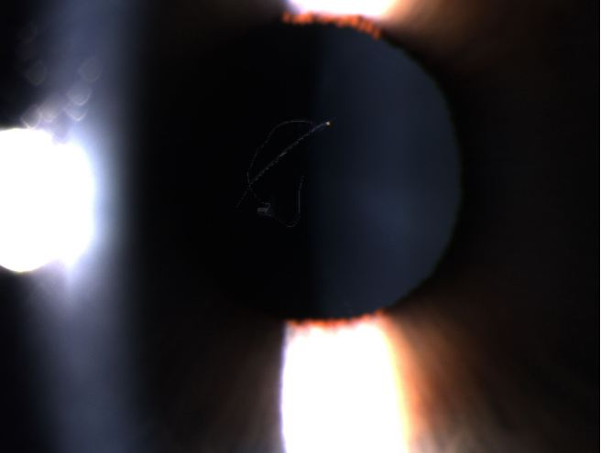

## Question 1 / 5

Based on the patient’s chief concern and examination findings, what is the MOST likely cause of her symptoms?

a) Accommodative infacility

b) Convergence excess

c) Basic exophoria

d) Accommodative insufficiency

e) Basic esophoria

f) Divergence insufficiency

## Question 2 / 5

What type of AC/A ratio is expected for this patient?

a) High AC/A ratio

b) Average AC/A ratio

c) The AC/A ratio is not relevant to this case

d) Low AC/A ratio

## Question 3 / 5

Which 3 of the following tests directly examine the accommodative system? (Select 3)

a) Positive fusional vergence ranges

b) Stereopsis

c) Monocular amplitudes

d) Monocular facility testing with +/- 2.00 D lenses

e) Monocular estimation method

f) Second-degree fusion

## Question 4 / 5

Which of the following represents an example of shallow suppression of the right eye while performing the red lens test (red lens over the right eye)?

a) The patient reports seeing two lights, one red and one white, with the white light being to the left of the red light

b) The patient reports seeing one white light in moderate illumination and one white light in dim illumination

c) The patient reports seeing one red light in moderate illumination and one pinkish light in dim illumination

d) The patient reports seeing two lights, one red and one white, with the white light being to the right of the red light

e) The patient reports seeing one red light in moderate illumination and one red light in dim illumination

f) The patient reports seeing one pinkish light in moderate illumination and one pinkish light in dim illumination

g) The patient reports seeing one white light in moderate illumination and one pinkish light in dim illumination

## Question 5 / 5

Which of the following represents the MOST likely cause of the patient's right eye anterior segment findings?

a) Posterior polymorphous dystrophy

b) Epicapsular stars

c) Persistent pupillary membrane

d) Mittendorf dot

e) Lattice dystrophy