Case NviPtQIVDNDbodxS9420 Details

**Demographics**

* 21-year-old white female; college student

**Chief complaint**

* problems with contact lenses

**History of present illness**

* Character/signs/symptoms:itchiness, irritation, and intermittent blurry vision with contact lens wear
* Location:OD, OS
* Severity:moderate
* Nature of onset:gradual
* Duration:2 weeks
* Frequency:constant
* Exacerbations/remissions:can only wear contacts for 3-4 hours, eyes feel better after removing lenses
* Relationship to activity or function:when wearing contact lenses
* Accompanying signs/symptoms:mild mucous discharge

**Secondary complaints/symptoms**

* none

**Patient ocular history**

* last eye exam 2 years ago; wears monthly planned replacement soft contact lenses, replaces every 4-6 weeks, sleeps in lenses once per month, uses multipurpose solution

**Family ocular history**

* unremarkable

**Patient medical history**

* unremarkable

**Medications taken by patient**

* Zyrtec®

**Patient allergy history**

* seasonal allergies, NKDA

**Family medical history**

* unremarkable

**Review of systems**

* Constitutional/general health:denies
* Ear/nose/throat:denies
* Cardiovascular:denies
* Pulmonary:denies
* Dermatological:denies
* Gastrointestinal:denies
* Genitourinary:denies
* Musculoskeletal:denies
* Neuropsychiatric:denies
* Endocrine:denies
* Hematologic:denies
* Immunologic:denies

**Mental status**

* Orientation:oriented to time, place, and person
* Mood:appropriate
* Affect:appropriate

**Clinical findings**

**Habitual contact lens Rx**

* ODCooperVision Biofinity / 14.0 / 8.6 / -4.00 DS; VA distance: 20/20-
* OSCooperVision Biofinity / 14.0 / 8.6 / -4.50 DS; VA distance: 20/20-

**Pupils:**

* PERRL, negative APD

**EOMs:**

* full, no restrictions OU

**Confrontation fields:**

* full to finger counting OD, OS

**Subjective refraction**

* OD:-4.25 DS; VA distance: 20/20
* OS:-4.75 DS; VA distance: 20/20

**Slit lamp**

* lids/lashes/adnexa:unremarkable OD, OS
* conjunctiva:see image 1 OD, OS similar to OD
* cornea:clear OD, OS
* anterior chamber:deep and quiet OD, OS
* iris:normal OD, OS
* lens:clear OD, OS
* vitreous:clear OD, OS

**Contact lens assessment**

* OD:good coverage and centration, excessive movement on blink, deposits on lens surface
* OS:good coverage and centration, excessive movement on blink, deposits on lens surface

**IOPs:**

* OD: 12 mmHg, OS: 13 mmHg @ 3:30 pm by Goldmann applanation tonometry

**Fundus OD**

* C/D:0.20 H/0.20 V
* macula:normal
* posterior pole:normal
* periphery:unremarkable

**Fundus OS**

* C/D:0.20 H/0.20 V
* macula:normal
* posterior pole:normal
* periphery:unremarkable

**Blood pressure:**

* 110/68 mmHg, right arm, sitting

**Pulse:**

* 68 bpm, regular

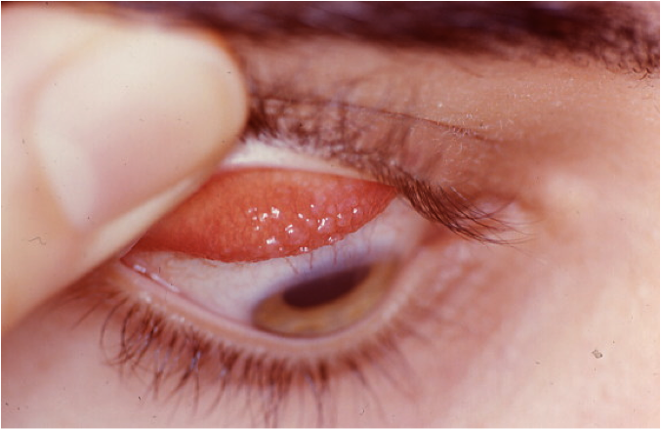

## Question 1 / 5

Which of the following represents the BEST diagnosis for the ocular condition observed in this patient?

a) Bacterial conjunctivitis

b) Vernal keratoconjunctivitis

c) Perennial allergic conjunctivitis

d) Giant papillary conjunctivitis

e) Atopic conjunctivitis

## Question 2 / 5

Which of the following 2 types of hypersensitivity reactions does this diagnosis represent? (Select 2)

a) Type I

b) Type II

c) Type IV

d) Type V

e) Type III

## Question 3 / 5

Which 2 of the following are the MOST widely accepted pathogenic mechanisms that result in the development of this patient’s ocular condition? (Select 2)

a) Immune reaction to denatured protein deposits

b) Immune response to protein breakdown from bacterial disintegration

c) Direct exposure to environmental allergens (dust, grass, animal dander)

d) Seasonally related immune response to circulating aero-antigens

e) Mechanical irritation of the superior tarsal conjunctiva

## Question 4 / 5

Which of the following describes the BEST topical medication regimen for the treatment of this patient’s condition?

a) Prednisolone acetate 1 gtt OU b.i.d. x 1 week

b) No topical ocular medication is necessary

c) Moxifloxacin 1 gtt OU t.i.d. x 1 week

d) Ketorolac 1 gtt OU b.i.d. x 1 week

e) Olopatadine 1 gtt OU b.i.d. x 2 weeks

## Question 5 / 5

Which of the following should be included in your patient education in this case?

a) Keeping a log of irritants that trigger your condition will be helpful in knowing what may exacerbate your symptoms

b) Your contact lenses may need to be changed to a daily disposable modality to prevent the likelihood of recurrences

c) Your condition will likely spontaneously resolve with time without any further symptoms or visual complications

d) Your condition is contagious; therefore frequent hand washing and caution should be implemented when in contact with others

e) It is likely for your condition to recur around the same time every year, so initiating treatment before symptoms occur will be beneficial