Case OSQUqnDhtxKhOMj14045 Details

**Demographics**

* 48-year-old Hispanic male; horticulturist

**Chief complaint**

* trouble reading

**History of present illness**

* Character/signs/symptoms:blurred near vision; difficulty reading
* Location:OD, OS
* Severity:moderate
* Nature of onset:gradual
* Duration:1 year
* Frequency:constant
* Exacerbations/remissions:vision improves with bright lighting or when holding material further away
* Relationship to activity or function:near vision only; distance vision is good
* Accompanying signs/symptoms:eye fatigue, headaches

**Secondary complaints/symptoms**

* none

**Patient ocular history**

* last eye exam 4 years ago; growth on right eye, has been present since childhood

**Family ocular history**

* father: pterygium surgery

**Patient medical history**

* hypercholesterolemia, depression, anxiety

**Medications taken by patient**

* lovastatin, Wellbutrin®, Prozac®

**Patient allergy history**

* NKDA

**Family medical history**

* father: Alzheimer disease

**Review of systems**

* Constitutional/general health:denies
* Ear/nose/throat:denies
* Cardiovascular:denies
* Pulmonary:denies
* Dermatological:denies
* Gastrointestinal:denies
* Genitourinary:denies
* Musculoskeletal:denies
* Neuropsychiatric:depression, anxiety
* Endocrine:denies
* Hematologic:denies
* Immunologic:denies

**Mental status**

* Orientation:oriented to time, place, and person
* Mood:appropriate
* Affect:appropriate

**Clinical findings**

**Uncorrected visual acuity**

* OD:VA distance: 20/25, VA near: 20/40 @ 40 cm
* OS:VA distance: 20/25, VA near: 20/30 @ 40 cm

**Pupils:**

* PERRL, negative APD

**EOMs:**

* full, no restrictions OU

**Cover test:**

* distance: orthophoria, near: 4 exophoria

**Confrontation fields:**

* full to finger counting OD, OS

**Keratometry**

* OD:44.25 @ 176 / 43.75 @ 086; no distortion of mires
* OS:44.50 @ 180 / 44.00 @ 090; no distortion of mires

**Subjective refraction**

* OD:plano -0.75 x 072 add: +1.50; VA distance: 20/20, VA near: 20/20 @ 40 cm
* OS:-0.50 DS add: +1.50; VA distance: 20/20, VA near: 20/20 @ 40 cm

**Slit lamp**

* lids/lashes/adnexa:see image 1 OD, OS similar to OD
* conjunctiva:see image 2 OD, normal OS
* cornea:clear OD, OS
* anterior chamber:deep and quiet OD, OS
* iris:normal OD, OS
* lens:clear OD, OS
* vitreous:clear OD, OS

**IOPs:**

* OD: 15 mmHg, OS: 16 mmHg @ 12:05 pm by Goldmann applanation tonometry

**Fundus OD**

* C/D:0.25 H/0.20 V
* macula:normal
* posterior pole:normal
* periphery:unremarkable

**Fundus OS**

* C/D:0.20 H/0.20 V
* macula:normal
* posterior pole:normal
* periphery:unremarkable

**Blood pressure:**

* 121/78 mmHg, right arm, sitting

**Pulse:**

* 76 bpm, regular

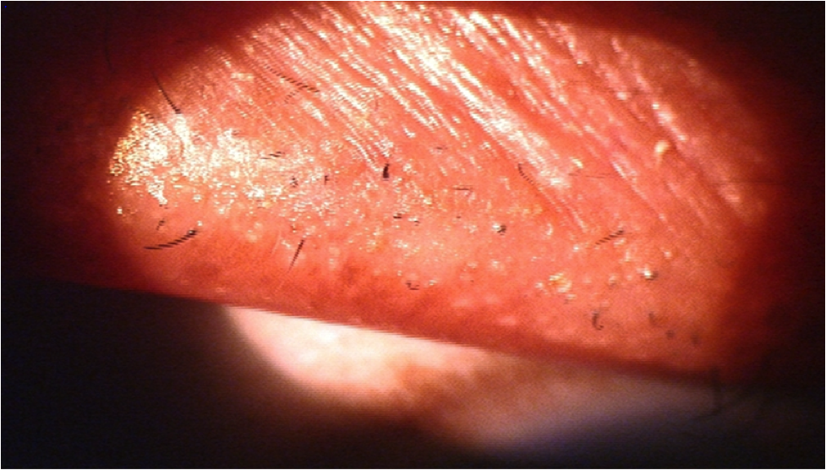

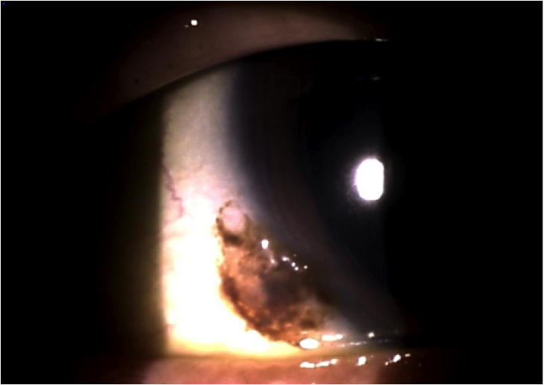

## Question 1 / 5

What is the MOST appropriate diagnosis for the patient's anterior segment condition observed in image 1?

a) Trichiasis

b) Trichomegaly

c) Trichotillomania

d) Polytrichosis

e) Poliosis

## Question 2 / 5

What is the MOST likely diagnosis of this patient's conjunctival condition observed in image 2?

a) Melanocytoma

b) Pigmented pinguecula

c) Primary acquired melanosis

d) Conjunctival nevus

e) Conjunctival melanoma

## Question 3 / 5

What is the MOST appropriate treatment of this patient's conjunctival condition?

a) Refer for excision with mitomycin C

b) Refer for biopsy

c) Monitor every 6-12 months

d) Refer for immediate exenteration

e) Refer for CT scan of the orbits

## Question 4 / 5

Which of the following should be included in your patient education regarding the lesion observed in image 2?

a) Do not use artificial tears with preservatives as these may irritate the lesion

b) There is a high mortality rate associated with this condition

c) It is normal for the right eye lesion to grow and change color over time

d) Ensure the use of sunglasses to protect the eyes from harmful ultraviolet light

e) If the left eye becomes red, return to the office immediately, as this can indicate that the lesion has spread

## Question 5 / 5

The patient returns to pick up his new polycarbonate progressive lenses. Before you dispense them, you notice that the fitting markings are still present on the lenses. Which of the following agents can NOT be used to clean off the markings?

a) Water

b) Dish soap

c) Acetone

d) Isopropyl alcohol

e) Acetic acid