Case OwZdwauIaQVxBlL14511 Details

**Demographics**

* 32-year-old white male; fisherman/hunter

**Chief complaint**

* blurred vision and ocular discomfort

**History of present illness**

* Character/signs/symptoms:blurry vision, light sensitivity, and eye pain
* Location:OD, OS
* Severity:mild
* Nature of onset:acute
* Duration:2 days
* Frequency:constant
* Exacerbations/remissions:had similar episode last month after hunting trip in Oregon; symptoms resolved on their own after a few days
* Relationship to activity or function:none
* Accompanying signs/symptoms:floaters

**Secondary complaints/symptoms**

* none

**Patient ocular history**

* last eye exam 2 years ago

**Family ocular history**

* unremarkable

**Patient medical history**

* ACL repair surgery

**Medications taken by patient**

* none

**Patient allergy history**

* NKDA

**Family medical history**

* mother: ovarian cancer, father: hypertension

**Review of systems**

* Constitutional/general health:denies
* Ear/nose/throat:denies
* Cardiovascular:denies
* Pulmonary:denies
* Dermatological:denies
* Gastrointestinal:denies
* Genitourinary:denies
* Musculoskeletal:denies
* Neuropsychiatric:denies
* Endocrine:denies
* Hematologic:denies
* Immunologic:denies

**Mental status**

* Orientation:oriented to time, place, and person
* Mood:appropriate
* Affect:appropriate

**Clinical findings**

**Uncorrected visual acuity**

* OD:distance: 20/40 (PH 20/30)
* OS:distance: 20/40 (PH 20/30)

**Pupils:**

* PERRL, negative APD

**EOMs:**

* full, no restrictions OU

**Confrontation fields:**

* full to finger counting OD, OS

**Slit lamp**

* lids/lashes/adnexa:unremarkable OD, OS
* conjunctiva:1+ hyperemia OD, OS
* cornea:clear OD, OS
* anterior chamber:deep and quiet OD, OS
* iris:normal OD, OS
* lens:clear OD, OS
* vitreous:OD similar to OS, see image 1 OS

**IOPs:**

* OD: 14 mmHg, OS: 13 mmHg @ 9:15 am by Goldmann applanation tonometry

**Fundus OD**

* C/D:0.30 H/0.30 V
* macula:normal
* posterior pole:similar to image 1
* periphery:unremarkable

**Fundus OS**

* C/D:0.30 H/0.30 V
* macula:normal
* posterior pole:similar to image 1
* periphery:unremarkable

**Blood pressure:**

* 117/73 mmHg, right arm, sitting

**Pulse:**

* 66 bpm, regular

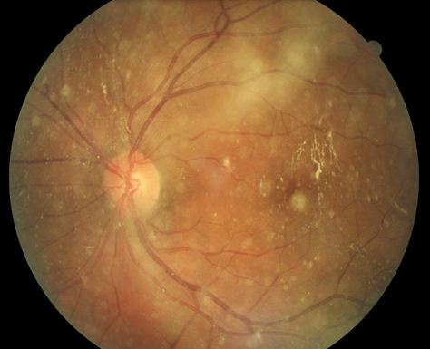

## Question 1 / 5

Considering the patient’s history and examination findings, what is the MOST likely etiology of his ocular condition?

a) Toxoplasmosis

b) Tuberculosis

c) Cat-scratch disease

d) Syphilis

e) Lyme disease

## Question 2 / 5

Which of the following organisms is responsible for the suspected infection of this patient?

a) Toxoplasma gondii

b) Treponema pallidum

c) Mycobacterium tuberculosis

d) Bartonella henselae

e) Borrelia burgdorferi

## Question 3 / 5

Which 2 of the following lab tests should be completed in order to confirm your suspected diagnosis? (Select 2)

a) Interferon-gamma release assay (IGRA)

b) Venereal disease research laboratory (VDRL)

c) Western blot

d) Immunoglobulin G (IgG) testing

e) Enzyme-linked immunosorbent assay (ELISA)

f) Rapid plasma reagin (RPR)

g) Tb skin test (TST)

## Question 4 / 5

Which of the following represents the BEST treatment for this patient?

a) Treatment is not required; the condition will resolve on its own

b) Ciprofloxacin

c) Azithromycin

d) Doxycycline

e) Prednisolone

f) Pyrimethamine and sulfadiazine

g) Isoniazid and rifapentine

## Question 5 / 5

Which of the following cranial nerve palsies is MOST commonly associated with the patient’s condition?

a) Cranial nerve VII palsy

b) Cranial nerve IV palsy

c) Cranial nerve V palsy

d) Cranial nerve VI palsy

e) Cranial nerve III palsy