Case PBAzoqXAvDMKSsweet72 Details

**Demographics**

* 36-year-old Asian female; computer programmer

**Chief complaint**

* concerned about growths on the eyes

**History of present illness**

* Character/signs/symptoms:small, yellowish growths on the white parts of her eyes
* Location:OD, OS
* Severity:mild
* Nature of onset:gradual
* Duration:2 years
* Frequency:constant
* Exacerbations/remissions:none
* Relationship to activity or function:none
* Accompanying signs/symptoms:occasional redness, dryness, and foreign body sensation (OS > OD)

**Secondary complaints/symptoms**

* none

**Patient ocular history**

* last eye exam 3 years ago; wears glasses for night driving

**Family ocular history**

* unremarkable

**Patient medical history**

* unremarkable

**Medications taken by patient**

* none

**Patient allergy history**

* NKDA

**Family medical history**

* father: prostate cancer

**Review of systems**

* Constitutional/general health:denies
* Ear/nose/throat:denies
* Cardiovascular:denies
* Pulmonary:denies
* Dermatological:denies
* Gastrointestinal:denies
* Genitourinary:denies
* Musculoskeletal:denies
* Neuropsychiatric:denies
* Endocrine:denies
* Hematologic:denies
* Immunologic:denies

**Mental status**

* Orientation:oriented to time, place, and person
* Mood:appropriate
* Affect:appropriate

**Clinical findings**

**Habitual spectacle Rx**

* OD:-0.75 DS; VA distance: 20/20
* OS:-0.50 -0.50 x 175; VA distance: 20/20

**Pupils:**

* PERRL, negative APD

**EOMs:**

* full, no restrictions OU

**Cover test:**

* distance: orthophoria, near: orthophoria

**Confrontation fields:**

* full to finger counting OD, OS

**Subjective refraction**

* OD:-0.75 -0.25 x 180; VA distance: 20/20
* OS:-0.50 -0.25 x 180; VA distance: 20/20

**Slit lamp**

* lids/lashes/adnexa:unremarkable OD, OS
* conjunctiva:see image 1 OD, OS similar to OD
* cornea:see image 1 OD, see images 2 and 3 OS
* anterior chamber:deep and quiet OD, OS
* iris:normal OD, OS
* lens:Mittendorf dot OD, OS
* vitreous:clear OD, OS

**IOPs:**

* OD: 18 mmHg, OS: 20 mmHg @ 12:25 pm by Goldmann applanation tonometry

**Fundus OD**

* C/D:0.35 H/0.30 V
* macula:normal
* posterior pole:normal
* periphery:unremarkable

**Fundus OS**

* C/D:0.35 H/0.30 V
* macula:normal
* posterior pole:normal
* periphery:unremarkable

**Blood pressure:**

* 102/81 mmHg, right arm, sitting

**Pulse:**

* 75 bpm, regular

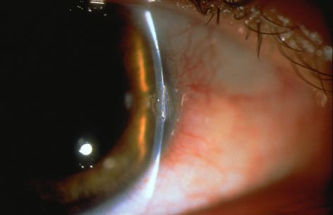

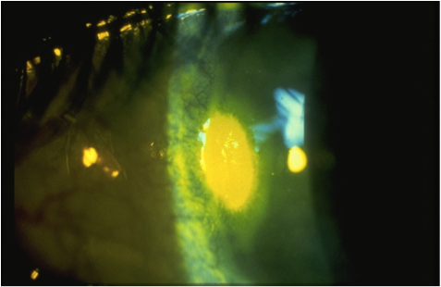

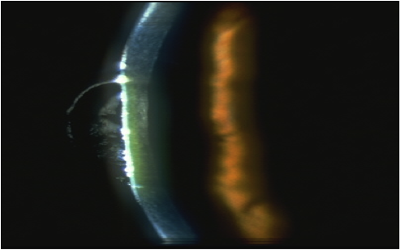

## Question 1 / 5

What is the MOST appropriate diagnosis of the patient's anterior segment condition of the RIGHT eye?

a) Pterygium

b) Corneal farinata

c) Crocodile shagreen

d) Pinguecula

e) Limbal girdle of Vogt

## Question 2 / 5

What is the MOST common etiology of the patient's anterior segment condition of the RIGHT eye?

a) Excessive exposure to UV light

b) Excessive eye rubbing

c) Congenital anomaly

d) Advancing age

e) Repeated exposure to an allergen

## Question 3 / 5

What is the MOST appropriate diagnosis of the patient's anterior segment condition of the LEFT eye?

a) Corneal dellen

b) Corneal abrasion

c) Pinguecula

d) Pterygium

e) Acanthamoeba keratitis

## Question 4 / 5

What is the MOST appropriate treatment of the patient's anterior segment condition of the LEFT eye?

a) Neosporin® ophthalmic ointment four times daily

b) Refer the patient to a corneal specialist

c) Preservative-free artificial tears every two hours with bland ophthalmic ointment at night

d) Application of a bandage contact lens

e) Moxifloxacin ophthalmic solution four times daily

## Question 5 / 5

After the initiation of treatment for the patient's LEFT eye condition, when should she return for a follow-up visit?

a) 1 month

b) 6 months

c) 1 day

d) 3 months

e) 1 week

f) No follow-up is needed