Case PnYmzBrDxbjlTyQ14316 Details

**Demographics**

* 62-year-old Hispanic female; teaching assistant

**Chief complaint**

* blurred vision

**History of present illness**

* Character/signs/symptoms:blurry vision at near with new glasses
* Location:OD, OS
* Severity:moderate
* Nature of onset:noticed after picking up her new glasses
* Duration:2 weeks
* Frequency:constant
* Exacerbations/remissions:vision improves if she brings reading material closer
* Relationship to activity or function:near vision tasks only
* Accompanying signs/symptoms:eye strain and fatigue

**Secondary complaints/symptoms**

* none

**Patient ocular history**

* last eye exam 1 month ago at another office, wears single vision reading glasses only, new glasses are 2 weeks old; history of refractive surgery (unsure of procedure)

**Family ocular history**

* father: macular degeneration

**Patient medical history**

* rheumatoid arthritis

**Medications taken by patient**

* Plaquenil® 200 mg b.i.d.

**Patient allergy history**

* Demerol®

**Family medical history**

* mother: hyperthyroidism, father: tuberculosis

**Review of systems**

* Constitutional/general health:denies
* Ear/nose/throat:denies
* Cardiovascular:denies
* Pulmonary:denies
* Dermatological:denies
* Gastrointestinal:denies
* Genitourinary:denies
* Musculoskeletal:joint pain and stiffness
* Neuropsychiatric:denies
* Endocrine:denies
* Hematologic:denies
* Immunologic:denies

**Mental status**

* Orientation:oriented to time, place, and person
* Mood:appropriate
* Affect:appropriate

**Clinical findings**

**Uncorrected visual acuity**

* OD:VA distance: 20/20
* OS:VA distance: 20/30

**New spectacle Rx**

* OD:+3.50 -0.25 x 133; VA near: 20/20 @ 33 cm
* OS:+4.25 -0.50 x 062; VA near: 20/20 @ 33 cm

**Pupils:**

* PERRL, negative APD

**EOMs:**

* full, no restrictions OU

**Cover test:**

* distance: orthophoria, near: 4 exophoria

**Confrontation fields:**

* full to finger counting OD, OS

**Subjective refraction**

* OD:+0.25 DS add: +2.50; VA distance: 20/20, VA near: 20/20 @ 40 cm
* OS:+1.00 -0.50 x 060 add: +2.50; VA distance: 20/20, VA near: 20/20 @ 40 cm

**Slit lamp**

* lids/lashes/adnexa:dermatochalasis OD, OS
* conjunctiva:normal OD, OS
* cornea:OD similar to OS, OS 8 small circular scars noted circumferentially in peripheral cornea (see images 1 & 2)
* anterior chamber:deep and quiet OD, OS
* iris:normal OD, OS
* lens:trace nuclear sclerosis OD, OS
* vitreous:posterior vitreous detachment OD, OS

**IOPs:**

* OD: 16 mmHg, OS: 18 mmHg @ 10:05 am by Goldmann applanation tonometry

**Fundus OD**

* C/D:0.40 H/0.40 V
* macula:normal
* posterior pole:normal
* periphery:see images 3 & 4

**Fundus OS**

* deep and quiet OD, OS
* C/D:0.40 H/0.40 V
* macula:normal
* posterior pole:normal
* periphery:similar to images 3 & 4

**Blood pressure:**

* 112/82 mmHg, right arm, sitting

**Pulse:**

* 74 bpm, regular

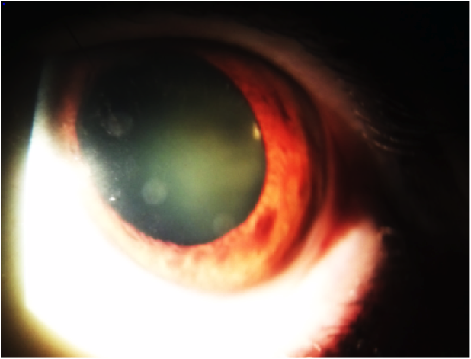

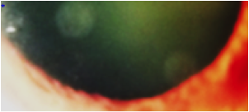

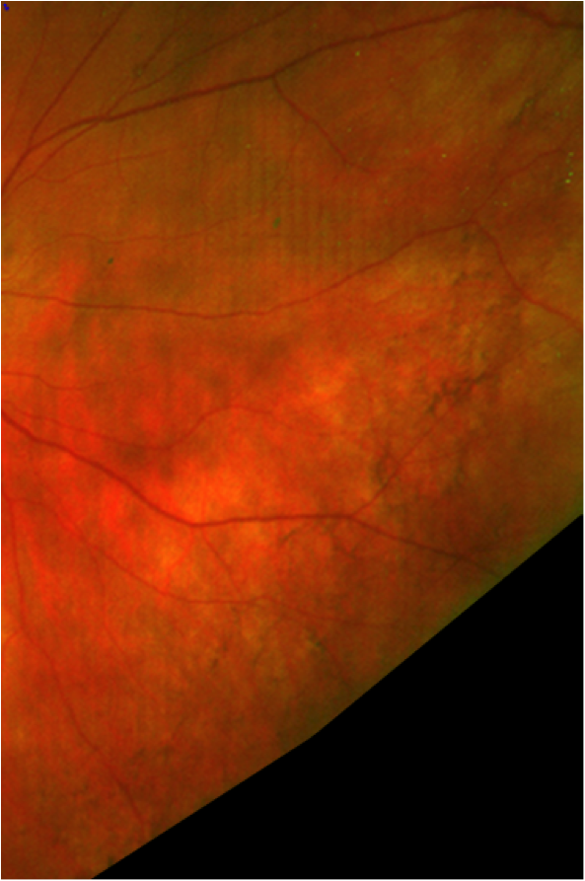

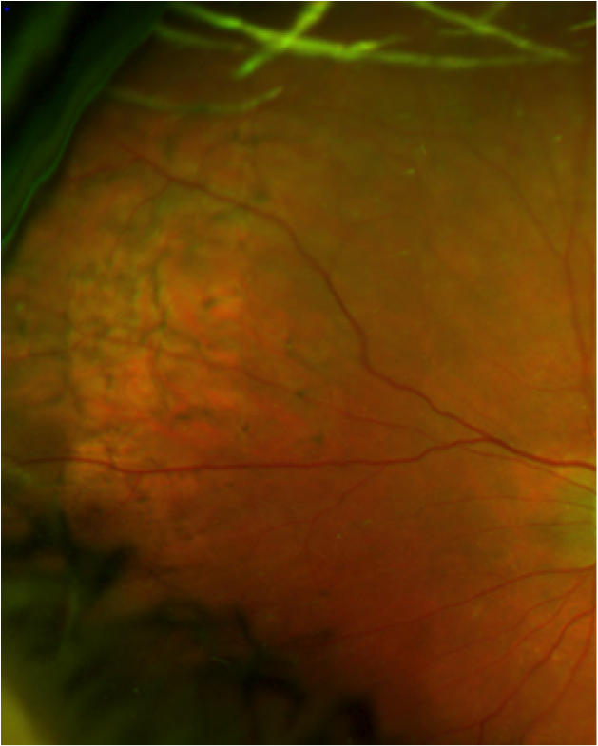

## Question 1 / 5

Given images 1 and 2, what is the MOST likely type of refractive surgery undergone by this patient?

a) Photorefractive keratectomy (PRK)

b) Implantable collamer lens (ICL)

c) Laser-assisted in situ keratomileusis (LASIK)

d) Conductive keratoplasty (CK)

e) Refractive lens exchange (RLE)

## Question 2 / 5

Which of the following refractive errors is best suited for that specific type of surgery?

a) +2.25 DS

b) -2.75 -1.25 x 090

c) -0.75 -0.75 x 180

d) -1.25 DS

e) +1.00 -1.00 x 180

f) +4.25 -0.75 x 180

## Question 3 / 5

How would you expect a patient's corneal topography to change after undergoing this type of refractive surgery?

a) Central and mid-peripheral flattening

b) Central flattening and mid-peripheral steepening

c) The corneal topography is not expected to change

d) Central and mid-peripheral steepening

e) Central steepening and mid-peripheral flattening

## Question 4 / 5

What is the MOST likely cause of the patient's entering visual concern?

a) Undercorrection; causing an increased focal length and further working distance

b) Overcorrection; causing an increased focal length and further working distance

c) Undercorrection; causing a reduced focal length and closer working distance

d) Overcorrection; causing a reduced focal length and closer working distance

## Question 5 / 5

Which of the following represents the MOST appropriate diagnosis of the patient's retinal findings observed in images 3 and 4?

a) Reticular pigmentary degeneration

b) Retinitis pigmentosa

c) Plaquenil® retinopathy

d) Lattice degeneration