Case RMTKmPzEkASaWtG12044 Details

**Demographics**

* 24-year-old Hispanic male; software engineer

**Chief complaint**

* droopy eyelids; was brought to his attention by his girlfriend after looking at old photos

**History of present illness**

* Character/signs/symptoms:progressive drooping of upper eyelids
* Location:OD, OS
* Severity:mild-moderate
* Nature of onset:gradual
* Duration:2 years
* Frequency:constant
* Exacerbations/remissions:none
* Relationship to activity or function:none
* Accompanying signs/symptoms:facial muscles occasionally feel weak

**Secondary complaints/symptoms**

* none

**Patient ocular history**

* last comprehensive eye exam 5 years ago; does not wear corrective lenses

**Family ocular history**

* unknown (patient adopted)

**Patient medical history**

* anxiety

**Medications taken by patient**

* Xanax®

**Patient allergy history**

* NKDA

**Family medical history**

* unknown

**Review of systems**

* Constitutional/general health:denies
* Ear/nose/throat:denies
* Cardiovascular:denies
* Pulmonary:denies
* Dermatological:denies
* Gastrointestinal:denies
* Genitourinary:denies
* Musculoskeletal:facial muscle weakness
* Neuropsychiatric:trouble sleeping, anxiety
* Endocrine:denies
* Hematologic:denies
* Immunologic:denies

**Mental status**

* Orientation:oriented to time, place and person
* Mood:appropriate
* Affect:appropriate

**Clinical findings**

**Uncorrected visual acuity**

* OD:distance: 20/20, near: 20/20 @ 40 cm
* OS:distance: 20/20, near: 20/20 @ 40 cm

**Pupils:**

* PERRL, negative APD

**EOMs:**

* mildly depressed ductions in all fields of gaze OU

**Cover test:**

* distance: orthophoria, near: orthophoria

**Confrontation fields:**

* mild superior field restriction OD, OS

**Subjective refraction**

* OD:+0.25 -0.25 x 098; VA distance: 20/20
* OS:-0.25 DS; VA distance: 20/20

**Slit lamp**

* lids/lashes/adnexa:see image 1 OD, OS
* conjunctiva:normal OD, OS
* cornea:clear OD, OS
* anterior chamber:deep and quiet OD, OS
* iris:normal OD, OS
* lens:clear OD, OS
* vitreous:clear OD, OS

**IOPs:**

* OD: 17 mmHg, OS: 16 mmHg @ 7:50 am by Goldmann applanation tonometry

**Fundus OD**

* C/D:0.30 H/0.30 V
* macula:normal
* posterior pole:normal
* periphery:unremarkable

**Fundus OS**

* C/D:0.30 H/0.30 V
* macula:normal
* posterior pole:normal
* periphery:3 DD choroidal nevus superior temporal

**Blood pressure:**

* 115/76 mmHg, right arm, sitting

**Pulse:**

* 67 bpm, regular

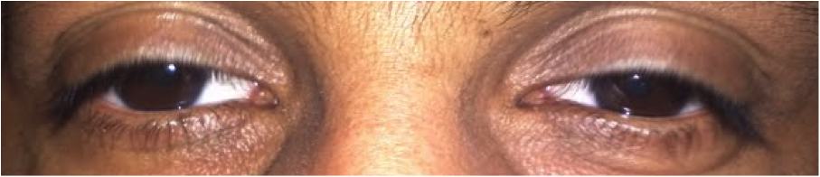

## Question 1

Which of the following represents the patient’s MOST likely diagnosis given his history and exam findings?

a) Kearns-Sayre syndrome

**b) Chronic progressive external ophthalmoplegia - Correct Answer**

c) Ophthalmoplegic migraine

d) Myasthenia Gravis

e) Oculopharyngeal dystrophy

f) Horner's syndrome

Explanation:

Chronic progressive external ophthalmoplegia (CPEO) typically occurs after the age of 20 and presents with bilateral ptosis that is often relatively symmetrical. Initially, patients may not be symptomatic and may not be aware of the ptosis until it is brought to their attention by others. With time, a progression of the ptosis may eventually impede vision if the visual axis becomes obstructed. As the condition progresses, ocular motility will become restricted with the superior gaze being affected first, followed by the lateral gaze. As the condition worsens, eye movements may become completely limited. Pupils are not affected in this condition and patients generally do not report diplopia because the condition is bilateral and relatively symmetrical. The symptomatology does not undergo diurnal variation. Patients may also note a concurrent weakness of ocular, facial, or limb muscles.Kearns-Sayre syndrome (KSS) is similar to CPEO and is often considered a subset of this condition. KSS occurs at a younger age than CPEO (prior to the age of 20) and additional clinical findings include degeneration of the retinal pigment epithelium, resulting in a 'salt and pepper' appearance of the posterior fundus. These patients may also be susceptible to heart block after the onset of the ocular symptoms, putting them at risk for sudden death. Patients with KSS may also experience deafness, delayed puberty, increased cerebrospinal fluid protein, mental retardation, nephropathy, and cerebellar ataxia.Ophthalmoplegic migraines typically occur in children younger than 10 years of age. As the headache resolves, transient extraocular muscle palsy occurs (most frequently of the 3rd nerve). This patient does not report headaches and does not fall into the correct age category to substantiate a diagnosis of an ophthalmoplegic migraine.Myasthenia gravis is ruled out because there is no diurnal variation of the ptosis. The patient reports no difficulty swallowing, which refutes a diagnosis of ocular pharyngeal dystrophy. The ptosis is bilateral with no pupil involvement, also effectively ruling out Horner syndrome.