Case RMTKmPzEkASaWtG12044 Details

**Demographics**

* 24-year-old Hispanic male; software engineer

**Chief complaint**

* droopy eyelids; was brought to his attention by his girlfriend after looking at old photos

**History of present illness**

* Character/signs/symptoms:progressive drooping of upper eyelids
* Location:OD, OS
* Severity:mild-moderate
* Nature of onset:gradual
* Duration:2 years
* Frequency:constant
* Exacerbations/remissions:none
* Relationship to activity or function:none
* Accompanying signs/symptoms:facial muscles occasionally feel weak

**Secondary complaints/symptoms**

* none

**Patient ocular history**

* last comprehensive eye exam 5 years ago; does not wear corrective lenses

**Family ocular history**

* unknown (patient adopted)

**Patient medical history**

* anxiety

**Medications taken by patient**

* Xanax®

**Patient allergy history**

* NKDA

**Family medical history**

* unknown

**Review of systems**

* Constitutional/general health:denies
* Ear/nose/throat:denies
* Cardiovascular:denies
* Pulmonary:denies
* Dermatological:denies
* Gastrointestinal:denies
* Genitourinary:denies
* Musculoskeletal:facial muscle weakness
* Neuropsychiatric:trouble sleeping, anxiety
* Endocrine:denies
* Hematologic:denies
* Immunologic:denies

**Mental status**

* Orientation:oriented to time, place and person
* Mood:appropriate
* Affect:appropriate

**Clinical findings**

**Uncorrected visual acuity**

* OD:distance: 20/20, near: 20/20 @ 40 cm
* OS:distance: 20/20, near: 20/20 @ 40 cm

**Pupils:**

* PERRL, negative APD

**EOMs:**

* mildly depressed ductions in all fields of gaze OU

**Cover test:**

* distance: orthophoria, near: orthophoria

**Confrontation fields:**

* mild superior field restriction OD, OS

**Subjective refraction**

* OD:+0.25 -0.25 x 098; VA distance: 20/20
* OS:-0.25 DS; VA distance: 20/20

**Slit lamp**

* lids/lashes/adnexa:see image 1 OD, OS
* conjunctiva:normal OD, OS
* cornea:clear OD, OS
* anterior chamber:deep and quiet OD, OS
* iris:normal OD, OS
* lens:clear OD, OS
* vitreous:clear OD, OS

**IOPs:**

* OD: 17 mmHg, OS: 16 mmHg @ 7:50 am by Goldmann applanation tonometry

**Fundus OD**

* C/D:0.30 H/0.30 V
* macula:normal
* posterior pole:normal
* periphery:unremarkable

**Fundus OS**

* C/D:0.30 H/0.30 V
* macula:normal
* posterior pole:normal
* periphery:3 DD choroidal nevus superior temporal

**Blood pressure:**

* 115/76 mmHg, right arm, sitting

**Pulse:**

* 67 bpm, regular

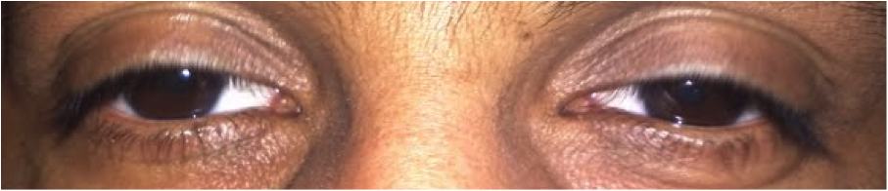

## Question 1

Which of the following represents the patient’s MOST likely diagnosis given his history and exam findings?

a) Kearns-Sayre syndrome

b) Chronic progressive external ophthalmoplegia

c) Ophthalmoplegic migraine

d) Myasthenia Gravis

e) Oculopharyngeal dystrophy

f) Horner's syndrome