Case RcqJOhGgkbicYGXK7953 Details

**Demographics**

* 12-year-old white male; student

**Chief complaint**

* worsening vision

**History of present illness**

* Character/signs/symptoms:blurred vision
* Location:OS
* Severity:severe
* Nature of onset:gradual
* Duration:1 year
* Frequency:constant
* Exacerbations/remissions:none
* Relationship to activity or function:none
* Accompanying signs/symptoms:none

**Secondary complaints/symptoms**

* none

**Patient ocular history**

* 1st eye exam

**Family ocular history**

* father: blepharoplasty OU

**Patient medical history**

* Gilbert syndrome

**Medications taken by patient**

* none

**Patient allergy history**

* NKDA

**Family medical history**

* father: COPD

**Review of systems**

* Constitutional/general health:denies
* Ear/nose/throat:denies
* Cardiovascular:denies
* Pulmonary:denies
* Dermatological:denies
* Gastrointestinal:occasional abdominal pain and diarrhea
* Genitourinary:denies
* Musculoskeletal:denies
* Neuropsychiatric:denies
* Endocrine:denies
* Hematologic:denies
* Immunologic:denies

**Mental status**

* Orientation:oriented to time, place, and person
* Mood:appropriate
* Affect:appropriate

**Clinical findings**

**Uncorrected visual acuity**

* OD:distance: 20/25, near: 20/25 @ 40 cm
* OS:distance: 20/400; PHNI, near: 20/400 @ 40 cm

**Pupils:**

* 1+ RAPD OS

**EOMs:**

* full, no restrictions OU

**Cover test:**

* distance: 10 exophoria, near: 10 exophoria

**Confrontation fields:**

* full to finger counting OD, OS

**Subjective refraction**

* OD:+1.25 -0.25 x 030; VA distance: 20/20, VA near: 20/20 @ 40 cm
* OS:+1.50 -1.00 x 180; VA distance: 20/400, VA near: 20/400 @ 40 cm

**Slit lamp**

* lids/lashes/adnexa:unremarkable OD, OS
* conjunctiva:normal OD, OS
* cornea:clear OD, OS
* anterior chamber:deep and quiet OD, OS
* iris:normal OD, OS
* lens:clear OD, OS
* vitreous:clear OD, OS

**IOPs:**

* OD: 13 mmHg, OS: 14 mmHg @ 12:02 pm by Goldmann applanation tonometry

**Fundus OD**

* C/D:0.15 H/0.15 V
* macula:normal
* posterior pole:normal
* periphery:unremarkable

**Fundus OS**

* C/D:see image 1
* macula:see image 1
* posterior pole:see image 1
* periphery:see image 1

**Blood pressure:**

* 102/72 mmHg, right arm, sitting

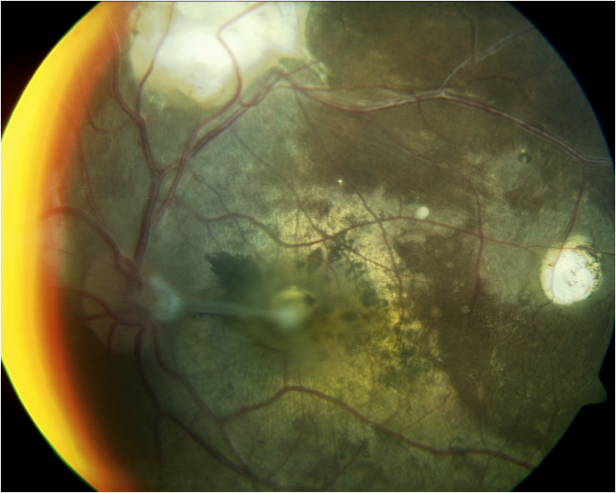

## Question 1 / 6

What is the MOST likely diagnosis of this patient’s retinal condition?

a) Presumed ocular histoplasmosis

b) Retinoblastoma

c) Toxocariasis

d) Toxoplasmosis

## Question 2 / 6

Which of the following laboratory tests would be the MOST useful in helping to confirm this patient’s diagnosis?

a) Serum anti-Toxoplasma antibody titer

b) FTA-ABS testing

c) HLA-B27 testing

d) Flourescein angiography

e) B-scan ultrasonography

f) Toxocara ELISA testing

## Question 3 / 6

What type of organism is the causative agent for this patient’s suspected retinal condition?

a) Oncotic cells

b) Bacterium

c) Virus

d) Protozoan

e) Nematode

f) Fungus

## Question 4 / 6

Which of the following treatments would be the MOST appropriate for this patient?

a) Chemotherapy

b) Thiabendazole

c) Prednisone

d) Trimethoprim & sulfamethoxazole

e) Pyrimethamine & sulfadiazine

## Question 5 / 6

Which of the following ocular signs is MOST commonly observed in a patient with Gilbert syndrome?

a) A shallow anterior chamber

b) Corneal guttata

c) Optic nerve pallor

d) Yellowing of the sclera

e) Sloughing of iris pigment

f) Subluxation of the crystalline lens

g) A relative afferent pupillary defect

## Question 6 / 6

Which 3 of the following are thought to be risk factors for chronic obstructive pulmonary disease (COPD)? (Select 3)

a) Alpha-1 antitrypsin deficiency

b) Overexposure to lead

c) Decreased angiotensin converting enzyme (ACE) levels

d) Overexposure to a decreased partial pressure of oxygen

e) Low birth weight

f) An increased production of surfactant

g) Frequent childhood infections