Case TKjmAXvAEdgLyRVR5486 Details

**Demographics**

* 6-year-old white male; student

**Chief complaint**

* mother reports that the patient constantly squints

**History of present illness**

* Character/signs/symptoms:squinting, photophobia, tearing
* Location:OD, OS
* Severity:moderate
* Nature of onset:gradual
* Duration:since he was a baby
* Frequency:constant, worsening
* Exacerbations/remissions:none
* Relationship to activity or function:mostly noticeable when he is watching television and when playing outside
* Accompanying signs/symptoms:mother reports that he sits very close to the tv

**Secondary complaints/symptoms**

* none

**Patient ocular history**

* born without an iris in both eyes; last eye exam was when he was 6 months old by a specialist

**Family ocular history**

* mother: born without irides, father: high hyperopia

**Patient medical history**

* unremarkable, born full term; normal developmental milestones

**Medications taken by patient**

* none

**Patient allergy history**

* NKDA

**Family medical history**

* mother: asthma

**Review of systems**

* Constitutional/general health:denies
* Ear/nose/throat:denies
* Cardiovascular:denies
* Pulmonary:denies
* Dermatological:denies
* Gastrointestinal:denies
* Genitourinary:denies
* Musculoskeletal:denies
* Neuropsychiatric:hyperactivity
* Endocrine:denies
* Hematologic:denies
* Immunologic:denies

**Mental status**

* Orientation:oriented to time, place, and person (age appropriate)
* Mood:appropriate
* Affect:appropriate

**Clinical findings**

**Uncorrected visual acuity**

* OD:VA distance: 20/150, VA near: 20/100 @ 40 cm
* OS:VA distance: 20/200, VA near: 20/150 @ 40 cm

**Pupils:**

* unable to test due to lack of irides

**EOMs:**

* see image 1

**Cover test:**

* 8 prism diopter constant left esotropia

**Confrontation fields:**

* full to finger counting OD, OS

**Stereo test:**

* 0" by LANG II

**Dry retinoscopy**

* * note: the esotropia is still present with full correction
* OD:+7.50 -2.00 x 005; VA distance: 20/40 (PHNI)
* OS:+7.75 -2.00 x 175; VA distance: 20/60 (PHNI)

**Slit lamp**

* lids/lashes/adnexa:unremarkable OD, OS
* conjunctiva:normal OD, OS
* cornea:clear OD, OS
* anterior chamber:deep and quiet OD, OS
* iris:see images 2 & 3 OD, OS
* lens:clear, (+) visualization of zonules OD, OS
* vitreous:clear OD, OS

**IOPs:**

* OD: 17 mmHg, OS: 15 mmHg @ 8:30 am by iCare tonometer

**Fundus OD**

* C/D:0.35 H/0.35 V
* macula:normal
* posterior pole:normal
* periphery:unremarkable

**Fundus OS**

* C/D:0.35 H/0.35 V
* macula:normal
* posterior pole:normal
* periphery:unremarkable

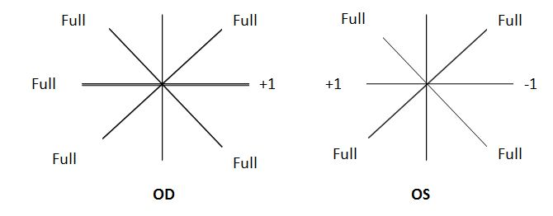

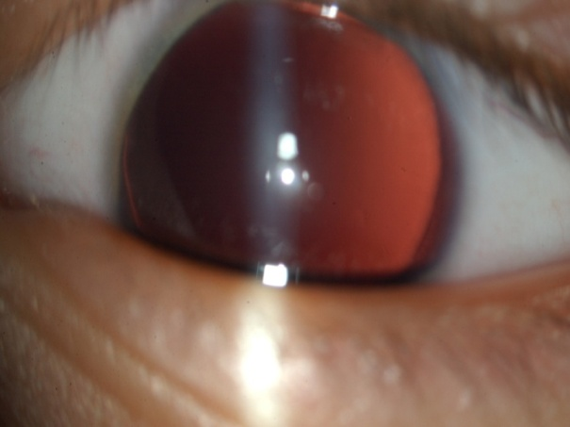

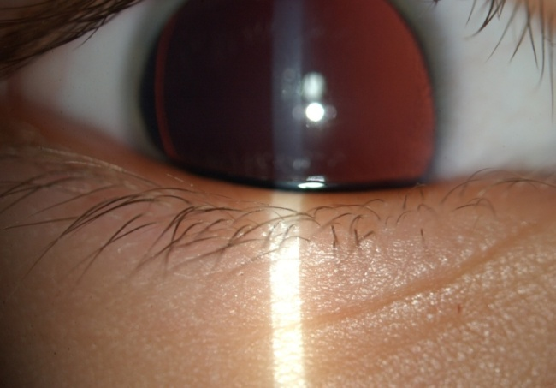

## Question 1 / 5

The genetic condition characterized by a lack of iris is known as which of the following terms?

a) Aniridia

b) Anisometropia

c) Aniseikonia

d) Anisocoria

## Question 2 / 5

Which of the following ocular conditions has NOT been associated with the congenital lack of an iris?

a) Glaucoma

b) Keratoconus

c) Foveal hypoplasia

d) Nystagmus

e) Lens opacities

f) Strabismus

## Question 3 / 5

Considering the extraocular muscle observations, which cranial nerve is MOST likely affected in this patient?

a) CN IV

b) CN III

c) CN VI

d) CN V

## Question 4 / 5

What is the MOST appropriate spectacle prescription for this patient at this time?

a) OD: +6.50 DS; OS: +6.75 DS

b) OD: +7.00 -1.00 x 005; OS: +7.25 -1.00 x 175

c) OD: +6.50 -2.00 x 005; OS: +7.75 -2.00 x 175

d) OD: +6.50 -2.00 x 005; OS: +6.75 -2.00 x 175

e) OD: +5.50 -1.00 x 005; OS: +5.75 -1.00 x 175

f) OD: +6.50 -1.50 x 005; OS: +6.75 -1.50 x 175

## Question 5 / 5

When should the patient return to your office for a follow-up visit once new glasses have been prescribed?

a) 2 months

b) 1 day

c) No follow-up is required

d) 1 week

e) 12 months

f) 6 months