Case VMqnaMcTYuQfwKXx8369 Details

**Demographics**

* 22-year-old Asian male; auctioneer

**Chief complaint**

* blurred vision

**History of present illness**

* Character/signs/symptoms:blurred vision; would like another opinion to see if glasses can improve vision
* Location:OS
* Severity:severe
* Nature of onset:unsure
* Duration:for as long as he can remember
* Frequency:constant
* Exacerbations/remissions:none
* Relationship to activity or function:none
* Accompanying signs/symptoms:none

**Secondary complaints/symptoms**

* none

**Patient ocular history**

* last eye exam 3 years ago; was told glasses wouldn't help

**Family ocular history**

* mother: presumed ocular histoplasmosis, father: retinitis pigmentosa

**Patient medical history**

* Unremarkable

**Medications taken by patient**

* fish oils, multivitamin

**Patient allergy history**

* penicillin

**Family medical history**

* mother: Grave disease, father: cardiovascular disease

**Review of systems**

* Constitutional/general health:denies
* Ear/nose/throat:denies
* Cardiovascular:denies
* Pulmonary:denies
* Dermatological:denies
* Gastrointestinal:denies
* Genitourinary:denies
* Musculoskeletal:denies
* Neuropsychiatric:denies
* Endocrine:denies
* Hematologic:denies
* Immunologic:denies

**Mental status**

* Orientation:oriented to time, place, and person
* Mood:appropriate
* Affect:appropriate

**Clinical findings**

**Uncorrected visual acuity**

* OD:distance: 20/25
* OS:distance: 20/250 (PHNI)

**Pupils:**

* PERRL; 1+ APD OS

**EOMs:**

* full, no restrictions OU

**Cover test:**

* full to finger counting OD, superior restriction OS

**Subjective refraction**

* OD:-0.25 -0.25 x 035; VA distance: 20/20
* OS:+0.50 -0.75 x 015; VA distance: 20/250

**Slit lamp**

* lids/lashes/adnexa:unremarkable OD, OS
* conjunctiva:normal OD, OS
* cornea:clear OD, OS
* anterior chamber:deep and quiet OD, OS
* iris:normal OD, inferior notch OS
* lens:clear OD, OS
* vitreous:clear OD, OS

**IOPs:**

* OD: 11 mmHg, OS: 12 mmHg @ 1:12 pm by Goldmann applanation tonometry

**Fundus OD**

* C/D:see image 1
* macula:see image 1
* posterior pole:see image 1
* periphery:unremarkable

**Fundus OS**

* C/D:see image 2
* macula:see image 2
* posterior pole:see image 2
* periphery:see image 2

**Blood pressure:**

* 107/70 mmHg, right arm, sitting

**Pulse:**

* 65 bpm, regular

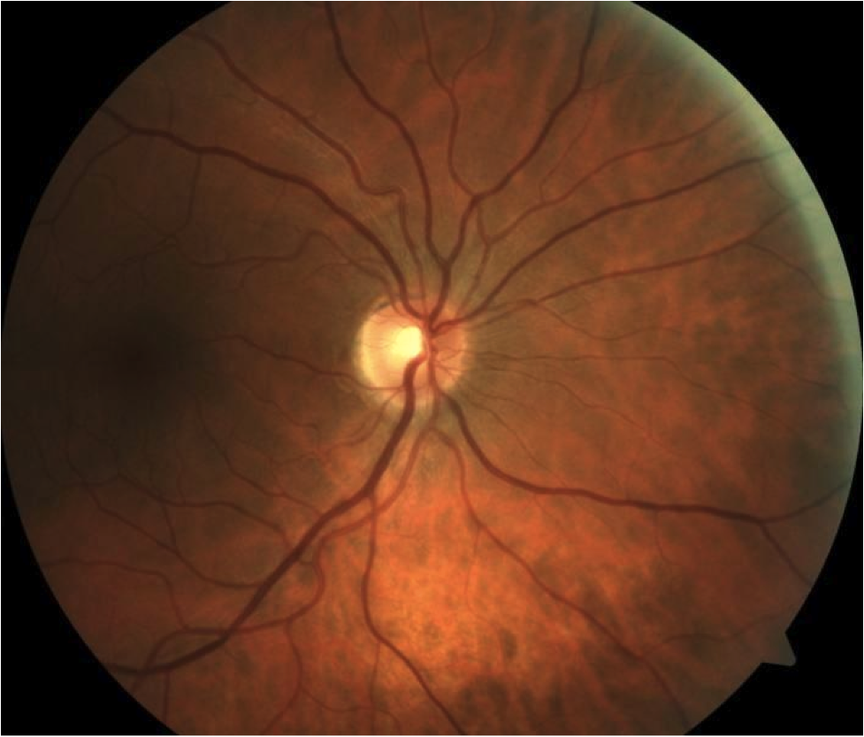

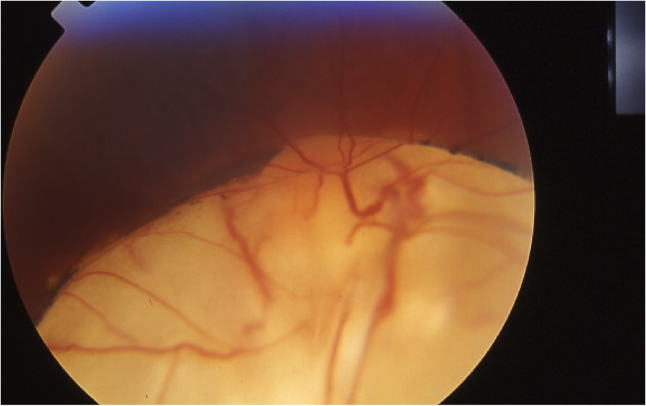

## Question 1 / 5

Given the patient’s fundus images, what is the MOST likely diagnosis of his left eye retinal condition?

a) Posterior staphyloma

b) Chorioretinal coloboma

c) Degenerative myopia

d) Morning glory anomaly

e) Retinal detachment

## Question 2 / 5

Which of the following represents the MOST appropriate treatment for this patient's retinal condition?

a) No treatment is necessary at this time; recommend glasses for protection purposes only

b) Prescribe low-vision aids such as a hand-held telescope for distance spotting tasks

c) Refer to a retinal specialist for the implantation of a scleral buckle

d) Prescribe gas permeable contact lenses to slow down the progression of myopia

e) Refer for cryotherapy of the affected area

## Question 3 / 5

Which of the following ocular complications is MOST likely to develop secondary to this patient’s retinal condition?

a) Inferior perforation of the globe

b) Iris prolapse

c) Lens subluxation

d) Rhegmatogenous retinal detachment

e) Primary open-angle glaucoma

## Question 4 / 5

Which of the following other ocular conditions is MOST frequently observed in conjunction with this patient’s retinal findings?

a) Microphthalmia

b) Iridocorneal endothelial syndrome

c) Posterior subcapsular cataract

d) One and a half syndrome

e) Keratoconus

## Question 5 / 5

Which of the following compounds may be added to amoxicillin in order to increase its effectiveness against bacteria that have demonstrated resistance to penicillin?

a) Potassium clavulanate

b) Hydrochloride

c) Dichromic acid

d) Etabonate

e) Chlorthalidone