Case VXxPREHSObwUUPB12816 Details

**Demographics**

* 64-year-old white male; banker

**Chief complaint**

* loss of vision

**History of present illness**

* Character/signs/symptoms:sudden decrease in vision
* Location:OD
* Severity:severe
* Nature of onset:acute
* Duration:2 days
* Frequency:constant
* Exacerbations/remissions:vision appears worse at night
* Relationship to activity or function:none
* Accompanying signs/symptoms:floaters, diminished color vision

**Secondary complaints/symptoms**

* none

**Patient ocular history**

* last eye exam 2 years ago; wears PALs full time

**Family ocular history**

* father: wet macular degeneration

**Patient medical history**

* hypertension, hyperlipidemia, asthma, myocardial infarction (2 years ago)

**Medications taken by patient**

* Atenolol®, Lipitor®, albuterol, baby aspirin

**Patient allergy history**

* NKDA

**Family medical history**

* mother: hypertension, osteoarthritis, father: hypertension, hyperlipidemia

**Review of systems**

* Constitutional/general health:denies
* Ear/nose/throat:denies
* Cardiovascular:denies
* Pulmonary:occasional shortness of breath
* Dermatological:denies
* Gastrointestinal:denies
* Genitourinary:denies
* Musculoskeletal:denies
* Neuropsychiatric:denies
* Endocrine:denies
* Hematologic:denies
* Immunologic:denies

**Mental status**

* Orientation:oriented to time, place, and person
* Mood:appropriate
* Affect:appropriate

**Clinical findings**

**Habitual spectacle Rx**

* OD:-1.75 -0.50 x 090 add: +2.25; VA distance: 20/200 (with eccentric viewing) PHNI
* OS:-3.00 -0.25 x 100 add: +2.25; VA distance: 20/40 PHNI

**Pupils:**

* PERRL, negative APD

**EOMs:**

* full, no restrictions OU

**Keratometry**

* OD:42.50 @ 090 / 42.00 @ 180; no distortion of mires
* OS:42.25 @ 110 / 42.00 @ 020; no distortion of mires

**Subjective refraction**

* OD:-2.00 -0.50 x 090 add: +2.50; VA distance: 20/200, VA near: 20/200 @ 40 cm
* OS:-3.25 -0.25 x 110 add: +2.50; VA distance: 20/40, VA near: 20/40 @ 40 cm

**Slit lamp**

* lids/lashes/adnexa:unremarkable OD, OS
* conjunctiva:trace injection OD, OS
* cornea:clear OD, OS
* anterior chamber:deep and quiet OD, OS
* iris:normal OD, OS
* lens:1+ nuclear sclerosis, trace posterior subcapsular cataract OD, 1+ nuclear sclerosis, 2+ posterior subcapsular cataract OS
* vitreous:1+ cells, 2+ vitreous haze OD, OS

**IOPs:**

* OD: 14 mmHg, OS: 12 mmHg @ 1:30 pm by Goldmann applanation tonometry

**Fundus OD**

* C/D:0.25 H / 0.25 V
* macula:choroidal neovascular membrane
* posterior pole:similar to OS (see image 1)
* periphery:unremarkable

**Fundus OS**

* C/D:see image 1
* macula:see image 1
* posterior pole:see image 1
* periphery:unremarkable

**Blood pressure:**

* 120/78 mmHg, right arm, sitting

**Pulse:**

* 74 bpm, regular

**Threshold visual fields:**

* OD:see image 2
* OS:see image 3

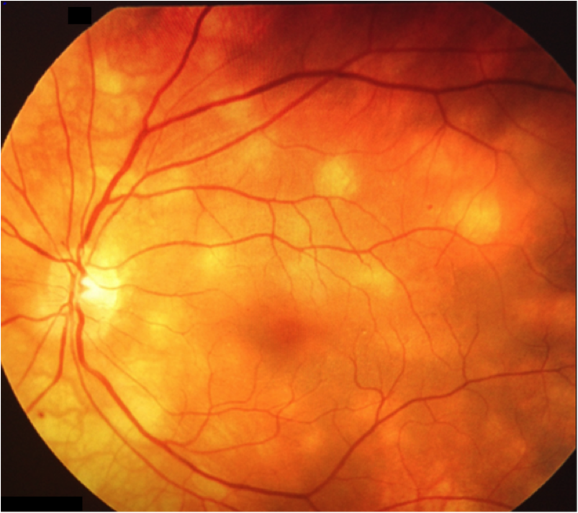

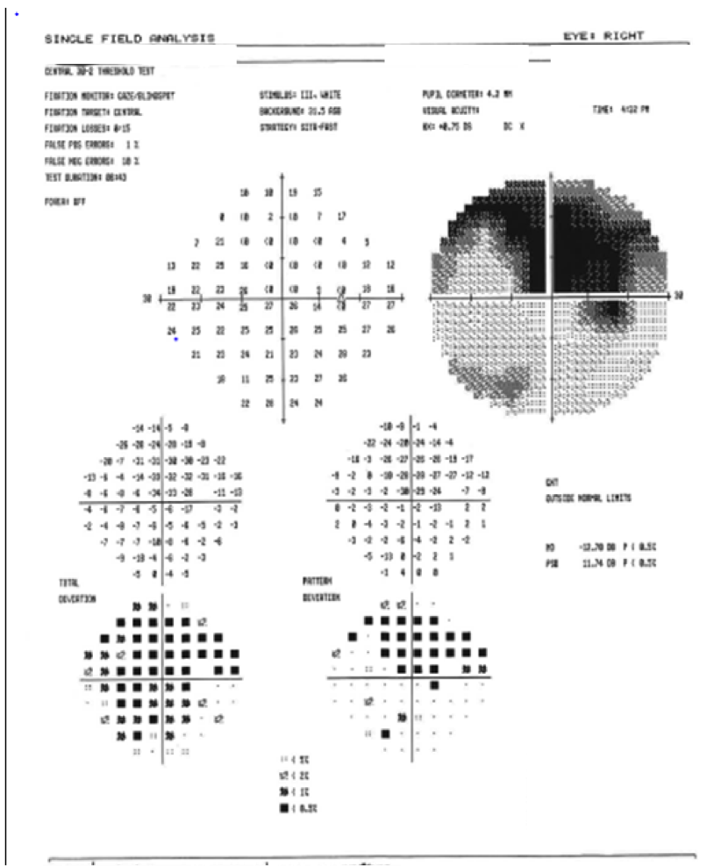

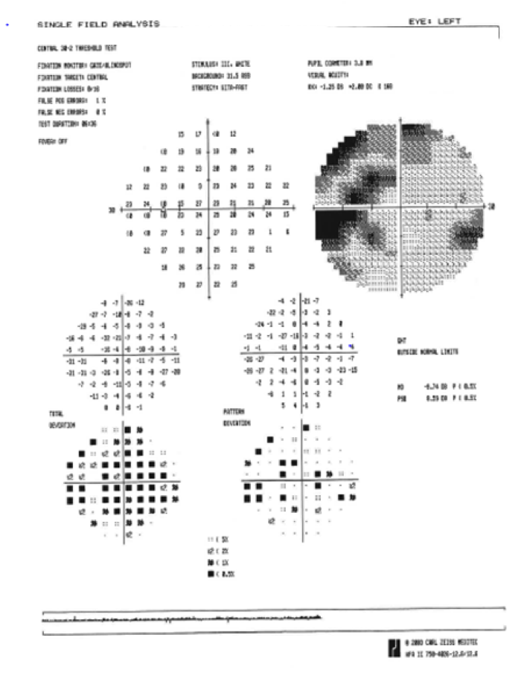

## Question 1 / 5

Given the examination findings, what is the MOST likely diagnosis of the patient's retinal condition observed in image 1?

a) Vogt-Koyanagi-Harada syndrome

b) Sarcoidosis

c) Birdshot chorioretinopathy

d) Serpiginous choroidopathy

e) Neurosyphilis

## Question 2 / 5

Which Human Leukocyte Antigen (HLA) is MOST likely associated with this patient’s condition?

a) HLA-B51

b) HLA-A29

c) This condition is not associated with HLA

d) HLA-B27

e) HLA-DR4

## Question 3 / 5

Which of the following represents the BEST initial treatment option given this patient’s diagnosis? (Select 2)

a) Topical corticosteroids

b) Oral corticosteroids

c) Oral acyclovir

d) No treatment is indicated

e) Topical cyclopentolate

f) Anti-VEGF injection

g) Penicillin G injection

## Question 4 / 5

What is the MOST likely cause of the patient's decreased best-corrected visual acuity in the left eye?

a) Dry eye syndrome

b) Keratoconus

c) Dry age-related macular degeneration

d) Cataract

## Question 5 / 5

With appropriate treatment for the retinal condition and cataract surgery, what is the visual prognosis for this patient?

a) Good OD and OS

b) Good OD, limited OS

c) Limited OD, good OS

d) Poor OD and OS