Case WcOevDDEKvVBAHh12746 Details

**Demographics**

* 3-year-old American Indian female; preschool student

**Chief complaint**

* occasional eye turn

**History of present illness**

* Character/signs/symptoms:patient's mother reports that her daughter's eye occasionally turns inward
* Location:OS
* Severity:moderate
* Nature of onset:gradual
* Duration:first noticed when she was 1 year old
* Frequency:intermittent; occurring more often recently
* Exacerbations/remissions:worse when tired or at the end of the day
* Relationship to activity or function:prolonged near activities
* Accompanying signs/symptoms:none

**Secondary complaints/symptoms**

* none

**Patient ocular history**

* 1st eye exam

**Family ocular history**

* paternal uncle: strabismus

**Patient medical history**

* unremarkable; normal birth history and developmental milestones

**Medications taken by patient**

* none

**Patient allergy history**

* NKDA

**Family medical history**

* father: type II diabetes

**Review of systems**

* Constitutional/general health:denies
* Ear/nose/throat:denies
* Cardiovascular:denies
* Pulmonary:denies
* Dermatological:denies
* Gastrointestinal:denies
* Genitourinary:denies
* Musculoskeletal:denies
* Neuropsychiatric:denies
* Endocrine:denies
* Hematologic:denies
* Immunologic:denies

**Mental status**

* Orientation:oriented to time, place, and person
* Mood:appropriate
* Affect:appropriate

**Uncorrected visual acuity (Lea Symbols)**

* OD:distance: 20/30, near: 20/25 @ 40 cm
* OS:distance: 20/80, near: 20/60 @ 40 cm

**Pupils:**

* PERRL, negative APD

**EOMs:**

* full, no restrictions OU

**Cover test:**

* distance: 16 prism diopter intermittent, left esotropia (frequency 8/10)near: 18 prism diopter intermittent, left esotropia (frequency 7/10)

**Confrontation fields:**

* full to finger counting OD, OS

**Gross observation:**

* see image 1

**Wet retinoscopy**

* 2 gtts of 1% cyclopentolate instilled 5 minutes apart
* OD:+3.50 -0.50 x 170 (gross retinoscopy findings with 67 cm working distance)
* OS:+6.25 -1.25 x 160 (gross retinoscopy findings with 67 cm working distance)

**Slit lamp**

* lids/lashes/adnexa:unremarkable OD, OS
* conjunctiva:normal OD, OS
* cornea:clear OD, OS
* anterior chamber:deep and quiet OD, OS
* iris:normal OD, OS
* lens:clear OD, OS
* vitreous:clear OD, OS

**IOPs:**

* OD: 11 mmHg, OS: 11 mmHg @ 8:05 am by via Tonopen

**Fundus OD**

* C/D:see images 2 & 3
* macula:see images 2 & 3
* posterior pole:see images 2 & 3
* periphery:unremarkable

**Fundus OS**

* C/D:see images 3 & 4
* macula:see images 3 & 4
* posterior pole:see images 3 & 4
* periphery:unremarkable

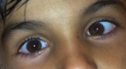

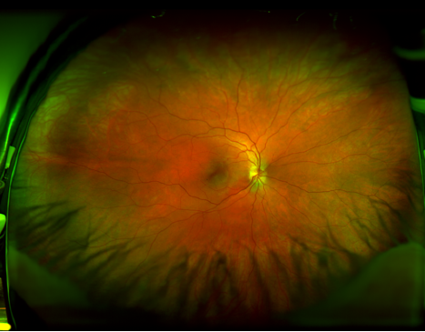

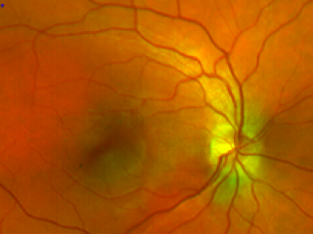

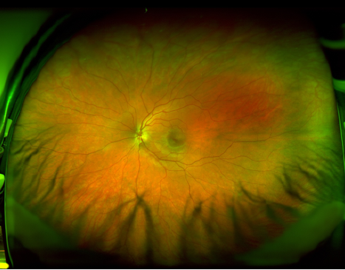

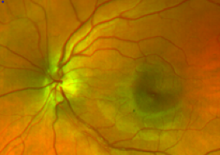

## Question 1 / 5

Given the GROSS wet retinoscopy findings for this patient, what are the NET retinoscopy findings for the right and left eye, respectively?

a) OD: +2.50 -0.50 x 170; OS: +5.25 -1.25 x 160

b) OD: +3.00 -0.50 x 170; OS: +5.75 -1.25 x 160

c) OD: +3.50 -0.50 x 170; OS: +6.35 -1.25 x 160

d) OD: +5.00 -0.50 x 170; OS: +7.75 -1.25 x 160

e) OD: +2.00 -0.50 x 170; OS: +4.75 -1.25 x 160

## Question 2 / 5

If you were to perform the Bruckner reflex test on this patient, which of the following results would you expect?

a) The reflex of both eyes would be equally bright

b) The left eye would display a brighter reflex

c) The reflex of both eyes would be equally dim

d) The right eye would display a brighter reflex

## Question 3 / 5

Which of the following methods of visual acuity testing for toddlers typically offers the MOST accurate measurement?

a) Landolt Cs

b) Lea symbols

c) Allen figures

d) Lighthouse cards

## Question 4 / 5

If you were to perform a fixation preference test on this patient, which of the following results would you MOST likely expect?

a) The patient will not likely cooperate due to the difficult nature of the test

b) After uncovering the right eye, the patient will change fixation from the left eye to the right eye

c) After uncovering the right eye, the patient will maintain fixation with the left eye

d) The patient will alternate fixation equally between the eyes

## Question 5 / 5

Considering developmental milestones, given this patient's age, which of the following drawings would you expect her to be able to reproduce?

a) A square

b) A heart

c) A vertical line

d) A diamond

e) A star