Case XGVfAnFZtYUfupBVAh84 Details

**Demographics**

* 7-year-old Asian female; student

**Chief complaint**

* blurred vision

**History of present illness**

* Character/signs/symptoms:vision becomes blurry during periods of prolonged near work
* Location:OD, OS
* Severity:moderate
* Nature of onset:gradual
* Duration:1 year
* Frequency:daily
* Exacerbations/remissions:worse at the end of the day; improves with rest
* Relationship to activity or function:occurs after 20 minutes of reading (or other near work)
* Accompanying signs/symptoms:fatigue, eyestrain

**Secondary complaints/symptoms**

* none

**Patient ocular history**

* 1st eye exam

**Family ocular history**

* mother: strabismus

**Patient medical history**

* unremarkable

**Medications taken by patient**

* multivitamins

**Patient allergy history**

* NKDA

**Family medical history**

* unremarkable

**Review of systems**

* Constitutional/general health:denies
* Ear/nose/throat:denies
* Cardiovascular:denies
* Pulmonary:denies
* Dermatological:denies
* Gastrointestinal:denies
* Genitourinary:denies
* Musculoskeletal:denies
* Neuropsychiatric:denies
* Endocrine:denies
* Hematologic:denies
* Immunologic:denies

**Mental status**

* Orientation:oriented to time, place, and person
* Mood:appropriate
* Affect:appropriate

**Clinical findings**

**Uncorrected visual acuity**

* OD:distance: 20/20, near: 20/20 @ 40 cm
* OS:distance: 20/20, near: 20/20 @ 40 cm

**Pupils:**

* PERRL, negative APD

**EOMs:**

* full, no restrictions OU

**Cover test:**

* distance: 2 exophoria, near: 2 exophoria

**Confrontation fields:**

* full to finger counting OD, OS

**Oculomotor system**

* Pursuits:normal
* Saccades:normal
* Fixations:normal

**Subjective refraction**

* OD:+0.25 -0.25 x 005; VA distance: 20/20, VA near: 20/20 @ 40 cm
* OS:plano -0.25 x 180; VA distance: 20/20, VA near: 20/20 @ 40 cm

**Accommodative system**

* Amplitudes:OD: 5 D, OS: 5 D, OU: 6 D
* Facility (+/- 2.00):OD: 5 cycles/minute, OS: 5 cycles/minute, OU: 4 cycles/minute
* NRA/PRA:+1.50 / -0.50
* Monocular estimation method (MEM):OD: +1.00, OS: +1.00

**Vergence system**

* NPC:3 cm
* Vergences:NFV @ far: x/6/3, NFV @ near: 11/22/14; PFV @ far: 11/19/11, PFV @ near: 18/22/19
* Facility:8 base-out/8 base-in: 9 cycles/minute @ 40 cm

**Sensory system**

* Worth 4 dot:far: no suppression, near: no suppression
* Stereopsis:25"

**DEM test (percentile rank):**

* 50% horizontal, 60% vertical, 55% ratio, 99% errors

**Slit lamp**

* lids/lashes/adnexa:unremarkable OD, OS
* conjunctiva:normal OD, OS
* cornea:clear OD, OS
* anterior chamber:deep and quiet OD, OS
* iris:normal OD, OS
* lens:epicapsular stars OD, OS
* vitreous:clear OD, OS

**IOPs:**

* OD: 15 mmHg, OS: 15 mmHg @ 1:15 pm by iCare tonometer

**Fundus OD**

* C/D:see image 1
* macula:see image 1
* posterior pole:see image 1
* periphery:unremarkable

**Fundus OS**

* C/D:see image 2
* macula:see image 2
* posterior pole:see image 2
* periphery:unremarkable

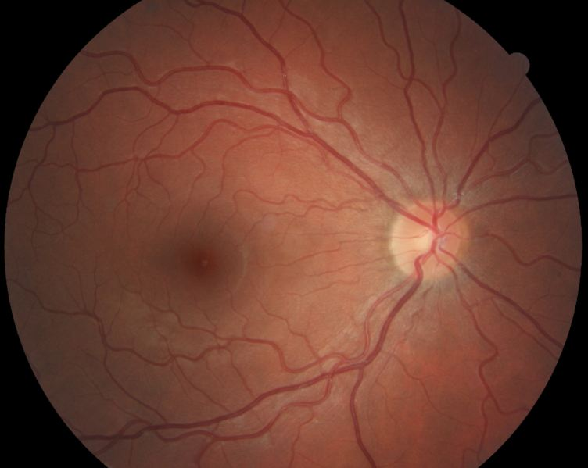

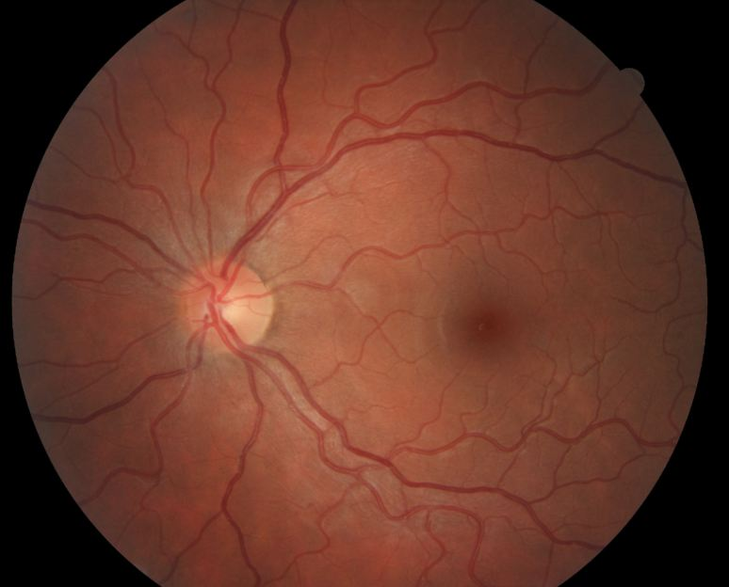

## Question 1 / 5

Based on the examination findings, what is the MOST likely cause of the patient's symptoms associated with prolonged near work?

a) Convergence excess

b) Accommodative insufficiency

c) Convergence insufficiency

d) Accommodative excess

e) Divergence excess

## Question 2 / 5

According to Hofstetter's formula, given this patient's age, what would her expected minimum monocular amplitude of accommodation be via the push-up method (rounded to the nearest whole dioptric value)?

a) 8 D

b) 15 D

c) 11 D

d) 10 D

e) 13 D

## Question 3 / 5

Which 2 of the following vision therapy techniques should be prescribed in order to help relieve this patient's symptoms? (Select 2)

a) Monocular push-ups

b) Binocular pencil push-ups

c) Monocular lens clearing and sorting

d) Brock string

e) Percon saccades

f) Vectograms

g) Pencil saccades

## Question 4 / 5

Which of the following monocular estimation method (MEM) findings is ALWAYS considered abnormal?

a) Any lag

b) Any lead

c) +0.25

d) +0.50

e) Plano

## Question 5 / 5

If the patient’s parents decided not to have the patient undergo vision therapy, which of the following alternative options would BEST help relieve her symptoms?

a) There are no other options available to this patient

b) Prescribe glasses with base-in prism for use with prolonged near work

c) Prescribe +1.00 DS OU glasses for use with prolonged near work

d) Prescribe -1.00 DS OU glasses for distance use

e) Prescribe glasses with base-out prism for use with prolonged near work

f) Prescribe patching of each eye for 2 hours a day with 30 minutes of near activities