Case ZBWMXLQsaFsscejs7885 Details

**Demographics**

* 23-year-old American Indian female; college student

**Chief complaint**

* blurred vision

**History of present illness**

* Character/signs/symptoms:blurry vision at all distances
* Location:OD, OS
* Severity:mild-moderate
* Nature of onset:gradual
* Duration:3 months
* Frequency:constant
* Exacerbations/remissions:worse at night, better when she turns her head to the right
* Relationship to activity or function:none
* Accompanying signs/symptoms:none

**Secondary complaints/symptoms**

* none

**Patient ocular history**

* last eye exam 2 years ago; was prescribed glasses but never wears them

**Family ocular history**

* mother: glaucoma suspect, maternal grandfather: macular degeneration

**Patient medical history**

* unremarkable

**Medications taken by patient**

* oral contraceptives

**Patient allergy history**

* NKDA

**Family medical history**

* father: hypertension

**Review of systems**

* Constitutional/general health:denies
* Ear/nose/throat:denies
* Cardiovascular:denies
* Pulmonary:denies
* Dermatological:denies
* Gastrointestinal:denies
* Genitourinary:denies
* Musculoskeletal:denies
* Neuropsychiatric:denies
* Endocrine:denies
* Hematologic:denies
* Immunologic:denies

**Mental status**

* Orientation:oriented to time, place, and person
* Mood:appropriate
* Affect:appropriate

**Clinical findings**

**Uncorrected visual acuity**

* OD:distance: 20/30, near: 20/20 @ 40 cm
* OS:distance: 20/30, near: 20/20 @ 40 cm

**Pupils:**

* PERRL, negative APD

**EOMs:**

* full, no restrictions OU

**Cover test:**

* distance: orthophoria, near: 10 exophoria

**Confrontation fields:**

* full to finger counting OD, OS

**Subjective refraction**

* OD:-0.25 -1.25 x 062; VA distance: 20/20
* OS:plano -1.50 x 170; VA distance: 20/20

**Slit lamp**

* lids/lashes/adnexa:unremarkable OD, OS
* conjunctiva:nasal pinguecula OD, OS
* cornea:clear OD, OS
* anterior chamber:deep and quiet OD, OS
* iris:normal OD, OS
* lens:clear OD, OS
* vitreous:clear OD, OS

**IOPs:**

* OD: 14 mmHg, OS: 13 mmHg @ 8:00 am by Goldmann applanation tonometry

**Fundus OD**

* C/D:see image 1
* macula:see image 1
* posterior pole:see image 1
* periphery:unremarkable

**Fundus OS**

* C/D:see image 2
* macula:see image 2
* posterior pole:see image 2
* periphery:unremarkable

**Blood pressure:**

* 115/78 mmHg, right arm, sitting

**Pulse:**

* 67 bpm, regular

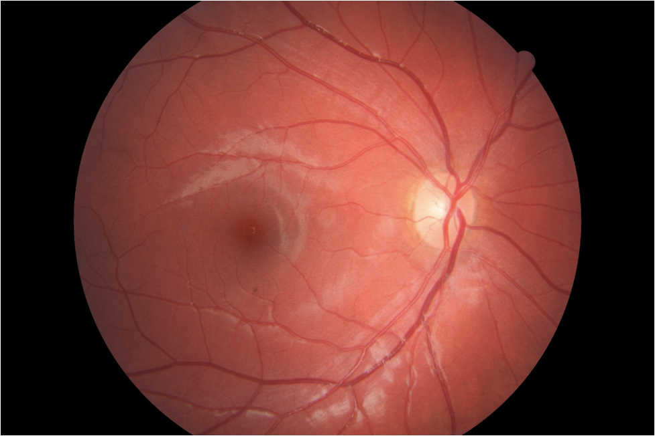

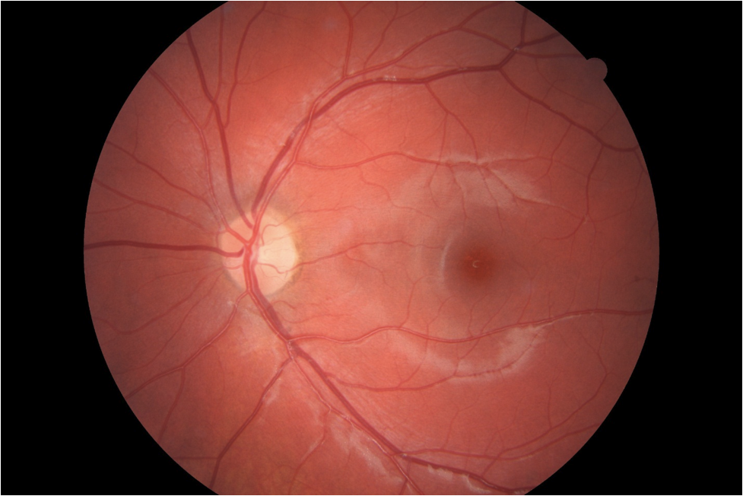

## Question 1 / 5

What is the MOST appropriate classification of the patient's right eye and left eye refractive errors?

a) OD: simple myopic astigmatism; OS: mixed astigmatism

b) OD: compound myopic astigmatism; OS: compound myopic astigmatism

c) OD: compound myopic astigmatism; OS: simple astigmatism

d) OD: mixed astigmatism; OS: mixed astigmatism

e) OD: simple myopic astigmatism; OS: simple myopic astigmatism

f) OD: mixed astigmatism; OS: compound myopic astigmatism

## Question 2 / 5

If you were to perform the modified Thorington technique to measure this patient's near phoria, which of the following results would you expect to observe if the Maddox rod is to be placed over the right eye?

a) A red vertical streak observed to the right of the spot of light

b) A red horizontal streak observed to the left of the spot of light

c) A red horizontal streak observed to the right of the spot of light

d) A red vertical streak observed to the left of the spot of light

## Question 3 / 5

You decide to evaluate the patient’s near vergence ranges. According to Sheard's criterion, which of the following findings would likely ensure that this patient remains asymptomatic?

a) Negative fusional convergence (NFC): 10/16/8

b) Positive fusional convergence (PFC): 22/28/16

c) Positive fusional convergence (PFC): 8/18/10

d) Negative fusional convergence (NFC): 15/20/12

## Question 4 / 5

If you perform the astigmatic clock dial on the patient’s right eye, which of the following lines would she MOST likely report to appear bolder, blacker, and sharper?

a) 3-9 line

b) 1-7 line

c) 2-8 line

d) 5-11 line

e) 6-12 line

f) 4-10 line

## Question 5 / 5

Given the patient's prescription, which of the following keratometry readings would you MOST expect for the right and left eye, respectively?

a) OD: 44.50 @ 065 / 45.25 @ 155; OS: 44.75 @ 170 / 46.75 @ 080

b) OD: 43.00 @ 060 / 41.75 @ 150; OS: 42.50 @ 171 / 41.00 @ 081

c) OD: 46.00 @ 070 / 44.75 @ 140; OS: 46.25 @ 165 / 44.75 @ 075

d) OD: 41.25 @ 090 /42.75 @ 180; OS: 41.00 @ 160 / 42.50 @ 070