Case ZMBZKUDVAiMGInv14250 Details

**Demographics**

* 31-year-old white female; professional skydiver

**Chief complaint**

* problems with contact lenses

**History of present illness**

* Character/signs/symptoms:contact lenses are very uncomfortable; can only wear them for a few hours
* Location:OD, OS
* Severity:moderate
* Nature of onset:gradual
* Duration:2 months
* Frequency:occurs every time she wears contacts
* Exacerbations/remissions:worsens with increased contact lens wear time; improved when removes contacts
* Relationship to activity or function:contact lens wear
* Accompanying signs/symptoms:itchy eyes, ropy discharge, blurred vision

**Secondary complaints/symptoms**

* none

**Patient ocular history**

* last eye exam 1 year ago; wears soft monthly disposable contact lenses, compliant with cleaning and replacement regimen, sleeps in contacts a few times per month

**Family ocular history**

* unremarkable

**Patient medical history**

* unremarkable

**Medications taken by patient**

* none

**Patient allergy history**

* NKDA

**Family medical history**

* father: hepatitis C

**Review of systems**

* Constitutional/general health:denies
* Ear/nose/throat:denies
* Cardiovascular:denies
* Pulmonary:denies
* Dermatological:denies
* Gastrointestinal:denies
* Genitourinary:denies
* Musculoskeletal:denies
* Neuropsychiatric:denies
* Endocrine:denies
* Hematologic:denies
* Immunologic:denies

**Mental status**

* Orientation:oriented to time, place, and person
* Mood:appropriate
* Affect:appropriate

**Clinical findings**

**Habitual contact lens Rx**

* ODB+L Ultra / 8.5 / 14.2 / -3.50 DS; VA distance: 20/20
* OSB+L Ultra / 8.5 / 14.2 / -3.50 DS; VA distance: 20/25

**Pupils:**

* PERRL, negative APD

**EOMs:**

* full, no restrictions OU

**Confrontation fields:**

* full to finger counting OD, OS

**Subjective refraction**

* OD:-3.50 -0.25 x 170; VA distance: 20/20
* OS:-4.25 -0.25 x 005; VA distance: 20/20

**Slit lamp**

* lids/lashes/adnexa:see images 1 & 2 OD, OS similar to OD
* conjunctiva:1+ injection OD, OS
* cornea:clear OD, OS
* anterior chamber:deep and quiet OD, OS
* iris:normal OD, OS
* lens:clear OD, OS
* vitreous:clear OD, OS

**IOPs:**

* OD: 13 mmHg, OS: 12 mmHg @ 12:00 pm by Goldmann applanation tonometry

**Fundus OD**

* C/D:0.20 H/0.25 V
* macula:normal
* posterior pole:normal
* periphery:unremarkable

**Fundus OS**

* C/D:0.20 H/0.25 V
* macula:normal
* posterior pole:normal
* periphery:unremarkable

**Blood pressure:**

* 105/73 mmHg, right arm, sitting

**Pulse:**

* 70 bpm, regular

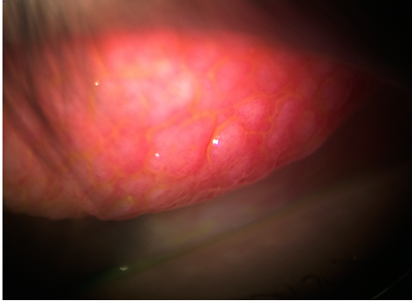

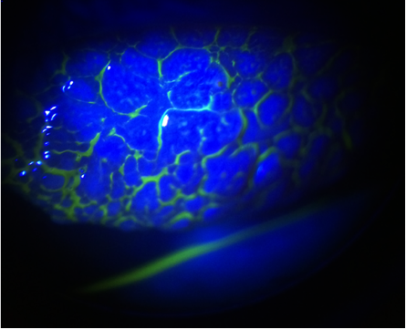

## Question 1 / 5

What is the MOST appropriate diagnosis of the patient's anterior segment condition?

a) Epidemic keratoconjunctivitis

b) Bacterial conjunctivitis

c) Vernal keratoconjunctivitis

d) Giant papillary conjunctivitis

e) Superior limbic keratoconjunctivitis

## Question 2 / 5

What is the MOST likely etiology of the patient's ocular condition observed in Images 1 and 2?

a) Mechanical trauma

b) Contact lens wear

c) Idiopathic

d) Unknown

e) Viral pathogen

f) Bacterial pathogen

## Question 3 / 5

What is the MOST appropriate treatment for the patient's ocular condition?

a) Oral antihistamine

b) Topical cyclosporine drops

c) Topical antiviral drops

d) Topical fluoroquinolone drops

e) Preservative-free artificial tears

f) Topical mast cell stabilizer and antihistamine drops

## Question 4 / 5

After the initiation of treatment, approximately when should the patient return to your office for a follow-up visit?

a) 1 day

b) 2 weeks

c) 2 months

d) 6 months

e) 7 weeks

f) 1 year

## Question 5 / 5

The FDA classification system groups hydrogel contact lens materials according to care system compatibility. Upon which of the following parameters is this system based?

a) Permeability and modulus

b) Wettability and lubricity

c) Water content and ionicity

d) Transmissibility and center thickness