Case ZjPgvUvLfRORFUNM4862 Details

**Demographics**

* 48-year-old Asian female; currently unemployed

**Chief complaint**

* blurred vision

**History of present illness**

* Character/signs/symptoms:vision is blurry when reading
* Location:OD, OS
* Severity:moderate
* Nature of onset:gradual
* Duration:2 years
* Frequency:constant
* Exacerbations/remissions:worse in dim illumination, better if she holds things further away
* Relationship to activity or function:reading and computer use
* Accompanying signs/symptoms:headaches and eye fatigue with prolonged near work

**Secondary complaints/symptoms**

* none

**Patient ocular history**

* last eye exam 4 years ago; unremarkable

**Family ocular history**

* mother: macular degeneration

**Patient medical history**

* hypertension, hyperlipidemia, type 2 diabetes (HbA1c: 6.5% 2 weeks ago, FBS: 102 mg/dL this morning), history of intravenous drug use

**Medications taken by patient**

* Lipitor®, amitriptyline, Actos®, lisinopril

**Patient allergy history**

* NKDA

**Family medical history**

* mother: scoliosis, father: hypertension

**Review of systems**

* Constitutional/general health:denies
* Ear/nose/throat:denies
* Cardiovascular:denies
* Pulmonary:denies
* Dermatological:denies
* Gastrointestinal:denies
* Genitourinary:denies
* Musculoskeletal:denies
* Neuropsychiatric:denies
* Endocrine:denies
* Hematologic:denies
* Immunologic:denies

**Mental status**

* Orientation:oriented to time, place, and person
* Mood:appropriate
* Affect:appropriate

**Clinical findings**

**Uncorrected visual acuity**

* OD:VA distance: 20/20, VA near: 20/40 @ 40 cm
* OS:VA distance: 20/20, VA near: 20/40 @ 40 cm

**Pupils:**

* PERRL, negative APD

**EOMs:**

* full, no restrictions OU

**Cover test:**

* distance: 4 exophoria, near: 8 exophoria

**Confrontation fields:**

* full to finger counting OD, OS

**Subjective refraction**

* OD:-0.25 DS add: +1.50; VA distance: 20/20, VA near: 20/20 @ 40 cm
* OS:+0.25 -0.25 x 125 add: +1.50; VA distance: 20/20, VA near: 20/20 @ 40 cm

**Slit lamp**

* lids/lashes/adnexa:unremarkable OD, OS
* conjunctiva:nasal pinguecula OD, OS
* cornea:1+ arcus OD, OS
* anterior chamber:deep and quiet OD, OS
* iris:normal OD, OS
* lens:clear OD, OS
* vitreous:clear OD, OS

**IOPs:**

* OD: 14 mmHg, OS: 14 mmHg @ 4:50 pm by Goldmann applanation tonometry

**Fundus OD**

* C/D:see image 1
* macula:see image 2
* posterior pole:see image 1
* periphery:unremarkable

**Fundus OS**

* C/D:see image 3
* macula:see image 4
* posterior pole:see image 3
* periphery:unremarkable

**Blood pressure:**

* 120/78 mmHg, right arm, sitting

**Pulse:**

* 70 bpm, regular

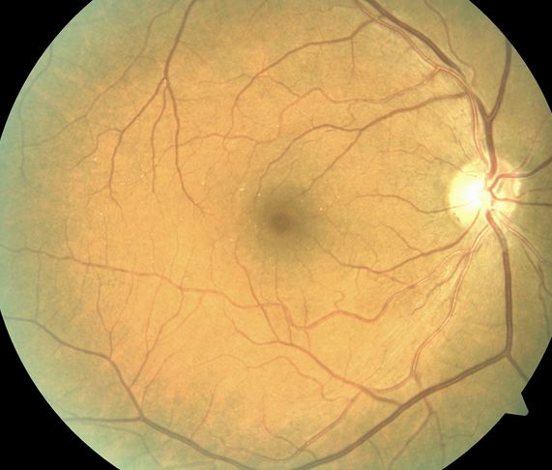

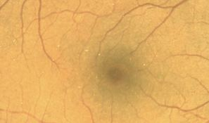

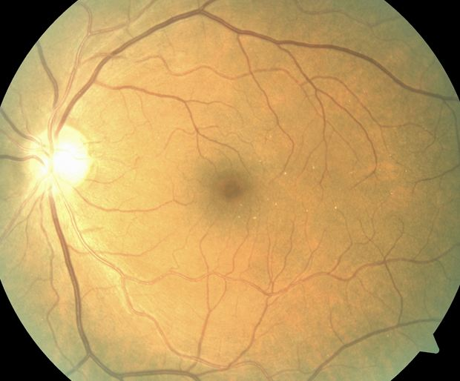

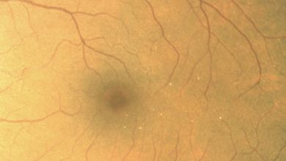

## Question 1 / 5

Which of the following substances is MOST likely to have caused the retinal deposits observed in images 1 through 4?

a) Talc

b) Actos®

c) Amitriptyline

d) Lisinopril

e) Lipitor®

f) Cholesterol

## Question 2 / 5

Which 2 of the following additional tests should be ordered given the patient's retinal findings? (Select 2)

a) Serum cholesterol levels

b) Chest x-ray

c) Glycosylated hemoglobin

d) Stool sample with culture

e) Biopsy of retinal tissue

f) Fluorescein angiography

g) Electrocardiogram

## Question 3 / 5

If the previous tests are performed and return with normal results, what immediate treatment should be recommended to the patient?

a) Cryotherapy of the peripheral retina

b) Vitrectomy

c) No treatment is necessary

d) Panretinal photocoagulation

e) Consult with the patient’s physician to adjust her systemic medications

## Question 4 / 5

Which of the following retinal complications may arise from the deposits observed in this patient?

a) Central serous chorioretinopathy

b) Peripheral neovascularization

c) Cystoid macular edema

d) Choroidal neovascular membrane

e) Papilledema

f) Pigment epithelial detachment

## Question 5 / 5

Which of the following ocular complications has been associated with the use of amitriptyline?

a) Choroidal rupture

b) Macular edema

c) Peripheral neovascularization

d) Optic nerve congestion

e) Dry eyes

f) Cataract formation