Case aMtbWZQpgHDhJwMT7469 Details

**Demographics**

* 52-year-old American Indian male; botanist

**Chief complaint**

* floaters

**History of present illness**

* Character/signs/symptoms:new onset of floaters, no flashes of light
* Location:OS
* Severity:mild
* Nature of onset:acute
* Duration:3 days
* Frequency:intermittent
* Exacerbations/remissions:more noticeable when looking up at the sky
* Relationship to activity or function:none
* Accompanying signs/symptoms:none

**Secondary complaints/symptoms**

* none

**Patient ocular history**

* last eye exam 10 years ago; wears single vision distance glasses only, takes glasses off for reading

**Family ocular history**

* father: cataract surgery

**Patient medical history**

* unremarkable

**Medications taken by patient**

* none

**Patient allergy history**

* shellfish, NKDA

**Family medical history**

* mother: Addison disease

**Review of systems**

* Constitutional/general health:denies
* Ear/nose/throat:denies
* Cardiovascular:denies
* Pulmonary:denies
* Dermatological:denies
* Gastrointestinal:denies
* Genitourinary:denies
* Musculoskeletal:denies
* Neuropsychiatric:denies
* Endocrine:denies
* Hematologic:denies
* Immunologic:denies

**Mental status**

* Orientation:oriented to time, place, and person
* Mood:appropriate
* Affect:appropriate

**Clinical findings**

**Habitual spectacle Rx**

* OD:-2.00 -0.50 x 080; VA distance: 20/20
* OS:-1.75 -1.00 x 100; VA distance: 20/20

**Pupils:**

* PERRL, negative APD

**EOMs:**

* full, no restrictions OU

**Confrontation fields:**

* full to finger counting OD, OS

**Slit lamp**

* lids/lashes/adnexa:1+ MGD OD, OS
* conjunctiva:normal OD, OS
* cornea:1+ arcus OD, OS
* anterior chamber:deep and quiet OD, OS
* iris:normal OD, OS
* lens:clear OD, OS
* vitreous:clear OD, OS

**IOPs:**

* OD: 12 mmHg, OS: 11 mmHg @ 12:00 pm by Goldmann applanation tonometry

**Fundus OD**

* C/D:see image 1
* macula:normal
* posterior pole:normal
* periphery:unremarkable

**Fundus OS**

* C/D:see image 2
* macula:normal
* posterior pole:see image 2
* periphery:unremarkable

**Blood pressure:**

* 113/74 mmHg, right arm, sitting

**Pulse:**

* 68 bpm, regular

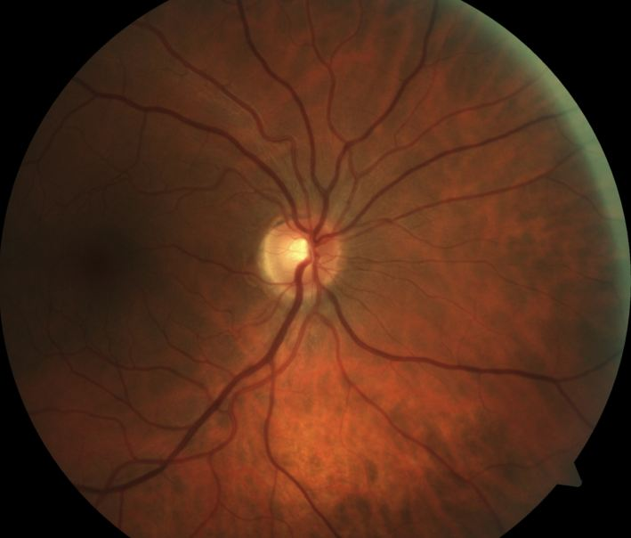

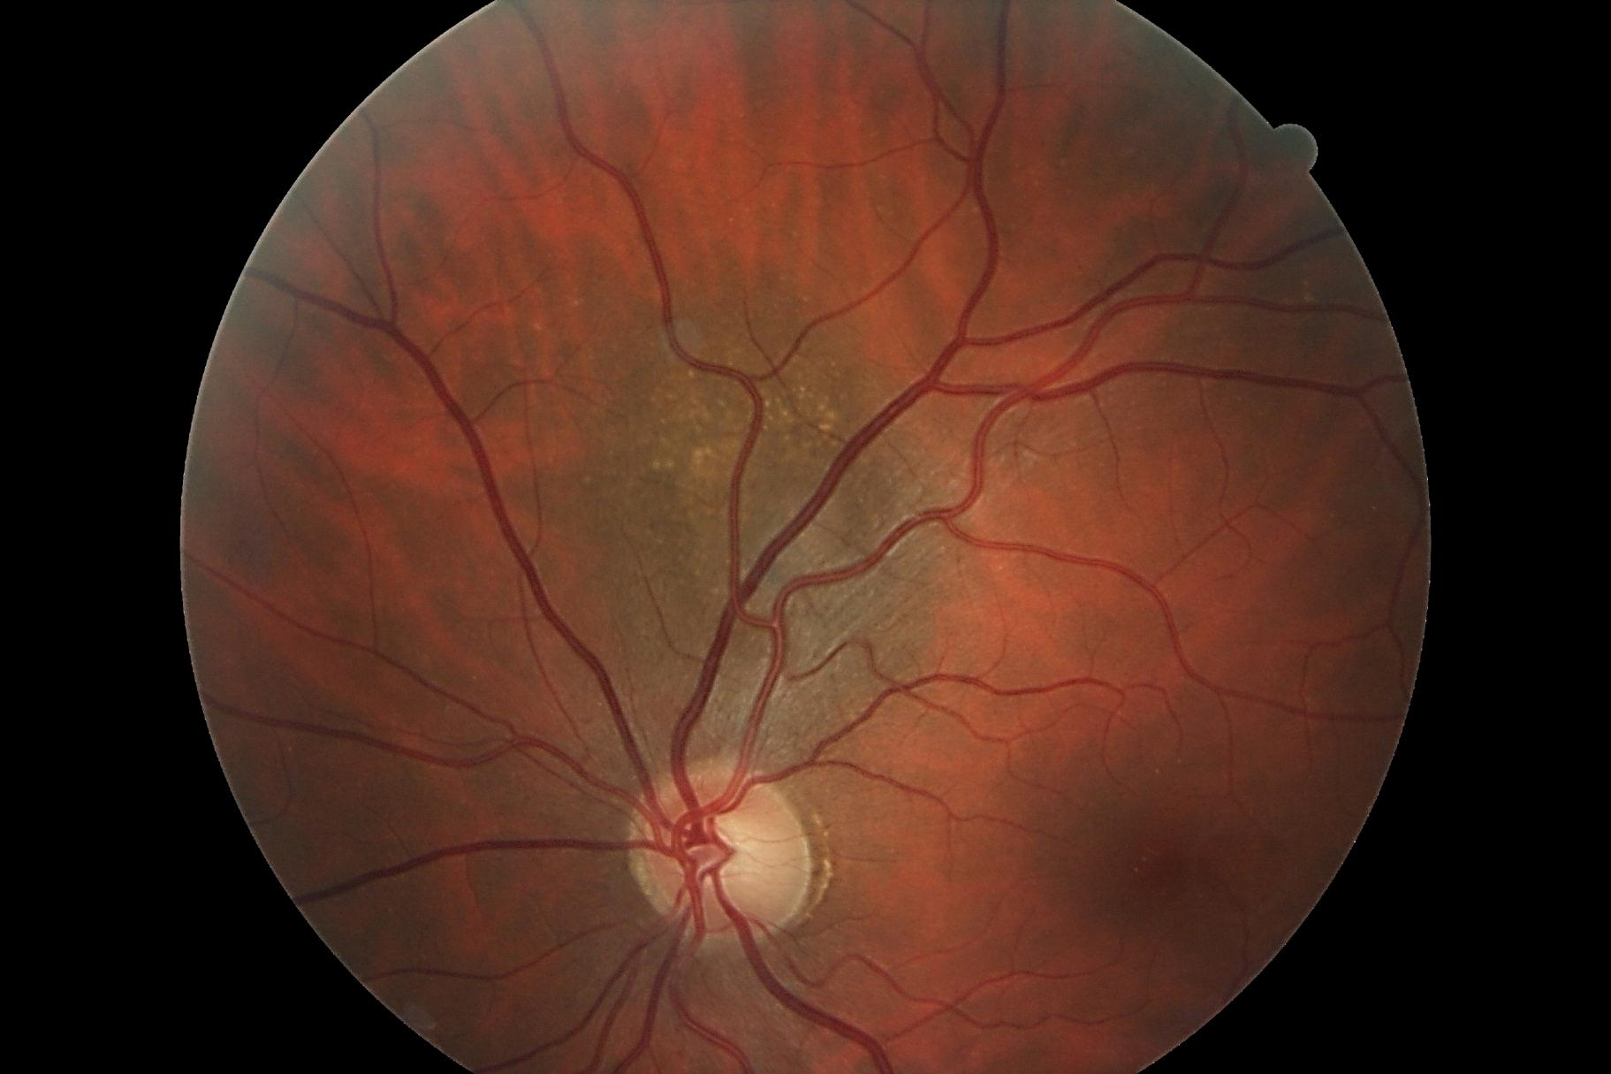

## Question 1 / 5

What is the MOST likely diagnosis of the patient's left eye retinal condition observed in image 2?

a) Choroidal nevus

b) RPE hyperplasia

c) Retinoschisis

d) Congenital hypertrophy of the RPE

e) Choroidal melanoma

## Question 2 / 5

This retinal condition is MOST commonly observed in patients of what ethnic background?

a) Caucasian

b) American Indian

c) African American

d) Hispanic

e) Asian

## Question 3 / 5

What is the MOST appropriate treatment for the patient's left fundus condition?

a) Prescribe polarized prescription sunglasses

b) Monitor every 6 months for growth

c) No treatment is necessary as the condition is benign

d) Refer to a retinal oncologist

## Question 4 / 5

Considering this patient’s diagnosis, which of the following associated findings increases the likelihood of requiring some form of treatment?

a) A lesion located more anteriorly than posteriorly

b) Lipofuscin on the surface of the lesion

c) Sharply-demarcated lesion borders

d) Drusen on the surface of the lesion

## Question 5 / 5

Choroidal melanomas have the potential to metastasize to other organs of the body. Which of the following sites is MOST commonly affected?

a) Lungs

b) Colon

c) Liver

d) Breast

e) Heart