Case aXovwJdGWkjFlVwxy134 Details

**Demographics**

* 26-year-old black male; optometry student

**Chief complaint**

* 1 week LASIK enhancement post-op; vision is great but has mild discomfort

**History of present illness**

* Character/signs/symptoms:foreign body sensation
* Location:OD, OS
* Severity:mild
* Nature of onset:acute
* Duration:1 week
* Frequency:constant
* Exacerbations/remissions:worse at the end of the day and with extended computer use; improves with artificial tears
* Relationship to activity or function:LASIK enhancement surgery
* Accompanying signs/symptoms:eyes are slightly red

**Secondary complaints/symptoms**

* none

**Patient ocular history**

* last comprehensive eye exam 1 month ago; LASIK OU 1 year ago, LASIK enhancement OU 1 week ago

**Family ocular history**

* mother: chronic progressive external ophthalmoplegia

**Patient medical history**

* unremarkable

**Medications taken by patient**

* as indicated by LASIK surgeon; compliant with all meds

**Patient allergy history**

* iodine

**Family medical history**

* father: mesothelioma

**Review of systems**

* Constitutional/general health:denies
* Ear/nose/throat:denies
* Cardiovascular:denies
* Pulmonary:denies
* Dermatological:denies
* Gastrointestinal:denies
* Genitourinary:denies
* Musculoskeletal:denies
* Neuropsychiatric:denies
* Endocrine:denies
* Hematologic:denies
* Immunologic:denies

**Mental status**

* Orientation:oriented to time, place, and person
* Mood:appropriate
* Affect:appropriate

**Clinical findings**

**Uncorrected visual acuity**

* OD:distance: 20/20
* OS:distance: 20/20

**Slit lamp**

* lids/lashes/adnexa:unremarkable OD, OS
* conjunctiva:trace injection OD, OS
* cornea:see image 1 OD, see image 2 OS
* anterior chamber:deep and quiet OD, OS
* iris:normal OD, OS
* lens:clear OD, OS
* vitreous:clear OD, OS

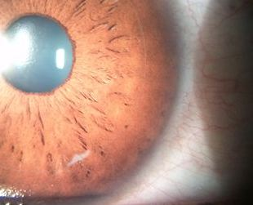

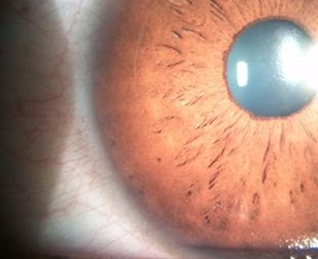

## Question 1 / 5

What is the MOST appropriate diagnosis of the patient's right eye corneal findings?

a) Microbial keratitis

b) Corneal foreign body

c) Diffuse lamellar keratitis

d) Epithelial ingrowth

e) Superficial punctate keratitis

## Question 2 / 5

What is the MOST appropriate treatment of the patient's condition?

a) Refer back to the surgeon for treatment

b) Have the patient return in 2 weeks and monitor carefully for change

c) Add Ilotycin® q.h.s. OD and return in 1 week for follow-up

d) Add Ilevro® b.i.d. OD and return in 1 week for follow-up

e) Increase Pred Forte® to q.2.h. OD and return in 2-3 days for follow-up

f) Increase preservative-free artificial tears to q.2.h OD and return in 1 week for follow-up

## Question 3 / 5

At the follow-up visit, the patient reports that his vision is reduced in the right eye. You note a best corrected visual acuity of 20/40. Biomicroscopy reveals a worsening of the condition with more corneal involvement. What is the MOST appropriate treatment at this time?

a) Prescribe Restasis® ophthalmic emulsion b.i.d. OU

b) Increase Pred-Forte® 1% ophthalmic suspension to q.1.h. OD

c) Increase preservative-free artificial tears to q.1.h OD

d) Refer back to the LASIK surgeon for flap lift and removal of aberrant cells

e) Prescribe Zymaxid® ophthalmic solution q.i.d. OD

## Question 4 / 5

Typical ophthalmic medications prescribed for use during the first week following LASIK surgery include which three of the following? (Select 3)

a) Topical steroid drops

b) Bland ophthalmic ointment

c) Artificial tears

d) Topical hyperosmotic drops

e) Mast cell stabilizer

f) Topical antibiotic drops

g) Topical vasoconstrictor

## Question 5 / 5

Which of the following activities is prohibited the day before LASIK surgery?

a) Drinking alcoholic beverages

b) Heavy lifting

c) Running

d) Wearing contact lenses

e) Surfing

f) Sleeping

g) Eating solid foods