Case asLtMVfxsnDYuACc9218 Details

**Demographics**

* 25-year-old white male; mail carrier

**Chief complaint**

* itchy eyes

**History of present illness**

* Character/signs/symptoms:eyelids are itchy and irritated
* Location:OD, OS
* Severity:mild
* Nature of onset:gradual
* Duration:3 weeks
* Frequency:constant
* Exacerbations/remissions:worse at night
* Relationship to activity or function:none
* Accompanying signs/symptoms:mild redness and tearing

**Secondary complaints/symptoms**

* none

**Patient ocular history**

* last eye exam 2 years ago; does not wear correction

**Family ocular history**

* unremarkable

**Patient medical history**

* unremarkable

**Medications taken by patient**

* none

**Patient allergy history**

* caffeine

**Family medical history**

* father: hypertension

**Review of systems**

* Constitutional/general health:denies
* Ear/nose/throat:denies
* Cardiovascular:denies
* Pulmonary:denies
* Dermatological:denies
* Gastrointestinal:denies
* Genitourinary:denies
* Musculoskeletal:denies
* Neuropsychiatric:denies
* Endocrine:denies
* Hematologic:denies
* Immunologic:denies

**Mental status**

* Orientation:oriented to time, place, and person
* Mood:appropriate
* Affect:appropriate

**Clinical findings**

**Uncorrected visual acuity**

* OD:distance: 20/20; near: 20/20 @ 40 cm
* OS:distance: 20/20; near: 20/20 @ 40 cm

**Pupils:**

* PERRL, negative APD

**EOMs:**

* full, no restrictions OU

**Confrontation fields:**

* full to finger counting OD, OS

**Subjective refraction**

* OD:+0.25 -0.25 x 013; VA distance: 20/20
* OS:+0.25 DS; VA distance: 20/20

**Slit lamp**

* lids/lashes/adnexa:see image 1 OD, see image 2 OS
* conjunctiva:1+ injection with palpebral follicles OD, OS
* cornea:clear OD, OS
* anterior chamber:deep and quiet OD, OS
* iris:normal OD, OS
* lens:clear OD, OS
* vitreous:clear OD, OS

**IOPs:**

* OD: 13 mmHg, OS: 14 mmHg @ 12:00 pm by Goldmann applanation tonometry

**Fundus OD**

* C/D:see image 3
* macula:see image 3
* posterior pole:see image 3
* periphery:unremarkable

**Fundus OS**

* C/D:see image 4
* macula:see image 4
* posterior pole:see image 4
* periphery:unremarkable

**Blood pressure:**

* 100/75 mmHg, right arm, sitting

**Pulse:**

* 66 bpm, regular

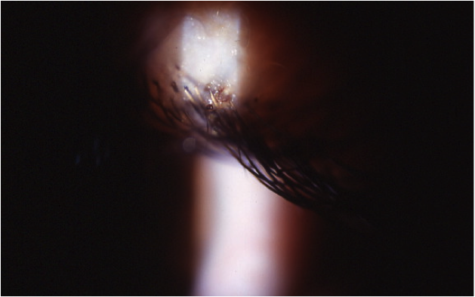

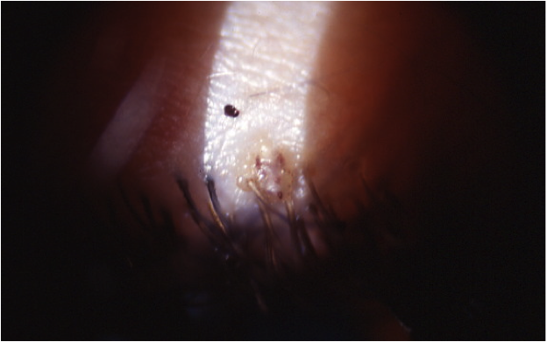

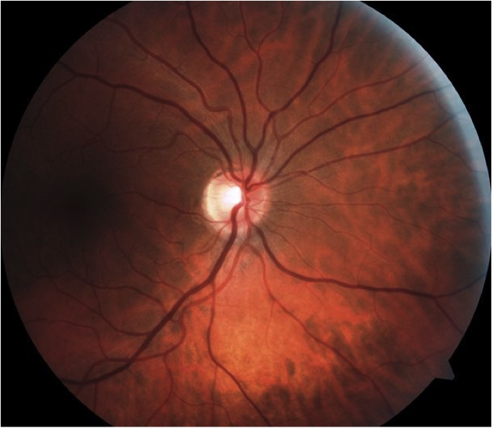

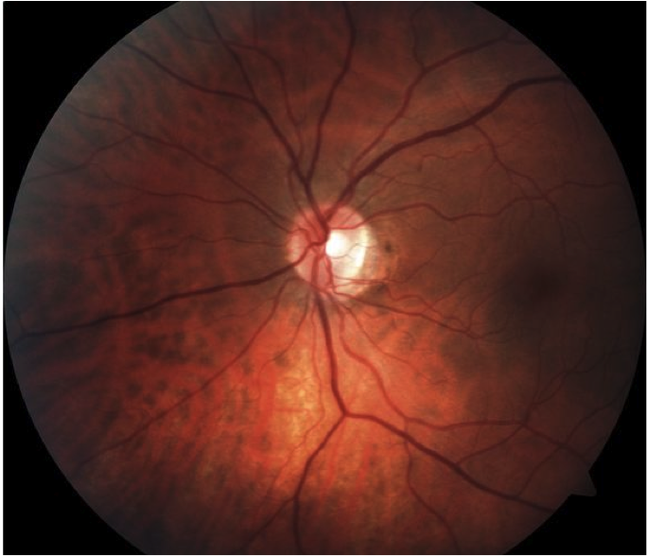

## Question 1 / 5

What is the MOST appropriate diagnosis of the patient's ocular condition?

a) Phthiriasis

b) Ticks

c) Demodex

d) Mites

## Question 2 / 5

What is the MOST appropriate initial treatment for this ocular condition?

a) Application of Kwell® shampoo to the lid margins and surrounding ocular structures

b) Exposure of the organisms to extreme heat

c) Removal of the organisms with jeweler's forceps

d) Application of petroleum jelly ophthalmic ointment q.h.s. to the eyelid margins

e) Cleansing of the eyelid margins with diluted tea tree oil

## Question 3 / 5

What other counseling should be included in your patient education considering this patient’s ocular condition?

a) All clothes, bath towels, and bedding must be laundered and dried on high heat and then sealed in a bag for 14 days

b) He is required to wear sunglasses and bandage contact lenses to ensure that this condition fully resolves

c) The condition can lead to severe permanent corneal damage if he is not compliant with the treatment

d) It is essential that he stays in isolation for two weeks given the extremely contagious nature of his condition

## Question 4 / 5

After the initiation of treatment, when should the patient return to your office for a follow-up visit?

a) 7 days

b) 6 months

c) 1 month

d) 14 days

e) 1 day

## Question 5 / 5

Given this diagnosis, what additional referrals should be made to ensure optimal results?

a) Referral to a neurologist

b) Referral to an ophthalmologist

c) Referral to his primary care physician

d) Referral to the centers for disease control and prevention (CDC)

e) Referral to a dermatologist