Case bOADRTLVqGskCyQS6972 Details

**Demographics**

* 46-year-old white female; administrative assistant

**Chief complaint**

* difficulties with vision; referred by neurologist for baseline evaluation

**History of present illness**

* Character/signs/symptoms:has been stumbling/bumping into things; difficulty reading, loses her place often
* Location:OD, OS
* Severity:moderate
* Nature of onset:gradual
* Duration:1 month
* Frequency:constant
* Exacerbations/remissions:none
* Relationship to activity or function:recently diagnosed with intracranial tumor
* Accompanying signs/symptoms:vision appears dimmer

**Secondary complaints/symptoms**

* none

**Patient ocular history**

* last eye exam 1 year ago; LASIK OU; wears PALs occasionally

**Family ocular history**

* unremarkable

**Patient medical history**

* intracranial tumor (diagnosed 2 weeks ago)

**Medications taken by patient**

* none

**Patient allergy history**

* NKDA

**Family medical history**

* unremarkable

**Review of systems**

* Constitutional/general health:denies
* Ear/nose/throat:denies
* Cardiovascular:denies
* Pulmonary:denies
* Dermatological:denies
* Gastrointestinal:denies
* Genitourinary:denies
* Musculoskeletal:denies
* Neuropsychiatric:headaches
* Endocrine:denies
* Hematologic:denies
* Immunologic:denies

**Mental status**

* Orientation:oriented to time and place and person
* Mood:appropriate
* Affect:appropriate

**Clinical findings**

**Habitual spectacle Rx**

* OD:-0.75 -0.75 x 165 add: +1.25; VA distance: 20/20, VA near: 20/20 @ 40 cm
* OS:plano -1.00 x 015 add: +1.50; VA distance: 20/20, VA near: 20/20 @ 40 cm

**Pupils:**

* PERRL, negative APD

**EOMs:**

* full, no restrictions OU

**Confrontation fields:**

* temporal restriction OD, nasal restriction OS

**Subjective refraction**

* OD:-0.75 -0.50 x 160 add: +1.50; VA distance: 20/20, VA near: 20/20 @ 40 cm
* OS:-0.25 -0.50 x 020 add: +1.50; VA distance: 20/20, VA near: 20/20 @ 40 cm

**Slit lamp**

* lids/lashes/adnexa:unremarkable OD, OS
* conjunctiva:normal OD, OS
* cornea:clear OD, OS
* anterior chamber:deep and quiet OD, OS
* iris:normal OD, OS
* lens:clear OD, OS
* vitreous:clear OD, OS

**IOPs:**

* OD: 19 mmHg, OS: 19 mmHg @ 10:22 am by Goldmann applanation tonometry

**Fundus OD**

* C/D:0.30 H/0.30 V
* macula:normal
* posterior pole:normal
* periphery:unremarkable

**Fundus OS**

* C/D:0.30 H/0.30 V
* macula:normal
* posterior pole:normal
* periphery:unremarkable

**Blood pressure:**

* 114/72 mmHg, right arm, sitting

**Pulse:**

* 70 bpm, regular

**Threshold visual fields:**

* OD:see image 1
* OS:see image 2

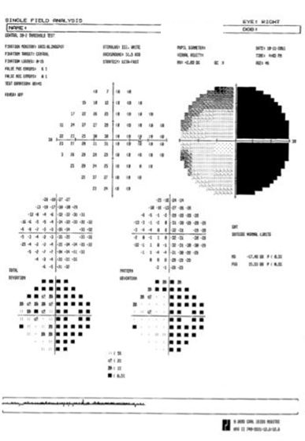

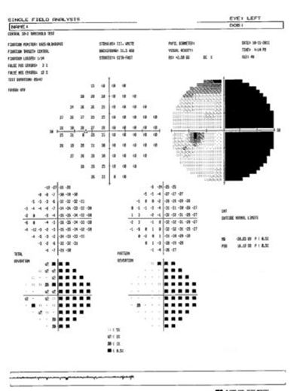

## Question 1 / 5

Based upon the results of the threshold visual field test, which of the following BEST describes the patient's visual field defect?

a) Right homonymous hemianopsia

b) Bitemporal hemianopsia

c) Left heteronymous hemianopsia

d) Right heteronymous hemianopsia

e) Left homonymous hemianopsia

f) Binasal hemianopsia

## Question 2 / 5

Which of the following represents the BEST choice of low vision therapy to achieve field expansion for this patient and help with her symptoms of bumping into things?

a) 10 diopters of base-in prism right eye, and 10 diopters of base-out prism left eye

b) 10 diopters of base-out prism right eye, and 10 diopters of base-in prism left eye

c) 10 diopters of base-in prism over each eye

d) Two 40 diopter Fresnel prism segments, placed base-out over the left eye in the Peli fashion

e) 10 diopters of base-out prism over each eye

f) Two 40 diopter Fresnel prism segments, placed base-out over the right eye in the Peli fashion

## Question 3 / 5

Based upon your answer for the previous question, what is the amount of field expansion that you would expect to achieve with the prism treatment?

a) 20 degrees

b) 40 degrees

c) 5 degrees

d) 10 degrees

## Question 4 / 5

In addition to field expansion, what 3 other devices would this patient MOST likely benefit from? (Select 3)

a) Reach-and-touch training with prism glasses

b) A lined bifocal

c) A hand-held telescope for distance spotting tasks

d) Yellow filters for improving contrast

e) A 20 D stand magnifier for near tasks

f) Cosmetic tinted contact lenses with a pinhole pupil

## Question 5 / 5

How would this patient's vision be classified?

a) This patient is classified as legally blind based upon visual fields

b) This patient is classified as legally blind based upon visual efficiency

c) This patient is not classified as legally blind

d) This patient is classified as legally blind based upon visual acuity