Case cnmaIUrxszmaJsG12679 Details

**Demographics**

* 42-year-old white female; information technology consultant

**Chief complaint**

* red eye

**History of present illness**

* Character/signs/symptoms:redness, irritation, excessive lacrimation, and photophobia
* Location:OS
* Severity:moderate
* Nature of onset:acute
* Duration:6 weeks; woke up with red, painful eye and went to urgent care; was directed to the emergency room, but she never went (worried about cost); symptoms have been ongoing since then, but pain has been gradually improving
* Frequency:constant
* Exacerbations/remissions:has been slightly improving since onset
* Relationship to activity or function:none
* Accompanying signs/symptoms:mildly blurred vision

**Secondary complaints/symptoms**

* none

**Patient ocular history**

* LASIK 9 years ago; last eye exam 2 years ago; wears soft contact lenses due to myopic regression, not compliant with replacement schedule and occasionally sleeps in lenses

**Family ocular history**

* mother: cataracts

**Patient medical history**

* unremarkable

**Medications taken by patient**

* multivitamins

**Patient allergy history**

* NDKA

**Family medical history**

* father: liver cirrhosis

**Review of systems**

* Constitutional/general health:denies
* Ear/nose/throat:denies
* Cardiovascular:denies
* Pulmonary:denies
* Dermatological:denies
* Gastrointestinal:denies
* Genitourinary:denies
* Musculoskeletal:denies
* Neuropsychiatric:denies
* Endocrine:denies
* Hematologic:denies
* Immunologic:denies

**Mental status**

* Orientation:oriented to time, place, and person
* Mood:appropriate
* Affect:appropriate

**Clinical findings**

**Uncorrected visual acuity**

* OD:VA distance: 20/40 (PH 20/20)
* OS:VA distance: 20/100 (PH 20/30)

**Pupils:**

* PERRL, negative APD

**EOMs:**

* full, no restrictions OU

**Confrontation fields:**

* full to finger counting OD, OS

**Slit lamp**

* lids/lashes/adnexa:unremarkable OD, OS
* conjunctiva:normal OD, 2+ injection OS
* cornea:clear OD, 1+ edema, fine keratic precipitates on endothelium, stromal neovascularization (see images 1 and 2) OS
* anterior chamber:deep and quiet OD, 1+ cells and flare OS
* iris:normal OD, OS
* lens:clear OD, OS
* vitreous:clear OD, OS

**IOPs:**

* OD: 14 mmHg, OS: 14 mmHg @ 10:15 am by Goldmann applanation tonometry

**Fundus OD**

* C/D:see image 3
* macula:see image 3
* posterior pole:see image 3
* periphery:unremarkable

**Fundus OS**

* C/D:see image 4
* macula:see image 4
* posterior pole:see image 4
* periphery:unremarkable

**Blood pressure:**

* 120/80 mmHg, right arm, sitting

**Pulse:**

* 68 bpm, regular

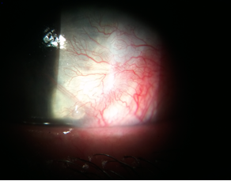

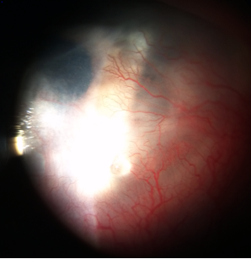

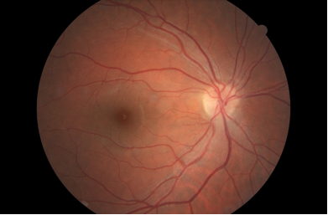

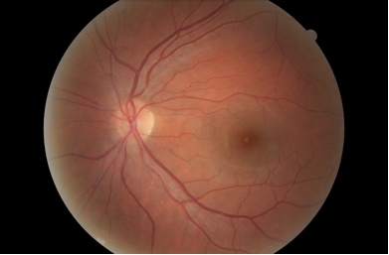

## Question 1 / 5

What is the MOST likely diagnosis of the patient's anterior segment condition of the LEFT eye?

a) Iritis

b) Contact lens associated red eye

c) Interstitial keratitis

d) Pterygium

e) Neovascular glaucoma

## Question 2 / 5

Although the patient denied any systemic medical history, what is the MOST likely etiology of this condition?

a) Congenital syphilis

b) Cogan syndrome

c) Leprosy

d) Lyme disease

e) Herpes simplex

## Question 3 / 5

Which 3 of the following represent the MOST appropriate treatment for the patient's anterior segment condition of the left eye? (Select 3)

a) Valtrex 1 gram p.o. t.i.d.

b) Intravenous aqueous crystalline penicillin G q.4.h.

c) Homatropine 2% ophthalmic solution t.i.d.

d) Pred Forte® 1% ophthalmic suspension q.2.h.

e) Doxycycline 100 mg p.o. b.i.d.

f) Zirgan® 0.15% ophthalmic gel 5x per day

g) Ofloxacin 0.3% ophthalmic solution q.i.d.

## Question 4 / 5

After the initiation of treatment, when should the patient return for a follow-up visit?

a) 2 months

b) 5 days

c) 1 month

d) 1 day

e) 2 weeks

## Question 5 / 5

Which of the following glaucoma medications can cause black/brown palpebral conjunctival deposits?

a) Timoptic®

b) Lumigan®

c) Pilocarpine

d) Brimonidine

e) Epinephrine

f) Rocklatan®