Case dHGtZbPmBtyhTioL8578 Details

**Demographics**

* 46-year-old Filipino male; nurse

**Chief complaint**

* red, irritated eye

**History of present illness**

* Character/signs/symptoms:right eye is constantly red, irritated, and dry
* Location:OD
* Severity:mild/moderate
* Nature of onset:gradual
* Duration:1 year
* Frequency:constant, but severity waxes and wanes
* Exacerbations/remissions:co-worker gave him steroid drops to help with symptoms; has been using them 2x per day for the past month in the right eye which has significantly helped the redness and irritation
* Relationship to activity or function:flares up in dry or windy weather conditions
* Accompanying signs/symptoms:intermittent blurry vision that improves with blinking

**Secondary complaints/symptoms**

* none

**Patient ocular history**

* last eye exam 2 years ago; pterygium OD; wears single vision distance glasses (removes for near vision)

**Family ocular history**

* unremarkable

**Patient medical history**

* unremarkable

**Medications taken by patient**

* multivitamin

**Patient allergy history**

* NKDA

**Family medical history**

* father: hypertension

**Review of systems**

* Constitutional/general health:denies
* Ear/nose/throat:denies
* Cardiovascular:denies
* Pulmonary:denies
* Dermatological:denies
* Gastrointestinal:denies
* Genitourinary:denies
* Musculoskeletal:denies
* Neuropsychiatric:denies
* Endocrine:denies
* Hematologic:denies
* Immunologic:denies

**Mental status**

* Orientation:oriented to time, place, and person
* Mood:appropriate
* Affect:appropriate

**Clinical findings**

**Habitual spectacle Rx**

* OD:-1.00 -1.50 x 165; VA distance: 20/20
* OS:-0.75 -0.50 x 165; VA distance: 20/20

**Pupils:**

* PERRL, negative APD

**EOMs:**

* full, no restrictions OU

**Confrontation fields:**

* full to finger counting OD, OS

**Slit lamp**

* lids/lashes/adnexa:unremarkable OD, OS
* conjunctiva:1+ injection nasal OD, normal OS
* cornea:nasal pterygium 1.5 mm onto cornea OD, clear OS
* anterior chamber:deep and quiet OD, OS
* iris:normal OD, OS
* lens:clear OD, OS
* vitreous:clear OD, OS

**IOPs:**

* OD: 29 mmHg, OS: 17 mmHg @ 10:15 am by Goldmann applanation tonometry

**Fundus OD**

* C/D:see images 1 and 3
* macula:see image 1
* posterior pole:see image 1
* periphery:unremarkable

**Fundus OS**

* C/D:see images 2 and 4
* macula:see image 2
* posterior pole:see image 2
* periphery:unremarkable

**Blood pressure:**

* 116/74 mmHg, right arm, sitting

**Pulse:**

* 68 bpm, regular

**Optical coherence tomography (OCT)**

* OD:see image 5
* OS:see image 5

**Threshold visual fields:**

* OD:see image 6
* OS:see image 7

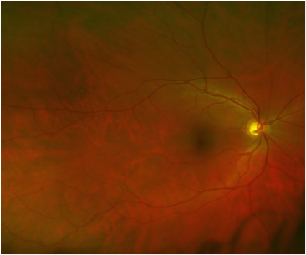

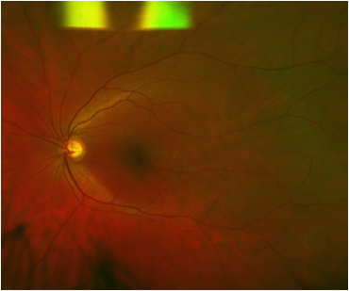

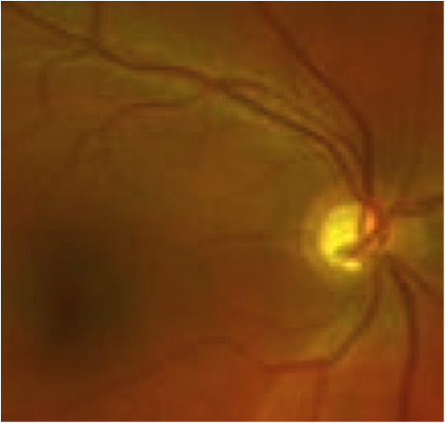

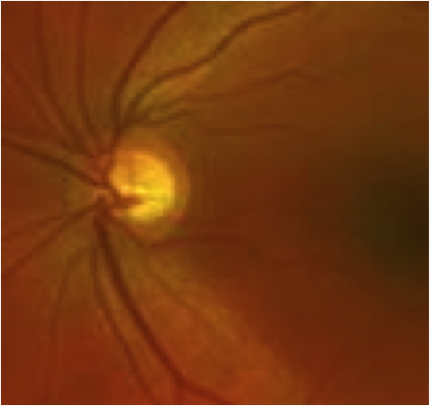

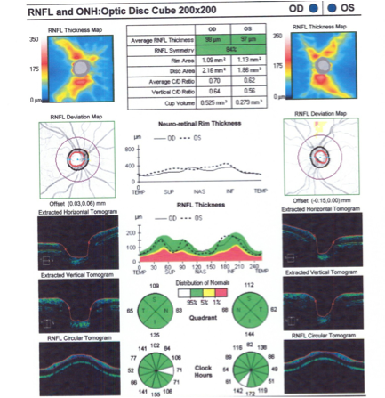

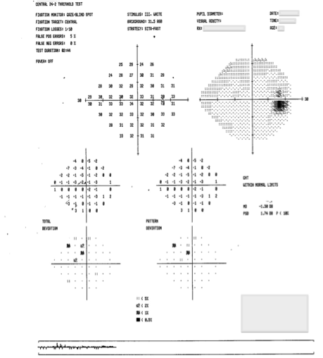

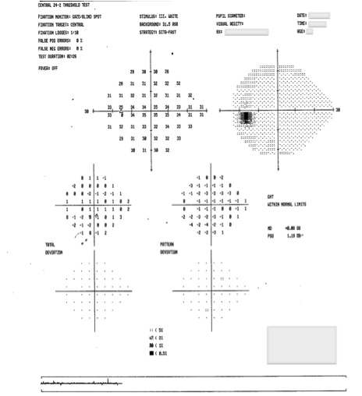

## Question 1 / 6

Considering the patient’s history and examination findings, what is the MOST likely diagnosis?

a) Steroid-induced glaucoma

b) Steroid-induced ocular hypertension

c) Acute angle-closure glaucoma

d) Primary open-angle glaucoma

## Question 2 / 6

Which of the following MOST closely represents the typical amount of time that it takes for a topical ocular corticosteroid to cause an elevation in the intraocular pressure?

a) 1 day

b) 6 months

c) 1 month

d) 1 hour

e) 3 months

## Question 3 / 6

Which of the following BEST describes the reasoning for the need to taper topical ocular corticosteroids?

a) Avoid signs and symptoms of rebound ocular inflammation

b) Minimize the risk of adrenal insufficiency due to decreased production of natural cortisol

c) Decrease the risk of posterior subcapsular cataract formation

d) Minimize the risk of developing steroid-induced elevation of IOP

e) Prevent possible secondary ocular infections

## Question 4 / 6

Patients with significantly elevated intraocular pressures are at a higher risk of developing which of the following retinal vascular conditions?

a) Central retinal vein occlusion

b) Ocular ischemic syndrome

c) Branch retinal artery occlusion

d) Central retinal artery occlusion

e) Branch retinal vein occlusion

## Question 5 / 6

Which of the following describes the BEST initial treatment for this patient?

a) Refer for peripheral iridotomy

b) Prescribe a prostaglandin analog

c) Refer for laser trabeculoplasty

d) Begin a taper of the corticosteroid medication

e) Refer for anterior chamber paracentesis

f) Prescribe oral capsules of acetazolamide

## Question 6 / 6

The patient returns to your office for a follow-up visit and presents with signs of acute iritis in the right eye. Which of the following topical corticosteroids is LEAST likely to increase intraocular pressure and why?

a) Dexamethasone; because it a ketone-based steroid

b) Dexamethasone; because it is an ester-based steroid

c) Prednisolone acetate; because it is an ester-based steroid

d) Loteprednol; because it is a ketone-based steroid

e) Prednisolone acetate; because it is a ketone-based steroid

f) Loteprednol; because it is an ester-based steroid