Case eNEoDLSOttZdYZog8019 Details

**Demographics**

* 42-year-old Hispanic female; cosmetologist

**Chief complaint**

* blurred vision

**History of present illness**

* Character/signs/symptoms:blurry vision at near
* Location:OD, OS
* Severity:mild-moderate
* Nature of onset:gradual
* Duration:6 months
* Frequency:constant
* Exacerbations/remissions:worse in dim illumination
* Relationship to activity or function:notices difficulty when working in close proximity to clients
* Accompanying signs/symptoms:eyestrain and fatigue

**Secondary complaints/symptoms**

* none

**Patient ocular history**

* last eye exam 2 years ago; unremarkable

**Family ocular history**

* mother: blepharoplasty

**Patient medical history**

* borderline hypertension

**Medications taken by patient**

* oral contraceptives

**Patient allergy history**

* pollen and ragweed, NKDA

**Family medical history**

* father: cardiovascular disease

**Review of systems**

* Constitutional/general health:denies
* Ear/nose/throat:denies
* Cardiovascular:denies
* Pulmonary:denies
* Dermatological:denies
* Gastrointestinal:denies
* Genitourinary:denies
* Musculoskeletal:denies
* Neuropsychiatric:denies
* Endocrine:denies
* Hematologic:denies
* Immunologic:denies

**Mental status**

* Orientation:oriented to time, place, and person
* Mood:appropriate
* Affect:appropriate

**Clinical findings**

**Uncorrected visual acuity**

* OD:VA distance: 20/25, VA near: 20/40 @ 40 cm
* OS:VA distance: 20/25, VA near: 20/40 @ 40 cm

**Pupils:**

* PERRL, negative APD

**EOMs:**

* full, no restrictions OU

**Cover test:**

* distance: 8 exophoria, near: 4 exophoria

**Confrontation fields:**

* full to finger counting OD, OS

**Subjective refraction**

* OD:+1.00 -0.25 x 115 add: +1.00; VA distance: 20/20, VA near: 20/20 @ 40 cm
* OS:+1.25 -1.00 x 110 add: +1.00; VA distance: 20/20, VA near: 20/20 @ 40 cm

**Pupillary distance:**

* distance: 61 mm, near: 58 mm

**Slit lamp**

* lids/lashes/adnexa:unremarkable OD, OS
* conjunctiva:nasal pinguecula OD, OS
* cornea:clear OD, OS
* anterior chamber:deep and quiet OD, OS
* iris:normal OD, OS
* lens:clear OD, OS
* vitreous:clear OD, OS

**IOPs:**

* OD: 12 mmHg, OS: 11 mmHg @ 10:00 am by Goldmann applanation tonometry

**Fundus OD**

* C/D:0.15 H/0.15 V
* macula:normal
* posterior pole:normal
* periphery:cobblestone degeneration temporal

**Fundus OS**

* C/D:0.15 H/0.15 V
* macula:normal
* posterior pole:normal
* periphery:unremarkable

**Blood pressure:**

* 120/80 mmHg, right arm, sitting

**Pulse:**

* 70 bpm, regular

**Additional info:**

* see image 1 for frames chosen for new glasses; A= 50 mm, B= 43 mm, ED= 51 mm, DBL= 18 mm, temple length= 132 mm

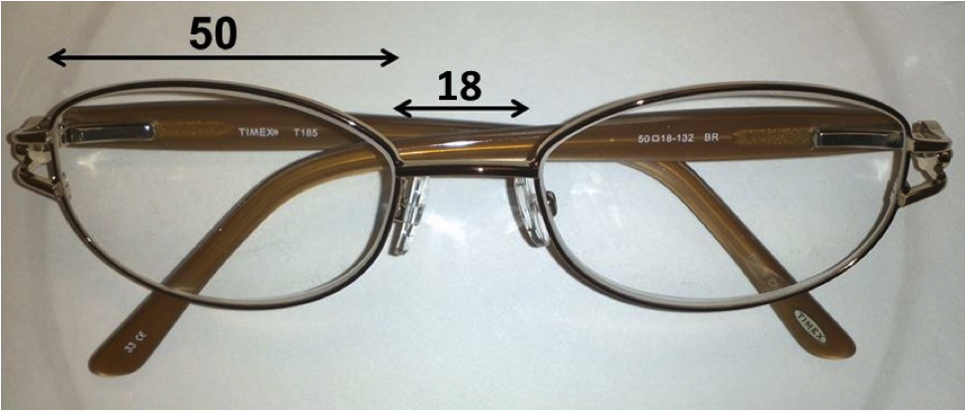

## Question 1 / 5

This patient wishes to order bifocals instead of PALs to correct her vision. Given her pupillary distance, what is the MOST appropriate segment inset for each lens?

a) 1.5 mm

b) 2.0 mm

c) 1.0 mm

d) 0.5 mm

e) 2.5 mm

f) 3.0 mm

## Question 2 / 5

What is the MOST appropriate minimum blank size that should be used for this patient's spectacle lenses?

a) 56 mm

b) 55 mm

c) 58 mm

d) 59 mm

e) 54 mm

f) 57 mm

## Question 3 / 5

Before the patient picks up her new glasses, you decide to verify the prescription; however, your lensometer is broken, so you must use hand neutralization. Which of the following lens combinations would CORRECTLY neutralize the prescription of the left lens (minus cylinder format)?

a) -1.25 DS lens with spectacle lens oriented at 110 degrees; -0.25 DS lens with spectacle oriented at 20 degrees

b) -1.00 DS lens with spectacle lens oriented at 110 degrees; +1.25 DS lens with spectacle lens oriented at 20 degrees

c) +0.25 DS lens with spectacle lens oriented at 110 degrees; +1.25 DS lens with spectacle lens oriented at 20 degrees

d) -0.25 DS lens with spectacle lens oriented at 110 degrees; -1.25 DS lens with spectacle lens oriented at 20 degrees

e) +1.25 DS lens with spectacle lens oriented at 110 degrees; -1.00 DS lens with spectacle lens oriented at 20 degrees

f) +1.25 DS lens with spectacle lens oriented at 110 degrees; +0.25 DS lens with spectacle lens oriented at 20 degrees

## Question 4 / 5

This patient brought in her husband's prescription sunglasses and wishes to know if they are polarized. Which of the following methods is a quick way to determine if the sunglasses are polarized?

a) Place the sunglasses next to a known polarized pair and compare the darkness of the lenses, if they appear the same his sunglasses are polarized

b) Place the sunglasses in front of a known polarized pair in the same orientation; if the light is completed blocked his sunglasses are polarized

c) Place the sunglasses in front of a liquid crystal display and rotate the lenses, if at some orientation the screen appears to “blacken out” his sunglasses are polarized

d) Place the sunglasses in front of a projector, if the resultant image appears elongated vertically his sunglasses are polarized

## Question 5 / 5

Your optician is trying to insert lenses into a frame made of polycarbonate and therefore cannot use heat. Which of the following techniques offers the easiest method of lens insertion?

a) Insert the nasal edge first, followed by the temporal edge of the lens from the back of the frame

b) Insert the temporal edge of the lens first, followed by the nasal aspect from the back of the frame

c) Insert the nasal edge first, followed by the temporal edge of the lens from the front of the frame

d) Insert the temporal edge of the lens first, followed by the nasal aspect from the front of the frame