Case gjOVjtAFCmuyrGnu6876 Details

**Demographics**

* 15-year-old Hispanic female; high school student

**Chief complaint**

* blurry vision

**History of present illness**

* Character/signs/symptoms:blurred vision at distance and near
* Location:OD, OS
* Severity:moderate to severe
* Nature of onset:gradual
* Duration:~5 years
* Frequency:constant
* Exacerbations/remissions:worse at night and dim lighting conditions; stumbles and bumps into things
* Relationship to activity or function:none
* Accompanying signs/symptoms:none

**Secondary complaints/symptoms**

* none

**Patient ocular history**

* 1st eye exam

**Family ocular history**

* father: diabetic retinopathy, cataracts

**Patient medical history**

* congenital hearing loss, delayed developmental milestones (walking), broken wrist (age 12)

**Medications taken by patient**

* none

**Patient allergy history**

* NKDA

**Family medical history**

* mother: hypertension; father: type II diabetes

**Review of systems**

* Constitutional/general health:denies
* Ear/nose/throat:hearing impaired
* Cardiovascular:denies
* Pulmonary:denies
* Dermatological:denies
* Gastrointestinal:denies
* Genitourinary:denies
* Musculoskeletal:denies
* Neuropsychiatric:denies
* Endocrine:denies
* Hematologic:denies
* Immunologic:denies

**Mental status**

* Orientation:oriented to time and place and person
* Mood:appropriate
* Affect:appropriate

**Clinical findings**

**Uncorrected visual acuity**

* OD:distance: 20/100, PH 20/50
* OS:distance: 20/100, PH 20/50

**Pupils:**

* PERRL, negative APD

**EOMs:**

* full, no restrictions; with jerky movements OU

**Confrontation fields:**

* restricted in all quadrants OD, OS

**Subjective refraction**

* OD:+4.25 -2.25 x 180; VA distance: 20/50, VA near: 20/40 @ 40 cm (+2.00 add, VA near: 20/25)
* OS:+3.75 -1.75 x 010; VA distance: 20/50, VA near: 20/40 @ 40 cm (+2.00 add, VA near: 20/25)

**Slit lamp**

* lids/lashes/adnexa:unremarkable OD, OS
* conjunctiva:normal OD, OS
* cornea:clear OD, OS
* anterior chamber:deep and quiet OD, OS
* iris:normal OD, OS
* lens:clear OD, OS
* vitreous:clear OD, OS

**IOPs:**

* OD: 14 mmHg, OS: 14 mmHg @ 2:13 pm by Goldmann applanation tonometry

**Fundus OD**

* C/D:0.30 H/0.30 V
* macula:normal
* posterior pole:see image 1
* periphery:see image 1

**Fundus OS**

* C/D:0.35 H/0.35 V
* macula:normal
* posterior pole:OS similar to OD
* periphery:OS similar to OD

**Threshold visual fields:**

* OD:see image 2
* OS:see image 3

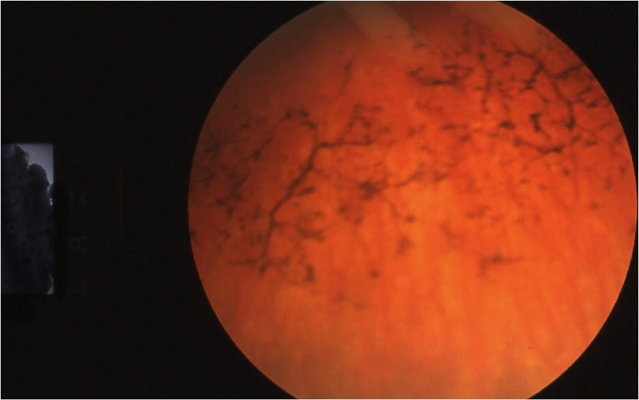

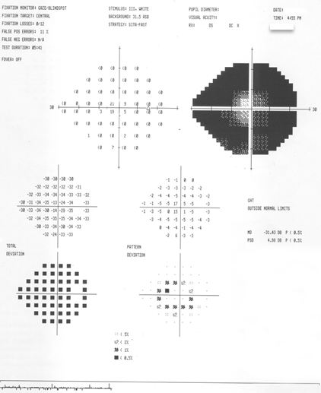

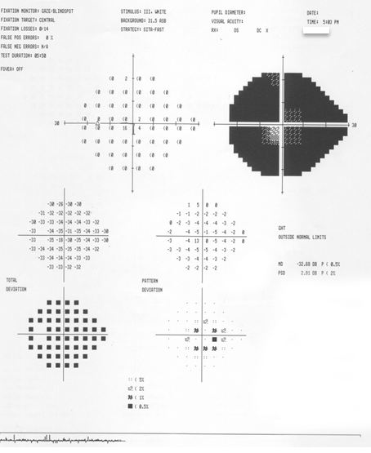

## Question 1 / 6

What is the MOST likely diagnosis for this patient considering her ocular findings and medical history?

a) Gyrate atrophy

b) Choroideremia

c) Honeycomb degeneration

d) Usher syndrome

## Question 2 / 6

Which of the following represents the MOST appropriate low vision treatment plan for this patient?

a) 4x stand magnifier, yoked prism glasses, and an implantable telescope

b) Lined bifocal with +2.00D add, 2.2x telescope, mobility training, and genetic counseling

c) Closed circuit television (CCTV), Max TV, and yellow filtered lenses

d) Mobility training, 6x telescope, 6x hand magnifier, referral for hearing aids

## Question 3 / 6

Based upon your patient's entering uncorrected visual acuities, what is her just-noticeable difference (JND), and what spherical trial lenses would you begin with if performing a trial frame refraction?

a) JND: 2 D; trial lenses: +/- 1.00 D

b) JND: 1 D; trial lenses: +/- 0.50 D

c) JND: 1 D; trial lenses: +/- 1.00 D

d) JND: 2 D; trial lenses: +/- 0.50 D

## Question 4 / 6

What is the inheritance pattern of this patient's condition?

a) X-linked recessive

b) Autosomal dominant

c) X-linked dominant

d) Autosomal recessive

## Question 5 / 6

Based upon the United States' definition of legal blindness, how would this patient's vision be classified?

a) This patient is classified as legally blind based upon her visual fields

b) This patient is classified as legally blind based upon poor visual efficiency

c) This patient is classified as legally blind based upon her visual acuities

d) This patient is not classified as legally blind

## Question 6 / 6

Which 3 of the following additional ocular findings would you MOST likely expect to see in a patient diagnosed with this retinal condition? (Select 3)

a) Vitreous cells

b) Dilated arterioles

c) Posterior embryotoxon

d) Posterior subcapsular cataracts

e) Narrow angles

f) Hyperopia

g) Waxy optic disc pallor