Case hJqfPxFLmsaCnxy11084 Details

**Demographics**

* 16-year-old Hispanic male; student

**Chief complaint**

* watery eye

**History of present illness**

* Character/signs/symptoms:eye waters and tears run down his cheek
* Location:OS
* Severity:mild
* Nature of onset:unsure
* Duration:since he can remember
* Frequency:occurs several times a day
* Exacerbations/remissions:worse with near work or looking at the board in class, but also often occurs spontaneously
* Relationship to activity or function:none
* Accompanying signs/symptoms:none

**Secondary complaints/symptoms**

* none

**Patient ocular history**

* 1st eye exam

**Family ocular history**

* father: chronic iritis

**Patient medical history**

* cystic acne

**Medications taken by patient**

* none; previous Accutane® use

**Patient allergy history**

* erythromycin

**Family medical history**

* father: pancreatitis, ulcerative colitis

**Review of systems**

* Constitutional/general health:denies
* Ear/nose/throat:denies
* Cardiovascular:denies
* Pulmonary:denies
* Dermatological:acne
* Gastrointestinal:denies
* Genitourinary:denies
* Musculoskeletal:denies
* Neuropsychiatric:denies
* Endocrine:denies
* Hematologic:denies
* Immunologic:denies

**Mental status**

* Orientation:oriented to time, place and person
* Mood:appropriate
* Affect:appropriate

**Clinical findings**

**Uncorrected visual acuity**

* OD:VA distance: 20/20; VA near: 20/20 @ 40 cm
* OS:VA distance: 20/20; VA near: 20/20 @ 40 cm

**Pupils:**

* PERRL, negative APD

**EOMs:**

* full, no restrictions OU

**Confrontation fields:**

* full to finger counting OD, OS

**Slit lamp**

* lids/lashes/adnexa:see images 1 & 2 OD, see images 3 & 4 OS
* conjunctiva:normal OD, OS
* cornea:clear OD, OS
* anterior chamber:deep and quiet OD, OS
* iris:normal OD, OS
* lens:clear OD, OS
* vitreous:clear OD, OS

**IOPs:**

* OD: 13 mmHg, OS: 14 mmHg @ 9:12 am by Goldmann applanation tonometry

**Fundus OD**

* C/D:0.20 H/ 0.20 V
* macula:normal
* posterior pole:normal
* periphery:unremarkable

**Fundus OS**

* C/D:0.25 H/0.25 V
* macula:normal
* posterior pole:normal
* periphery:unremarkable

**Blood pressure:**

* 101/73 mmHg, right arm, sitting

**Pulse:**

* 67 bpm, regular

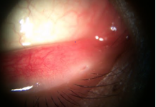

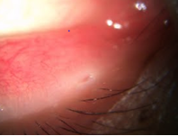

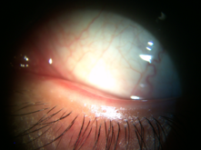

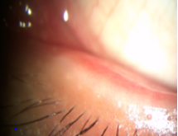

## Question 1 / 4

What is the MOST likely diagnosis of the patient's left eye anterior segment condition?

a) Canaliculitis

b) Punctal obstruction

c) Centurion syndrome

d) Punctal stenosis

e) Punctal atresia

## Question 2 / 4

What is the MOST appropriate treatment to help resolve this patient's chief complaint of epiphora?

a) Nasolacrimal probing and irrigation

b) Cannulation with placement of silicone tubes

c) A canaliculotomy

d) Blepharoplasty to reposition the puncta against the globe

e) Topical corticosteroids

f) Topical antibiotics

## Question 3 / 4

What is the MOST common etiology of the patient's anterior segment condition?

a) Congenital

b) Cicatricial

c) Developmental

d) Involutional

e) Secondary to chronic rubbing/manipulation

f) Secondary to multiple eyelid infections

## Question 4 / 4

The patient stated that he previously took Accutane® for his cystic acne. Which of the following is the MOST common side effect associated with Accutane® use?

a) Corneal whorl-like deposits

b) Optic atrophy

c) A red-orange tinge to urine, sweat, and tears

d) Elevated intraocular pressure

e) Increased sun sensitivity