Case hOAMZTKIEiQqsHeM9085 Details

**Demographics**

* 34-year-old white female; artist

**Chief complaint**

* bulging eyes

**History of present illness**

* Character/signs/symptoms:has been told by family and friends recently that her eyes appear as though they are bulging out
* Location:OD, OS
* Severity:moderate
* Nature of onset:gradual
* Duration:1 year
* Frequency:constant
* Exacerbations/remissions:none
* Relationship to activity or function:none
* Accompanying signs/symptoms:dry eyes

**Secondary complaints/symptoms**

* none

**Patient ocular history**

* last eye exam 2 years ago; unremarkable

**Family ocular history**

* father: retinal detachment

**Patient medical history**

* last physical exam 2 weeks ago; see table 1 for laboratory test results

**Medications taken by patient**

* none

**Patient allergy history**

* NKDA

**Family medical history**

* father: hypertension, hypercholesterolemia

**Review of systems**

* Constitutional/general health:weight loss, hair loss
* Ear/nose/throat:denies
* Cardiovascular:denies
* Pulmonary:denies
* Dermatological:denies
* Gastrointestinal:denies
* Genitourinary:less frequent menstruation
* Musculoskeletal:denies
* Neuropsychiatric:denies
* Endocrine:denies
* Hematologic:denies
* Immunologic:denies

**Mental status**

* Orientation:oriented to time, place, and person
* Mood:appropriate
* Affect:appropriate

**Clinical findings**

**Uncorrected visual acuity**

* OD:VA distance: 20/20
* OS:VA distance: 20/20

**Pupils:**

* PERRL, negative APD

**EOMs:**

* full, no restrictions OU

**Confrontation fields:**

* full to finger counting OD, OS

**Subjective refraction**

* OD:+0.25 -0.50 x 175; VA distance: 20/20
* OS:+0.50 DS; VA distance: 20/20

**Slit lamp**

* lids/lashes/adnexa:see image 1 OD, OS
* conjunctiva:normal OD, OS
* cornea:clear OD, OS
* anterior chamber:deep and quiet OD, OS
* iris:normal OD, OS
* lens:clear OD, OS
* vitreous:clear OD, OS

**IOPs:**

* OD: 17 mmHg, OS: 17 mmHg @ 10:30 am by Goldmann applanation tonometry

**Fundus OD**

* C/D:0.30 H/0.30 V
* macula:normal
* posterior pole:normal
* periphery:unremarkable

**Fundus OS**

* C/D:0.35 H/0.35 V
* macula:normal
* posterior pole:normal
* periphery:unremarkable

**Blood pressure:**

* 122/82 mmHg, right arm, sitting

**Pulse:**

* 82 bpm, regular

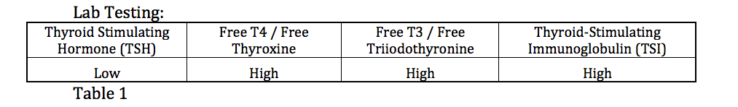

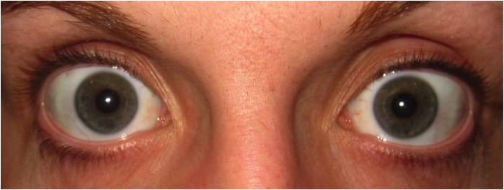

## Question 1 / 6

Considering the patient's examination findings and laboratory results, which of the following represents the MOST SPECIFIC diagnosis for the patient?

a) Hypothyroidism

b) Thyrotoxicosis

c) Graves disease

d) Hyperthyroidism

e) Hashimoto thyroiditis

## Question 2 / 6

Which of the following is the MOST significant risk factor for developing ocular manifestations once a patient is diagnosed with this systemic condition?

a) Gender

b) Diet

c) Smoking

d) Age

e) Race

## Question 3 / 6

When evaluating the possible presence of orbital proptosis with a Hertel exophthalmometer, what is considered the upper limit of normal for Caucasians and African Americans, respectively?

a) 22 mm in Caucasians; 24 mm in African Americans

b) 18 mm in Caucasians; 20 mm in African Americans

c) 16 mm in Caucasians; 18 mm in African Americans

d) 20 mm in Caucasians; 22 mm in African Americans

## Question 4 / 6

Considering the patient’s diagnosis, extraocular motility deficits typically occur following a specific pattern. What is the order of these motility defects from the most COMMON to the most INFREQUENT?

a) Elevation → abduction → depression → adduction

b) Depression → adduction → elevation → abduction

c) Elevation → adduction → depression → abduction

d) Depression → abduction → elevation → adduction

## Question 5 / 6

In cases where surgical intervention is indicated for patients with this condition, a stepwise approach is implemented. Which procedure is MOST commonly executed first to allow for the most predictable results?

a) Tarsorrhaphy

b) Eyelid surgery

c) Orbital decompression

d) Strabismus surgery

## Question 6 / 6

If a blood test fails to detect the disease that it was designed to detect in a patient who actually has the disease, this is known as what type of error?

a) Type I error

b) Type II error

c) Type IV error

d) Type III error