Case hjSArmeoVKZoglXA9354 Details

**Demographics**

* 36-year-old Hispanic female; attorney

**Chief complaint**

* returning for follow-up visit and fluorescein angiography

**History of present illness**

* Character/signs/symptoms:retinopathy observed at last visit; advised to return for fluorescein angiography
* Location:OD, OS
* Severity:severe
* Nature of onset:unknown
* Duration:comprehensive exam was 1 week ago
* Frequency:n/a
* Exacerbations/remissions:n/a
* Relationship to activity or function:patient is diabetic with poorly controlled blood sugar
* Accompanying signs/symptoms:blurred vision

**Secondary complaints/symptoms**

* none

**Patient ocular history**

* last eye exam 1 week ago; prior to that, last comprehensive exam was unremarkable 2 years ago; wears single vision distance glasses

**Family ocular history**

* mother: strabismus, father: retinal detachment

**Patient medical history**

* type I diabetes (diagnosed 15 years ago), last HbA1c 9.1% (2 weeks ago), fasting blood sugar 165 mg/dL (this morning)

**Medications taken by patient**

* insulin; currently working with endocrinologist to adjust medication to improve blood sugar control

**Patient allergy history**

* NKDA

**Family medical history**

* mother: ovarian cancer

**Review of systems**

* Constitutional/general health:denies
* Ear/nose/throat:denies
* Cardiovascular:denies
* Pulmonary:denies
* Dermatological:denies
* Gastrointestinal:denies
* Genitourinary:denies
* Musculoskeletal:denies
* Neuropsychiatric:depression
* Endocrine:poorly controlled blood sugar
* Hematologic:denies
* Immunologic:denies

**Mental status**

* Orientation:oriented to time, place, and person
* Mood:appropriate
* Affect:appropriate

**Clinical findings**

**Habitual spectacle Rx**

* OD:-3.50 -1.25 x 082; VA distance: 20/60 (PHNI)
* OS:-3.00 -1.50 x 112; VA distance: 20/60 (PHNI)

**Pupils:**

* PERRL, negative APD

**Slit lamp**

* lids/lashes/adnexa:unremarkable OD, OS
* conjunctiva:pinguecula OD, OS
* cornea:clear OD, OS
* anterior chamber:deep and quiet OD, OS
* iris:normal OD, OS
* lens:clear OD, OS
* vitreous:clear OD, OS

**IOPs:**

* OD: 15 mmHg, OS: 15 mmHg @ 9:50 am by Goldmann applanation tonometry

**Fundus OD**

* C/D:see image 1
* macula:see image 1
* posterior pole:see image 1
* periphery:unremarkable

**Fundus OS**

* C/D:see image 2
* macula:see image 2
* posterior pole:see image 2
* periphery:unremarkable

**Blood pressure:**

* 116/81 mmHg, right arm, sitting

**Pulse:**

* 70 bpm, regular

**Additional info:**

* several minutes after injecting the patient with fluorescein dye, she reports that she has difficulty breathing, her tongue and lips feel swollen, and her throat feels like it is closing

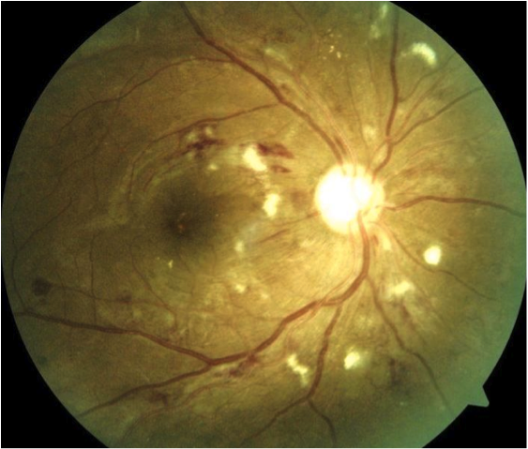

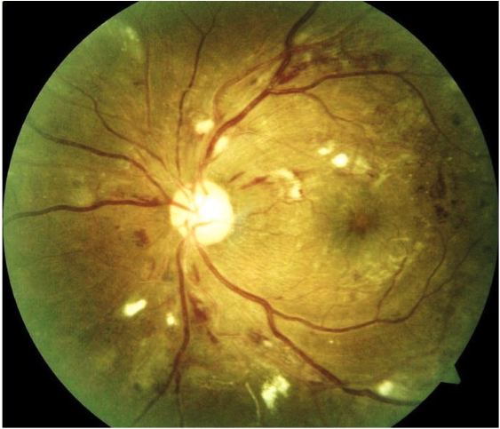

## Question 1 / 5

Which of the following represent the MOST appropriate cause of the patient’s symptoms following the injection of fluorescein?

a) Anaphylactic shock

b) Orthostatic hypotension

c) Ketoacidosis

d) Vasovagal syncope

e) Myocardial infarction

## Question 2 / 5

Considering the patient’s symptoms, what is the FIRST thing you should do in this situation?

a) Have the patient place her hands above her head and stretch upwards as far as possible

b) Have the patient place her head between her knees and breathe in and out of a paper bag

c) Place the patient in an upright position and give her water

d) Initiate cardiopulmonary resuscitation

e) Place an ammonia ampule under the patient's nose

f) Place the patient in a supine position while having a staff member call 9-1-1

## Question 3 / 5

What is the MOST appropriate initial treatment for the patient in this situation?

a) Injection of epinephrine into the patient's thigh

b) Administration of 100% oxygen to the patient

c) Administration of nitroglycerin spray

d) Administration of oral Benadryl® tablets

e) Give the patient orange juice or another high-sugar content beverage

f) Have the patient continue to lay down until the blood pressure returns to normal for several minutes

## Question 4 / 5

Given the patient's retinal findings, which of the following fluorescein angiography results would you expect?

a) Areas of hypofluorescence corresponding with cotton wool spots, and hyperfluorescence where edema is present

b) Dot/blot hemorrhages and areas of neovascularization will appear hypofluorescent

c) Areas with dot/blot hemorrhages will appear hyperfluorescent, and areas of neovascularization will appear hypofluorescent

d) Areas of hyperfluorescence corresponding with cotton wool spots, as will areas of neovascularization

## Question 5 / 5

The patient returns for a follow-up visit several months later and you note the following retinal findings in the right eye: scattered dot/blot hemorrhages and cotton wool spots in all four quadrants, venous beading in the superotemporal and inferotemporal quadrants, and intraretinal microvascular abnormalities in the superotemporal quadrant. Which of the following represents the correct classification for the patient's right eye retinal findings at this time?

a) Mild non-proliferative diabetic retinopathy

b) Proliferative diabetic retinopathy

c) Moderate non-proliferative diabetic retinopathy

d) Severe non-proliferative diabetic retinopathy