Case jsFwxpQzgrjpYHybsn56 Details

**Demographics**

* 10-year-old white male; student

**Chief complaint**

* red eyes

**History of present illness**

* Character/signs/symptoms:red, itchy, swollen eyes
* Location:OD, OS
* Severity:severe
* Nature of onset:sudden
* Duration:5 days
* Frequency:constant
* Exacerbations/remissions:had similar episodes the past 2 summers
* Relationship to activity or function:none
* Accompanying signs/symptoms:tearing and ropy discharge

**Secondary complaints/symptoms**

* none

**Patient ocular history**

* 1st eye exam; saw pediatrician in the past for similar symptoms (was given drops- unknown)

**Family ocular history**

* Mother: glaucoma suspect

**Patient medical history**

* asthma

**Medications taken by patient**

* albuterol inhaler

**Patient allergy history**

* sulfa-based medications, dust, pollen

**Family medical history**

* mother: type II diabetes; father: hypertension

**Review of systems**

* Constitutional/general health:denies
* Ear/nose/throat:frequent runny nose
* Cardiovascular:denies
* Pulmonary:occasional shortness of breath
* Dermatological:itchy skin
* Gastrointestinal:denies
* Genitourinary:denies
* Musculoskeletal:denies
* Neuropsychiatric:denies
* Endocrine:denies
* Hematologic:denies
* Immunologic:denies

**Mental status**

* Orientation:oriented to time, place, and person
* Mood:appropriate
* Affect:appropriate

**Clinical findings**

**Uncorrected visual acuity**

* OD:20/20
* OS:20/20

**Pupils:**

* PERRL, negative APD

**EOMs:**

* full, no restrictions OU

**Confrontation fields:**

* full to finger counting OD, OS

**Slit lamp**

* lids/lashes/adnexa:see image 1 OD, OS similar to OD
* conjunctiva:2+ injection, 1+ conjunctival chemosis OD, OS
* cornea:see image 2 OD, OS similar to OD
* anterior chamber:deep and quiet OD, OS
* iris:normal OD, OS
* lens:clear OD, OS
* vitreous:clear OD, OS

**IOPs:**

* OD: 11 mmHg, OS: 12 mmHg @ 1:32pm by non-contact tonometry

**Fundus OD**

* C/D:0.30 H/0.25 V
* macula:normal
* posterior pole:normal
* periphery:unremarkable

**Fundus OS**

* C/D:0.25 H/0.25 V
* macula:normal
* posterior pole:normal
* periphery:unremarkable

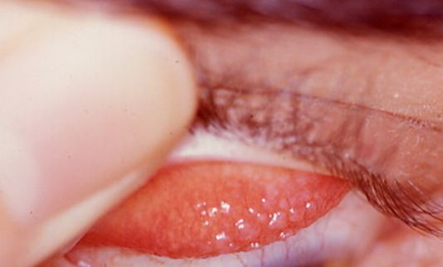

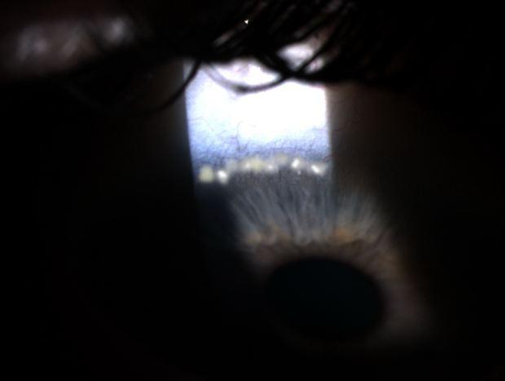

## Question 1 / 6

Given the above findings, what is the MOST likely diagnosis for this patient?

a) Epidemic keratoconjunctivitis

b) Keratoconjunctivitis sicca

c) Vernal keratoconjunctivitis

d) Herpes simplex keratitis

e) Superior limbic keratoconjunctivitis

## Question 2 / 6

Which of the following represents the MOST appropriate initial treatment option, given the above diagnosis?

a) Natamycin suspension q.4h

b) Zymaxid® solution q.i.d.

c) Erythromycin ointment b.i.d

d) Viroptic® solution q.2h

e) FML® suspension q.i.d.

f) Betadine ophthalmic prep solution in-office treatment

## Question 3 / 6

Given the above treatment, what MUST be included in your patient education?

a) Calcium-rich foods must be avoided while using the medication

b) The medication will blur vision for approximately 30 minutes

c) The medication can darkening of the iris

d) The medication must be shaken well just before each use

e) The medication must be kept in the refrigerator

f) The medication must be taken with food

## Question 4 / 6

Which of the following ocular conditions MOST commonly occurs in association with the above diagnosis?

a) Lattice corneal dystrophy

b) Posterior polymorphous dystrophy

c) High axial myopia

d) Limbal stem cell deficiency

e) Keratoconus

f) Glaucoma

## Question 5 / 6

Patients diagnosed with the above condition also frequently suffer from which of the following systemic conditions?

a) Diabetes

b) Atopy

c) Systemic lupus erythematosus

d) Rheumatoid arthritis

e) Sjogren syndrome

f) Gastroesophageal reflux disease

## Question 6 / 6

You decide to evaluate if there is any lymph node involvement in this patient by examining the preauricular area. What would you expect to observe and feel when palpating these nodes?

a) Visible, tender, palpable nodes

b) Non-visible, non-tender, palpable nodes

c) Non-visible, tender, palpable nodes

d) Visible, non-tender, palpable nodes

e) Non-visible, non-tender, non-palpable nodes