Case mdpDvLqLuIruZTjyye80 Details

**Demographics**

* 32-year-old white male; air traffic controller

**Chief complaint**

* blurred vision

**History of present illness**

* Character/signs/symptoms:sudden decrease in vision
* Location:OD
* Severity:moderate
* Nature of onset:acute
* Duration:2 days
* Frequency:constant
* Exacerbations/remissions:none
* Relationship to activity or function:none
* Accompanying signs/symptoms:none

**Secondary complaints/symptoms**

* none

**Patient ocular history**

* last eye exam 6 months ago; no vision correction; corneal scar OD due to previous injury

**Family ocular history**

* mother: glaucoma

**Patient medical history**

* anxiety disorder

**Medications taken by patient**

* Xanax®

**Patient allergy history**

* NKDA

**Family medical history**

* mother: hyperthyroid, father: hypertension

**Review of systems**

* Constitutional/general health:difficulty sleeping
* Ear/nose/throat:denies
* Cardiovascular:denies
* Pulmonary:denies
* Dermatological:denies
* Gastrointestinal:denies
* Genitourinary:denies
* Musculoskeletal:denies
* Neuropsychiatric:anxiety
* Endocrine:denies
* Hematologic:denies
* Immunologic:denies

**Mental status**

* Orientation:oriented to time, place, and person
* Mood:nervous
* Affect:appropriate

**Clinical findings**

**Uncorrected visual acuity**

* OD:VA distance: 20/40 (PHNI)
* OS:VA distance: 20/20

**Pupils:**

* PERRL, negative APD

**EOMs:**

* full, no restrictions OU

**Confrontation fields:**

* full to finger counting OD, OS

**Slit lamp**

* lids/lashes/adnexa:unremarkable OD, OS
* conjunctiva:nasal pinguecula OD, OS
* cornea:small round scar OD, clear OS
* anterior chamber:deep and quiet OD, OS
* iris:normal OD, OS
* lens:clear OD, OS
* vitreous:clear OD, OS

**IOPs:**

* OD: 13 mmHg, OS: 13 mmHg @ 10:15 am by Goldmann applanation tonometry

**Fundus OD**

* C/D:see image 1
* macula:see image 1
* posterior pole:see image 1
* periphery:unremarkable

**Fundus OS**

* C/D:see image 2
* macula:see image 2
* posterior pole:see image 2
* periphery:unremarkable

**Blood pressure:**

* 121/82 mmHg, right arm, sitting

**Pulse:**

* 82 bpm, regular

**Optical coherence tomography (OCT)**

* OD:see image 3
* OS:see image 4

**Amsler grid**

* OD:central metamorphopsia, see image 5
* OS:normal, see image 6

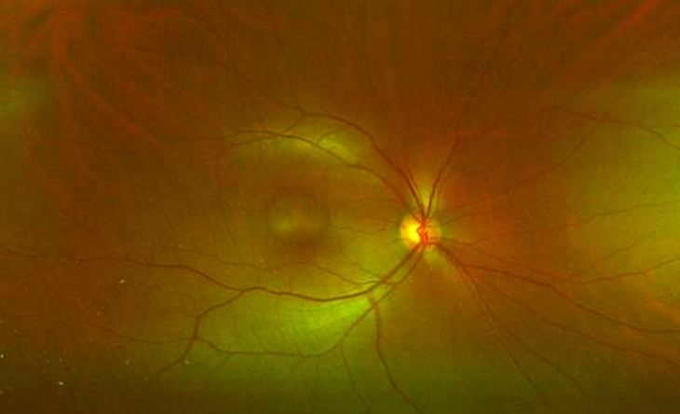

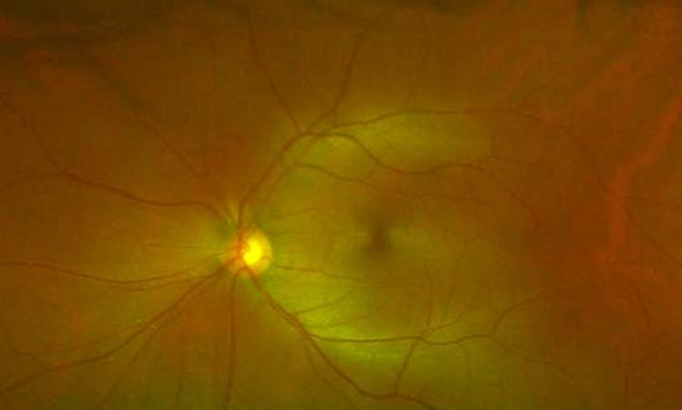

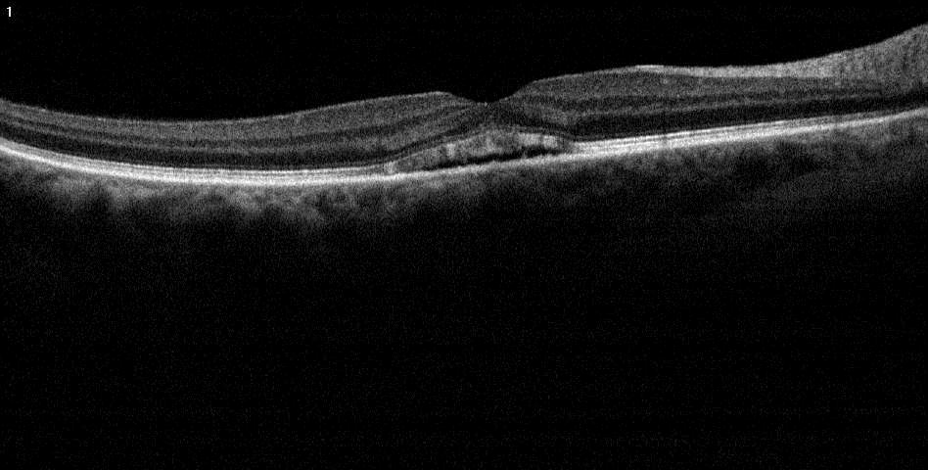

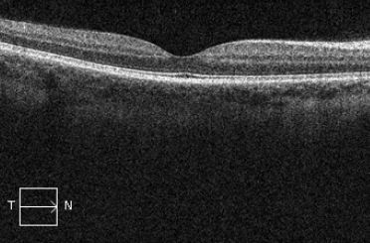

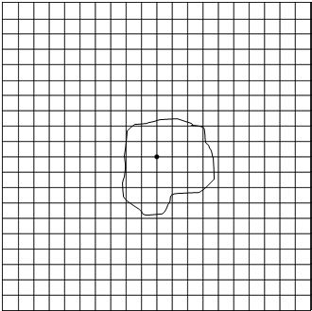



## Question 1 / 4

Given the examination findings, what is the MOST likely diagnosis of the patient's right eye fundus condition?

a) Full-thickness macular hole

b) Macular degeneration

c) Bull's eye maculopathy

d) Central serous retinopathy

## Question 2 / 4

What gender and age group are MOST characteristically affected by this retinal condition?

a) Males and females are equally affected; ages 40-60

b) Males; ages 10-30

c) Females; ages 20-40

d) Males; ages 30-50

e) Females; ages 50-80

f) Males; ages 60-80

## Question 3 / 4

What is the MOST appropriate treatment for the patient's fundus condition at this time?

a) UV protection and AREDS II vitamins

b) Discontinue the patient's oral medication

c) Refer patient for a vitrectomy

d) Refer for photodynamic therapy

e) No treatment is necessary at this time

f) Refer patient for laser photocoagulation

## Question 4 / 4

When should the patient return for a follow-up visit at your office?

a) 1 week

b) After the retinal specialist releases care back to you

c) 3 months

d) 6 months

e) 1 month