Case pRkGXaijodIxOgjto142 Details

**Demographics**

* 72-year-old white female; avid tennis player

**Chief complaint**

* sudden decreased vision and eye pain

**History of present illness**

* Character/signs/symptoms:eye pain, swelling, redness, and blurred vision
* Location:OD
* Severity:severe
* Nature of onset:acute
* Duration:1 day; started last night, but much worse when she woke up this morning
* Frequency:constant
* Exacerbations/remissions:none
* Relationship to activity or function:had cataract surgery 4 days ago
* Accompanying signs/symptoms:headache, light sensitivity

**Secondary complaints/symptoms**

* none

**Patient ocular history**

* last comprehensive exam 4 months ago, cataract surgery OS 2 months ago, cataract surgery OD 4 days ago

**Family ocular history**

* mother: presumed ocular histoplasmosis, father: cataracts

**Patient medical history**

* cardiovascular disease, hypertension, melanoma on back (removed 5 years ago)

**Medications taken by patient**

* coumadin, atenolol, Moxeza® q.i.d. OD, Ilevro® q.d. OD, Pred-Forte® q.i.d. OD

**Patient allergy history**

* macrolides

**Family medical history**

* father: gout

**Review of systems**

* Constitutional/general health:denies
* Ear/nose/throat:denies
* Cardiovascular:denies
* Pulmonary:occasional shortness of breath
* Dermatological:denies
* Gastrointestinal:denies
* Genitourinary:denies
* Musculoskeletal:lower back pain
* Neuropsychiatric:denies
* Endocrine:denies
* Hematologic:denies
* Immunologic:denies

**Mental status**

* Orientation:oriented to time, place, and person
* Mood:appropriate
* Affect:appropriate

**Clinical findings**

**Uncorrected visual acuity**

* OD:VA distance: 20/400 (PHNI)
* OS:VA distance: 20/25

**Pupils:**

* PERRL, negative APD

**Slit lamp**

* lids/lashes/adnexa:2+ lid edema OD, unremarkable OS
* conjunctiva:4+ injection, 2+ chemosis OD, normal OS
* cornea:see image 1 OD, clear OS
* anterior chamber:4+ cells, hypopyon OD, deep and quiet OS
* iris:normal OD, OS
* lens:PCIOL, clear and centered OD, OS
* vitreous:3+ cells OD, clear OS

**IOPs:**

* OD: 19 mmHg, OS: 18 mmHg @ 9:10 am by Goldmann applanation tonometry

**Fundus OD**

* C/D:poor view
* macula:poor view
* posterior pole:poor view
* periphery:poor view

**Fundus OS**

* C/D:0.30 H/0.35 V
* macula:normal
* posterior pole:normal
* periphery:unremarkable

**Blood pressure:**

* 123/84 mmHg, right arm, sitting

**Pulse:**

* 78 bpm, regular

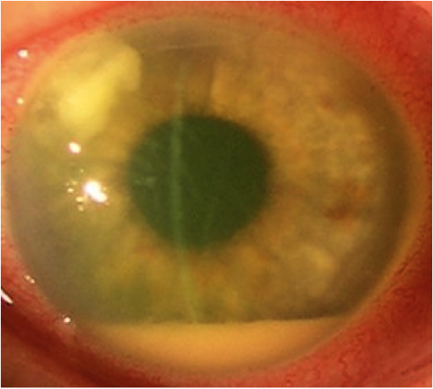

## Question 1 / 5

Given the patient’s history and examination findings, what is the MOST likely diagnosis of her right eye condition?

a) Bacterial conjunctivitis

b) Trachoma

c) Endophthalmitis

d) Verruca

e) Acanthamoeba keratitis

## Question 2 / 5

What is the MOST appropriate treatment for the above patient’s right eye condition?

a) Add Besivance® ophthalmic solution b.i.d. OD for seven days

b) Add oral doxycycline and erythromycin ointment q.h.s. OD for two weeks

c) Immediate referral to an ophthalmologist

d) Increase Pred-Forte® to q.1.h. OD until inflammation improves

## Question 3 / 5

What is the MOST likely causative organism of the patient’s right eye condition?

a) Salmonella enterica

b) Haemophilus influenzae

c) Escherichia coli

d) Pseudomonas aeruginosa

e) Staphylococcus epidermidis

## Question 4 / 5

After undergoing treatment, the patient returns one year later and you notice that she has a mild case of bacterial conjunctivitis. Which of the following medications should NOT be prescribed to her at this time?

a) Besivance®

b) Tobramycin

c) Moxeza®

d) AzaSite®

## Question 5 / 5

Which of the following infections must be reported to the CDC (Centers for Disease Control and Prevention)?

a) Herpes simplex

b) Syphilis

c) Vaginal warts

d) Epidemic keratoconjunctivitis (EKC)